User Test – Feb 26

Name | Freda Xiaoyun Yu | Gender | female | Age | 27
Job | Computer Science student | Date | Feb. 26 | Version | Alex Chu Feb. 19 version
Have seen this game before? |  | Y | Is one of the developers before? |  | N
Platform working fine? |  | Difficulty | Whole speed runs normally? |  | Y
Operations and keys are correctly related? |  | Y | Main story is understandable? |  | ?
Button are understandable? |  | Y | If you have disability, how do you feel about our game? |  | -
Do you think you are always clear with the help of navigation buttons ? |  | N | Volume control / skin customization? |  | N
Is it fluent for choice of towers or levels? |  | Y | Do you think buttons are in consistent style? |  | Y
Do you think characters are in consistent style? |  | ? | You don’t need to remember any names. Is it true? |  | Y
See tutorials? |  | N | See our contact info? |  | N
Help document? |  | N
Likes
- I can see where to call the enemies now!
- The lower left button can also arrange the enemies’ speed, and the icon is meaningful that everyone can understand.
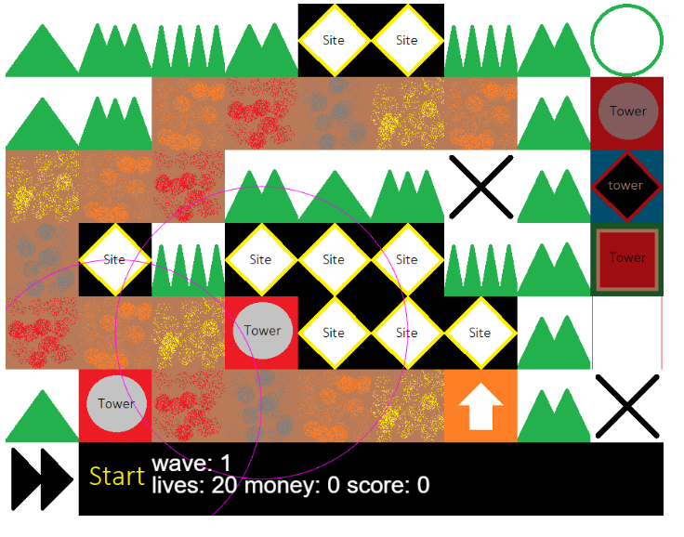
- There is a level completion page.
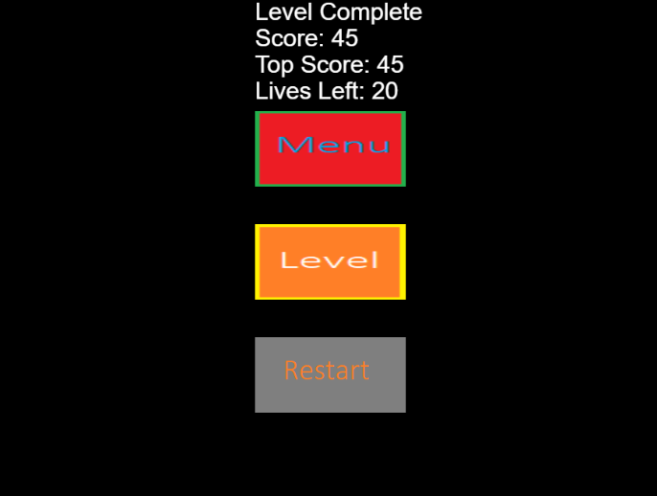
- I think the basic functionalities are complete!
- Now all of the words and the pictures don’t overlap each other.
- It’s brilliant to see the life Hit-Point bar.
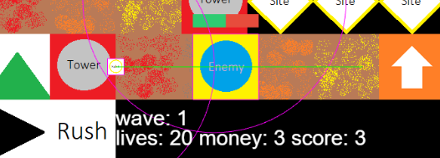
Dislikes
- The ‘Site’ picture should be more meaningful that everyone can know that there is an empty position and towers can be put on there. Perhaps there needs a tutorial.
- The level-completion page should award more satisfaction to the game player. Should change the background.
- There are two ‘menu’ buttons (the ‘circle’ and the ‘menu’). Should change the first to ‘menu’, and the second to the ‘main panel’ or something similar.
- the ‘site’ should be more meaningful to users that they can put towers there. Change the picture.
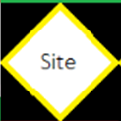

- Shoud add meaningful characters.

