User Test – Feb 19
User’s name: Freda Xiaoyun Yu
User’s age: 27
User’s gender: female
User’s job: Computer Science student

Game version: Alex Chu early Feb version

How to Open The Game
Firstly I downloaded the zip file from our Github page. Then unzip it.
1. I tried to open it with Brackets, but it cannot show the live window.
2. I tried to open the folder with VSCode, then right click the ‘index.html’ file -> ‘Open With Live Server’. It cannot show anything in the browser.
Then I asked Alex, and he told me I should install Node.js, and type ‘npm install’ in the unzipped folder’s route. Then type ‘npm start’. I spent a while to install these things. As a developer, I know it’s my responsibility to learn how to operate it with Node.js, but as a user, I would expect a more convenient method to open the game. I would expect that, once I open some web page, it will show a link. I click on the link, then it will pop up a window for the game in the browser.

Surprises ☺
- Wow! The music is melodic. It’s continuous, without too much fluctuation, so that it allows me to concentrate on the game and how I should operate.
- I like the icon in the first page.
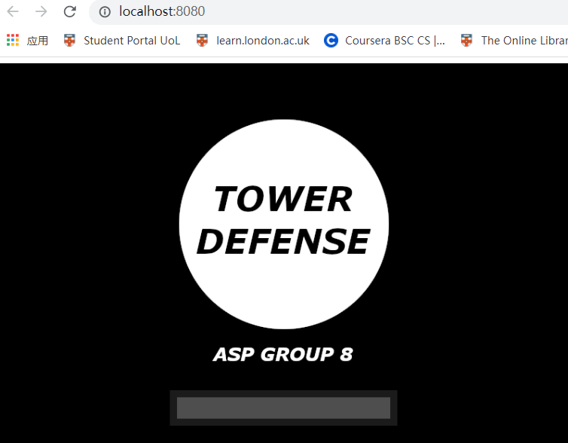

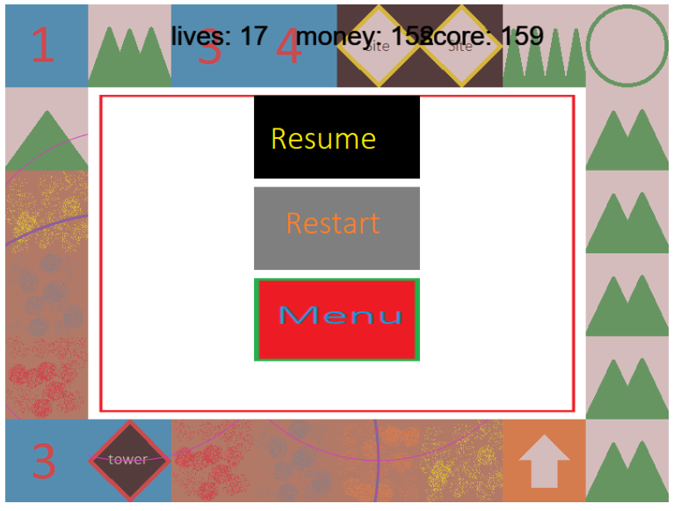
- It’s a surprise that the bullets work well!
- I can see the enemies coming in.
- It’s good to see there is a menu. It’s handy.

Difficulties ☹
- I cannot identify where the enemies will come. Well, finally I noticed that I should click on the upper left button to let the enemies in. There should some tutorials.
- I do not know where the menu is.
- I’m not quite sure where I can put towers – places other than the roads and the mountains?

