User Test – Feb 19
User’s name: Freda Xiaoyun Yu
User’s age: 27
User’s gender: female
User’s job: Computer Science student

Game version: Alex Chu Feb 19 version

Surprises ☺
- I can see where to call the enemies now!
- The lower left button can also arrange the enemies’ speed, and the icon is meaningful that everyone can understand.
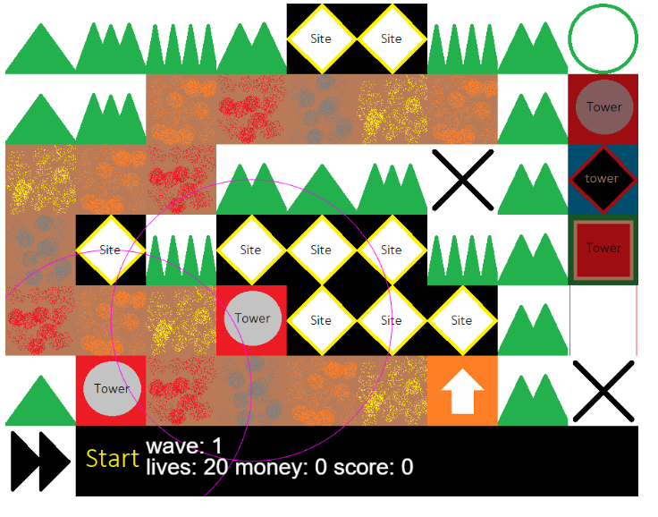
- There is a level completion page.
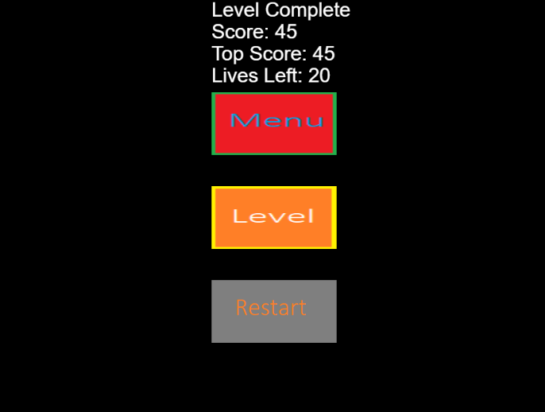
- It’s brilliant to see the life progression bar.
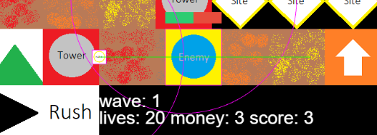
- Now all of the words and the pictures don’t overlap each other.
- I think the basic functionalities are complete!

Difficulties ☹
- The ‘Site’ picture should be more meaningful that everyone can know that there is an empty position and towers can be put on there. Perhaps there needs a tutorial.

- The level-completion page should award more satisfaction to the game player. Should change the background.
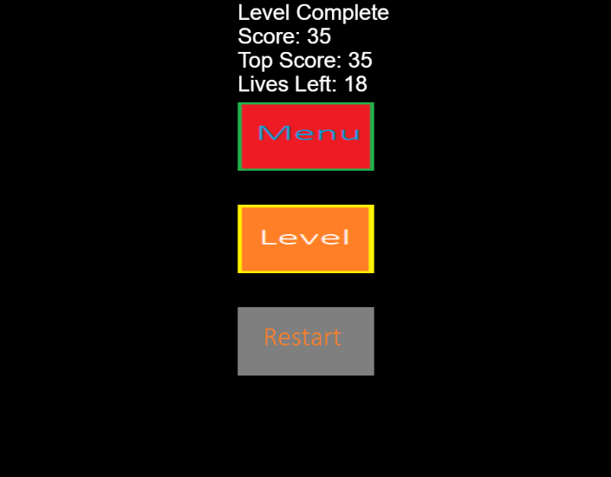
- There are two ‘menu’ buttons (the ‘circle’ and the ‘menu’). Should change the first to ‘menu’, and the second to the ‘main panel’ or something similar.
- the ‘site’ should be more meaningful to users that they can put towers there. Change the picture.
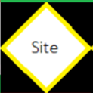
- Shoud add meaningful characters.

