 | Sofia University “St. Kliment Ohridski”  Faculty of mathematics and informatics  Department “Software technologies”

COURSE PROJECT
for the Parallel programming with Python course

Prime numbers generation with parallel programs

Student:
Radostin Dimitrov, 7MI3400760

Lecturer:
Prof. Krassen Stefanov

Sofia, Jun. 2026
- Problem definition and feasibility
The output of a prime generating program, could be the complete list of primes less than a given integer or just one prime (or a subset of primes) satisficing a given criteria. For the project we select the first. In addition, we specify that the usual Sieve of Eratosthenes algorithm with all primes in memory
  - Memory analysis
For the so selected variant we can do a feasibility using the expected memory for such a list and to determine what numerical datatypes could be used, based on the known number of primes. While there is no elementary expression of the prime counting function $π\left(x\right)$ (the number of primes ≤x), formula (1) approximates it.
$π\left(x\right)≈x/ln⁡(x)$ (1)
There are also calculated values for up to $π\left({10}^{29}\right)$, but for the purposes of this project
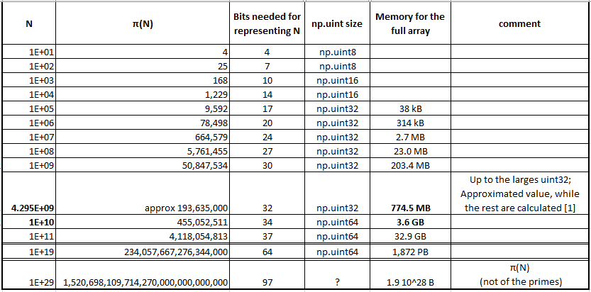
Table 1, List of $π\left(x\right)$ taken from [1], with analysis of the expected memory of an NumPy array holding that many numbers; Analysis done in file pi(x).xlsx
The other aspect of the required memory is the is that of the sieve which is directly proportional to $N_{max}$. In fact, it is the bigger memory contributor and the more important one as it is a necessary part of the algorithm, while the final representation of the list of primes could be done separately or skipped depending on the desired output. The memory for the sieve in bits will be exactly equal to $N_{max}$, it if the optimal representation is used (bitarray from the bitarray library), or it will be ${8 N}_{max}$ if a numpy.bool_ type is used. A comparison of the two will be made as an exercise for memory measurement and to see how it affects the run time.

From the analysis in table 1, we see that if we limit the problem to primes $≤N_{max}≈ 4.3 {10}^{9}$ we can work only 32-bit unsigned integers (np.uint32). In this limit case the memory of the array of primes will be 774 MB and that of the sieve ~ 4.3 GB. While this seems beneficial on first glance, as most of the work and of the memory use is concentrated at the sieve array only a small benefit is actually expected, so the more general 64-bit integers variant will be used.
The good thing for the sieve algorithms is that they could be segmented and that to work on a segment not all prior primes are needed. The original problem’s memory complexity is $O(N_{max})$, but the memory complexity of each segmented run is $O(\sqrt{N_{max}}+d )$, where d is the size of the segments.
The output’s size (on disk) is also proportional to $N_{max}$ as the number of primes grows slower (formula 1) but the size of each number in bits increases with $N_{max}$ . The size of the output is between 18% and 40% that of the (non-segmented) sieve.

Figure 1, Memory of the output as a percentage of the sieve. It decreases as the number of primes grows slower than N, but jumps when the representation (the type) of the integers has to increase. From the figures in file pi(x).xlsx

1.2 Plan
- Serial version
  - Verify correctness;
  - Measure execution time and compare with expected complexity;
  - Measure memory for different data type of the sieve and for multiple values of $N_{max}$;
- Parallelization of the work per prime (the inner loop)
  - Numba - run with different number of cores
- Segmented version and parallelization
  - Run this version without parallelization (1 thread) which could still yield a speedup a each segment could benefit from the smaller memory used
  - Numba
    - Shared memory – sweet spot at the cache size ?
  - Multiprocessing
    - Combo with run on diff nodes and on each do the inner || as well?
- MPI
  - Similar to the last multiprocessing option

- Sieve of Eratosthenes algorithm
The well-known algorithm could be stated as: in a prepared list of integers, all initially threated as potential primes, for each number $i ≥ 2$it is taken as prime if is not yet marked then all its multiples starting from $i^{2}-1$ are marked as not primes. The algorithm concludes when $i^{2}>N_{max}$and all unmarked numbers are prime.
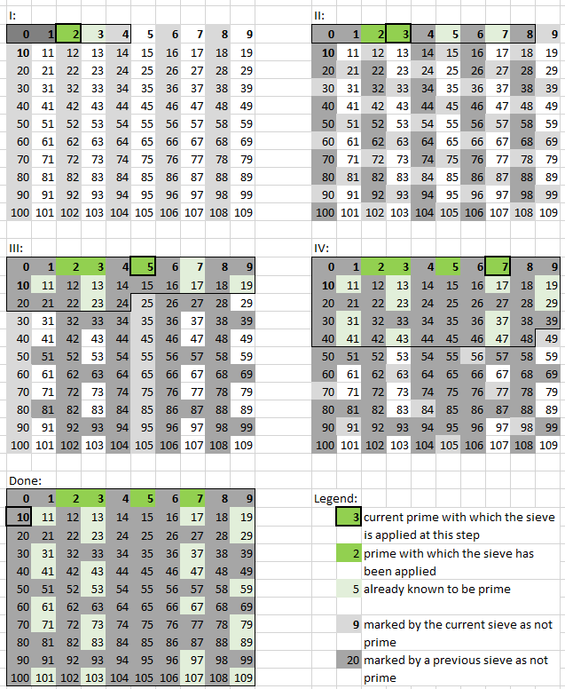
Figure 2, Illustration of the four (not trivial) steps needed to find the primes up to 109
- Serial versions
- Main version – correctness and time complexity verification
Here is the algorithm implementation with a bitarray from the bitarray library. The actual function can be found in the file serial_versions.py under the name serial_bitarray_sieve(N_max).
sieve = bitarray(N_max)
sieve.setall(True)
sieve[0:2] = False # including 0 and 1 for convenience

N_sqrt = int(np.floor(np.sqrt(N_max)))

for i in range(2, N_sqrt):
if sieve[i] != 0:
for j in range(i**2, N_max, i):
sieve[j] = False

count = sieve.count()
primes = np.zeros(count, dtype=np.uint64)
idx = 0
for i in sieve.search(1): # iterator over set-bit indices
primes[idx] = i
idx += 1

As the input and output are quite simple, to check the correctness we compare to just a couple of known correct values e.g. for $N_{max}=110,$ $N_{max}=111$ and a bigger one as 100 000 000, for which the number of primes and the last prime are taken from ana online source [2] (in utils.py→check_correctness()).
To verify that the time complexity is the expected one of $O(N_{max} loglogN_{max})$ a testbench with $N_{max}$ in a bigger range (6 decades with 2 points each) is made. Figure 3 shows the statistics (average and standard deviation) of the run times, measured 10 times
The results are plotted in double log scale and a model fit is made with the expected time complexity $t=c n\log{(\log{n)}}$, accounting for the standard deviations of the measurements.
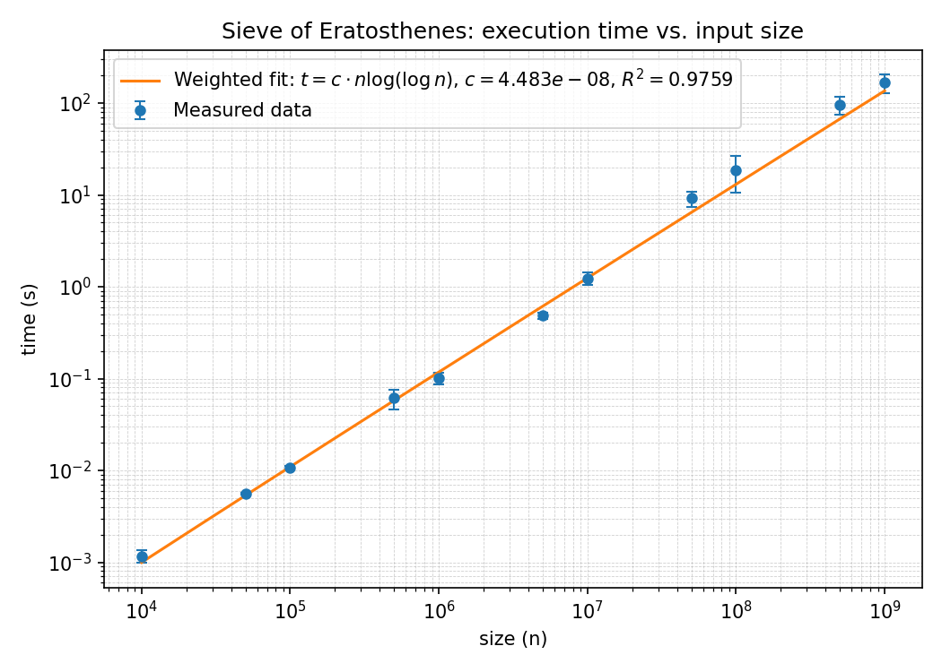
Figure 3, serial algorithm execution time and time complexity model fit
- Comparison of sieve data types
As mentioned in the feasibly, the sieve determines the memory used and could be implemented as a bitarray or as an np.array, both of these and even a third variant (even more naïve) using integers (np.uint64) are implemented so that:
- a memory measurement is implemented and its reliability checked;
- the 3 methods usages are compared to the expected and between them;
- the effect of the memory use on the execution times can be observed (some improvement is expected if for the same problem the size is reduced, but clear how much);
To achieve this, the 3 versions are implemented without returning the primes at all, so that the expected memory
A most naïve version is to follow the explanation of the of the algorithm and create an array with the natural numbers as the sieve. This ‘mistake’ is intentionally including to have an additional comparison. The other 2 included variants are a Boolean type sieve (1 Byte per integer) and a variant using bitarray (1 bit per integer)
and to confirm the memory pe
Memory and time at a few N_max

Conclusion:

References

[1] | [Online]. Available: https://en.wikipedia.org/wiki/Prime-counting_function.
[2] | [Online]. Available: https://www.numberempire.com/primenumbers.php.

