# Exercises: NUnit Basics

This document defines the exercises and homework assignments for the ["QA Automation" Course @ SoftUni](https://softuni.bg/trainings/2550/qa-automation-may-2020).

## Unit Testing the Collection<T> Class

You are given a C# class Collection<T>, which implements a generic collection, holding an indexed sequence of elements:

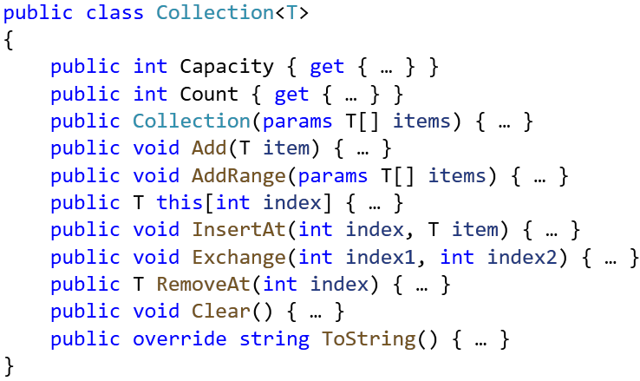

Write **unit tests** for the class Collection<T>. Ensure that the **code coverage** is high and that all interesting cases are covered: test **all public methods**, test the **auto growing** of the underlying array, test with valid and invalid ranges, and try to cover all other **special cases**.

### Hints

* Test **all public methods**.
* Think about all **different scenarios**, which can happen, e. g. insert at the start, insert at the end, insert at the middle, insert with auto-grow, insert at invalid position, insert into empty collection, etc.
* Ensure you test each method with **valid and invalid data**.
* Implement a **performance test** with 1 million items, with **timeout**.

You may implement the following unit tests:

