Министерство образования и науки Российской Федерации

Санкт-Петербургский политехнический университет Петра Великого

—

Институт компьютерных наук и технологий

Высшая школа программной инженерии

**Лабораторная работа №2**

**по дисциплине «Вычислительная математика»**

Выполнил

Студент группы 5130904/20004 Шелковников Д.С.

Преподаватель Устинов С.М.

Оглавление

Задание 2

Результаты 3

Выводы 5

Код программы 5

<DIR>/computational_mathematics/second_lab/Decomp.cpp 5

<DIR>/computational_mathematics/second_lab/Decomp.h 11

<DIR>/computational_mathematics/second_lab/Solve.cpp 11

<DIR>/computational_mathematics/second_lab/Solve.h 14

<DIR>/computational_mathematics/second_lab/main.cpp 14

# Задание

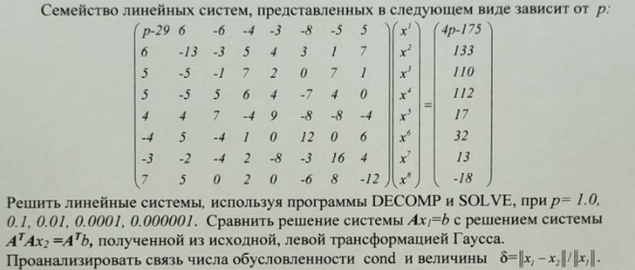

# Результаты

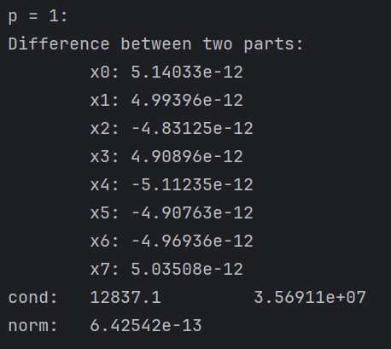

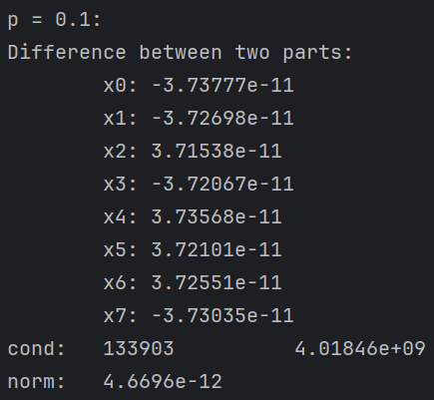

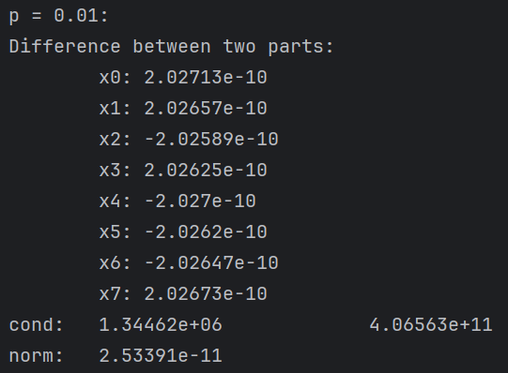

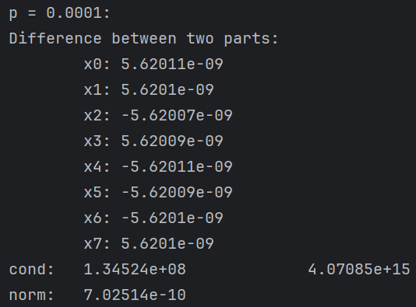

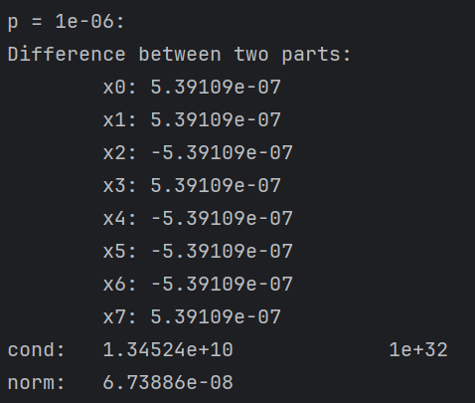

# Выводы

Решения двух систем максимально схожи, что видно по разности между соответствующими значениями x. Причем с уменьшением значения параметра P увеличивается разница между ними. Так же с уменьшением параметра Р увеличивается число обусловленности и уменьшается подсчитываемая величина. Это происходит потому что:

* Матрица близка к вырождению (определитель стремится к 0 с изменением параметра)
* Различия между элементами растет

# Код программы

## <DIR>/computational_mathematics/second_lab/Decomp.cpp

#include "Decomp.h"

#include <stdexcept>

#include <cmath>

#include "Solve.h"

int dimkashelk::details::decomp(int n, int ndim,

double *a, double *cond,

int pivot[], int *flag)

/* Purpose ...

-------

Decomposes a real matrix by gaussian elimination

and estimates the condition of the matrix.

Use Solve to compute solutions to linear systems.

Input ...

-----

n = order of the matrix

ndim = row dimension of matrix as defined in the calling program

*a = pointer to matrix to be triangularized

Output ...

------

*a pointer to an upper triangular matrix U and a

permuted version of a lower triangular matrix I-L

so that

(permutation matrix) * a = L * U

cond = an estimate of the condition of a .

For the linear system a * x = b, changes in a and b

may cause changes cond times as large in x.

If cond+1.0 .eq. cond , a is singular to working

precision, cond is set to 1.0e+32 if exact (or near)

singularity is detected.

pivot = the pivot vector.

pivot[k] = the index of the k-th pivot row

pivot[n-1]= (-1)**(number of interchanges)

flag = Status indicator

0 : successful execution

1 : could not allocate memory for workspace

2 : illegal user input n < 1, a == NULL,

pivot == NULL, n > ndim.

3 : matrix is singular

Work Space ...

----------

The vector work[0..n] is allocated internally by decomp().

This C code written by ... Peter & Nigel,

---------------------- Design Software,

42 Gubberley St,

Kenmore, 4069,

Australia.

Version ... 1.1 , 2-Dec-87

------- 2.0 , 11-Feb-89 (pointer used for a)

2.1 , 15-Apr-89 (work[] allocated internally)

2.2 , 14-Aug-89 (fixed pivoting)

2.3 , 3 -Sep-89 (face lift)

3.0 , 30-Sep-89 (optimize for rowwise storage)

Notes ...

-----

(1) Subscripts range from 0 through (ndim-1).

(2) The determinant of a can be obtained on output by

det(a) = pivot[n-1] * a[0][0] * a[1][1] * ... * a[n-1][n-1].

(3) This routine has been adapted from that in the text

G.E. Forsythe, M.A. Malcolm & C.B. Moler

Computer Methods for Mathematical Computations.

(4) Uses the functions fabs(), free() and malloc().

*/

{

/* --- function decomp() --- */

double EPSILON = 2.2e-16;

double ek, t, pvt, anorm, ynorm, znorm;

int i, j, k, m;

double *pa, *pb; /* temporary pointers */

double *work;

*flag = 0;

work = (double *) NULL;

if (a == NULL || pivot == NULL || n < 1 || ndim < n) {

*flag = 2;

return (0);

}

pivot[n - 1] = 1;

if (n == 1) {

/* One element only */

*cond = 1.0;

if (*a == 0.0) {

*cond = 1.0e+32; /* singular */

*flag = 3;

return (0);

}

return (0);

}

work = (double *) malloc(n * sizeof(double));

if (work == NULL) {

*flag = 1;

return (0);

}

/* --- compute 1-norm of a --- */

anorm = 0.0;

for (j = 0; j < n; ++j) {

t = 0.0;

for (i = 0; i < n; ++i) t += fabs(a[(i * ndim + j)]);

if (t > anorm) anorm = t;

}

/* Apply Gaussian elimination with partial pivoting. */

for (k = 0; k < n - 1; ++k) {

/* Find pivot and label as row m.

This will be the element with largest magnitude in

the lower part of the kth column. */

m = k;

pvt = fabs(a[(m * ndim + k)]);

for (i = k + 1; i < n; ++i) {

t = fabs(a[(i * ndim + k)]);

if (t > pvt) {

m = i;

pvt = t;

}

}

pivot[k] = m;

pvt = a[(m * ndim + k)];

if (m != k) {

pivot[n - 1] = -pivot[n - 1];

/* Interchange rows m and k for the lower partition. */

for (j = k; j < n; ++j) {

pa = a + (m * ndim + j);

pb = a + (k * ndim + j);

t = *pa;

*pa = *pb;

*pb = t;

}

}

/* row k is now the pivot row */

/* Bail out if pivot is too small */

if (fabs(pvt) < anorm * EPSILON) {

/* Singular or nearly singular */

*cond = 1.0e+32;

*flag = 3;

goto DecompExit;

}

/* eliminate the lower matrix partition by rows

and store the multipliers in the k sub-column */

for (i = k + 1; i < n; ++i) {

pa = a + (i * ndim + k); /* element to eliminate */

t = -(*pa / pvt); /* compute multiplier */

*pa = t; /* store multiplier */

for (j = k + 1; j < n; ++j) /* eliminate i th row */

{

if (fabs(t) > anorm * EPSILON)

a[(i * ndim + j)] += a[(k * ndim + j)] * t;

}

}

} /* End of Gaussian elimination. */

/* cond = (1-norm of a)*(an estimate of 1-norm of a-inverse)

estimate obtained by one step of inverse iteration for the

small singular vector. This involves solving two systems

of equations, (a-transpose)*y = e and a*z = y where e

is a vector of +1 or -1 chosen to cause growth in y.

estimate = (1-norm of z)/(1-norm of y)

Solve (a-transpose)*y = e */

for (k = 0; k < n; ++k) {

t = 0.0;

if (k != 0) {

for (i = 0; i < k; ++i) t += a[(i * ndim + k)] * work[i];

}

if (t < 0.0) ek = -1.0;

else ek = 1.0;

pa = a + (k * ndim + k);

if (fabs(*pa) < anorm * EPSILON) {

/* Singular */

*cond = 1.0e+32;

*flag = 3;

goto DecompExit;

}

work[k] = -(ek + t) / *pa;

}

for (k = n - 2; k >= 0; --k) {

t = 0.0;

for (i = k + 1; i < n; i++)

t += a[(i * ndim + k)] * work[i];

/* we have used work[i] here, however the use of work[k]

makes some difference to cond */

work[k] = t;

m = pivot[k];

if (m != k) {

t = work[m];

work[m] = work[k];

work[k] = t;

}

}

ynorm = 0.0;

for (i = 0; i < n; ++i) ynorm += fabs(work[i]);

/* --- solve a * z = y */

solve(n, ndim, a, work, pivot);

znorm = 0.0;

for (i = 0; i < n; ++i) znorm += fabs(work[i]);

/* --- estimate condition --- */

*cond = anorm * znorm / ynorm;

if (*cond < 1.0) *cond = 1.0;

if (*cond + 1.0 == *cond) *flag = 3;

DecompExit:

if (work != NULL) {

free(work);

work = (double *) NULL;

}

return (0);

} /* --- end of function decomp() --- */

dimkashelk::Decomp::Decomp(): cond_(0.0),

size_(0),

data_(nullptr),

pivot_(nullptr),

flag_(0) {

}

void dimkashelk::Decomp::operator()(const std::vector<std::vector<double> > &matrix) {

if (matrix.empty()) {

throw std::logic_error("Check matrix");

}

if (matrix.size() != matrix[0].size()) {

throw std::logic_error("Check size of matrix");

}

free();

size_ = static_cast<int>(matrix.size());

data_ = new double[size_ * size_];

try {

pivot_ = new int[matrix.size() * matrix.size()];

} catch (...) {

delete[] data_;

throw;

}

int ind = 0;

for (auto &i: matrix) {

for (double j: i) {

data_[ind] = j;

ind++;

}

}

details::decomp(size_, size_, data_, std::addressof(cond_), pivot_, std::addressof(flag_));

}

dimkashelk::Decomp::~Decomp() {

free();

}

void dimkashelk::Decomp::free() const {

if (data_ != nullptr) {

delete[] data_;

}

if (pivot_ != nullptr) {

delete[] pivot_;

}

}

## <DIR>/computational_mathematics/second_lab/Decomp.h

#ifndef DECOMP_H

#define DECOMP_H

#include <vector>

namespace dimkashelk {

namespace details {

int decomp(int n, int ndim,

double *a, double *cond,

int pivot[], int *flag);

}

class Solve;

class Decomp {

friend class Solve;

public:

Decomp();

void operator()(const std::vector<std::vector<double> > &matrix);

~Decomp();

private:

double cond_;

int size_;

double *data_;

int *pivot_;

int flag_;

void free() const;

};

}

#endif

## <DIR>/computational_mathematics/second_lab/Solve.cpp

#include "Solve.h"

#include <stdexcept>

#include "Decomp.h"

int dimkashelk::details::solve(int n, int ndim,

double *a, double b[],

int pivot[])

/* Purpose :

-------

Solution of linear system, a * x = b.

Do not use if decomp() has detected singularity.

Input..

-----

n = order of matrix

ndim = row dimension of a

a = triangularized matrix obtained from decomp()

b = right hand side vector

pivot = pivot vector obtained from decomp()

Output..

------

b = solution vector, x

*/

{

/* --- begin function solve() --- */

int i, j, k, m;

double t;

if (n == 1) {

/* trivial */

b[0] /= a[0];

} else {

/* Forward elimination: apply multipliers. */

for (k = 0; k < n - 1; k++) {

m = pivot[k];

t = b[m];

b[m] = b[k];

b[k] = t;

for (i = k + 1; i < n; ++i) b[i] += a[(i * ndim + k)] * t;

}

/* Back substitution. */

for (k = n - 1; k >= 0; --k) {

t = b[k];

for (j = k + 1; j < n; ++j) t -= a[(k * ndim + j)] * b[j];

b[k] = t / a[(k * ndim + k)];

}

}

return (0);

} /* --- end function solve() --- */

dimkashelk::Solve::Solve(): size_(0),

data_right_(nullptr),

cond_(0.0) {

}

void dimkashelk::Solve::operator()(const std::vector<std::vector<double> > &matrix_left,

const std::vector<double> &matrix_right) {

if (matrix_left.size() != matrix_right.size()) {

throw std::logic_error("Check data");

}

free();

size_ = static_cast<int>(matrix_right.size());

data_right_ = new double[size_];

for (int i = 0; i < size_; i++) {

data_right_[i] = matrix_right[i];

}

Decomp dec;

dec(matrix_left);

cond_ = dec.cond_;

const int size = static_cast<int>(matrix_left.size());

details::solve(size, size, dec.data_, data_right_, dec.pivot_);

}

std::vector<double> dimkashelk::Solve::get_result() const {

std::vector<double> res(size_);

for (int i = 0; i < size_; i++) {

res[i] = data_right_[i];

}

return res;

}

double dimkashelk::Solve::get_cond() const {

return cond_;

}

dimkashelk::Solve::~Solve() {

free();

}

void dimkashelk::Solve::free() const {

if (data_right_ != nullptr) {

delete[] data_right_;

}

}

## <DIR>/computational_mathematics/second_lab/Solve.h

#ifndef SOLVE_H

#define SOLVE_H

#include <vector>

namespace dimkashelk {

namespace details {

int solve(int n, int ndim,

double *a, double b[],

int pivot[]);

}

class Decomp;

class Solve {

friend class Decomp;

public:

Solve();

void operator()(const std::vector<std::vector<double> > &matrix_left, const std::vector<double> &matrix_right);

[[nodiscard]] std::vector<double> get_result() const;

[[nodiscard]] double get_cond() const;

~Solve();

private:

int size_;

double *data_right_;

double cond_;

void free() const;

};

}

#endif

## <DIR>/computational_mathematics/second_lab/main.cpp

#include <algorithm>

#include <iostream>

#include "Solve.h"

std::vector<double> get_difference_of_matrix(const std::vector<double> &left,

const std::vector<double> &right) {

std::vector result = left;

for (int i = 0; i < left.size(); i++) {

result[i] -= right[i];

}

return result;

}

double get_matrix_norm(const std::vector<double> &matrix) {

return *std::max_element(matrix.begin(), matrix.end());

}

std::vector<std::vector<double> > get_gaussian_elimination(std::vector<std::vector<double> > &m) {

auto matrix = m;

const int n = static_cast<int>(matrix.size());

for (int i = 0; i < n; ++i) {

int maxRow = i;

for (int k = i + 1; k < n; ++k) {

if (std::abs(matrix[k][i]) > std::abs(matrix[maxRow][i])) {

maxRow = k;

}

}

if (maxRow != i) {

std::swap(matrix[i], matrix[maxRow]);

}

for (int k = i + 1; k < n; ++k) {

const double factor = matrix[k][i] / matrix[i][i];

for (int j = i; j < n + 1; ++j) {

matrix[k][j] -= factor * matrix[i][j];

}

}

}

for (int i = n - 1; i >= 0; --i) {

for (int j = i + 1; j < n; ++j) {

matrix[i][n] -= matrix[i][j] * matrix[j][n];

}

matrix[i][n] /= matrix[i][i];

}

return matrix;

}

std::vector<std::vector<double> > multiply_matrices(const std::vector<std::vector<double> > &matrix1,

const std::vector<std::vector<double> > &matrix2) {

const int rows1 = static_cast<int>(matrix1.size());

const int cols1 = static_cast<int>(matrix1[0].size());

const int cols2 = static_cast<int>(matrix2[0].size());

std::vector result(rows1, std::vector(cols2, 0.0));

for (int i = 0; i < rows1; ++i) {

for (int j = 0; j < cols2; ++j) {

for (int k = 0; k < cols1; ++k) {

result[i][j] += matrix1[i][k] * matrix2[k][j];

}

}

}

return result;

}

std::vector<double> multiply_matrices(const std::vector<std::vector<double> > &matrix1,

const std::vector<double> &matrix2) {

const int rows1 = static_cast<int>(matrix1.size());

const int cols1 = static_cast<int>(matrix1.size());

const int cols2 = static_cast<int>(matrix2.size());

std::vector result(rows1, 0.0);

for (int i = 0; i < cols2; i++) {

for (int j = 0; j < rows1; j++) {

result[i] += matrix1[i][j] * matrix2[j];

}

}

return result;

}

std::vector<std::vector<double> > get_left_matrix(double p) {

return {

{p - 29, 6, -6, -4, -3, -8, -5, 5},

{6, -13, -3, 5, 4, 3, 1, 7},

{5, -5, -1, 7, 2, 0, 7, 1},

{5, -5, 5, 6, 4, -7, 4, 0},

{4, 4, 7, -4, 9, -8, -8, -4},

{-4, 5, -4, 1, 0, 12, 0, 6},

{-3, -2, -4, 2, -8, -3, 16, 4},

{7, 5, 0, 2, 0, -6, 8, -12}

};

}

std::vector<double> get_right_matrix(double p) {

return {

4 * p - 175,

133,

110,

112,

17,

32,

13,

-18

};

}

int main() {

dimkashelk::Solve solve;

const auto numbers = {1.0, 0.1, 0.01, 0.0001, 0.000001};

for (const auto number: numbers) {

std::cout << "p = " << number << ": \n";

std::cout << "Part one\t\t\tPart two\n";

auto left = get_left_matrix(number);

auto right = get_right_matrix(number);

solve(left, right);

auto res1 = solve.get_result();

const auto cond1 = solve.get_cond();

auto gaussian = get_gaussian_elimination(left);

auto new_left = multiply_matrices(gaussian, left);

auto new_right = multiply_matrices(gaussian, right);

solve(new_left, new_right);

auto res2 = solve.get_result();

const auto cond2 = solve.get_cond();

for (int i = 0; i < res1.size(); i++) {

std::cout << "\tx" << i << ": " << res1[i] << "\t\t\t" << res2[i] << '\n';

}

std::cout << "cond: \t" << cond1 << "\t\t" << cond2 << "\n";

const auto res3 = get_matrix_norm(get_difference_of_matrix(res1, res2)) / get_matrix_norm(res1);

std::cout << "norm:\t" << res3 << "\n";

std::cout << "\n";

}

return 0;

}