Stroop Effect Simulation using Drift Diffusion Model

Introduction

The Stroop Effect is a psychological phenomenon in which the brain experiences interference when the meaning of the word conflicts with the color it is written in. The study explores how conflicting information can affect “participant’s” (simulated responses) accuracy and speed.

Research Objective

The objective of this experiment is to investigate the Stroop effect, by comparing the results of different simulated responses in congruent and incongruent trials. This allows us to gain an insight into selective attention and cognitive control.

Methodology

Instead of human participants, a Drift Diffusion Model was used to simulate reaction times and decision accuracy for both congruent and incongruent trials. The model parameters were designed to reflect varying levels of cognitive interference from conflicting word information.

Simulation Procedure:

Model: Drift Diffusion Model

Drift rate computation: I calculated the drift for each trial as:
Drift = (color weight * color signal) + (word weight * word signal)
Congruent trials: color and word signals aligned (+1).
Incongruent trials: color and word signals conflicted (+1 vs -1).

Other Parameters:
Decision threshold: 0.8
Noise: 0.5
Time step: 0.001
Maximum trial duration: 5.0

I ran 500 trials per condition for congruent and incongruent trials. For each trial I used the stroop_drift function to compute the reaction time and error rate and varied the word weight to examine how increasing cognitive conflict affected the performance.

Results

The simulation produced clear results in both trials. In incongruent trials the results indicate that the reaction time and error rate are higher in incongruent trials than those in congruent trials. We can observe that as word weight increases, the mean reaction time sharply increases in incongruent trials. Whie in congruent trials an increase in word weight signifies a decrease in reaction time. Meanwhile error rate is near zero in congruent trials regardless of word weight. Lastly, in incongruent trials, error rate increases dramatically alongside word weight especially when we change word weight from 0.5 to 1.0 .

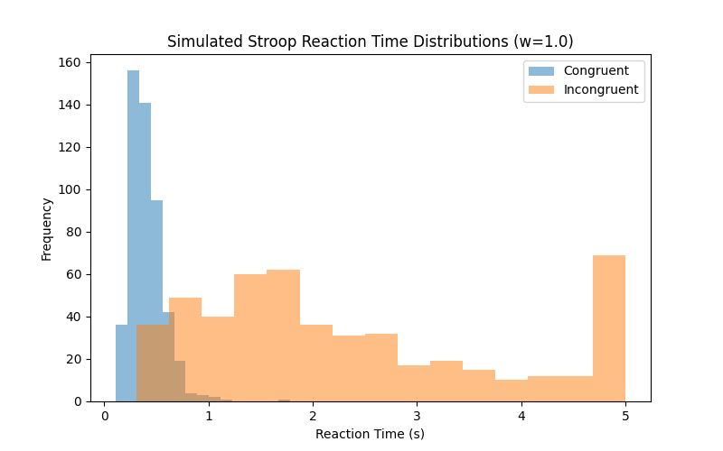
Figure 1: Reaction time for word weight = 1

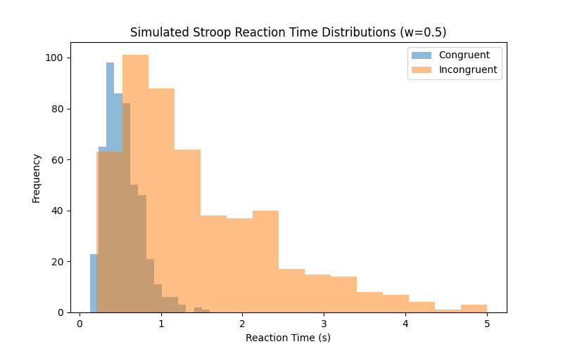
Figure 2: Reacrtion time for word weight = 0.5

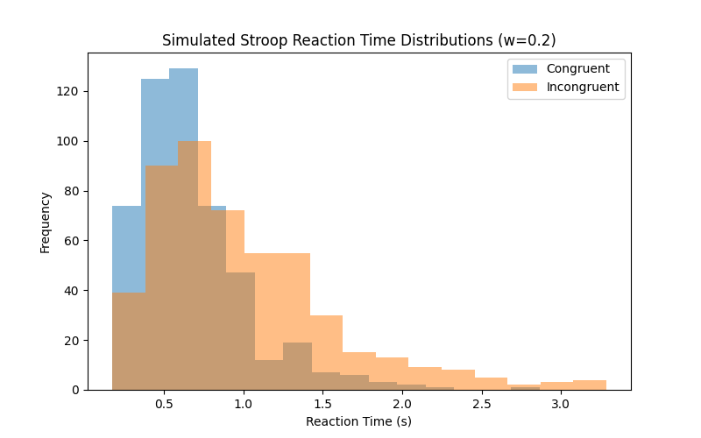
Figure 3: Reaction time for word weight = 0.2

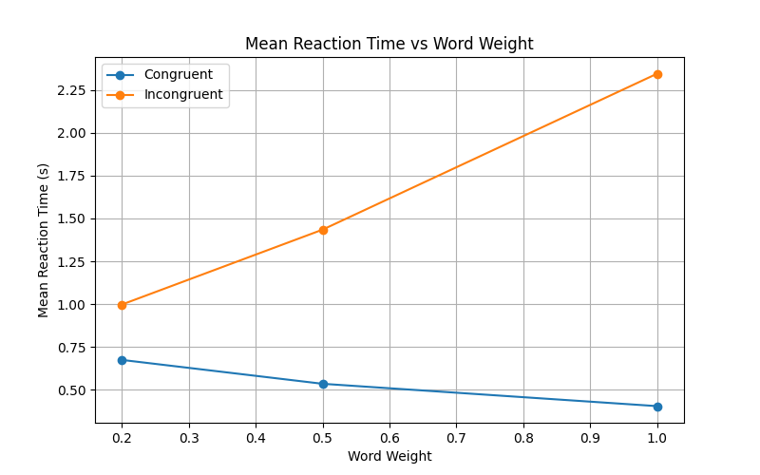
Figure 4: Reaction time based on word weight

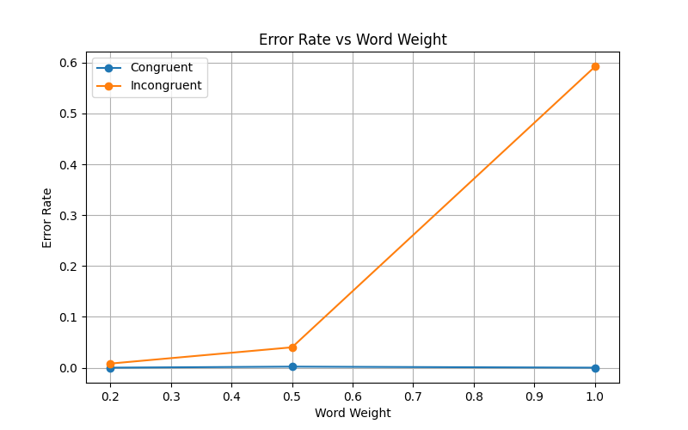
Figure 5: Error rate based on word weight
Conclusion

In conclusion, the experiment confirmed the Stroop effect: incongruent trials produce longer reaction times and higher error rates, while congruent trials show minimal changes. These results illustrate how conflicting information interferes with selective attention and cognitive control.

