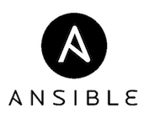

As a latest entrant in the market compared with Puppet and Chef, Ansible was developed to simplify complex orchestration and configuration management tasks. The platform is written in Python and allows users to script commands in YAML.

Ansible offers multiple push models to send command modules to nodes via SSH that are executed sequentially. Ansible doesn’t require agents on every system, and modules can reside on any server. A centralized Ansible workstation is commonly used to tunnel commands through multiple host servers and access machines in a private network.

- Easy remote execution, and low barrier to entry.
- Strong documentation, support and contributions from an active community + multiple existing repositories.
- Suitable for environments designed to scale rapidly.
- Shares facts between multiple servers, so they can query each other.
- Easy installation and initial setup.
- Syntax and workflow is fairly easy to learn for new users.
- Sequential execution order.
- Lack of master eliminates failure points and performance issues. Agent-less deployment and communication is faster than the master-agent model.
- High security with SSH.
- Simple tool in terms of its deployment, configuration and ease of use.
- No TLS certificates. Ability to run in adhoc, pull and push modes.
- Easy learning curve in terms of usage and ansible playbooks writing
- Huge variety of available modules covering 99% of DevOps use cases in an enterprise
Ansible is a great orchestrator. One-time shot operations are something that Ansible does very well. Its also pretty easy to understand in that there are no dependencies other than ssh and a python json serializer.

Why it Matters

Complexity & Cost
For developers, using a CM(configuration management) tool meant weeks of effort learning complex concepts, struggling with a complex installation process, and maintaining that complex system over time. They are somewhat aware of the benefits, but the costs of using a CM tool just seems too high to make it worth the effort.

In-depth statistics show a proven fact that the cost savings for a business are huge when the team uses a CM tool. When it takes a couple minutes to bring up a new server/environment instead of hours/days/weeks, that's a huge savings (assuming your engineers cost greater than $0/hour).


- Being that Configuration Management is like the framework for greater information management programs, it should go without saying that it is critical for greater management and organization of information as a whole. With a well-ordered system in place, a good IT worker should be able to see all of the past system implementations of the business, and can better address future needs and changes to keep the system up to date and running smoothly.

- IT staff productivity increase. Optimizing IT staff activities through automation reduced IT staff time spent "keeping the lights on", freeing up valuable staff resources for business-related initiatives.
- Configuration Management saves money with the constant system maintenance, record keeping, and checks and balances to prevent repetition and mistakes.

- User productivity increase. User downtime caused by system outages, change and configuration activities or security intrusions is reduced.

- IT cost reduction. Optimizing IT operations reduces costs in multiple areas, including infrastructure, outsourced services and management software.

Shell Scripts vs Ansible:
Note: Here we mostly talk about Shell Scripts as the enemy. However, in practice, there are much worse offenders like not using any kind of script or not even having a checklist or any documentation whatsoever.

Comparison
Ansible has brought the learning curve down so far that it can actually be EASIER to use Ansible than to do a manual install or a shell scripting.
The high cost of using a CM tool is now gone and you also get all the benefits of configuration management and remote execution.
Hopefully I will convince folks who are still on the fence to start using a CM tool like Ansible for more awesome systems.

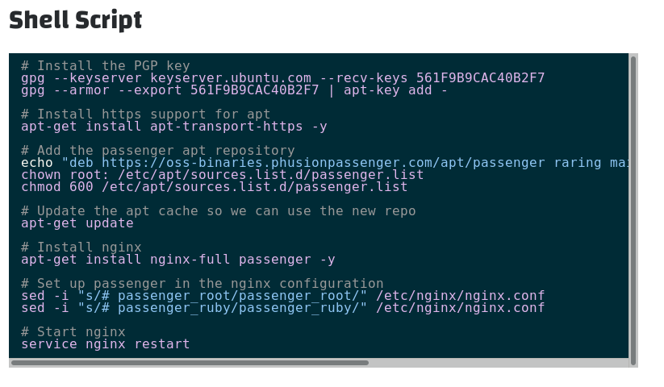
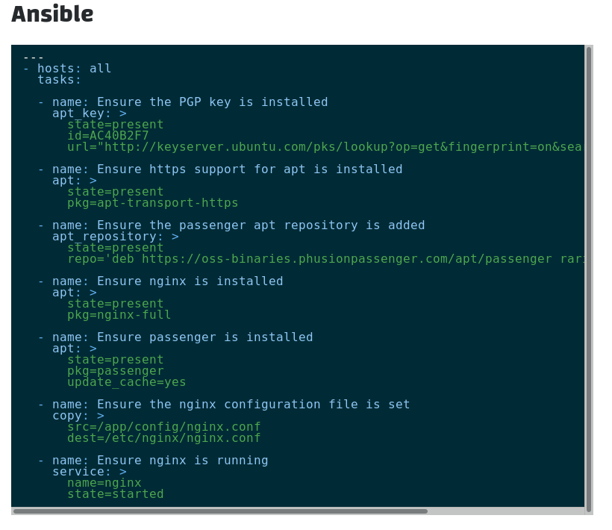



Some Differences
You may notice that I copied over the nginx config file for Ansible rather than just modifying the file directly on the server like I did for the shell script. Initially I looked into editing the file with Ansible's lineinfile module, but it just felt so wrong. That's another nice thing about Ansible, it encourages better practices. So, I decided to save the nginx config file locally so I could track it in version control and copy it over instead.
You'll also notice that I start the comments for Ansible with "Ensure". That is because Ansible will not only do the initial installation, but can also be run again and again to 'ensure' that the system is in the desired state. Ansible can perform the function of not only setting up your systems, but also testing them for correctness.
By contrast, a shell script can be very dangerous to run more than once unless you're extremely careful and know exactly what every line does. For example, what will those gpg commands do if I run them again? I have no idea. I could invest time to see if they are safe to run multiple times, or I could just use Ansible. - Tasks are meant to be idempotent... which is a hipster tech word to mean that it should be safe to run a task over and over again without any side effects. Idempotence is an important concept in Ansible!

The Winner
- Which method is most likely to end up in source control?
- Which method can be run multiple times safely with confidence?
- Which method can easily be run against multiple servers?
- Which method actually verifies (tests) your server for correctness?
- Which method can target certain servers easily (web, db, etc)?
- Which method supports easily templating your configuration files?
- Which method will grow to easily support your whole stack?
I didn't cover some of these topics, but the answer to all of these is: Ansible

