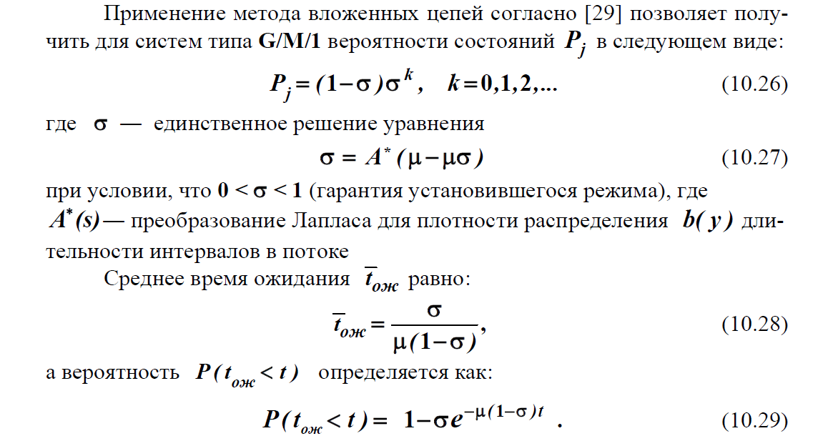



> help roots

roots Find polynomial roots. 

roots(C) computes the roots of the polynomial whose coefficients

are the elements of the vector C. If C has N+1 components,

the polynomial is C(1)*X^N + ... + C(N)*X + C(N+1).

Note: Leading zeros in C are discarded first. Then, leading relative

zeros are removed as well. That is, if division by the leading

coefficient results in overflow, all coefficients up to the first

coefficient where overflow occurred are also discarded. This process is

repeated until the leading coefficient is not a relative zero.

Class support for input c:

float: double, single

See also poly, residue, fzero.

Reference page for roots

Other functions named roots

>> p=[1 -3.8 3.61 -0.81]

p =

1.0000 -3.8000 3.6100 -0.8100

>> r=roots(p)

r =

2.4724

1.0000

0.3276

>> syms ro

>> P=[1 -2*(1+ro) (1+ro) ^2 -ro^2]

P =

[ 1, - 2*ro - 2, (ro + 1)^2, -ro^2]

>> SIGMA=roots(P)

SIGMA =

1

**ro - (4*ro + 1)^(1/2)/2 + 1/2**

ro + (4*ro + 1)^(1/2)/2 + ½

>> subs(R,{0.5; 0.6; 0.7; 0.8; 0.9})

ans =

[ 1, 1, 1, 1, 1]

**[ 1 - 3^(1/2)/2, 11/10 - (5^(1/2)*17^(1/2))/10, 6/5 - (5^(1/2)*19^(1/2))/10, 13/10 - (5^(1/2)*21^(1/2))/10, 7/5 - (5^(1/2)*23^(1/2))/10]**

[ 3^(1/2)/2 + 1, (5^(1/2)*17^(1/2))/10 + 11/10, (5^(1/2)*19^(1/2))/10 + 6/5, (5^(1/2)*21^(1/2))/10 + 13/10, (5^(1/2)*23^(1/2))/10 + 7/5]

Sigma= **ro - (4*ro + 1)^(1/2)/2 + ½**





(*)  
  
Здесь , где — интенсивность потока E2 (Эрланга 2-го порядка), а не простейшего потока

Лучше бы использовать , тогда 

Или или  или





>> P=[1 -2*(1+2*ro) (1+2*ro)^2 -4*ro^2]

Находим корни уравнения  с использованием Матлаб

P =

[ 1, - 4*ro - 2, (2*ro + 1)^2, -4*ro^2]

>> SIGMA=roots(P)

SIGMA =

1

**2*ro - (8*ro + 1)^(1/2)/2 + ½ % правильный корень <1**

2*ro + (8*ro + 1)^(1/2)/2 + ½

 Здесь 

Для СМО М/М/1  при заданных условиях

**λ**= 0,8,**μ** = 1  и 

Значит для СМО E2/М/1

/(1-(**2*ro - (8*ro + 1)^(1/2)/2 + ½**)) = ro/(1-(**2*ro - (8*ro + 1)^(1/2)/2 + ½**))

 (**)

Проверка формулы (**). По формуле (*)



Пусть , и формула (**)

тогда 

По формуле (*) или (**) нужно подобрать , такое, чтобы 

Подбирать можно с помощью маталаб

>> syms ro

>> J=ro/(1-(2*ro - (8*ro + 1)^(1/2)/2 + 1/2)) % среднее число заявок

J =

ro/((8*ro + 1)^(1/2)/2 - 2*ro + 1/2)

>> subs(J,0.9)

ans =

9/(10*((5^(1/2)*41^(1/2))/10 - 13/10))

>> 9/(10*((5^(1/2)*41^(1/2))/10 - 13/10))

ans =

6.8295

>> subs(J,0.6)

ans =

3/(5*((5^(1/2)*29^(1/2))/10 - 7/10))

>> 3/(5*((5^(1/2)*29^(1/2))/10 - 7/10))

ans =

1.1901

>> subs(J,0.8)

ans =

4/(5*((5^(1/2)*37^(1/2))/10 - 11/10))

>> 4/(5*((5^(1/2)*37^(1/2))/10 - 11/10))

ans =

3.0752

>> subs(J,0.87)

ans =

87/(100*(199^(1/2)/10 - 31/25))

>> 87/(100*(199^(1/2)/10 - 31/25))

ans =

5.0974

>> subs(J,0.83)

ans =

83/(100*(191^(1/2)/10 - 29/25))

>> 83/(100*(191^(1/2)/10 - 29/25))

ans =

3.7383

>>