KickStart

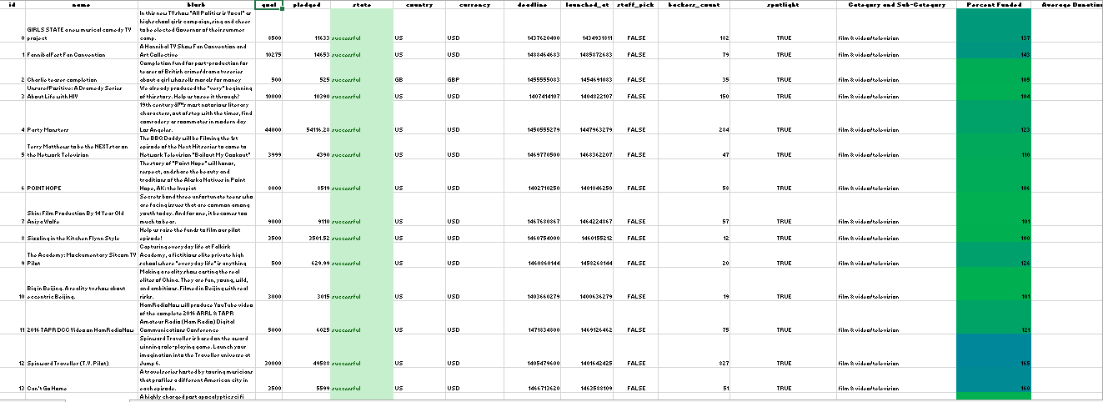

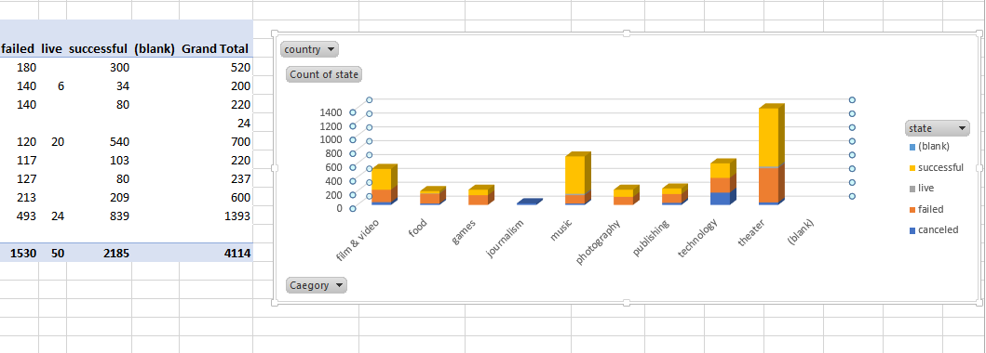

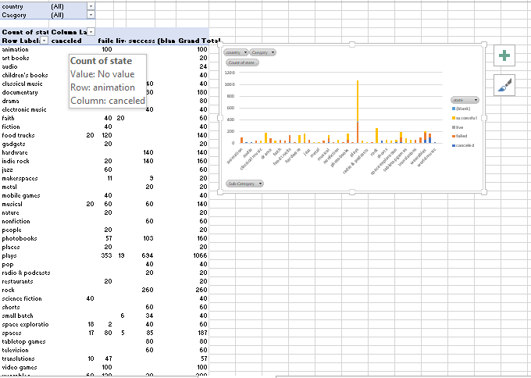

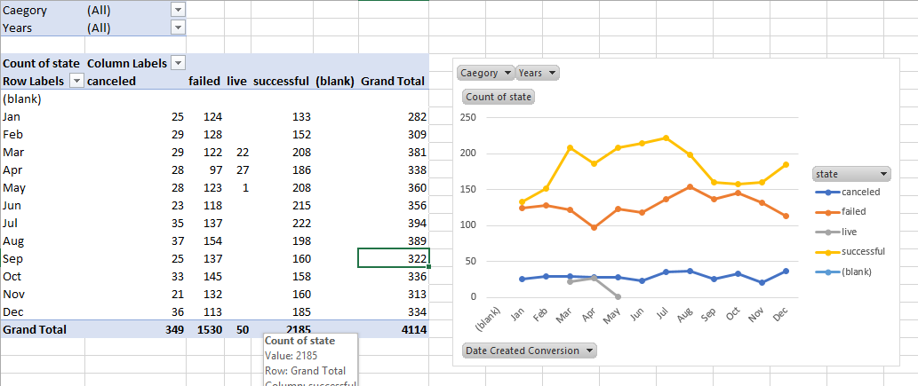

Three conclusions we can make about Kickstarter campaigns given the provided data?

State

Pledged Funds

Goal

What are some of the limitations of this dataset?

Data Validation

What are some other possible tables/graphs that we could create?

1. **Date Created Conversion, Percent Funded, state**
2. **Category, goal, State**
3. **Category, goal, Average Donation**