DATA ALCOTT SYSTEMS
COMPLETE SEO AUDIT REPORT
FreeInternships.in
Digital Marketing Internship Project
Student: Dimpal Aswani
Student Code: DAS009566
Internship ID: 4363
Task ID: #3673 / DM-SEO-001
Website Audited: https://www.freeinternships.in/
Audit Evidence Date: 17 September 2026

1. Executive Summary
This report presents an SEO audit of FreeInternships.in using the supplied Google PageSpeed Insights and SEMrush screenshots, together with visible robots.txt and sitemap.xml evidence. The review covers technical performance, crawlability, on-page SEO indicators, off-page metrics, and recommended next steps.
The supplied evidence shows a mixed performance picture. Mobile real-user Core Web Vitals are marked as passed, while the desktop real-user assessment is marked as failed because the visible CLS value is 0.23. The PageSpeed lab performance scores are 34 on mobile and 61 on desktop. SEMrush shows an Authority Score of 8, estimated organic traffic of 908, 111 organic keywords, 61 referring domains, and 75 backlinks.
Evidence limitation: this report is based on screenshots supplied by the student. Google Search Console data, a complete crawl export, individual broken URLs, exact title/meta tag inventories, and detailed backlink quality data were not supplied and are not presented as verified findings.

2. Project Overview
Project | Complete SEO Audit of FreeInternships.in
Domain | Digital Marketing
Organization | Data Alcott Systems
Target audience | Students, freshers, and internship seekers
Primary objective | Identify SEO issues and provide actionable recommendations
Tools evidenced | Google PageSpeed Insights and SEMrush

3. Technical SEO Audit

3.1 PageSpeed Insights – Mobile
Metric | Observed result | Interpretation
Core Web Vitals assessment | Passed | Real-user assessment shown as passed
LCP | 2.0 s | Within the displayed green range
INP | 134 ms | Within the displayed green range
CLS | 0 | No layout shift shown in field data
FCP | 1.6 s | Displayed as green
TTFB | 0.9 s | Displayed as orange
Performance score | 34 | Needs improvement
Accessibility | 75 | Improvement opportunity
Best Practices | 100 | Strong displayed score
SEO | 85 | Improvement opportunity
Mobile finding: the real-user Core Web Vitals assessment is passed, but the lab Performance score is 34. Optimize large images, JavaScript, third-party resources, and above-the-fold content.

3.2 PageSpeed Insights – Desktop
Metric | Observed result | Interpretation
Core Web Vitals assessment | Failed | Real-user assessment shown as failed
LCP | 1.9 s | Displayed as green
INP | 30 ms | Displayed as green
CLS | 0.23 | Layout shift needs improvement
FCP | 1.4 s | Displayed as green
TTFB | 0.8 s | Displayed as orange
Performance score | 61 | Moderate; improvement opportunity
Accessibility | 79 | Improvement opportunity
Best Practices | 96 | Generally strong
SEO | 92 | Good displayed score
Desktop finding: the visible CLS value of 0.23 is the clearest performance issue. Reserve space for images, banners, advertisements, and dynamic elements.

3.3 SEMrush Site Audit
SEMrush item | Observed result
Pages crawled | 100 / 100
Site Health | 71%
AI Search Health | 78%
Errors | 38
Warnings | 455
Crawlability | 85%
HTTPS | 98%
Site Performance | 91%
Internal Linking | 84%
Markups | 87%
Core Web Vitals | Not implemented in the displayed project view
Internal SEO | Not implemented in the displayed project view
SEMrush displays 38 errors and 455 warnings. Open and export the individual issues to map each one to an exact URL and fix.

3.4 Robots.txt and Sitemap
- The supplied robots.txt screenshot shows multiple user-agent sections and a visible Sitemap directive.
- The supplied sitemap.xml screenshot displays a list of URLs, indicating that an XML sitemap is available.
- A full validation of every sitemap URL, last-modified date, canonical URL, and indexability status requires opening the files or using a crawler.

4. On-Page SEO Audit
The supplied screenshots do not show the complete HTML source or page-level title/meta inventories. Therefore, the following are audit checks and recommendations rather than confirmed page-level defects.
- Review unique title tags.
- Write descriptive meta descriptions.
- Ensure one clear H1 per important page.
- Use logical H2/H3 headings.
- Add descriptive image alt text.
- Improve internal links between relevant pages.
- Avoid repetitive keyword use.
- Review consistency of pricing, certificate, eligibility, and duration information.

5. Off-Page SEO Audit
Metric | SEMrush screenshot result | Comment
Authority Score | 8 | Low authority indicator in the displayed tool
Organic Traffic | 908 (-2.4%) | Tool estimate; date shown as 17 Sep 2026
Organic Keywords | 111 (+44%) | Tool estimate
Referring Domains | 61 | Displayed count
Backlinks | 75 | Displayed count
Paid Traffic | 0 | Displayed count
The displayed Authority Score is 8, with 61 referring domains and 75 backlinks. Inspect the quality and relevance of these domains rather than focusing only on quantity.

6. Competitor Analysis
Potential comparison websites include Internshala, Unstop, and LetsIntern. Compare them using the same country, database, device, and date settings.
Comparison area | What to compare
Organic keywords | Shared keywords, missing keywords, and relevant landing pages
Content | Internship guides, FAQs, eligibility, projects, and blog depth
Backlinks | Referring domains, relevance, and link quality
Technical SEO | Mobile performance, indexability, structured data, and internal linking
Conversion UX | Clarity of registration, fees, certificates, and calls to action
Competitor metric values were not supplied, so no competitor ranking or numerical comparison is fabricated.

7. Prioritized Action Plan
Priority | Action | Reason
High | Investigate the 38 SEMrush errors | Errors may affect crawling, indexability, links, or page experience
High | Reduce desktop CLS from 0.23 | Desktop real-user Core Web Vitals assessment is shown as failed
High | Improve mobile lab Performance score of 34 | Mobile performance is the weakest displayed PageSpeed score
High | Export and review the 455 warnings | Warnings may reveal repeated site-wide issues
Medium | Improve accessibility from 75 mobile / 79 desktop | Supports usability and inclusive access
Medium | Review internal linking score of 84% | Strengthen navigation and discovery of important pages
Medium | Review markup score of 87% | Validate structured data and eligibility for rich results
Medium | Inspect backlinks behind Authority Score 8 | Prioritize relevant, trustworthy referring domains
Low | Create content around student search intent | Build topical relevance and long-tail visibility

8. Conclusion
FreeInternships.in has positive signals such as passed mobile field Core Web Vitals, strong displayed best-practice scores, HTTPS coverage of 98%, and an existing organic keyword/backlink footprint.
The key improvement areas are mobile lab performance, desktop CLS, SEMrush errors and warnings, and authority-building. Re-test after fixes.

9. Evidence Appendix

Screenshot 1
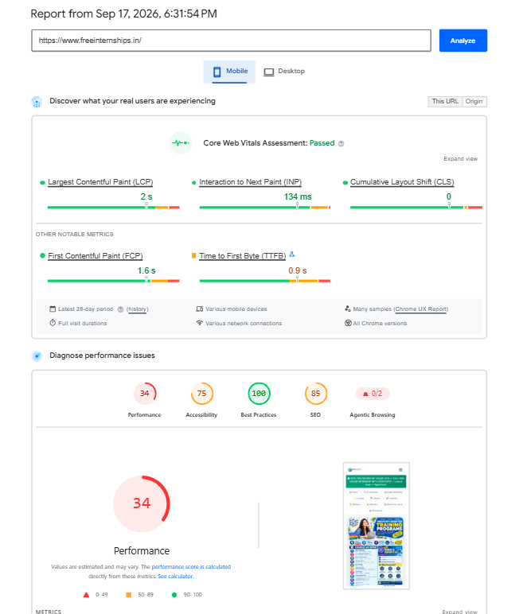

Screenshot 2
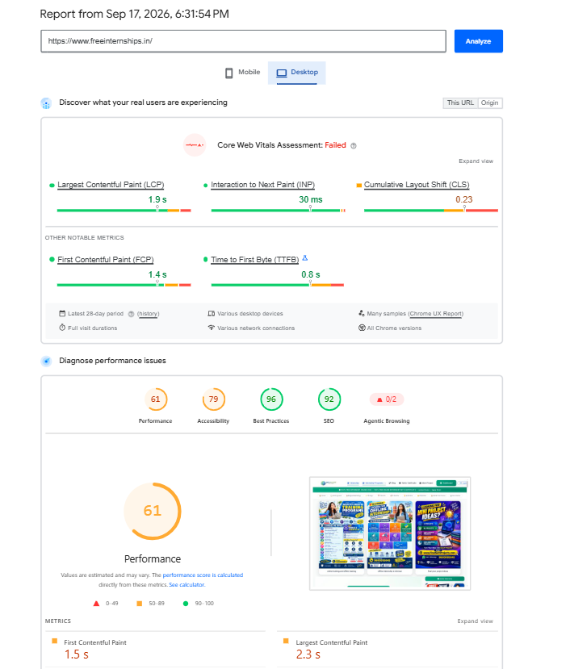

Screenshot 3
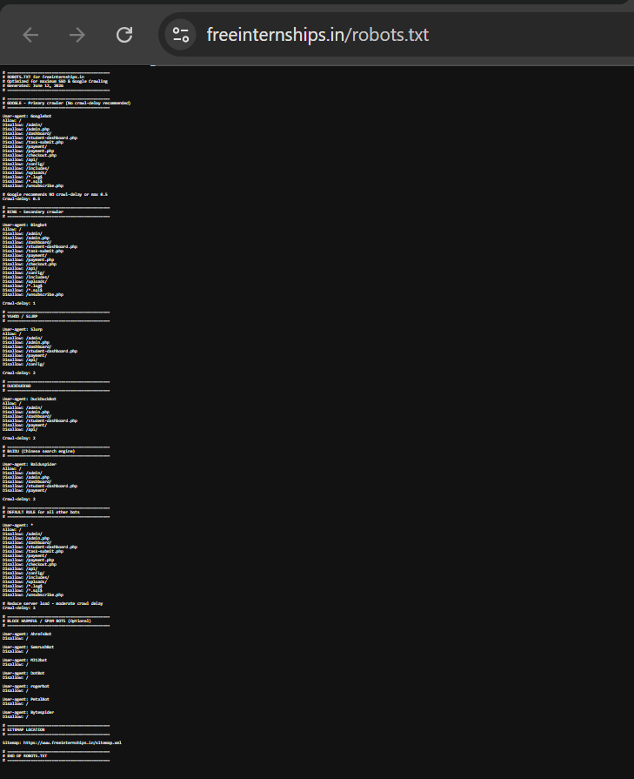

Screenshot 4
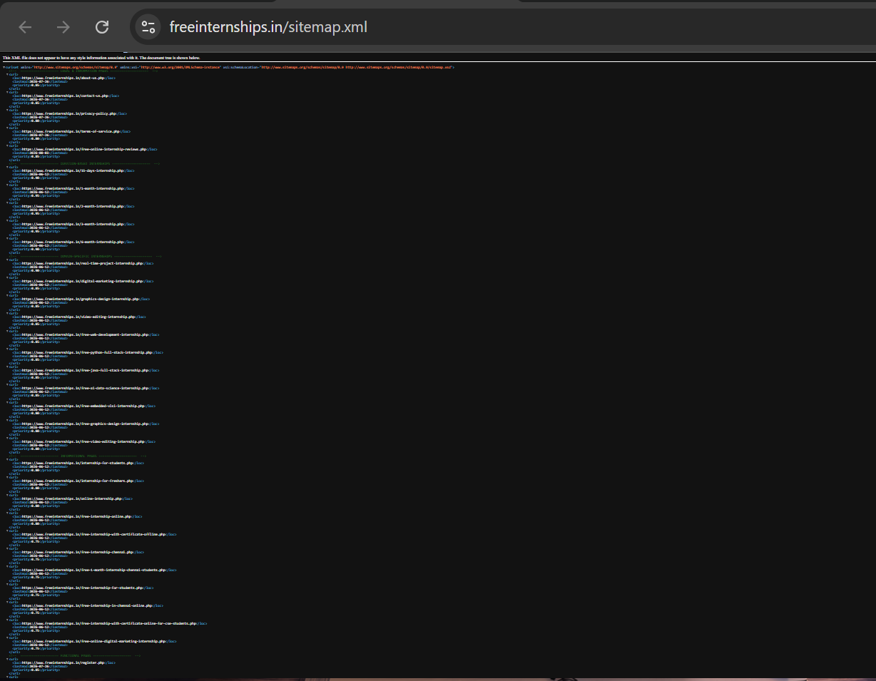

Screenshot 5
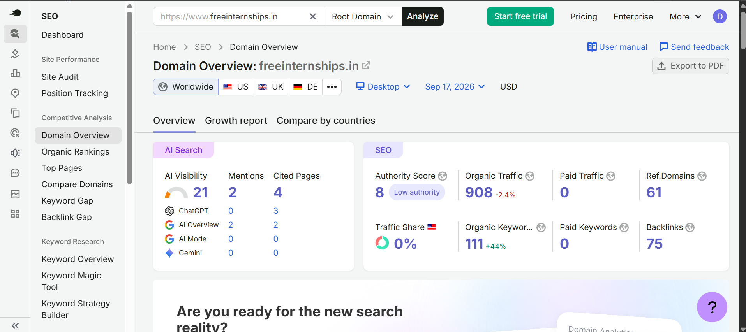

Screenshot 6
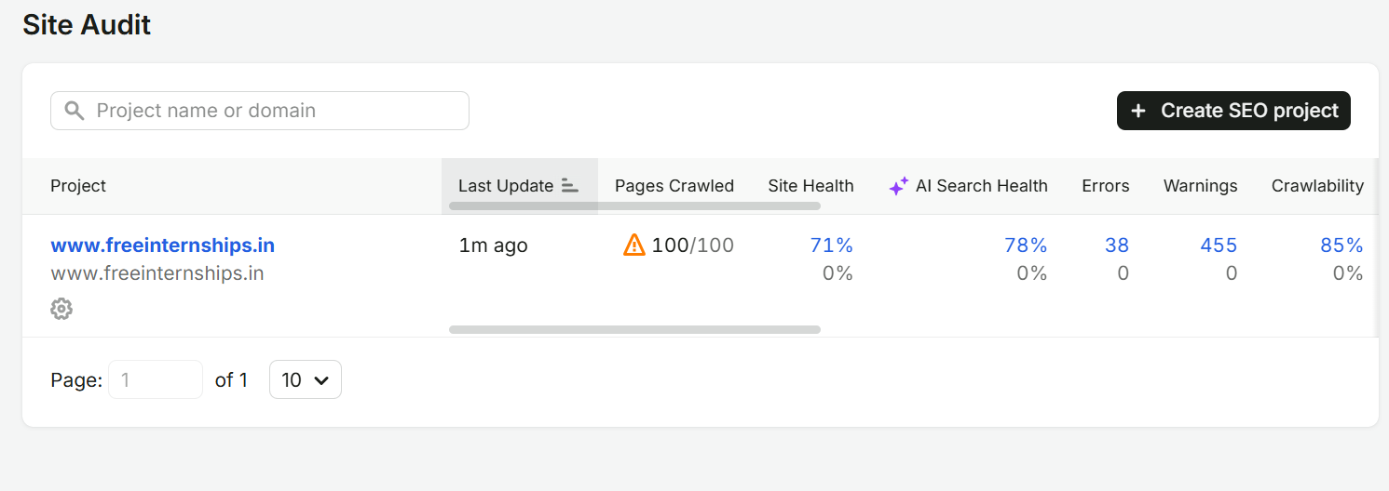

Screenshot 7
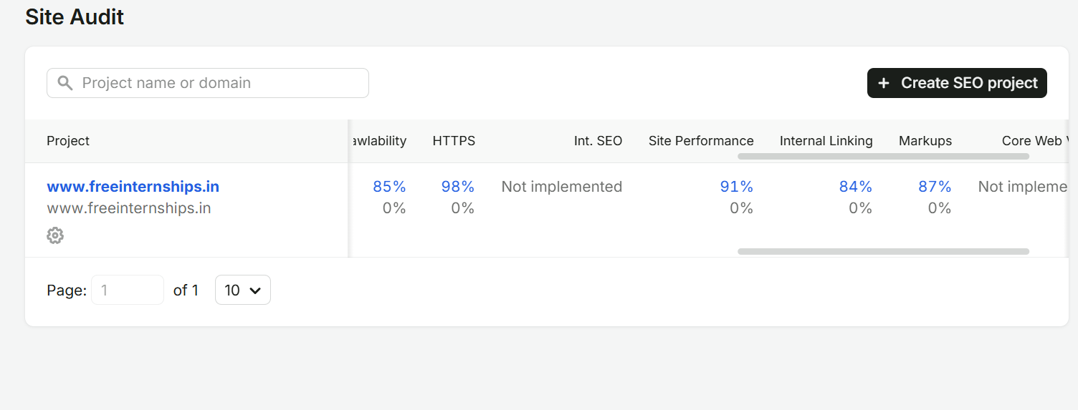

Screenshot 8
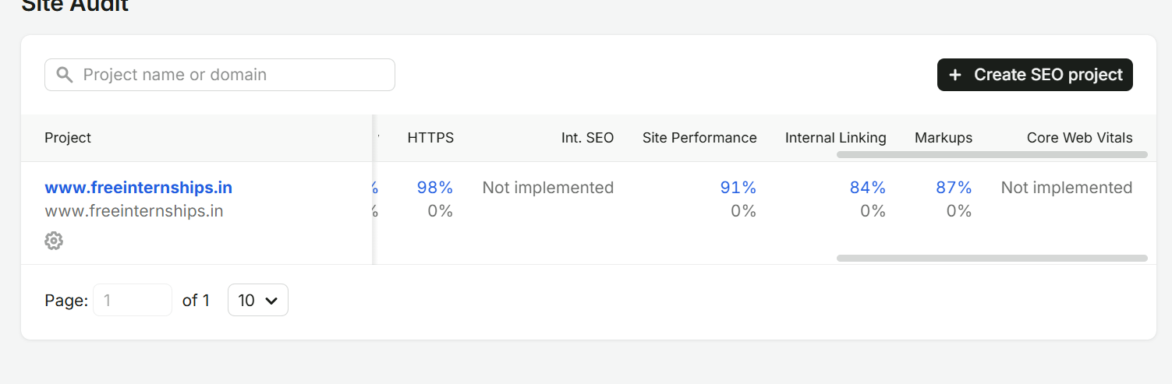

10. References and Tools
- https://pagespeed.web.dev/
- https://search.google.com/search-console/
- https://www.semrush.com/
- https://ahrefs.com/
- https://www.screamingfrog.co.uk/seo-spider/
- https://developers.google.com/search/docs/fundamentals/seo-starter-guide

