##### <Staff> Create Product

**Use case diagram**

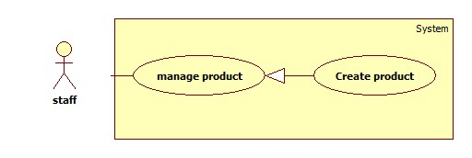

Figure: <Staff> Create Product

**Use case Specification**

|  |  |  |  |
| --- | --- | --- | --- |
| **USE CASE –** | | | |
| **Use Case No.** |  | **Use Case Version** | 2.0 |
| **Use Case Name** | Create Product | | |
| **Author** | Ha Chi Danh | | |
| **Date** | 30/05/2014 | **Priority** | High |
| **Actor:**   * Staff.   **Summary:**   * This use case allows staff to input product manually.   **Goal:**   * New product will be added to the database.   **Triggers:**   * Staff wants to input new product manually. * To input product manually, staff must do the following steps:   + Click “Quản lý sản phẩm” in the menu.   + Click “Tạo sản phẩm” button.   **Preconditions:**   * User must log in the system with staff role.   **Post Conditions:**   * **Success**: New product will be added to the database. * **Fail:** Product is not added to the database. Show error message.   **Main Success Scenario:**   |  |  |  | | --- | --- | --- | | Step | Actor Action | System Response | | 1 | Click “Tạo sản phẩm” button. | Navigate to “Tạo sản phẩm” page which contains:   * Tên sản phẩm: textbox (min length: 5, max length: 50), required. * Tên Hãng: dropdown box. * Chi tiết: rich textbox. * “Thêm sản phẩm” button. * “Hủy” button. | | 2 | Enter information into text fields.  Click “Thêm sản phẩm” button to finish. [Alternative 1] | System will add product to database.  A new product will be displayed in list product page. Then, redirect to list product page. [Exception 1, 2] |   **Alternative Scenario:**   |  |  |  | | --- | --- | --- | | Step | Actor Action | System Response | | 1 | Click on “Hủy” button to finish. | No product is added. System will return back to list product page. |   **Exceptions:**   |  |  |  | | --- | --- | --- | | Step | Actor Action | System Response | | 1 | “Tên sản phẩm” is not in range [5, 50]. | Display error message: “Tên sản phẩm phải từ 5 đến 50 ký tự”. | | 2 | “Tên sản phẩm” is a blank. | Display error message: “Vui lòng nhập Tên sản phẩm”. |   **Relationships:** Manage Product.  **Business Rules:**   * When staff clicks “thêm sản phẩm”, system will save product into database. | | | |

##### <Staff> Update Product

**Use case diagram**

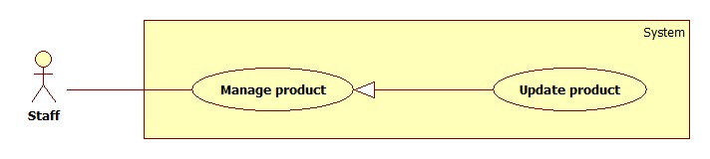

Figure: <Staff> Update Product

**Use case Specification**

|  |  |  |  |
| --- | --- | --- | --- |
| **USE CASE –** | | | |
| **Use Case No.** |  | **Use Case Version** |  |
| **Use Case Name** | Update Product | | |
| **Author** | Ha Chi Danh | | |
| **Date** | 30/05/2014 | **Priority** | Normal |
| **Actor:**   * Staff.   **Summary:**   * This use case allows staff to update product information.   **Goal:**   * New information will be updated to selected product.   **Triggers:**   * Staff wants to change product information. * To change product information, staff must do the following steps:   + Choose “Quản lý sản phẩm” in sidebar menu.   + Click “Danh sách sản phẩm” sub-menu.   + Click at product.   + Change information.   + Click “Cập nhật” button to save new data to database.   **Preconditions:**   * User must log in the system with staff role. * There is at least one product in the database.   **Post Conditions:**   * **Success**: New information will be updated to selected product. * **Fail:** Product is not updated. Show error message.   **Main Success Scenario:**   |  |  |  | | --- | --- | --- | | Step | Actor Action | System Response | | 1 | Click “Danh sách sản phẩm” sub-menu. | Navigate to “Danh sách sản phẩm” page which contains:   * A table has 6 columns:   + Số thứ tự.   + Mã Sản phẩm   + Tên sản phẩm.   + Tên Hãng.   + Chi tiết   + Trạng Thái * A drop down list:   + Tìm kiếm bằng tên  + Tìm kiếm bằng hang   * Search: text box. * Tìm kiếm: button | | 2 | Click at any product name. | Navigate to “Thông tin sản phẩm” page which contains:   * Tên sản phẩm: textbox, min length: 5, max length: 50, required. * Tên Hãng: drop down box. * Chi Tiết: rich textbox. * Cập nhật: button. | | 3 | Update new data. Click “Cập nhật” button. | Save new data to the database. Redirect to “Quản lý sản phẩm” page.[Exception 1, 2] |   **Alternative Scenario:** N/A  **Exceptions:**   |  |  |  | | --- | --- | --- | | Step | Actor Action | System Response | | 1 | “Tên sản phẩm” is not in range [5, 50]. | Display error message: “Tên sản phẩm phải từ 5 đến 50 ký tự”. | | 2 | “Tên sản phẩm” is a blank. | Display error message: “Vui lòng nhập tên sản phẩm”. |   **Relationships:** Manage Product.  **Business Rules:** When staff clicks “cập nhật” button. This product will be update information in database. | | | |

1. **<Staff> Deactivate Product**

Use Case Diagram

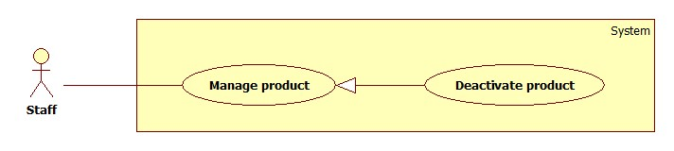

Figure … : <Staff> Deactivate Product

Use Case Specification

|  |  |  |  |
| --- | --- | --- | --- |
| **USE CASE –** | | | |
| **Use Case No.** |  | **Use Case Version** | 2.0 |
| **Use Case Name** | Deactivate Product | | |
| **Author** | Ha Chi Danh | | |
| **Date** | 30/05/2014 | **Priority** | Normal |
| **Actor:**   * Staff.   **Summary:**   * This use case allows staff to deactivate product.   **Goal:**   * Selected product will be deactivated.   **Triggers:**   * Staff wants to deactivate a product in the system. * To deactivate a product, staff must do the following steps:   + Choose “Quản lý sản phẩm” in sidebar menu.   + Click “Danh sách sản phẩm” sub-menu.   + Uncheck any activated product.   **Preconditions:**   * User must log in the system with staff role. * There are least one product activated in database.   **Post Conditions:**   * **Success**: Selected product will be deactivated. * **Fail:** Status of product is not change to Deactivate. Show error message.   **Main Success Scenario:**   |  |  |  | | --- | --- | --- | | Step | Actor Action | System Response | | 1 | Click “Danh sách sản phẩm” sub-menu. | Navigate to “Danh sách sản phẩm” page which contains:   * A table has 6 columns:   + Số thứ tự.   + Mã Sản phẩm   + Tên sản phẩm.   + Tên Hãng.   + Chi tiết   + Trạng thái * A drop down list:   + Tìm kiếm bằng tên  + Tìm kiếm bằng hang   * Search: textbox * Tìm kiếm: button. | | 2 | Uncheck any active product. | Deactivate selected product. Show success message.  [Exception 1] |   **Alternative Scenario:** N/A  **Exceptions:**   |  |  |  | | --- | --- | --- | | No | Actor Action | System Response | | 1 | Cannot deactivate product due to database connection problem | Show error message: “Thao tác thất bại. Vui lòng thử lại sau!” |   **Relationships:** Manage Product.  **Business Rules:** When staff clicks “Deactivate” status of this product will be changed Activate to Deactivate at column “Trạng thái” in database. | | | |

##### <Staff> Activate Product

Use Case Diagram

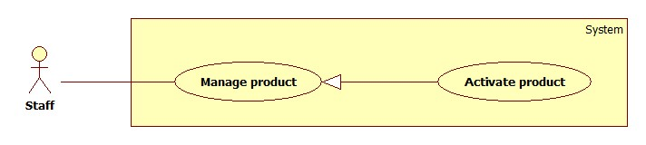

Figure … : <Staff> Activate Product

Use Case Specification

|  |  |  |  |
| --- | --- | --- | --- |
| **USE CASE –** | | | |
| **Use Case No.** |  | **Use Case Version** | 2.0 |
| **Use Case Name** | Activate Product | | |
| **Author** | Ha Chi Danh | | |
| **Date** | 30/05/2014 | **Priority** | Normal |
| **Actor:**   * Staff.   **Summary:**   * This use case allows staff to activate product.   **Goal:**   * Selected product will be activated.   **Triggers:**   * Staff wants to activate a product in the system. * To deactivate a product, staff must do the following steps:   + Choose “Quản lý sản phẩm” in sidebar menu.   + Click “Danh sách sản phẩm” sub-menu.   + Check any deactivated product.   **Preconditions:**   * User must log in the system with staff role. * There are least product deactivated in database.   **Post Conditions:**   * **Success**: Selected product will be activated. * **Fail:** Status of product is not changed to Activate. Show error message.   **Main Success Scenario:**   |  |  |  | | --- | --- | --- | | Step | Actor Action | System Response | | 1 | Click “Danh sách sản phẩm” sub-menu. | Navigate to “Danh sách sản phẩm” page which contains:   * A table has 6 columns:   + Số thứ tự.   + Mã Sản phẩm   + Tên sản phẩm.   + Tên Hãng.   + Chi tiết   + Trạng thái * A drop down list:   + Tìm kiếm bằng tên.  + Tìm kiếm bằng hang.   * Search: textbox * Tìm kiếm: button | | 2 | Check any deactived product. | Activate selected product. Show success message.  [Exception 1] |   **Alternative Scenario:** N/A  **Exceptions:**   |  |  |  | | --- | --- | --- | | No | Actor Action | System Response | | 1 | Cannot activate product due to database connection problem | Show error message: “Thao tác thất bại. Vui lòng thử lại sau!” |   **Relationships:** Manage Product.  **Business Rules:** When staff clicks “Activate”, status of this product will be changed Deactive to Activate at column “Trạng thái” in database. | | | |

1. **<Admin> Notify**

**Use case Diagram**

**Use case Diagram Specification**

|  |  |  |  |
| --- | --- | --- | --- |
| **USE CASE –** | | | |
| **Use Case No.** |  | **Use Case Version** | 2.0 |
| **Use Case Name** | Notify | | |
| **Author** | Ha Chi Danh | | |
| **Date** | 30/05/2014 | **Priority** | High |
| **Actor:**   * Admin.   **Summary:**   * This use case allows admin to confirm to send notify to user.   **Goal:**   * Notify is sent to user successfully.   **Triggers:**   * Product which has trained, will require to send to user. * To Send notify, admin must do the following step:   + Choose “Thông báo” in slide bar menu.  + Choose a notify that admin want to send to user.   * + Click “Xác nhận” button.   **Preconditions:**   * User must log in the system with admin role.   **Post Conditions:**   * **Success**: Notify will be sent to user. * **Fail:** Notify sent fail. Show error message.   **Main Success Scenario:**   |  |  |  | | --- | --- | --- | | Step | Actor Action | System Response | | 1 | Click “Thông báo” menu. | Navigate to “Thông báo” page which contains:   * A table with 3 columns :   +Tên tài khoản.  + Nội dung.  + Trạng thái | |  | Click notify to send to user. | Show alert with contains:   * Xác nhận: button * Hủy: button | | 2 | Click “Xác nhận” button to finish. [Alternative 1] | Notify will be sent to user. Then, redirect to notify page. [Exception 1] |   **Alternative Scenario:**   |  |  |  | | --- | --- | --- | | Step | Actor Action | System Response | | 1 | Click on “Hủy” button to finish. | Notify will be not sent. System will return back to notify page. |   **Exceptions:**   |  |  |  | | --- | --- | --- | | Step | Actor Action | System Response | | 1 | System connects failed | Notify will be not sent to user. |     **Relationships:** Train machine.  **Business Rules:**   * When admin send notify, it will show as message to user. Then user can check that product again. | | | |

1. **<Guest> Compare Product**

**Use case Diagram**

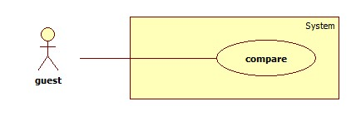

**Use case Diagram Specification**

|  |  |  |  |
| --- | --- | --- | --- |
| **USE CASE –** | | | |
| **Use Case No.** |  | **Use Case Version** | 2.0 |
| **Use Case Name** | Compare product | | |
| **Author** | Ha Chi Danh | | |
| **Date** | 30/05/2014 | **Priority** | Normal |
| **Actor:**   * **Guest**   **Summary:**   * This use case allows guest to compare products on website.   **Goal:**   * Guest compare 2 or 3 products on website.   **Triggers:**   * When cart is as least 2 products, Guest clicks “so sánh” button.   **Preconditions:**   * In cart must has least 2 products.   **Post Conditions:**   * **Success**: Show table compare least two products. * **Fail:** Show error message.   **Main Success Scenario:**   |  |  |  | | --- | --- | --- | | Step | Actor Action | System Response | | 1 | User clicks “So Sánh” button. | Negative to “So sánh” page with contains:   * Table with result: product winner , product(s) runner-up.[exception 1] |   **Alternative Scenario:**  N/A  **Exceptions:**   |  |  |  | | --- | --- | --- | | No | Actor Action | System Response | | 1 | User clicks “So Sánh” button. | Show error message: “Giỏ hang dưới 2 sản phẩm, vui lòng thêm sản phẩm vào giỏ hang để so sánh” |   **Relationships:** Add to cart  **Business Rules:** when guest clicks “So sánh” button, “So sánh” page will show result of products in guest’s cart. | | | |

1. **<Member> Compare Product**

**Use case Diagram**

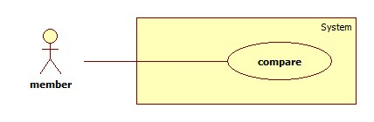

**Use case Diagram Specification**

|  |  |  |  |
| --- | --- | --- | --- |
| **USE CASE –** | | | |
| **Use Case No.** |  | **Use Case Version** | 2.0 |
| **Use Case Name** | Compare product | | |
| **Author** | Ha Chi Danh | | |
| **Date** | 30/05/2014 | **Priority** | Normal |
| **Actor:**   * Member.   **Summary:**   * This use case allows member to compare products on website.   **Goal:**   * Member compare 2 or 3 products on website.   **Triggers:**   * When cart is as least 2 products, member clicks “so sánh” button.   **Preconditions:**   * In cart must has least 2 products.   **Post Conditions:**   * **Success**: Show table compare least two products. * **Fail:** Show error message.   **Main Success Scenario:**   |  |  |  | | --- | --- | --- | | Step | Actor Action | System Response | | 1 | User clicks “So Sánh” button. | Negative to “So sánh” page with contains:   * Table with information products, product winner , product(s) runner-up.[exception 1] * Show Point of products. * Show recommend as list of product. |   **Alternative Scenario:**  N/A  **Exceptions:**   |  |  |  | | --- | --- | --- | | No | Actor Action | System Response | | 1 | User clicks “So Sánh” button. | Show error message: “Giỏ hang dưới 2 sản phẩm, vui lòng thêm sản phẩm vào giỏ hang để so sánh” |   **Relationships:** Add to cart  **Business Rules:** when member clicks “So sánh” button, “So sánh” page will show result and points of products and show recommend with list of product that similar with products in member’s cart. | | | |

1. **<Authorized user>Log out**

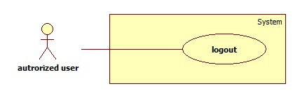

Figure: <Authorized user> Logout

Use Case Specification

|  |  |  |  |
| --- | --- | --- | --- |
| **USE CASE –** | | | |
| **Use Case No.** |  | **Use Case Version** | 2.0 |
| **Use Case Name** | Logout | | |
| **Author** | Ha Chi Danh | | |
| **Date** | 30/05/2014 | **Priority** | Normal |
| **Actor:**   * Authorized user.   **Summary:**   * This use case allows Authorized user to log out of the system.   **Goal:**   * Authorized user logs out of the system. Authorized user’s current session is destroyed.   **Triggers:**   * Authorized user wants to log out. * Authorized user clicks “Đăng xuất” link.   **Preconditions:**   * Authorized user has logged in to the system.   **Post Conditions:**   * **Success**: Authorized user’s current session is destroyed. Redirect to homepage. * **Fail:** Show error message.   **Main Success Scenario:**   |  |  |  | | --- | --- | --- | | Step | Actor Action | System Response | | 1 | Authorized user clicks “Thoát” link. | Show message “Bạn thực sự muốn thoát”   * Xác nhận: button * Hủy: button | | 2 | Authorized user clicks “Xác nhận” button. [Alternative 1] | Destroy Authorized user’s session. Redirect to homepage. [Exception 1] |   **Alternative Scenario:**   |  |  |  | | --- | --- | --- | | No | Actor Action | System Response | | 1 | Authorized user clicks “Hủy” button. | Redirect to home page. |   **Exceptions:**   |  |  |  | | --- | --- | --- | | No | Actor Action | System Response | | 1 | Fail to destroy Authorized user’s session | Redirect to error page. |   **Relationships:** Login  **Business Rules:** When Authorized user clicks “thoát” link, Authorized user’s role will be changed to guest. | | | |

1. **<** **Authorized user> Change Password**

**Use case Diagram**

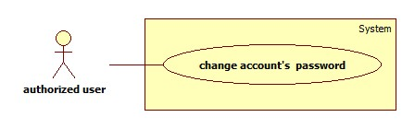

**Use case Diagram Specification**

|  |  |  |  |
| --- | --- | --- | --- |
| **USE CASE –** | | | |
| **Use Case No.** |  | **Use Case Version** | 2.0 |
| **Use Case Name** | Change Password | | |
| **Author** | Ha Chi Danh | | |
| **Date** | 30/05/2014 | **Priority** | Normal |
| **Actor:**   * Authorized user.   **Summary:**   * This use case allows Authorized user to change password.   **Goal:**   * Authorized user change password successfully.   **Triggers:**   * Authorized user login to website. * Authorized user clicks “Thay đổi mật khẩu” link.   **Preconditions:** Authorized user has register in to the system.  **Post Conditions:**   * **Success:** New password will be set into new password and save into database. * **Fail:** Show error message.   **Main Success Scenario:**   |  |  |  | | --- | --- | --- | | Step | Actor Action | System Response | | 1 | Authorized user clicks “Thay đổi mật khẩu” link. | Show “Thay đổi mật khẩu ” page with includes:   * Mật khẩu cũ: textbox, password box, min length: 6, max length: 20, required. * Mật khẩu mới: textbox, password box, min length: 6, max length: 20, required. * Xác nhận mật khẩu mới: textbox, password box, min length: 6, max length: 20, required. * Thay đổi: button. * Xóa trắng: button. | |  | Authorized user click “Thay đổi” button [Alternative 1] | Show message successful and return to home page. [Exception 1,2, 3,4,5,6] |   **Alternative Scenario:**   |  |  |  | | --- | --- | --- | | No | Actor Action | System Response | | 1 | Authorized user clicks “Xóa trắng” button. | Clear all input fields. |   **Exceptions:**   |  |  |  | | --- | --- | --- | | No | Actor Action | System Response | | 1 | Length of password is not in range. | Show error message: “Độ dài mật khẩu phải từ 6-20 ký tự!” | | 2 | “Mật khẩu cũ” is wrong. | Show error message:”Sai mật khẩu.” | | 3 | “Mật khẩu cũ” is a blank. | Show error message:”Vui lòng nhập mật khẩu” | | 4 | “Mật khẩu mới” is a blank. | Show error message:”Vui lòng nhập mật khẩu mới” | | 5 | “Xác nhận mật khẩu mới” is a blank. | Show error message:”Vui lòng nhập xác nhận mật khẩu mới” | | 6 | “Mật khẩu mới” and “Xác nhận mật khẩu mới” is not similar. | Show error message: “Mật khẩu mới và Xác nhận mật khẩu mới không trùng khớp”. |   **Relationships:** Login.  **Business Rules:**   * New password will set into new password and save in database. | | | |

1. **<Guest>Register**

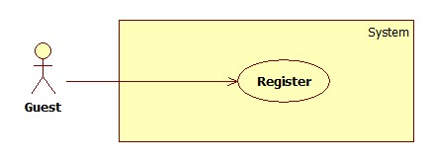

Figure: <Guest> Register

|  |  |  |  |
| --- | --- | --- | --- |
| **USE CASE –** | | | |
| **Use Case No.** |  | **Use Case Version** | 2.0 |
| **Use Case Name** | Register | | |
| **Author** | Ha Chi Danh | | |
| **Date** | 30/05/2014 | **Priority** | Normal |
| **Actor:**   * Guest.   **Summary:**   * This use case allows guest to register.   **Goal:**   * User can register new account to become a member of the system.   **Triggers:**   * Guest wants to be a member of the system. * To register, click “Đăng ký” link in menu bar.   **Preconditions:** N/A.  **Post Conditions:**   * **Success:** New member account is created. * **Fail:** Show error message.   **Main Success Scenario:**   |  |  |  | | --- | --- | --- | | Step | Actor Action | System Response | | 1 | Guest clicks “Đăng ký” link. | System show a register form which includes:   * Username: textbox, min length: 6, max length: 30, required. * Password: textbox, password box, min length: 6, max length: 20, required. * Đăng ký: button. * Xóa trắng: button. | | 2 | Guess enters required information, then clicks “Đăng ký” button. [Alternative 1] | Create new member account. Show success message.  [Exception 1,2, 3] |   **Alternative Scenario:**   |  |  |  | | --- | --- | --- | | No | Actor Action | System Response | | 1 | Guest clicks “Xóa trắng” button. | Clear all input fields. |   **Exceptions:**   |  |  |  | | --- | --- | --- | | No | Actor Action | System Response | | 1 | Length of username is not in range. | Show error message: “Độ dài username phải từ 6-30 ký tự!” | | 2 | Length of password is not in range. | Show error message: “Độ dài password phải từ 6-20 ký tự!” | | 3 | Username’s existed already. | Show error message: “Trùng tên đăng nhập! Vui lòng chọn tên khác!” |   **Relationships:** N/A  **Business Rules:**   * The role of new created account is “member”. | | | |

1. **<Guest> Log in**

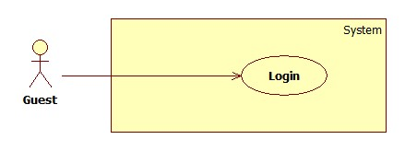

Figure: <Guest> Login

|  |  |  |  |
| --- | --- | --- | --- |
| **USE CASE –** | | | |
| **Use Case No.** |  | **Use Case Version** | 2.0 |
| **Use Case Name** | Login | | |
| **Author** | Ha Chi Danh | | |
| **Date** | 30/05/2014 | **Priority** | Normal |
| **Actor:**   * Guest.   **Summary:**   * This use case allows guest to login to the system.   **Goal:**   * Allow authentication and authorization of the system.   **Triggers:**   * Guest want to login into system. * To login: Guests go to the login link, enter username and password, and click “Đăng nhập” button to login.   **Preconditions:**   * Database has an account registered   **Post Conditions:**   * **Success:** Guest is authorized, redirect to corresponding page. * **Fail:** System will show error on current page.   **Main Success Scenario:**   |  |  |  | | --- | --- | --- | | Step | Actor Action | System Response | | 1 | Guest goes to login page. | System show a login form, includes:   * Username: textbox, min length: 6, max length: 30, required. * Password: textbox, password box, min length: 6, max length: 20, required. * Đăng nhập: button. * Hủy: button * Create new account. | | 2 | Guess enter username and password into textboxes.  Press “Đăng nhập” button.[Alternative 1] | * Show message successful * “Ghi nhớ tài khoản”: check box   [Exception 1,2,3,4] |   **Alternative Scenario:**   |  |  |  | | --- | --- | --- | | No | Actor Action | System Response | | 1 | Press “Cancel” button. | Negative to home page. |   **Exceptions:**   |  |  |  | | --- | --- | --- | | No | Actor Action | System Response | | 1 | “Tên tài khoản” is a blank | Show error message: “Vui lòng điền đủ username và password!” | | 2 | “Mật khẩu” is a blank | Show error message: “Vui lòng điền đủ username và password!” | | 3 | Username/Password not in range [5,30] | Show error message: “Thông tin không hợp lệ. Vui lòng thử lại!” | | 4 | Input invalid “Username” and “Password” | Show error message: “Thông tin không hợp lệ. Vui lòng thử lại!” |   **Relationships:** Register use case.  **Business Rules:**   * Each member, staff, admin has an account. * Only active account can log in. | | | |

1. **<Guest> View Detail**

**Use case Diagram**

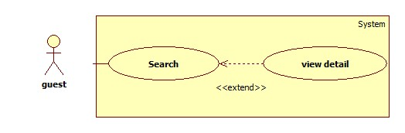

**Use case diagram specification**

|  |  |  |  |
| --- | --- | --- | --- |
| **USE CASE –** | | | |
| **Use Case No.** |  | **Use Case Version** | 2.0 |
| **Use Case Name** | Search Product and View Detail Product | | |
| **Author** | Ha Chi Danh | | |
| **Date** | 30/05/2014 | **Priority** | High |
| **Actor:**   * Member. * Guest.   **Summary:**   * This use case allows user to search and view product information.   **Goal:**   * A page detail of products will be shown to user.   **Triggers:**   * User inputs to a blank textbox then clicks “Tìm kiếm” button. * User inputs URL of product or serial number then they search all products with relative URL or serial number which they inputted. The searching results will show product detail.   **Preconditions:** N/A  **Post Conditions:**   * **Success**: Show search results as a page of product with URL or serial number that user inputted * **Fail:** Show an error message.   **Main Success Scenario:**   |  |  |  | | --- | --- | --- | | Step | Actor Action | System Response | | 1 | User inputs the product’s URL or serial number into textbox. | Show “Search” page with includes:   * Tìm bằng đường dẫn/ tìm bằng số seri: drop down box * Search: textbox * Tìm kiếm: button | | 2 | User clicks “Tìm kiếm” button. | * System will show page detail product by product URL or serial number.[Exception1] * A product will show in a table as a record with these information:   + First column is name, brand and image of product.   + Second column is information of product.   + Buttons: “Thêm vào giỏ”. |   **Alternative Scenario:** N/A  **Exceptions:**   |  |  |  | | --- | --- | --- | | Step | Actor Action | System Response | | 1 | Search not found | System will show a message: “Không tìm thấy”. |   **Relationships:** N/A  **Business Rules:**   * Search by URL or serial number of product. System will search all products in database. | | | |