1. Functional requirements
2. 2 Functional requirement Register
3. 2.1 Guest registers Use case

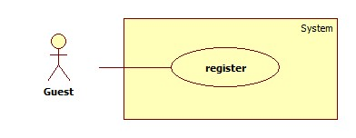

1. 2.2 Use case Register specification

|  |  |  |  |  |
| --- | --- | --- | --- | --- |
| **USE CASE – 001** | | | | |
| **Use case No.** | UC001 | **Use case version** | | 0.1 |
| **Use case name** | Register | | | |
| **Author** | Danhhc | | | |
| **Date** | 28/05/2014 | **Priority** | Normal | |
| **Actor:** Guest  **Summary:**  Guest use this case to register.  **Goal:**  Allow Guest to create a new account of website.  **Triggers:**   * User needs an account to login into the system in other to have more authorization in the system. * Guest click on “Register” button at home page.   **Preconditions:** N/A  **Post Conditions:**   * **Success:** A new account is crated in the system. This account is User account type. * **Fail:** Error message will be showed.   **Main Success Scenario:**   |  |  |  | | --- | --- | --- | | Step | Actor Action | System Response | | 1 | Click on “Register” to request register page | System will response Register page :   * Username: Textbox(min length: 1, max length: 20, required) * Email: Textbox(min length: 1, max length: 30, required) * Password: Textbox(min length: 1, max length: 20, required) * Confirm Password: Textbox(min length: 1, max length: 20, required) * Verify Code: Textbox(required) * Register: button | | 2 | Enter information into text fields.  Click on “Register” button to finish. [Alternative 1] | System will create new account in database, pop-up message “Register successfully” and system will transfer to login page.  [Exception 1,2,3,4,5] |   **Alternative Scenario:**   |  |  |  | | --- | --- | --- | | ID | Actor Action | System Response | | 1 | Click on “Cancel” button to finish | System will transfer to home page |   **Exceptions:**   |  |  |  | | --- | --- | --- | | ID | Actor Action | System Response | | 1 | Username is not in length [6, 30] | Username must be in length [6, 30] | | 2 | Password is not in length [6, 30] | Password must be in length [6, 30] | | 3 | Email has existed in database | Display error message: “Email already exists. Please choose another” | | 4 | Input not a valid information in Email’s textbox | Display error message: “Your email contains illegal characters” | | 5 | Input confirm password information different with password | Display error message: “Your password and confirmation password do not match” | | 6 | Verify code is not correct | Display error message: ”Wrong Verify code, Please reenter” |   **Relationships:**  N/A  **Business Rules:**   * User can use account to login and use services of CPS depend on role. | | | | |

1. 3 Functional requirement Login
2. 3. 1 Use case Login

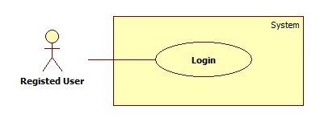

1. 3. 2 Use case Login Specification

|  |  |  |  |  |
| --- | --- | --- | --- | --- |
| **USE CASE – 002** | | | | |
| **Use case No.** | UC002 | **Use case version** | | 0.1 |
| **Use case name** | Login | | | |
| **Author** | Danhhc | | | |
| **Date** | 28/05/2014 | **Priority** | Normal | |
| **Actor:** Registed user  **Summary:**  Guest use this case to login.  **Goal:**  Allow Registed user to login website.  **Triggers:**   * User needs an account to login into the system in other to have more authorization in the system. * Registed user click on “Login” button at home page.   **Preconditions:** N/A  **Post Conditions:**   * **Success:** Registed user login successful with username and password. * **Fail:** Error message will be showed.   **Main Success Scenario:**   |  |  |  | | --- | --- | --- | | Step | Actor Action | System Response | | 1 | Click on “Login” to request login page | System will response Login page :   * Username: Textbox(min length: 1, max length: 20, required) * Password: Textbox(min length: 1, max length: 20, required) * Login: button | | 2 | Enter information into text fields.  Click on “Login” button to finish. [Alternative 1] | System will verify account in database, pop-up message “Login successfully” and system will transfer to home page.  [Exception 1,2] |   **Alternative Scenario:**   |  |  |  | | --- | --- | --- | | ID | Actor Action | System Response | | 1 | Click on “Cancel” button to finish | System will transfer to home page |   **Exceptions:**   |  |  |  | | --- | --- | --- | | ID | Actor Action | System Response | | 1 | Username is not in length [6, 30] | Username must be in length [6, 30] | | 2 | Password is not in length [6, 30] | Password must be in length [6, 30] |   **Relationships:**  N/A  **Business Rules:**   * User can use services of CPS depend on role. | | | | |

1. 4 Functional requirement Log out
2. 4. 1 Use case Log out

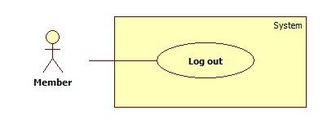

1. 4.2 Use case Log out Specification

|  |  |  |  |  |
| --- | --- | --- | --- | --- |
| **USE CASE – 003** | | | | |
| **Use case No.** | UC003 | **Use case version** | | 0.1 |
| **Use case name** | Log out | | | |
| **Author** | Danhhc | | | |
| **Date** | 28/05/2014 | **Priority** | Normal | |
| **Actor:** User  **Summary:**  User use this case to log out.  **Goal:**  Allow User to log out of website.  **Triggers:**   * User has to login * User clicks on “Log out” button at home page.   **Preconditions:** N/A  **Post Conditions:**   * **Success:** User log out of website. * **Fail:** Error message will be showed.   **Main Success Scenario:**   |  |  |  | | --- | --- | --- | | Step | Actor Action | System Response | | 1 | Click on “Log out” to request log out Alert | System will response Log out Alert :   * Do you want to log out?: label * Confirm: button * Cancel: button | | 2 | Click on “Comfirm” button to log out. [Alternative 1] | Pop-up message “Log out successfully” and system will transfer to home page.  [Exception ] |   **Alternative Scenario:**   |  |  |  | | --- | --- | --- | | ID | Actor Action | System Response | | 1 | Click on “Cancel” button to finish | System will transfer to home page |   **Exceptions:**  N/A  **Relationships:**  N/A  **Business Rules:**   * User can log out of website. | | | | |

1. 5 Functional Requirement Manage product
2. 5.1 Use case Manage products

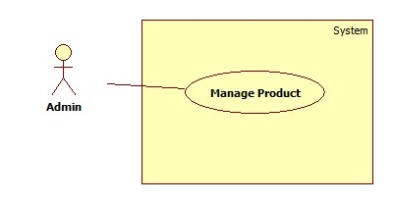

1. 5.2 Use case Manage Products Specification

|  |  |  |  |  |
| --- | --- | --- | --- | --- |
| **Use case No.** | UC004 | **Use case version** | | 0.1 |
| **Use case name** | Manage Product | | | |
| **Author** | Danhhc | | | |
| **Date** | 28/05/2014 | **Priority** | Normal | |
| **Actor:** Admin  **Summary:**  Admin uses this case to Manage Product.  **Goal:**  Allow Admin to add new, edit, delete products of website.  **Triggers:**   * Admin needs login into the admin’page to have more authorization in the system. * Admin clicks on “Manage Product” menu at Admin’s page.   **Preconditions:** N/A  **Post Conditions:**   * **Success:** Admin add new,edit , delete products successfull. * **Fail:** Error message will be showed.   **Main Success Scenario:**   |  |  |  | | --- | --- | --- | | Step | Actor Action | System Response | | 1 | Click on “Manage product” to request Manage product page | System will response Manage Product page :   * View by all/ view by brand: drop down list * Go: button * Add new product: button * Search: Textbox(min length: 1, max length: 500, required), button * Table Product * View: icon * Update: icon * Delete: icon | | 2 | In cell “Action” has 3 icon: view, update, delete. Click on 1 in 3 icon to do with product in that row | System will update or delete product in database and system will transfer to Manage product page.  [Exception 1,2,3,4,5] |   **Alternative Scenario:**  N/A  **Exceptions:**   |  |  |  | | --- | --- | --- | | ID | Actor Action | System Response | | 1 | Edit an Id and submit but it is duplicated | Id is existed | | 2 | Edit a Name and submit but it is duplicated | Name is existed |   **Relationships:**  N/A  **Business Rules:**  N/A | | | | |

1. 6 Functional requirement Notify for User
2. 6. 1 Use case Notify for User

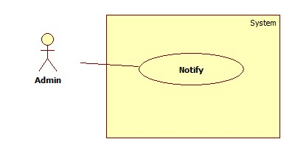

1. 6. 2 Use case Notify for User specification

|  |  |  |  |  |
| --- | --- | --- | --- | --- |
| **Use case No.** | UC005 | **Use case version** | | 0.1 |
| **Use case name** | Manage Notify | | | |
| **Author** | Danhhc | | | |
| **Date** | 28/05/2014 | **Priority** | Normal | |
| **Actor:** Admin  **Summary:**  Admin uses this case to Manage Notify.  **Goal:**  Allow Admin to add new, edit, delete and send notify to users.  **Triggers:**   * Admin needs login into the admin’page to have more authorization in the system. * Admin clicks on “Manage Notify” menu at Admin’s page.   **Preconditions:** N/A  **Post Conditions:**   * **Success:** Admin add new,edit , delete and send notify successfull. * **Fail:** Error message will be showed.   **Main Success Scenario:**   |  |  |  | | --- | --- | --- | | Step | Actor Action | System Response | | 1 | Click on “Manage Notify” to request Manage Notify page | System will response Manage Product page :   * Search: Textbox(min length: 1, max length: 500, required), button * Send:button * View: icon * Update: icon * Delete: icon * Table Notify | | 2 | In cell “Action” has 3 icon: view, update, delete. Click on 1 in 3 icon to do with product in that row, click button “send” to send notify to user | System will update,delete notify in database, send notify and system will transfer to Manage Notify page. |   **Alternative Scenario:**  N/A  **Exceptions:**  N/A  **Relationships:**  N/A  **Business Rules:**  N/A | | | | |

1. 7 Functional requirement Manage Log file
2. 7. 1 Use case Manage Log file

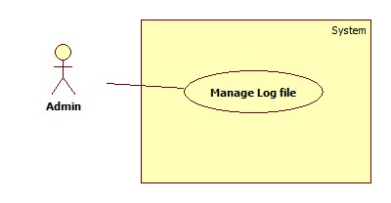

1. 7. 2 Use case Manage Log file Specification

|  |  |  |  |  |
| --- | --- | --- | --- | --- |
| **Use case No.** | UC006 | **Use case version** | | 0.1 |
| **Use case name** | Manage Log file | | | |
| **Author** | Danhhc | | | |
| **Date** | 28/05/2014 | **Priority** | Normal | |
| **Actor:** Admin  **Summary:**  Admin uses this case to Manage Log file.  **Goal:**  Allow Admin to add new, edit, delete log files of website.  **Triggers:**   * Admin needs login into the admin’s page to have more authorization in the system. * Admin clicks on “Manage Log file” menu at Admin’s page.   **Preconditions:** N/A  **Post Conditions:**   * **Success:** Admin view, edit , delete products successful. * **Fail:** Error message will be showed.   **Main Success Scenario:**   |  |  |  | | --- | --- | --- | | Step | Actor Action | System Response | | 1 | Click on “Manage Log file” to request Manage Log file page | System will response Manage Product page :   * Search: Textbox(min length: 1, max length: 500, required), button * Table Log file * View: icon * Update: icon * Delete: icon | | 2 | In cell “Action” has 3 icon: view, update, delete. Click on 1 in 3 icon to do with log file in that row | System will update or delete log file in database and system will transfer to Manage log file page. |   **Alternative Scenario:**  N/A  **Exceptions:**  N/A  **Relationships:**  N/A  **Business Rules:**  N/A | | | | |

1. 8 Functional requirement Change Pasword
2. 8. 1 Use case Change Password

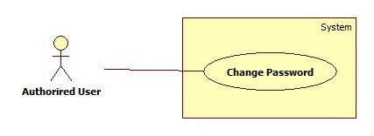

1. 8. 2 Use case Change Password Specification

|  |  |  |  |  |
| --- | --- | --- | --- | --- |
| **USE CASE – 007** | | | | |
| **Use case No.** | UC007 | **Use case version** | | 0.1 |
| **Use case name** | Change Password | | | |
| **Author** | Danhhc | | | |
| **Date** | 28/05/2014 | **Priority** | Normal | |
| **Actor:** User  **Summary:**  User use this case to change password.  **Goal:**  Allow User to change password successfully.  **Triggers:**   * User has to login * User clicks on “Change Password” button at user profile page.   **Preconditions:** N/A  **Post Conditions:**   * **Success:** Acess to change password page. * **Fail:** Error message will be showed.   **Main Success Scenario:**   |  |  |  | | --- | --- | --- | | Step | Actor Action | System Response | | 1 | Click on “Change Password” to request Change password page. | System will response Change Password page :   * Old Password: Textbox(min length: 1, max length: 20, required) * New Password: Textbox(min length: 1, max length: 20, required) * Confirm New Password: Textbox(min length: 1, max length: 20, required) * Confirm: button * Cancel: button | | 2 | Click on “Comfirm” button to change password. [Alternative 1] | Pop-up message “Change password successfully” and system will transfer to user profile page.  [Exception ] |   **Alternative Scenario:**   |  |  |  | | --- | --- | --- | | ID | Actor Action | System Response | | 1 | Click on “Cancel” button to finish | System will transfer to profile page |   **Exceptions:**  N/A  **Relationships:**  N/A  **Business Rules:**   * User can change password on website. | | | | |