1. **Demo Functional Requirements**

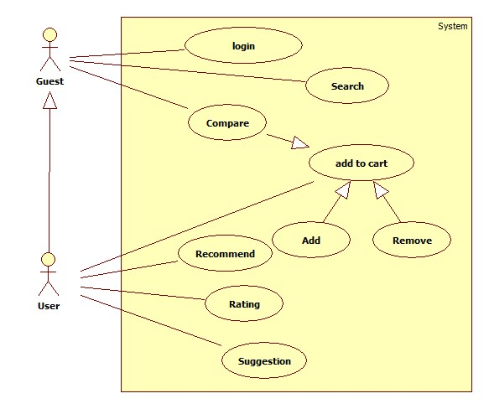

* 1. **Functional requirement Search Product**
     1. **Use case Search Product**

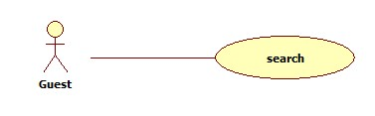

**1.1.2 Use case Search Product specification**

|  |  |  |  |  |  |  |  |  |
| --- | --- | --- | --- | --- | --- | --- | --- | --- |
| **Actor:**  *Guest*  **Summary:**  *Allows guest to search products on the system of website*  **Goal:**  *The Guest searchs products on the system of website*  **Triggers:**  *Guest clicks “Search” button.*  **Preconditions:**  *Guest has to enter name of product*  **Post Conditions:**  *Success: User found the information of product*  *Fail: Display error message.*  **Main Success Scenario:**   |  |  | | --- | --- | | ***Guest*** | ***System*** | | *2. Enters name of product*  *3. Clicks “Search” button* | *1. Display:*   * *Name of product: textbox.* * *Search: button*   *4. Check availability of the product on the system.* |   **Alternative Scenario:**  *N/A*  **Exceptions:**   |  |  | | --- | --- | | ***Guest*** | ***System*** | | *1. Name of product is empty*  *3. Wrong or invalid name of product* | *2. Display error message “Please enter name of product”.*  *4. Display error message “product not found”.* |   **Relationships:**  N/A  **Business Rules:**  *N/A* |

* 1. **Functional Compare Products**
     1. **Use case Compare Products**

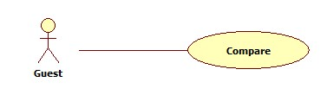

* + 1. **Use case Compare Products specification**

|  |  |  |  |  |
| --- | --- | --- | --- | --- |
| **USE CASE LOGIN** | | | | |
| **Use-case No.** | UC02 | **Use-case Version** | | 1.0 |
| **Use-case Name** | Compare Products | | | |
| **Author** | Hà Chí Danh | | | |
| **Date** |  | **Priority** | Normal | |
| **Actor:**  *Guest*  **Summary:**  *Allows guest to compare products on the website*  **Goal:**  *Guest compares products on the website*  **Triggers:**  *Guest clicks “Compare” button.*  **Preconditions:**  *Guest has to enter name of 2 products that want to compare.*  **Post Conditions:**  *Success: Show 2 tables to compare 2 products .*  *Fail: Display error message.*  **Main Success Scenario:**   |  |  | | --- | --- | | ***Guest*** | ***System*** | | *2. Clicks “Compare” button*  *3. Clicks “Confirm” button* | *1. Display:*  *- Compare : Button*  *3. Display:*  *-Name of product 1: textbox*  *- Name of product 2: textbox* |   **Alternative Scenario:**  *N/A*  **Exceptions:**   |  |  | | --- | --- | | ***Guest*** | ***System*** | | *1. name of product is empty*  *3. Wrong name of product* | *2. Display error message “Enter name of product”.*  *4. Display error message “Product not found”.* |   **Relationships:**  N/A  **Business Rules:**  *Not let empty any text box of products* | | | | |