**Use case 01: Force parse data**

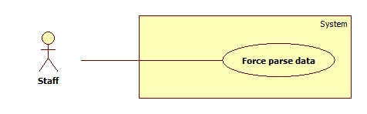

|  |  |  |  |
| --- | --- | --- | --- |
| **USE CASE – CPS001** | | | |
| **Use Case No.** | CPS001 | **Use Case Version** | 2.0 |
| **Use Case Name** | Force Parse Data | | |
| **Author** | Huynh Thanh Viet | | |
| **Date** | 19/05/2014 | **Priority** | High |
| **Actor:**   * Staff.   **Summary:**   * Staff can force system to parse data at any time.   **Goal:**   * Get data from many websites.   **Triggers:**   * Staff wants to run the parser at that time. * Staff clicks “Parse” button.   **Preconditions:**   * User logged in with “Staff” role.   **Post Conditions:**   * **Success:** New data is inserted to database. Log file is generated. * **Fail:** Nothing is changed in the database. Log file is generated.   **Main Success Scenario:**   |  |  |  | | --- | --- | --- | | Step | Actor Action | System Response | | 1 | Staff clicks “Parse” button. | * Disable “Parse” button. Change its text into “Parsing…” * Send request to the parsed link. * Fetch data from the response based on the inputted XPaths. * Validate data [Exception 1]. * If data is valid, insert to database [Alternative 1]. * Generate log file. * Enable “Parse” button. Change its text into “Parse”. |   **Alternative Scenario:**   |  |  |  | | --- | --- | --- | | Step | Actor Action | System Response | | 1 | Staff clicks “Parse” button. | * If fetched product is already in the database, update its information. * Generate log file. |   **Exceptions:**   |  |  |  | | --- | --- | --- | | No | Actor Action | System Response | | 1 | Data is not valid. | * Don’t insert to database. * Generate log file. |   **Relationships:** N/A  **Business Rules:** N/A | | | |

**Use case 02: Define weight criteria**

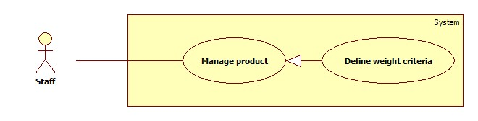

|  |  |  |  |
| --- | --- | --- | --- |
| **USE CASE – CPS001** | | | |
| **Use Case No.** | CPS002 | **Use Case Version** | 2.0 |
| **Use Case Name** | Define weight criteria | | |
| **Author** | Huynh Thanh Viet | | |
| **Date** | 19/05/2014 | **Priority** | High |
| **Actor:**   * Staff.   **Summary:**   * Staff can force system to parse data at any time.   **Goal:**   * Get data from many websites.   **Triggers:**   * Staff wants to run the parser at that time. * Staff clicks “Parse” button.   **Preconditions:**   * User logged in with “Staff” role.   **Post Conditions:**   * **Success:** New data is inserted to database. Log file is generated. * **Fail:** Nothing is changed in the database. Log file is generated.   **Main Success Scenario:**   |  |  |  | | --- | --- | --- | | Step | Actor Action | System Response | | 1 | Staff clicks “Parse” button. | * Disable “Parse” button. Change its text into “Parsing…” * Send request to the parsed link. * Fetch data from the response based on the inputted XPaths. * Validate data [Exception 1]. * If data is valid, insert to database [Alternative 1]. * Generate log file. * Enable “Parse” button. Change its text into “Parse”. |   **Alternative Scenario:**   |  |  |  | | --- | --- | --- | | Step | Actor Action | System Response | | 1 | Staff clicks “Parse” button. | * If fetched product is already in the database, update its information. * Generate log file. |   **Exceptions:**   |  |  |  | | --- | --- | --- | | No | Actor Action | System Response | | 1 | Data is not valid. | * Don’t insert to database. * Generate log file. |   **Relationships:** N/A  **Business Rules:** N/A | | | |