1. **Prototype**

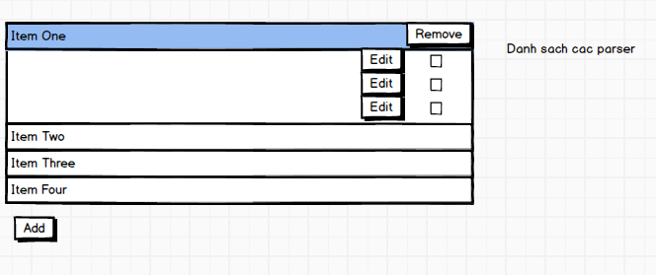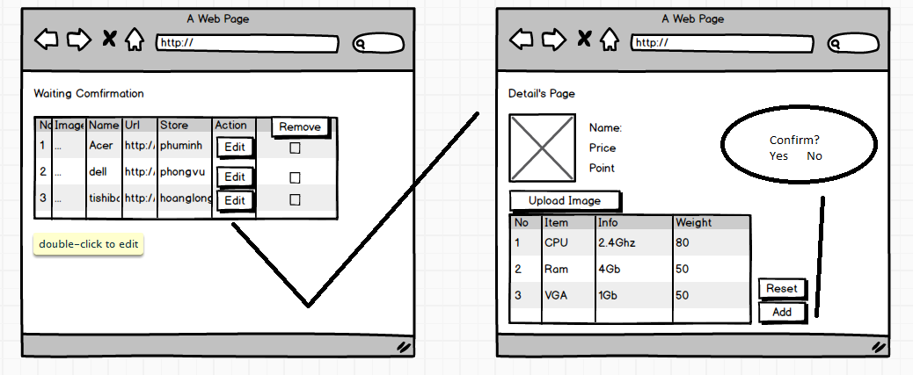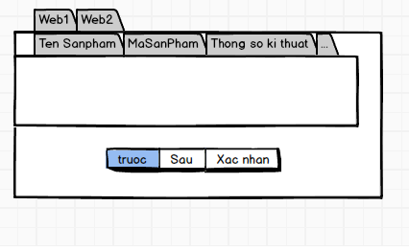

1. **Use case diagram**
   1. **Staff –training machine**

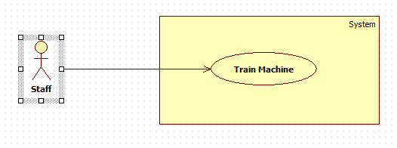

|  |  |  |  |  |
| --- | --- | --- | --- | --- |
| **USE CASE – SU001** | | | | |
| **Use-case No.** | SU001 | **Use-case Version** | | 2.0 |
| **Use-case Name** | Training machine | | | |
| **Author** | Pham Hong Sang | | | |
| **Date** | 19/5/2014 | **Priority** | High | |
| **Actor:** Staff  **Summary:** This use case allows staff can train for the machine what products are new.  **Goal:** New Product will be inserted to database.  **Triggers:**   * Staff clicks on “**Product Manager**” in menu sidebar, and **Product Manager** will be showed. * Staff clicks on “**Waiting Confirmations**” tab, and all product are waiting to confirm will be showed. * After that Staff will click one “**Edit**” to confirm 1 specified product. * Last, Staff will confirm all of that change about 1 specified product by clicking on “**Yes**” in pop-up message.   **Pre-conditions:** User must log in to the system with role is staff.  **Post-conditions:**  **Success:** Products are added into database. Show success message.  **Fail:** Nothing is saved to the database. Display an error list.  **Main Success Scenario**   |  |  |  | | --- | --- | --- | | **Step** | **Actor Action** | **System Response** | | 1 | Click “**Edit**” button on result row in “**Waiting Confirmations**” tab. | * System will redirect to details page. * **Name**: textbox (min length: 5, max length: 80), required. * **Price**: textbox (min length: 5, max length: 20), required. * **Point**: textbox (min length: 5, max length: 20), required. * **Table of Detail**:  -Table with 4 columns (**No.** **,Item** ,**Info** , **Weight**) * “**Confirm**” button. * “**Reset**” button. [Alternative 1]   [Exception 1, 2, 3, 4] | | 2 | Staff clicks “**Add**” button to save product. [Alternative 2] | * “**Yes**” button. * “**No**” button. | | 3 | Staff clicks “**Yes**” button to save product. | * Save products into database.   [Exception 5] |   **Alternative Scenario:**   |  |  |  | | --- | --- | --- | | **No.** | **Actor Action** | **System Response** | | 1 | Click on “**Reset**” button to finish. | Clear all textbox in Detail’s page. | | 2 | Click on “**No**” button to finish. | No product is added. System will return back to **“Waiting Confirmations”** page. |   **Exceptions:**   |  |  |  | | --- | --- | --- | | **No.** | **Actor Action** | **System Response** | | 1 | Weight Criteria is not in range [1; 100]. | * Display Error Message:” **Weight Criteria is not in range [1-100**]. ” | | 2 | Name is not blank. | * Display Error Message**:” Product Name can’t be bank.** ” | | 3 | Price is not in range[1;1,000,000,000] | * Display Error Message**:” Price is out of range [1; 1,000,000,000].”** | | 4 | Weight Criteria is not blank. | * Display Error Message**:” Weight Criteria can’t be bank.** ” | | 5 | Fail to insert to database. | * Display Error Message**: “Error. Please try again.”** |   **Relationships:** N/A.  **Business Rules:**   * N/A. | | | | |