1. **<Staff> Confirm to send notification**

**Use case Diagram**

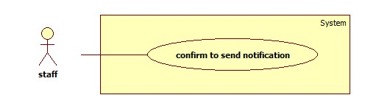

**Use case Diagram Specification**

|  |  |  |  |
| --- | --- | --- | --- |
| **USE CASE –** | | | |
| **Use Case No.** |  | **Use Case Version** | 2.0 |
| **Use Case Name** | Confirm to send notification | | |
| **Author** | Ha Chi Danh | | |
| **Date** | 30/05/2014 | **Priority** | Normal |
| **Actor:**   * Staff.   **Summary:**   * This use case allows staff to confirm to send notification to member.   **Goal:**   * Staff confirm to send notification to member successfully.   **Triggers:**   * Staff chooses notification that staff want to send to member. * System will show message with “Xác nhận” button and “Hủy” button. * Staff clicks “Xác nhận” to send notification.   **Preconditions:**   * User must log in the system with staff role.   **Post Conditions:**   * **Success**: Confirm to send notification to member successfully. * **Fail:** Show error message.   **Main Success Scenario:**   |  |  |  | | --- | --- | --- | | Step | Actor Action | System Response | | 1 | Click “Thông báo” menu. | Navigate to “Thông báo” page which contains:   * A table with 3 columns :   +Tên tài khoản.  + Nội dung.  + Trạng thái | | 2 | Click on member’s account that staff wants to send notification. | Show message Confirm with contains:   * Xác nhận: button * Hủy: button | | 3 | Click “Xác nhận” button to finish. [Alternative 1,2] | Notification will be sent to member. Then, redirect to notification page. [Exception 1] |   **Alternative Scenario:**   |  |  |  | | --- | --- | --- | | Step | Actor Action | System Response | | 1 | Click on “Hủy” button to finish. | Notification won’t be sent. System will return back to notification page. | | 2 | Session time out | * Show error message“Bạn rời máy tính quá lâu, vui lòng đăng nhập lại để tiếp tục” * Redirect to login page. |   **Exceptions:**   |  |  |  | | --- | --- | --- | | Step | Actor Action | System Response | | 1 | Cannot send notification due to database connection. | Notification won’t be sent to member. |     **Relationships: N/A**.  **Business Rules:**   * If Product is trained, it will be updated into database. * Admin confirm to send notification. * System will notify to member. * Member can check that product again. | | | |

##### <Staff> Create Product

**Use case diagram**

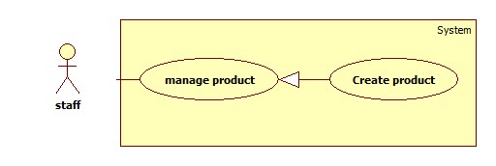

Figure: <Staff> Create Product

**Use case Specification**

|  |  |  |  |
| --- | --- | --- | --- |
| **USE CASE –** | | | |
| **Use Case No.** |  | **Use Case Version** | 2.0 |
| **Use Case Name** | Create Product | | |
| **Author** | Ha Chi Danh | | |
| **Date** | 30/05/2014 | **Priority** | Normal |
| **Actor:**   * Staff.   **Summary:**   * This use case allows staff to create product manually.   **Goal:**   * New product will be added to the database.   **Triggers:**   * Staff wants to create new product manually. * To input product manually, staff must do the following steps:   + Click “Quản lý sản phẩm” in the menu.   + Click “Tạo sản phẩm” button.   **Preconditions:**   * User must log in the system with staff role.   **Post Conditions:**   * **Success**: New product will be added to the database. * **Fail:** Show error message.   **Main Success Scenario:**   |  |  |  | | --- | --- | --- | | Step | Actor Action | System Response | | 1 | Click “Tạo sản phẩm” button. | Navigate to “Tạo sản phẩm” page which contains:   * Tên sản phẩm: textbox (min length: 5, max length: 50), required. * Tên Hãng: dropdown list. * Chi tiết: rich textbox. * “Thêm sản phẩm” button. * “Thêm hình ảnh” button * “Hủy” button. | | 2 | Enter information into text fields.  Click “Thêm sản phẩm” button to finish. [Alternative 1,2] | System will add product into database.  A new product will be displayed in list product page. Then, redirect to manage product page. [Exception 1, 2] |   **Alternative Scenario:**   |  |  |  | | --- | --- | --- | | Step | Actor Action | System Response | | 1 | Click on “Hủy” button to finish. | Product is not added. System will return back to manage product page. | | 2 | Session time out. | Display error message: “Bạn rời máy tính quá lâu, vui lòng đăng nhập lại để tiếp tục”.  Redirect to login page. |   **Exceptions:**   |  |  |  | | --- | --- | --- | | Step | Actor Action | System Response | | 1 | “Tên sản phẩm” is not in range [5, 50]. | Display error message: “Tên sản phẩm phải từ 5 đến 50 ký tự”. | | 2 | “Tên sản phẩm” is a blank. | Display error message: “Vui lòng nhập Tên sản phẩm”. |   **Relationships:** N/A  **Business Rules:**   * Staff clicks on “thêm sản phẩm” button. * System will save new product into database. | | | |

##### <Staff> Update Product

**Use case diagram**

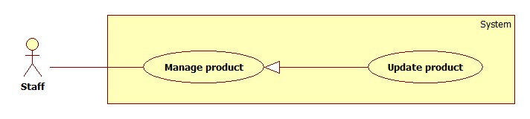

Figure: <Staff> Update Product

**Use case Specification**

|  |  |  |  |
| --- | --- | --- | --- |
| **USE CASE –** | | | |
| **Use Case No.** |  | **Use Case Version** |  |
| **Use Case Name** | Update Product | | |
| **Author** | Ha Chi Danh | | |
| **Date** | 30/05/2014 | **Priority** | Normal |
| **Actor:**   * Staff.   **Summary:**   * This use case allows staff to update product information.   **Goal:**   * New information will be updated to selected product.   **Triggers:**   * Staff wants to change product information. * To change product information, staff must do the following steps:   + Choose “Quản lý sản phẩm” in sidebar menu.   + Click at product.   + Change information.   + Click “Cập nhật” button to save new data to database.   **Preconditions:**   * User must log in the system with staff role. * There is at least one product in the database.   **Post Conditions:**   * **Success**: New information will be updated to selected product. * **Fail:** Show error message.   **Main Success Scenario:**   |  |  |  | | --- | --- | --- | | Step | Actor Action | System Response | | 1 | Click “Quản lý sản phẩm” sub-menu. | Navigate to “Quản lý sản phẩm” page which contains:   * A table has 6 columns:   + Số thứ tự.   + Mã Sản phẩm   + Tên sản phẩm.   + Tên Hãng.   + Hình ảnh   + Chi tiết   + Trạng Thái * A drop down list:   + Tìm kiếm bằng tên  + Tìm kiếm bằng hang   * Search: text box. * Tìm kiếm: button | | 2 | Click at any product name. | Navigate to “Thông tin sản phẩm” page which contains:   * Tên sản phẩm: textbox, min length: 5, max length: 50, required. * Tên Hãng: drop down list. * Chi Tiết: rich textbox. * Cập nhật: button. * Hủy: button | | 3 | Click “Cập nhật” button.  [Alternative 1,2] | Save new data to the database. Redirect to “Quản lý sản phẩm” page.[Exception 1, 2] |   **Alternative Scenario:**   |  |  |  | | --- | --- | --- | | Step | Actor Action | System Response | | 1 | Click “Hủy” button. | Redirect to manage product page. | | 2 | Session time out. | Display error message: “Bạn rời máy tính quá lâu, vui lòng đăng nhập lại để tiếp tục”.  Redirect to login page. |   **Exceptions:**   |  |  |  | | --- | --- | --- | | Step | Actor Action | System Response | | 1 | “Tên sản phẩm” is not in range [5, 50]. | Display error message: “Tên sản phẩm phải từ 5 đến 50 ký tự”. | | 2 | “Tên sản phẩm” is a blank. | Display error message: “Vui lòng nhập tên sản phẩm”. |   **Relationships:** N/A.  **Business Rules:**   * Staff clicks “cập nhật” button. * This product will be update information in database. | | | |

1. **<Staff> Deactivate Product**

Use Case Diagram

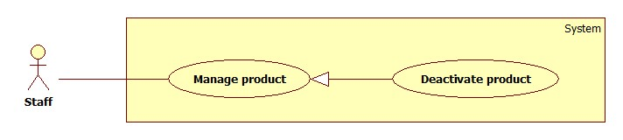

Figure … : <Staff> Deactivate Product

Use Case Specification

|  |  |  |  |
| --- | --- | --- | --- |
| **USE CASE –** | | | |
| **Use Case No.** |  | **Use Case Version** | 2.0 |
| **Use Case Name** | Deactivate Product | | |
| **Author** | Ha Chi Danh | | |
| **Date** | 30/05/2014 | **Priority** | Normal |
| **Actor:**   * Staff.   **Summary:**   * This use case allows staff to deactivate product.   **Goal:**   * Selected product will be deactivated.   **Triggers:**   * Staff wants to deactivate a product in the system. * To deactivate a product, staff must do the following steps:   + Choose “Quản lý sản phẩm” in sidebar menu.   + Uncheck any activated product.  **Preconditions:**   * User must log in the system with staff role. * There is least one product activated in database.   **Post Conditions:**   * **Success**: Selected product will be deactivated. * **Fail:** Show error message.   **Main Success Scenario:**   |  |  |  | | --- | --- | --- | | Step | Actor Action | System Response | | 1 | Click “Quản lý sản phẩm” menu. | Navigate to “Quản lý sản phẩm” page which contains:   * A table has 6 columns:   + Số thứ tự.   + Mã Sản phẩm   + Tên sản phẩm.   + Tên Hãng.   + Chi tiết   + Trạng thái * A drop down list:   + Tìm kiếm bằng tên  + Tìm kiếm bằng hang   * Search: textbox * Tìm kiếm: button. | | 2 | Uncheck any active product. | Deactivate selected product. Show success message.  [Exception 1] |   **Alternative Scenario:**   |  |  |  | | --- | --- | --- | | Step | Actor Action | System Response | | 1 | Session time out | Display error message: “Bạn rời máy tính quá lâu, vui lòng đăng nhập lại để tiếp tục”.  Redirect to login page. |   **Exceptions:**   |  |  |  | | --- | --- | --- | | No | Actor Action | System Response | | 1 | Cannot deactivate product due to database connection problem | Show error message: “Thao tác thất bại. Vui lòng thử lại sau!” |   **Relationships: N/A**  **Business Rules:**   * Staff clicks activated button. * Button is changed name to ”Deactivate” and colour to red. | | | |

##### <Staff> Activate Product

Use Case Diagram

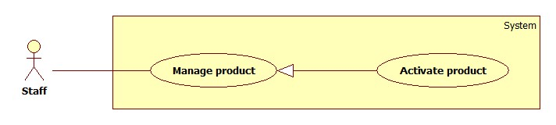

Figure … : <Staff> Activate Product

Use Case Specification

|  |  |  |  |
| --- | --- | --- | --- |
| **USE CASE –** | | | |
| **Use Case No.** |  | **Use Case Version** | 2.0 |
| **Use Case Name** | Activate Product | | |
| **Author** | Ha Chi Danh | | |
| **Date** | 30/05/2014 | **Priority** | Normal |
| **Actor:**   * Staff.   **Summary:**   * This use case allows staff to activate product.   **Goal:**   * Selected product will be activated.   **Triggers:**   * Staff wants to activate a product in the system. * To deactivate a product, staff must do the following steps:   + Choose “Quản lý sản phẩm” in sidebar menu.   + Click any deactivated button.  **Preconditions:**   * User must log in the system with staff role. * There is least one product deactivated in database.   **Post Conditions:**   * **Success**: Selected product will be activated. * **Fail:** Show error message.   **Main Success Scenario:**   |  |  |  | | --- | --- | --- | | Step | Actor Action | System Response | | 1 | Clicks “Quan lý sản phẩm” menu. | Navigate to “Quản lý sản phẩm” page which contains:   * A table has 6 columns:   + Số thứ tự.   + Mã Sản phẩm   + Tên sản phẩm.   + Tên Hãng.   + Chi tiết   + Trạng thái * A drop down list:   + Tìm kiếm bằng tên.  + Tìm kiếm bằng hang.   * Search: textbox * Tìm kiếm: button | | 2 | Clicks any deactivated button. | Activate selected product. Show success message.  [Exception 1] |   **Alternative Scenario:**   |  |  |  | | --- | --- | --- | | No | Actor Action | System Response | | 1 | Session time out | Show error message: “Bạn rời máy tính quá lâu, vui lòng đăng nhập lại để tiếp tục”.  Redirect to login page. |   **Exceptions:**   |  |  |  | | --- | --- | --- | | No | Actor Action | System Response | | 1 | Cannot activate product due to database connection problem | Show error message: “Thao tác thất bại. Vui lòng thử lại sau!” |   **Relationships:** N/A  **Business Rules:**   * Staff clicks deactivated button. * Button is changed name to ”Activate” and colour to blue. | | | |

1. **<Guest> Compare Product**

**Use case Diagram**

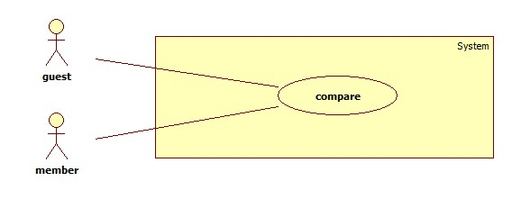

**Use case Diagram Specification**

|  |  |  |  |
| --- | --- | --- | --- |
| **USE CASE –** | | | |
| **Use Case No.** |  | **Use Case Version** | 2.0 |
| **Use Case Name** | Compare | | |
| **Author** | Ha Chi Danh | | |
| **Date** | 30/05/2014 | **Priority** | Normal |
| **Actor:**   * **Guest/member**   **Summary:**   * This use case allows guest/member to compare products on website.   **Goal:**   * Guest/member compares products in cart successfully.   **Triggers:**   * When cart has least 2 products, Guest clicks “so sánh” button.   **Preconditions:**   * Cart must has least 2 products.   **Post Conditions:**   * **Success**: Show comparison table with result of 2 or 3 products. * **Fail:** Show error message.   **Main Success Scenario:**   |  |  |  | | --- | --- | --- | | Step | Actor Action | System Response | | 1 | -Guest/member adds 2 or more products to cart  -Guest/member clicks “So sánh” button.  [Alternative 1,2,3] | Show comparison table with result:   * Winner product * Runner-up product(s).   [exception 1] |   **Alternative Scenario:**     |  |  |  | | --- | --- | --- | | Step | Actor Action | System Response | | 1 | -Guest/member adds 1 product to cart  -Guest/member clicks “So sánh” button. | Show error message:”Phải có ít nhất 2 sản phẩm trong giỏ”. | |  | -Cart has no product.  -Guest/member clicks “so sánh” button | Show error message:”Phải có ít nhất 2 sản phẩm trong giỏ”. | | 2 | Session time out | Create new cart object in session. |   **Exceptions:**   |  |  |  | | --- | --- | --- | | Step | Actor Action | System Response | | 1 | Cannot compare product due to database connection. | Show error message:”Thao tác thất bại, xin hãy thử lại”. |   **Relationships:** Add to cart  **Business Rules:** Guest clicks “So sánh” button, “So sánh” page will show in 2 situations:   * Situation 1: Result table of products in guest’s cart. * Situation 2: Error message :”Phải có ít nhất 2 sản phẩm trong giỏ” | | | |

1. **<Member> See suggestion**

**Use case Diagram**

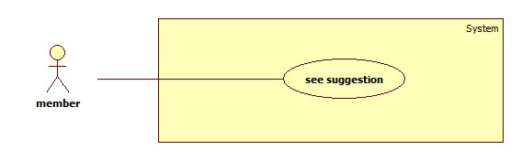

**Use case Diagram Specification**

|  |  |  |  |
| --- | --- | --- | --- |
| **USE CASE –** | | | |
| **Use Case No.** |  | **Use Case Version** | 2.0 |
| **Use Case Name** | See suggestion | | |
| **Author** | Ha Chi Danh | | |
| **Date** | 30/05/2014 | **Priority** | Normal |
| **Actor:**   * Member.   **Summary:**   * This use case allows member to see suggestion when comparing products on website.   **Goal:**   * Member sees suggestion when comparing products in cart successfully.   **Triggers:**   * When cart has least 2 products, member clicks “so sánh” button.   **Preconditions:**   * User must login with member role.   **Post Conditions:**   * **Success**:   **+** Show comparison table with result of 2 products or 3 products.  **+** Show points of product.  **+** Show recommend as list of products.   * **Fail:** Show error message.   **Main Success Scenario:**   |  |  |  | | --- | --- | --- | | Step | Actor Action | System Response | | 1 | * Member adds 2 or 3 products to cart * Member clicks “So sánh” button.   [Alternative 1,2,3] | Navigate to “So sánh” page with contains:   * Comparison table with information:   + Product which is winner and which is (are) runner-up in cart.  + Show Point of products.  + Show recommend as list of products.  [Exception 1] |   **Alternative Scenario:**   |  |  |  | | --- | --- | --- | | No | Actor Action | System Response | | 1 | * Cart has no product. * Member clicks “So sánh” button. | Show error message:” Phải có ít nhất 2 sản phẩm trong giỏ”. | | 2 | * Member adds 1 product to cart. * Member clicks “So sánh” button. | Show error message:” Phải có ít nhất 2 sản phẩm trong giỏ”. | | 3 | Session time out. | Show error message:”Vui lòng đăng nhập lại để được hỗ trợ nhiều hơn”.  Redirect to login page |     **Exceptions:**   |  |  |  | | --- | --- | --- | | No | Actor Action | System Response | | 1 | Cannot compare product due to database connection. | Show error message:”Thao tác thất bại, xin hãy thử lại”. |   **Relationships:** Add to cart  **Business Rules:**  Member adds 2 or 3 products to cart.  Member clicks “So sánh” button, “So sánh” page will show in 2 situations:   * Situation 1: Error message :”Phải có ít nhất 2 sản phẩm trong giỏ” * Situation 2:   + Show comparison table with result of products in member’s cart  + Points of products.  + Show recommend as list of products that similar with products in member’s cart. | | | |

1. **<Authorized user>Log out**

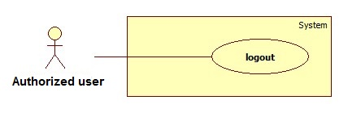

Figure: <Authorized user> Logout

Use Case Specification

|  |  |  |  |
| --- | --- | --- | --- |
| **USE CASE –** | | | |
| **Use Case No.** |  | **Use Case Version** | 2.0 |
| **Use Case Name** | Logout | | |
| **Author** | Ha Chi Danh | | |
| **Date** | 30/05/2014 | **Priority** | Normal |
| **Actor:**   * Authorized user.   **Summary:**   * This use case allows Authorized user to log out of the system.   **Goal:**   * Authorized user logs out of the system. Authorized user’s current session is destroyed.   **Triggers:**   * Authorized user wants to log out. * Authorized user clicks “Đăng xuất” link.   **Preconditions:**   * Authorized user has logged in to the system.   **Post Conditions:**   * **Success**: Authorized user’s current session is destroyed. Redirect to homepage. * **Fail:** Show error message.   **Main Success Scenario:**   |  |  |  | | --- | --- | --- | | Step | Actor Action | System Response | | 1 | Authorized user clicks “Thoát” link. | Show message “Bạn thực sự muốn thoát”   * Xác nhận: button * Hủy: button | | 2 | Authorized user clicks “Xác nhận” button. [Alternative 1] | Destroy Authorized user’s session. Redirect to homepage. [Exception 1] |   **Alternative Scenario:**   |  |  |  | | --- | --- | --- | | No | Actor Action | System Response | | 1 | Authorized user clicks “Hủy” button. | Do nothing. |   **Exceptions:**   |  |  |  | | --- | --- | --- | | No | Actor Action | System Response | | 1 | Fail to destroy Authorized user’s session | Redirect to error page. |   **Relationships:** N/a  **Business Rules:**   * Authorized user clicks “thoát” link, * Authorized user’s role will be changed to guest. | | | |

1. **<** **Authorized user> Change Password**

**Use case Diagram**

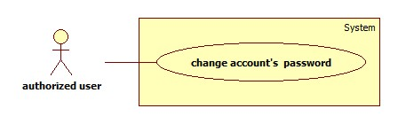

**Use case Diagram Specification**

|  |  |  |  |
| --- | --- | --- | --- |
| **USE CASE –** | | | |
| **Use Case No.** |  | **Use Case Version** | 2.0 |
| **Use Case Name** | Change account’s password | | |
| **Author** | Ha Chi Danh | | |
| **Date** | 30/05/2014 | **Priority** | Normal |
| **Actor:**   * Authorized user.   **Summary:**   * This use case allows Authorized user to change password.   **Goal:**   * Authorized user changes password successfully.   **Triggers:**   * Authorized user logins to website. * Authorized user clicks “Thay đổi mật khẩu” link.   **Preconditions:** Authorized user has register into the system.  **Post Conditions:**   * **Success:** New password has been updated into database. * **Fail:** Show error message.   **Main Success Scenario:**   |  |  |  | | --- | --- | --- | | Step | Actor Action | System Response | | 1 | Authorized user clicks “Thay đổi mật khẩu” link. | Show “Thay đổi mật khẩu ” page with includes:   * Mật khẩu cũ: textbox, password box, min length: 6, max length: 20, required. * Mật khẩu mới: textbox, password box, min length: 6, max length: 20, required. * Xác nhận mật khẩu mới: textbox, password box, min length: 6, max length: 20, required. * Thay đổi: button. * Xóa trắng: button. | |  | Authorized user clicks “Thay đổi” button [Alternative 1] | Show successful message and return to home page. [Exception 1,2, 3,4,5,6] |   **Alternative Scenario:**   |  |  |  | | --- | --- | --- | | No | Actor Action | System Response | | 1 | Authorized user clicks “Xóa trắng” button. | Clear all input fields. |   **Exceptions:**   |  |  |  | | --- | --- | --- | | No | Actor Action | System Response | | 1 | Length of password is not in range. | Show error message: “Độ dài mật khẩu phải từ 6-20 ký tự!” | | 2 | “Mật khẩu cũ” is wrong. | Show error message:”Sai mật khẩu.” | | 3 | “Mật khẩu cũ” is a blank. | Show error message:”Vui lòng nhập mật khẩu” | | 4 | “Mật khẩu mới” is a blank. | Show error message:”Vui lòng nhập mật khẩu mới” | | 5 | “Xác nhận mật khẩu mới” is a blank. | Show error message:”Vui lòng nhập xác nhận mật khẩu mới” | | 6 | “Mật khẩu mới” and “Xác nhận mật khẩu mới” is not similar. | Show error message: “Mật khẩu mới và Xác nhận mật khẩu mới không trùng khớp”. |   **Relationships:** N/A  **Business Rules:**   * Authorized user click “Thay đổi” button * New password has been updated into database. | | | |

1. **<Guest>Register**

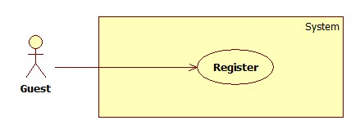

Figure: <Guest> Register

|  |  |  |  |
| --- | --- | --- | --- |
| **USE CASE –** | | | |
| **Use Case No.** |  | **Use Case Version** | 2.0 |
| **Use Case Name** | Register | | |
| **Author** | Ha Chi Danh | | |
| **Date** | 30/05/2014 | **Priority** | Normal |
| **Actor:**   * Guest.   **Summary:**   * This use case allows guest to register.   **Goal:**   * User can register new account to become a member of the system.   **Triggers:**   * Guest wants to be a member of the system. * To register, click “Đăng ký” link in menu bar.   **Preconditions:** N/A.  **Post Conditions:**   * **Success:** New member account is created. * **Fail:** Show error message.   **Main Success Scenario:**   |  |  |  | | --- | --- | --- | | Step | Actor Action | System Response | | 1 | Guest clicks “Đăng ký” link. | System show a register form which includes:   * Username: textbox, min length: 6, max length: 30, required. * Password: textbox, password box, min length: 6, max length: 20, required. * Đăng ký: button. * Xóa trắng: button. | | 2 | Guess enters required information, then clicks “Đăng ký” button. [Alternative 1] | Create new member account. Show success message.  [Exception 1,2, 3] |   **Alternative Scenario:**   |  |  |  | | --- | --- | --- | | No | Actor Action | System Response | | 1 | Guest clicks “Xóa trắng” button. | Clear all input fields. |   **Exceptions:**   |  |  |  | | --- | --- | --- | | No | Actor Action | System Response | | 1 | Length of username is not in range. | Show error message: “Độ dài username phải từ 6-30 ký tự!” | | 2 | Length of password is not in range. | Show error message: “Độ dài password phải từ 6-20 ký tự!” | | 3 | Username’s existed already. | Show error message: “Trùng tên đăng nhập! Vui lòng chọn tên khác!” |   **Relationships:** N/A  **Business Rules:**   * The role of new created account is “member”. | | | |

1. **<Guest> Log in**

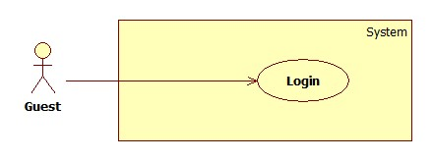

Figure: <Guest> Login

|  |  |  |  |
| --- | --- | --- | --- |
| **USE CASE –** | | | |
| **Use Case No.** |  | **Use Case Version** | 2.0 |
| **Use Case Name** | Login | | |
| **Author** | Ha Chi Danh | | |
| **Date** | 30/05/2014 | **Priority** | Normal |
| **Actor:**   * Guest.   **Summary:**   * This use case allows guest to login to the system.   **Goal:**   * Allow authentication and authorization of the system.   **Triggers:**   * Guest want to login into system. * To login: Guests go to the login link, enter username and password, and click “Đăng nhập” button to login.   **Preconditions:**   * Database has a registered account.   **Post Conditions:**   * **Success:** Guest is authorized, redirect to corresponding page. * **Fail:** System will show error on current page.   **Main Success Scenario:**   |  |  |  | | --- | --- | --- | | Step | Actor Action | System Response | | 1 | Guest goes to login page. | System show a login form, includes:   * Username: textbox, min length: 6, max length: 30, required. * Password: textbox, password box, min length: 6, max length: 20, required. * Đăng nhập: button. * Hủy: button * Create new account. | | 2 | Guess enter username and password into textboxes.  Press “Đăng nhập” button.[Alternative 1] | * Show message successful * “Ghi nhớ tài khoản”: check box   [Exception 1,2,3,4] |   **Alternative Scenario:**   |  |  |  | | --- | --- | --- | | No | Actor Action | System Response | | 1 | Press “Cancel” button. | Navigate to home page. |   **Exceptions:**   |  |  |  | | --- | --- | --- | | No | Actor Action | System Response | | 1 | “Tên tài khoản” is a blank | Show error message: “Vui lòng điền đủ username và password!” | | 2 | “Mật khẩu” is a blank | Show error message: “Vui lòng điền đủ username và password!” | | 3 | Username/Password not in range [5,30] | Show error message: “Thông tin không hợp lệ. Vui lòng thử lại!” | | 4 | Enter invalid “Username” and “Password” | Show error message: “Thông tin không hợp lệ. Vui lòng thử lại!” |   **Relationships:** N/A.  **Business Rules:**   * Each member, staff, admin has an account. * Only active account can log in. | | | |

1. **<Guest> View Detail**

**Use case Diagram**

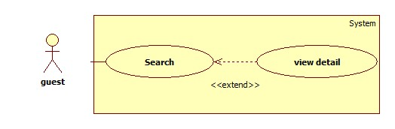

**Use case diagram specification**

|  |  |  |  |
| --- | --- | --- | --- |
| **USE CASE –** | | | |
| **Use Case No.** |  | **Use Case Version** | 2.0 |
| **Use Case Name** | View detail | | |
| **Author** | Ha Chi Danh | | |
| **Date** | 30/05/2014 | **Priority** | Normal |
| **Actor:**   * Guest.   **Summary:**   * This use case allows guest to search and view product information.   **Goal:**   * A page detail of products will be shown to guest.   **Triggers:**   * Guest inputs to a blank textbox then clicks “Tìm kiếm” button. * Guest inputs URL of product or serial number then they search all products with relative URL or serial number which they inputted. The searching results will show product detail.   **Preconditions:** N/A  **Post Conditions:**   * **Success**: Show search results as a page of product with URL or serial number that guest inputted * **Fail:** Show an error message.   **Main Success Scenario:**   |  |  |  | | --- | --- | --- | | Step | Actor Action | System Response | | 1 | Guest inputs the product’s URL or serial number into textbox. | Show “Search” page with includes:   * Tìm bằng đường dẫn/ tìm bằng số seri: drop down list. * Search: textbox * Tìm kiếm: button | | 2 | Guest clicks “Tìm kiếm” button. | * System will show page detail product by product URL or serial number.[Exception1] |   **Alternative Scenario:** N/A  **Exceptions:**   |  |  |  | | --- | --- | --- | | Step | Actor Action | System Response | | 1 | Search not found | Redirect to Not found page.  Show message:”Vui lòng đăng nhập để được hỗ trợ nhiều hơn”. |   **Relationships:** Search  **Business Rules:**   * User search by URL or serial number of product * System will search all products in database. * If that product is existed, system will show detail page of that product. | | | |

1. **<Member> View Detail**

**Use case Diagram**

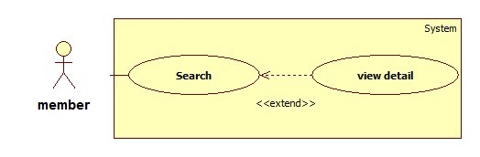

**Use case diagram specification**

|  |  |  |  |
| --- | --- | --- | --- |
| **USE CASE –** | | | |
| **Use Case No.** |  | **Use Case Version** | 2.0 |
| **Use Case Name** | View detail | | |
| **Author** | Ha Chi Danh | | |
| **Date** | 30/05/2014 | **Priority** | Normal |
| **Actor:**   * Member.   **Summary:**   * This use case allows member to search and view product information.   **Goal:**   * A page detail of products will be shown to member.   **Triggers:**   * Member inputs to a blank textbox then clicks “Tìm kiếm” button. * Member inputs URL of product or serial number then they search all products with relative URL or serial number which they inputted. The searching results will show product detail.   **Preconditions:** N/A  **Post Conditions:**   * **Success**: Show search results as a page of product with URL or serial number that user inputted * **Fail:** Show an error message.   **Main Success Scenario:**   |  |  |  | | --- | --- | --- | | Step | Actor Action | System Response | | 1 | Member inputs the product’s URL or serial number into textbox. | Show “Search” page with includes:   * Tìm bằng đường dẫn/ tìm bằng số seri: drop down list * Search: textbox * Tìm kiếm: button | | 2 | User clicks “Tìm kiếm” button.  [Alternative 1] | * System will show page detail product by product URL or serial number. * Rating: icon * Thêm vào giỏ: button   [Exception 1] |   **Alternative Scenario:**   |  |  |  | | --- | --- | --- | | Step | Actor Action | System Response | | 1 | Session time out. | Show message:”bạn rời máy tính quá lâu, vui lòng đăng nhập lại để tiếp tục”  Redirect to login page. |   **Exceptions:**   |  |  |  | | --- | --- | --- | | Step | Actor Action | System Response | | 1 | Search not found | Redirect to Recommend Page |   **Relationships:** Search.  **Business Rules:**   * User search by URL or serial number of product * System will search all products in database. * If that product is existed, system will show detail page of that product. * If that one is not existed, system will navigate to recommend page. | | | |

1. **<System> Send notification**

**Use case Diagram**

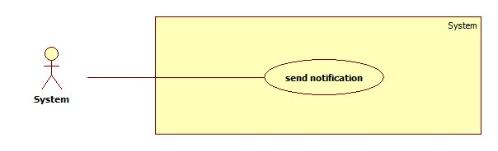

**Use case Diagram Specification**

|  |  |  |  |
| --- | --- | --- | --- |
| **USE CASE –** | | | |
| **Use Case No.** |  | **Use Case Version** | 2.0 |
| **Use Case Name** | send notification | | |
| **Author** | Ha Chi Danh | | |
| **Date** | 30/05/2014 | **Priority** | Normal |
| **Actor:**   * System.   **Summary:**   * This use case allows system to send notification to member.   **Goal:**   * System sends notification to member successfully.   **Triggers:**   * Staff clicks “Xác nhận” to send notification. * System will send notification to member.   **Precondition: N/A**  **Post Conditions:**   * **Success**: send notification to member successfully. * **Fail:** notification is not sent to member.   **Main Success Scenario:**   |  |  |  | | --- | --- | --- | | Step | Actor Action | System Response | | 1 | * System checks the product in database * Product is existed.   [Alternative 1] | System sends notification to member  [exception 1] |   **Alternative Scenario:**  N/A  **Exceptions:**   |  |  |  | | --- | --- | --- | | Step | Actor Action | System Response | | 1 | Cannot send notification due to database connection. | Notification won’t be sent to member. |     **Relationships: N/A**.  **Business Rules:**   * If Product is trained, it will be updated into database. * Admin confirm to send notification. * System will notify to member. * Member can check that product again. | | | |