1. Functional requirements
2. 2 Functional requirement Register
3. 2.1 Guest registers Use case

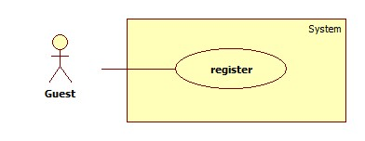

1. 2.2 Use case Register specification

|  |  |  |  |  |
| --- | --- | --- | --- | --- |
| **USE CASE – 001** | | | | |
| **Use case No.** | UC001 | **Use case version** | | 0.1 |
| **Use case name** | Register | | | |
| **Author** | Danhhc | | | |
| **Date** | 28/05/2014 | **Priority** | Normal | |
| **Actor:** Guest  **Summary:**  Guest use this case to register.  **Goal:**  Allow Guest to create a new account of network.  **Triggers:**   * User needs an account to login into the system in other to have more authorization in the system. * Guest click on “Register” button at home page.   **Preconditions:** N/A  **Post Conditions:**   * **Success:** A new account is crated in the system. This account is User account type. * **Fail:** Error message will be showed.   **Main Success Scenario:**   |  |  |  | | --- | --- | --- | | Step | Actor Action | System Response | | 1 | Click on “Register” to request register page | System will response Register page :   * Username: Textbox(min length: 1, max length: 20, required) * Email: Textbox(min length: 1, max length: 30, required) * Password: Textbox(min length: 1, max length: 20, required) * Confirm Password: Textbox(min length: 1, max length: 20, required) * Verify Code: Textbox(required) * Register: button | | 2 | Enter information into text fields.  Click on “Register” button to finish. [Alternative 1] | System will create new account in database, pop-up message “Register successfully” and system will transfer to login page.  [Exception 1,2,3,4,5] |   **Alternative Scenario:**   |  |  |  | | --- | --- | --- | | ID | Actor Action | System Response | | 1 | Click on “Cancel” button to finish | System will transfer to home page |   **Exceptions:**   |  |  |  | | --- | --- | --- | | ID | Actor Action | System Response | | 1 | Username is not in length [6, 30] | Username must be in length [6, 30] | | 2 | Password is not in length [6, 30] | Password must be in length [6, 30] | | 3 | Email has existed in database | Display error message: “Email already exists. Please choose another” | | 4 | Input not a valid information in Email’s textbox | Display error message: “Your email contains illegal characters” | | 5 | Input confirm password information different with password | Display error message: “Your password and confirmation password do not match” | | 6 | Verify code is not correct | Display error message: ”Wrong Verify code, Please reenter” |   **Relationships:**  N/A  **Business Rules:**   * User can use account to login and use services of CPS depend on role. | | | | |

1. 3 Functional requirement Login
2. 3. 1 Use case Login

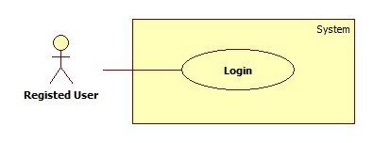

1. 3. 2 Use case Login Specification

|  |  |  |  |  |
| --- | --- | --- | --- | --- |
| **USE CASE - 002** | | | | |
| **Use-case No.** | UC02 | **Use-case Version** | | 1.0 |
| **Use-case Name** | Login | | | |
| **Author** | Danhhc | | | |
| **Date** | 28/05/2014 | **Priority** | Normal | |
| **Actor:**  *User*  **Summary:**  *Allows user to login to website*  **Goal:**  *The public users login to the website*  **Triggers:**  *User clicks “Login” button.*  **Preconditions:**  *User has to enter username and password.*  **Post Conditions:**  *Success: User signed in to the system.*  *Fail: Display error message.*  **Main Success Scenario:**   |  |  | | --- | --- | | ***User*** | ***System*** | | *2. Enters username and password*  *3. Clicks “Login” button* | *1. Display:*   * *Username: textbox.* * *Password: password textbox.* * *Login: button*   *4. Check login and sign in to the system.* |   **Alternative Scenario:**  *N/A*  **Exceptions:**   |  |  | | --- | --- | | ***User*** | ***System*** | | *1. Username or password is empty*  *3. Wrong username or password* | *2. Display error message “Enter your username and password”.*  *4. Display error message “Wrong username or password”.* |   **Relationships:**  N/A  **Business Rules:**  *Username is in email format (ex: epcs@gmail.com).*  *Password must be more than 5 characters.* | | | | |

1. 4 Functional requirement Log out
2. 4. 1 Use case Log out

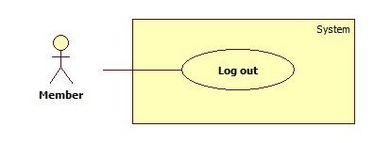

1. 4.2 Use case Log out Specification

|  |  |  |  |  |
| --- | --- | --- | --- | --- |
| **USE CASE - 003** | | | | |
| **Use-case No.** | UC03 | **Use-case Version** | | 1.0 |
| **Use-case Name** | Log out | | | |
| **Author** | Danhhc | | | |
| **Date** | 28/05/2014 | **Priority** | Normal | |
| **Actor:**  *User*  **Summary:**  *Allows user to logout from website.*  **Goal:**  *User logout from website.*  **Triggers:**  *User clicks “Log out” link.*  **Preconditions:**  *User logged in CPS system.*  **Post Conditions:**  *Current session will be invalid.*  **Main Success Scenario:**   |  |  | | --- | --- | | ***User*** | ***System*** | | *1. User clicks “Log out” link* | *2. Goes to “Log in” page and invalid session.* |   **Alternative Scenario:**  *N/A*  **Exceptions:**  *N/A*  **Relationships:**  *N/A*  **Business Rules:**  *N/A* | | | | |

1. 5 Functional Requirement Manage product
2. 5.1 Use case Manage products

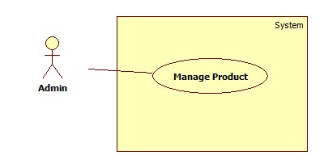

1. 5.2 Use case Manage Products Specification

|  |  |  |  |  |
| --- | --- | --- | --- | --- |
| **USE CASE - 004** | | | | |
| **Use-case No.** | UC04 | **Use-case Version** | | 1.0 |
| **Use-case Name** | Manage Products | | | |
| **Author** | Danhhc | | | |
| **Date** | 28/05/2014 | **Priority** | Normal | |
| **Actor:**  *Admin*  **Summary:**  *Allows admin to manage products from website.*  **Goal:**  *Admin can add new, edit and delete products from website.*  **Triggers:**  *Admin clicks “Manage Products” menu.*  **Preconditions:**  *Admin log in to admin’s page.*  **Post Conditions:**  *N/A*  **Main Success Scenario:**   |  |  | | --- | --- | | ***User*** | ***System*** | | *2. User clicks “Manage products” menu.* | *1. Show Admin page.* |   **Alternative Scenario:**  *N/A*  **Exceptions:**  *N/A*  **Relationships:**  *N/A*  **Business Rules:**  *N/A* | | | | |

1. 6 Functional requirement Notify for User
2. 6. 1 Use case Notify for User

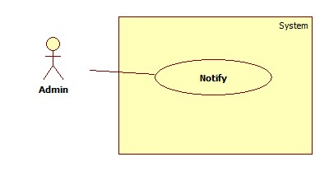

1. 6. 2 Use case Notify for User specification

|  |  |  |  |  |
| --- | --- | --- | --- | --- |
| **USE CASE - 005** | | | | |
| **Use-case No.** | UC05 | **Use-case Version** | | 1.0 |
| **Use-case Name** | Notify for User | | | |
| **Author** | Danhhc | | | |
| **Date** | 28/05/2014 | **Priority** | Normal | |
| **Actor:**  *Admin*  **Summary:**  *Allows admin to notify to User.*  **Goal:**  *Admin send a message to user when system update product that user wants.*  **Triggers:**  *Admin clicks “Manage Notify” menu.*  **Preconditions:**  *Admin log in to admin’s page.*  **Post Conditions:**  *N/A*  **Main Success Scenario:**   |  |  | | --- | --- | | ***User*** | ***System*** | | *2. User clicks “Manage notify” menu.* | *1. Show Admin page* |   **Alternative Scenario:**  *N/A*  **Exceptions:**  *N/A*  **Relationships:**  *N/A*  **Business Rules:**  *N/A* | | | | |

1. 7 Functional requirement Manage Log file
2. 7. 1 Use case Manage Log file

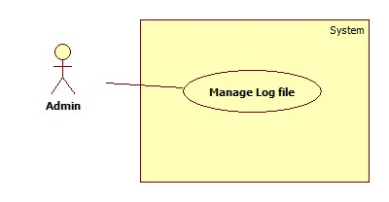

1. 7. 2 Use case Manage Log file Specification

|  |  |  |  |  |
| --- | --- | --- | --- | --- |
| **USE CASE - 006** | | | | |
| **Use-case No.** | UC06 | **Use-case Version** | | 1.0 |
| **Use-case Name** | Manage log file | | | |
| **Author** | Danhhc | | | |
| **Date** | 28/05/2014 | **Priority** | Normal | |
| **Actor:**  *Admin*  **Summary:**  *Allows admin to manage log files from Users.*  **Goal:**  *Admin view, update and delete files log.*  **Triggers:**  *Admin clicks “Manage Log file” menu.*  **Preconditions:**  *Admin log in to admin’s page.*  **Post Conditions:**  *N/A*  **Main Success Scenario:**   |  |  | | --- | --- | | ***User*** | ***System*** | | *2. User clicks “Manage Log file” menu.* | *1. Show Admin page* |   **Alternative Scenario:**  *N/A*  **Exceptions:**  *N/A*  **Relationships:**  *N/A*  **Business Rules:**  *N/A* | | | | |