1. **Prototype**

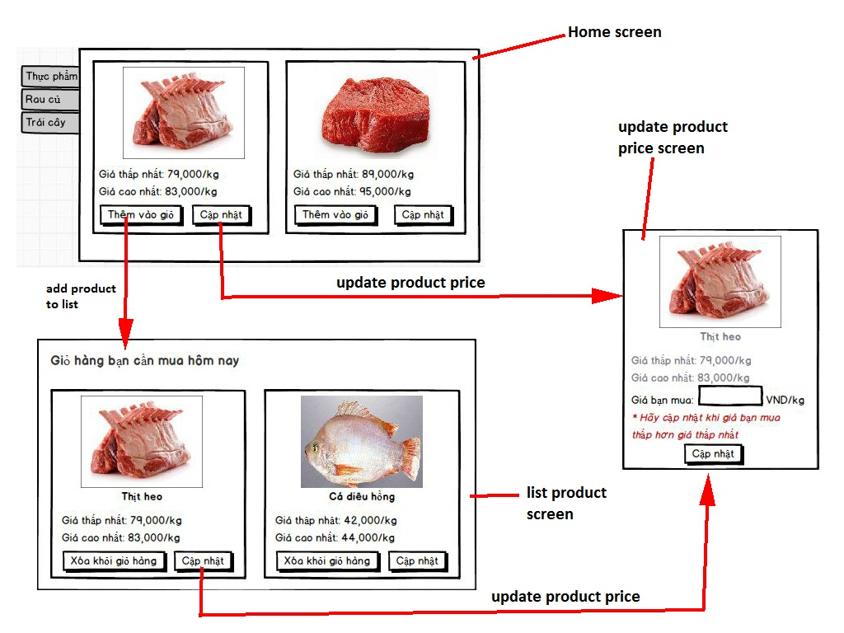

1. **Use case diagram**
   1. Add list product forday



|  |  |  |  |  |
| --- | --- | --- | --- | --- |
| **USE CASE _Add list product forday_ SPECIFICATION** | | | | |
| Use-case No. | UC01 | Use-case Version | | 1.0 |
| Use-case Name | Add list product forday | | | |
| Author | HoangDH | | | |
| Date | 11/01/2014 | Priority | Normal | |
| **Actor** | User | | | |
| **Summary** | A user adds a product to his/her list. | | | |
| **Goal** | The user can add the product which he/she needs to buy to his/her list. | | | |
| **Triggers** | N/A | | | |
| **PreConditions** | N/A | | | |
| **PostConditions** | The product is added to list of the user and that information is showed in the list product page. | | | |
| **Main Success Scenario** | | | | |
| 1. In home screen, the user chooses a product. 2. The user clicks “**Thêm vào giỏ**” button. 3. The system checks if the product has existed in list of the user. 4. The product has not existed in list of the user, the system adds the product to the list. | | | | |
| **Alternative Scenario** | | | | |
| A1: The product has existed in list of the user.  4. The product has existed in list of the user, the system will show message “**Sản phẩm này đã có trong giỏ**”. | | | | |
| **Exceptions** | | | | |
| N/A | | | | |
| **Relationships** | N/A | | | |
| **Business Rules** | N/A | | | |

* 1. Update product price



|  |  |  |  |  |
| --- | --- | --- | --- | --- |
| **USE CASE _Update product price_ SPECIFICATION** | | | | |
| Use-case No. | UC02 | Use-case Version | | 1.0 |
| Use-case Name | Update product price | | | |
| Author | HoangDH | | | |
| Date | 11/01/2014 | Priority | Normal | |
| **Actor** | User | | | |
| **Summary** | A user updates product price. | | | |
| **Goal** | The user can update the product price if it is lower than lowest price of server. | | | |
| **Triggers** | N/A | | | |
| **PreConditions** | N/A | | | |
| **PostConditions** | The product price is updated to server if it is lower than lowest price of server. | | | |
| **Main Success Scenario** | | | | |
| 1. The user chooses a product. 2. The user clicks “**Cập nhật**” button. 3. A details page of the product is returned with product’s information. 4. The user edit price of product. 5. The user submits the form. 6. The system validates all information in the form. 7. All information are valid, the system updates new information of the product and store this information in the database if product price of the user is lower than lowest price of server | | | | |
| **Recovery Scenario** | | | | |
| R1: Information is invalid.   1. The input information is not valid, warning(s) is/are returned to the user to correct the information in step 4.   The use case continues at step 4. | | | | |
| **Exceptions** | | | | |
| N/A | | | | |
| **Relationships** | N/A | | | |
| **Business Rules** | N/A | | | |