Website Project Proposal
Target Organisation: Nexa Mobiles

Subject: Web Development (WEDE5020)
Full Name: Dimpho Makhene
Student Number: ST10501982
Group: 1

Table of content
Contents
1. Organisation Overview 1
2. Website Goals and Objectives 1
3. Current Website Analysis 1
4. Proposed Website Features and Functionality 1
5. Design and User Experience 1
6. Technical Requirements 1
7. Timeline and Milestones 1
8. Budget 1
9. References 1

Proposal 1: Nexa Mobiles
Nexa Mobiles is a South African side business specialising in the resale of quality Apple iPhones. This proposal outlines a website to formalise its online presence and support business growth.

Organisation Overview

• Brand Name: Nexa Mobiles
• Company Background: It originally began as a small independent business selling brand new as well as second-hand Apple iPhones through word-of-mouth advertising and various social media techniques within student limits.
• Corporate Goal: To make high-quality products by Apple affordable to as many people as possible.
• Corporate Vision: To become a reputable shop for Apple products in South Africa.
• Target Customers: Young individuals and working professionals within the age group of 18 till the age of 35 who wish to spend less on an iPhone.

Website Goals and Objectives
• Build online credibility to win customers’ trust.
• Use the company website for obtaining sales inquiries.
• Show the devices currently in stock and their prices.
• Key performance indicators include the number of unique visitors per month, number of WhatsApp clicks or contact options, and number of sales generated through inquiries.

Current Website Analysis
• There is no website as sales take place through informal social media advertisements.
• A limitation of the business is that customers cannot search independently for product information.
• It is not as credible as its registered retail competitors.
• However, there is a chance to establish an effective website that will improve how the business operates.

Proposed Website Features and Functionality

• The homepage consists of highlighted devices and promotional offers.
• The About Us page describes the company and its principles.
• The Catalogue/Products page contains devices, their specifications, and their prices.
• The Contact page features a WhatsApp click-to-chat feature and an enquiry form.

Design and User Experience
• Colour Palette: The blue and white hues correlate with the current branding of Nexa Mobiles.
• Font: The Montserrat and Open Sans typefaces are used for headings and body text respectively, to convey modernity.
• Design and Layout: The design is minimalist and mobile-responsive, with ample white space.
• User Experience: The design emphasizes top navigation, clear call to action on the contact page, as well as card-based product display.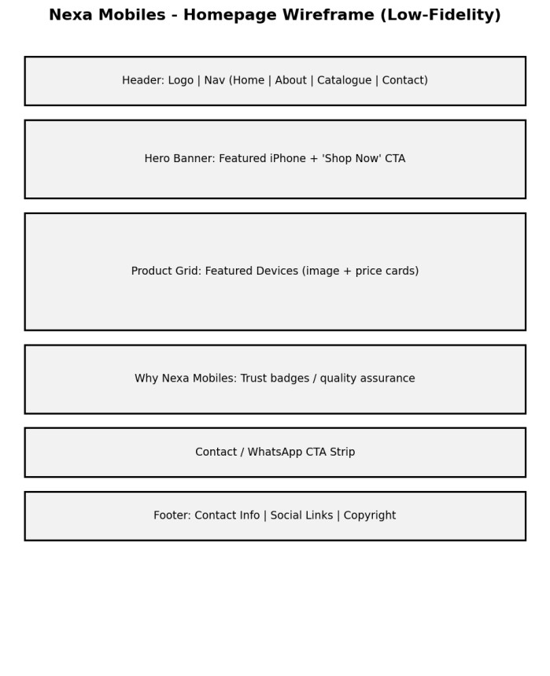

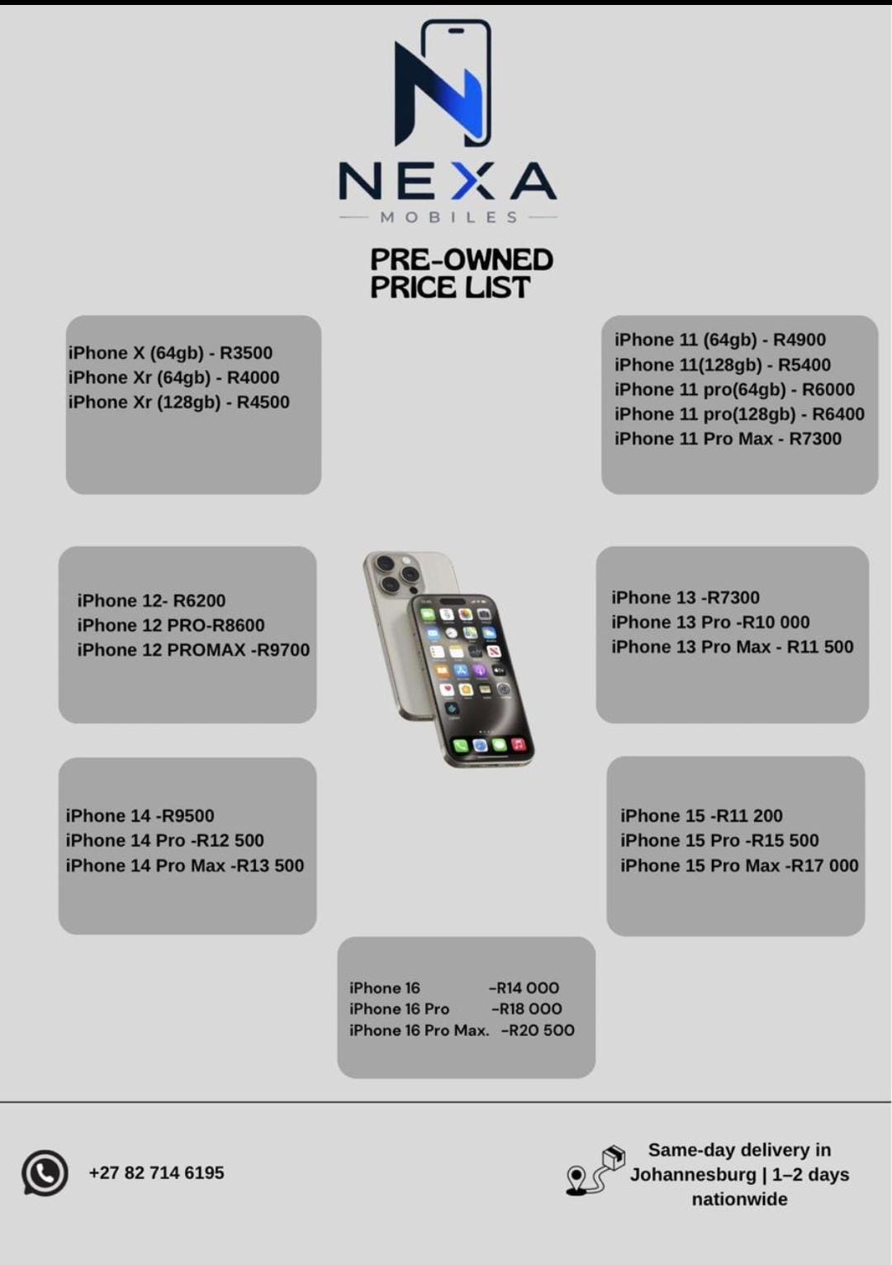

Technical Requirements
Hosting: Inexpensive sharing hosting suited for a static website.
• Domain: nexamobiles.co.za
• Languages/Frameworks: HTML, CSS, and JavaScript for a lightweight static website.

Timeline and Milestones
Week One: Creating and approving wireframes. •
Week Two: Constructing the main page and important pages. •
Week Three: Uploading content, establishing the catalogue, and carrying out tests. •
Week Four: Conducting the final review and launching the project.

Budget
- Domain registration: approx. R150/year.
- Web hosting: approx. R100/month (R1,200/year).
- Development: R0 (self-built as part of coursework).
- Estimated Total (Year 1): Approximately R1,350.

References
Nexa (2026) Business Proposal for pre-owned Iphone retail operations.
Unpublished corporate proposal

