|  |  |  |
| --- | --- | --- |
|  |  |  |
| Ruby on Rails & Angular JS Tutorial |  | Web Applications Development |
|  |  |  |

|  |  |  |
| --- | --- | --- |
| Overview Building a Web Application in Ruby on Rails & AngularJS using a mixture of online resources. Ruby on Rails & AngularJS can both be used to their best and thus are suitable modern day approaches to web application. Objectives The Objectives of this tutorial:   * Build a Basic Web Application in Ruby on Rails & Angular JS. * Generate Simple API Controllers, Models and Views. * Introduce Bootstrap. * Perform Testing of Controllers, Models.  StepsSetup a new Rails ApplicationMake a new Rails Application and include a postgresql database **Rails new app –skip-bundle –quiet –database=postgresql-** Remove turbolinks Remove turbolinks from the gemfile and application.js. Add AngularJS to the Application with bundler and bower**Add the following Gems to the Gemfile and Install.**  * gem ‘angular-rails-templates’ * gem ‘bower-rails’   bundle install **Generate bower_rails to enable us to install AngularJS** **Rails g bower_rails:initialize json** **Modify the bower.json file** **{ "lib": { "name": "bower-rails generated lib assets", "dependencies": { "angular": "v1.2.25" } }, "vendor": { "name": "bower-rails generated vendor assets", "dependencies": { } } }** **Install bower dependencies** **Bundle exec rake bower:install** **Create an Organized Directory for AngularJS Application** **In app/assets/javascript create the following folder:** angular-app.  **Inside angular-app, create the following folders:**   * templates * modules * filters * directives * models * services * controllers  **Require the folders and files in application.js** //= require jquery  //= require jquery_ujs  //= require angular  //= require angular-rails-templates  //= require angular-app/app  //= require_tree ./angular-app/templates  //= require_tree ./angular-app/modules  //= require_tree ./angular-app/filters  //= require_tree ./angular-app/directives  //= require_tree ./angular-app/models //= require_tree ./angular-app/services  //= require_tree./angular-app/controllers | " | Materials Materials were taken from:   * <http://blog.honeybadger.io/beginners-guide-to-angular-js-rails/> * <http://www.intridea.com/blog/2014/9/25/how-to-set-up-angular-with-rails> * http://angular-rails.com/bootstrap.html |

## Setup and Configure the Angular App

### **In app/assets/javascripts/angular-app/app.js.coffee, add the following:**

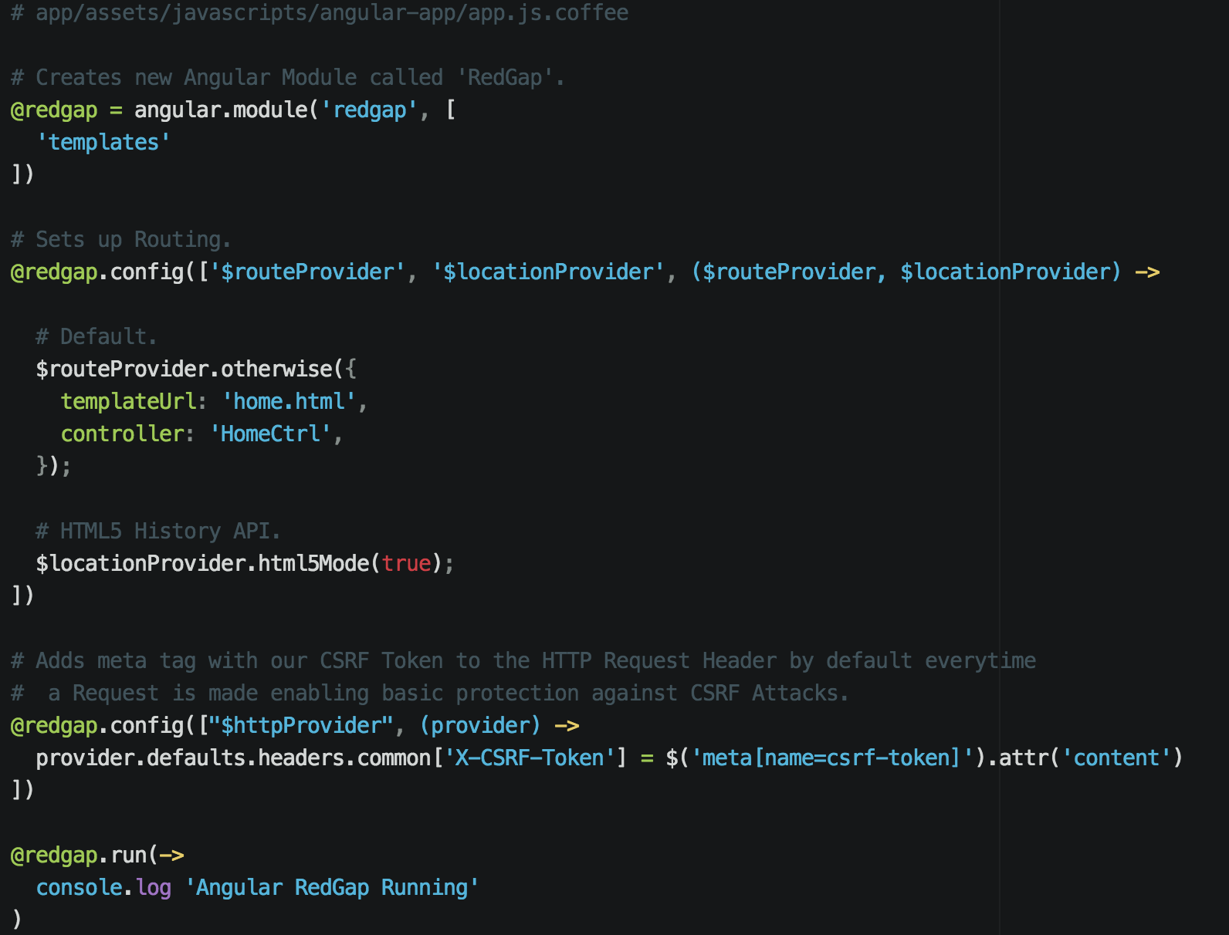

### **Create Angular Module in app/assets/javascripts/angular-app/modules/home.js.coffee.erb.**

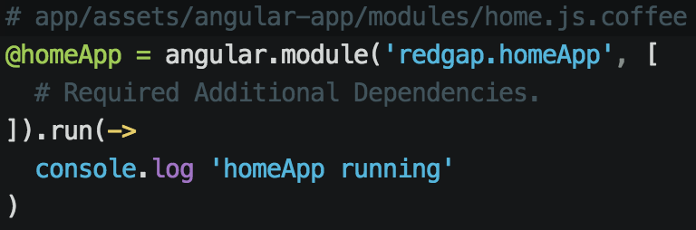

### **Create Angular Controller in app/assets/javascripts/angular-app/controllers/homeCtrl.js.coffee.**

### **Generate a default controller with an action index using rails:**

As we’ll be using AngularJS Templates, we need to set up our default controller with action index thus what all of traffic will go through only to deliver the application.html.erb in layouts.

rails generate controller Default index

### **Set our rails routes for Default Controller Action Index being our default route:**

In config/routes.rb:

