Customer Shopping Behaviour Analysis

Project Overview
This project undertakes a comprehensive analysis of customer shopping behaviour using transactional data captured from 3,900 purchases spanning multiple product categories. The primary objective is to derive meaningful insights into customer spending patterns, demographic segments, product preferences, discount dependency, and subscription behaviour in order to inform data-driven strategic business decisions. The analysis follows an end-to-end pipeline — from raw data ingestion and cleaning in Python, through structured querying in PostgreSQL, to interactive visual reporting in Power BI.

Dataset Summary
The dataset is a structured CSV file containing 3,900 rows and 18 columns. It captures a broad set of attributes related to customer demographics, individual transactions, and shopping behaviour patterns:
- Rows: 3,900
- Columns: 18
- Key Feature Groups:
  - Customer demographics — Age, Gender, Location, Subscription Status
  - Purchase details — Item Purchased, Category, Purchase Amount (USD), Season, Size, Color
  - Shopping behaviour — Discount Applied, Promo Code Used, Previous Purchases, Frequency of Purchases, Review Rating, Shipping Type, Payment Method
- Missing Data: 37 null values identified in the Review Rating column only.

Exploratory Data Analysis using Python
The data preparation and exploratory analysis phase was carried out entirely in Python using the pandas library. The following steps were performed sequentially:

Data Loading
The dataset was imported from a CSV file into a pandas DataFrame. An initial inspection was performed to review the column structure, data types, and row counts.
import pandas as pd
df = pd.read_csv('customer_shopping_behavior.csv') df.head()

Initial Exploration
Structural inspection was done using df.info() to examine column data types and non-null counts, and df.describe() to generate summary statistics across numerical and categorical features. This step confirmed the presence of 37 missing values in the Review Rating column.

Missing Data Handling
Null values were identified across all columns. The 37 missing entries in the Review Rating column were imputed using the median review rating computed per product category, preserving category-level rating distributions rather than applying a global average.
df.isnull().sum()
df['Review Rating'] = df.groupby('Category')['Review Rating'].transform( lambda x: x.fillna(x.median()))

Column Standardisation
All column names were converted to lowercase snake_case to ensure compatibility with PostgreSQL, which is case-sensitive when column names are not quoted. This eliminates the need to use double quotes in every SQL query.
df.columns = (df.columns
.str.strip()
.str.lower()
.str.replace(' ', '_')
.str.replace(r'[^\w]', '', regex=True))

Feature Engineering
Age Group: A new categorical column age_group was created by binning customer ages into five cohorts for demographic segmentation analysis.
df['age_group'] = pd.cut(df['age'],
bins=[17, 25, 35, 45, 55, 100],
labels=['Young Adult', 'Adult', 'Middle-aged', 'Senior', 'Elderly'])
Purchase Frequency Days: The text-based Frequency of Purchases column was mapped to a numeric equivalent representing approximate days between purchases, enabling quantitative analysis.
freq_map = {'Weekly': 7, 'Fortnightly': 14, 'Monthly': 30,
'Quarterly': 90, 'Annually': 365, 'Bi-Weekly': 14} df['purchase_frequency_days'] = df['frequency_of_purchases'].map(freq_map)

Data Consistency Check
A verification check confirmed that the discount_applied and promo_code_used columns were entirely identical across all 3,900 rows — a 100% correlation. As the columns carried redundant information, promo_code_used was dropped to reduce dimensionality.
(df['discount_applied'] == df['promo_code_used']).all() # Returns True
df = df.drop('promo_code_used', axis=1)

Database Integration
The cleaned DataFrame was loaded into a PostgreSQL database (customer_behavior) using SQLAlchemy. The URL.create() method was used to safely handle the special character (@) present in the database password, which would otherwise corrupt the connection string if embedded directly.
from sqlalchemy import create_engine from sqlalchemy.engine import URL
url = URL.create( drivername="postgresql+psycopg2", username="postgres", password="PostgreSQL@12345", host="localhost", port=5432, database="customer_behavior"
)
engine = create_engine(url)
df.to_sql('customer', engine, if_exists='replace', index=False)

Data Analysis using SQL (Business Queries)
Following data ingestion into PostgreSQL, ten structured business queries were executed in pgAdmin 4 to answer key analytical questions. Each query is documented below along with its result.

Q1. Revenue by Gender
Total revenue was calculated for male and female customers separately to identify gender-based revenue contribution and spending volume.
SELECT gender, SUM(purchase_amount) AS revenue FROM customer
GROUP BY gender;

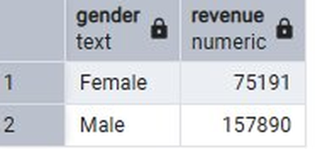

Q2. High-Spending Discount Users
Customers who applied a discount but whose purchase amount still exceeded the overall average were identified — indicating that discounts attracted high-value buyers rather than only bargain shoppers.
SELECT customer_id, purchase_amount FROM customer
WHERE discount_applied = 'Yes'
AND purchase_amount >= (SELECT AVG(purchase_amount) FROM customer);

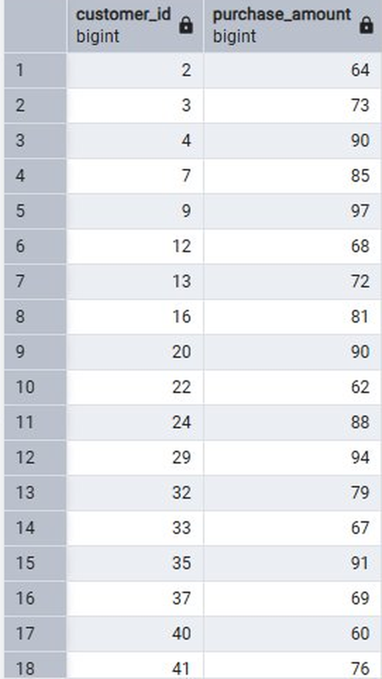

Q3. Top 5 Products by Average Review Rating
The five products with the highest average customer review ratings were ranked. These products represent the strongest candidates for featured placement in marketing campaigns.
SELECT item_purchased,
ROUND(AVG(review_rating::numeric), 2) AS "Average Product Rating" FROM customer
GROUP BY item_purchased
ORDER BY AVG(review_rating) DESC

LIMIT 5;

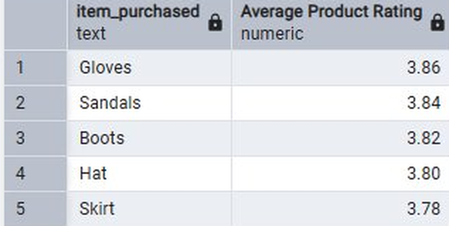

Q4. Shipping Type vs. Average Purchase Amount
Average purchase amounts were compared between Standard and Express shipping types to assess whether customers who opt for faster delivery also tend to spend more per transaction.

SELECT shipping_type,
ROUND(AVG(purchase_amount), 2) AS avg_purchase FROM customer
WHERE shipping_type IN ('Standard', 'Express')
GROUP BY shipping_type;
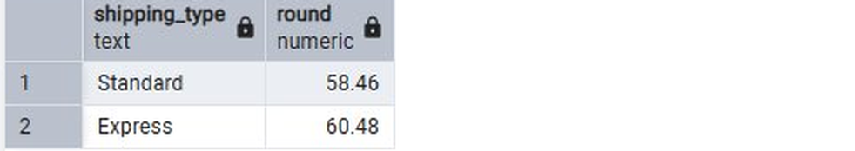

Q5. Subscribers vs. Non-Subscribers — Spend Comparison
Average spend per transaction and total revenue were compared across subscription status groups to determine whether subscribers demonstrate higher lifetime value.
SELECT subscription_status, ROUND(AVG(purchase_amount), 2) AS avg_spend,
SUM(purchase_amount) AS total_revenue,
COUNT(customer_id) AS total_customers FROM customer
GROUP BY subscription_status
ORDER BY total_revenue, avg_spend DESC;

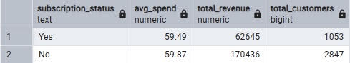

Q6. Discount-Dependent Products
The five products where the highest proportion of purchases involved a discount were identified. A high discount rate signals potential margin risk and may require a review of pricing or promotional strategy for those items.
SELECT item_purchased,
ROUND(100 * SUM(CASE WHEN discount_applied = 'Yes' THEN 1 ELSE 0 END)
/ COUNT(*), 2) AS discount_rate
FROM customer
GROUP BY item_purchased ORDER BY discount_rate DESC LIMIT 5;

[ Insert Result Table for Q6. Discount-Dependent Products ]

Q7. Customer Segmentation by Purchase History
Customers were classified into three behavioural segments — New, Returning, and Loyal — based on their count of previous purchases. This segmentation supports targeted retention and acquisition strategies.
SELECT
CASE
WHEN previous_purchases = 1
THEN 'New'
WHEN previous_purchases BETWEEN 2 AND 10 THEN 'Returning' ELSE 'Loyal'
END AS customer_segment, COUNT(*) AS customer_count
FROM customer
GROUP BY customer_segment ORDER BY customer_count DESC;

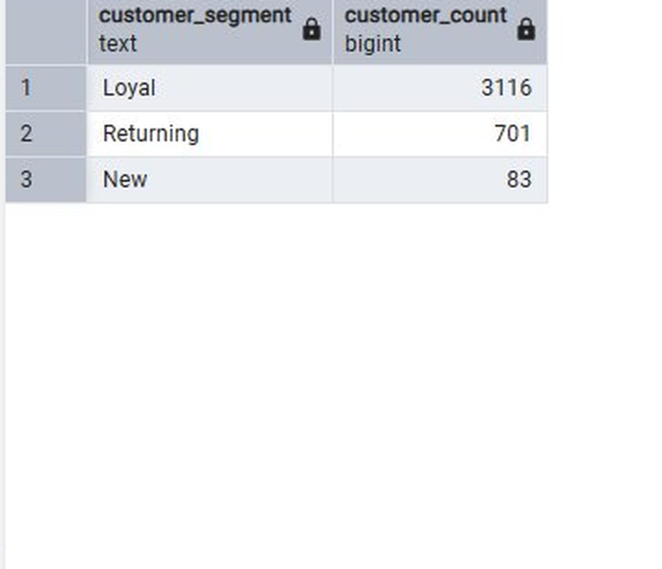

Q8. Top 3 Most Purchased Products per Category
A window function (RANK) was applied to identify the three best-selling products within each product category. This reveals category-level demand concentration.
SELECT category, item_purchased, total_purchases FROM (
SELECT category, item_purchased, COUNT(*) AS total_purchases,
RANK() OVER (PARTITION BY category
ORDER BY COUNT(*) DESC) AS item_rank
FROM customer
GROUP BY category, item_purchased
) ranked
WHERE item_rank <= 3
ORDER BY category, total_purchases DESC;

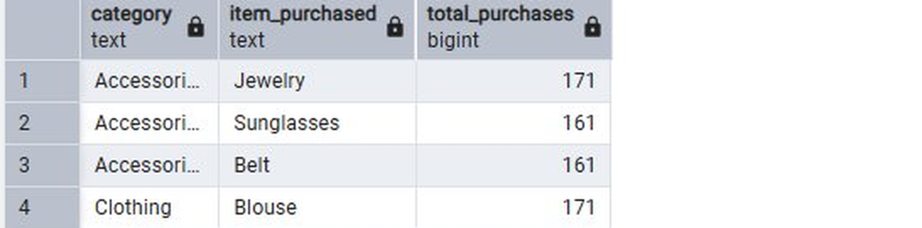

Q9. Repeat Buyers and Subscription Likelihood
Customers with more than five previous purchases were classified as Repeat Buyers. Their subscription rates were compared against Non-Repeat Buyers to determine whether purchase frequency is a reliable predictor of subscription uptake.
SELECT
CASE WHEN previous_purchases > 5 THEN 'Repeat Buyer' ELSE 'Non-Repeat Buyer' END AS buyer_type,
subscription_status, COUNT(*) AS customer_count, ROUND(COUNT(*) * 100.0 /
SUM(COUNT(*)) OVER (PARTITION BY
CASE WHEN previous_purchases > 5
THEN 'Repeat Buyer' ELSE 'Non-Repeat Buyer' END), 2) AS pct
FROM customer
GROUP BY buyer_type, subscription_status ORDER BY buyer_type, subscription_status;

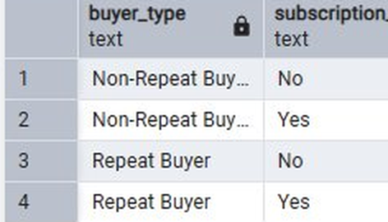

Q10. Revenue Contribution by Age Group
Total revenue was aggregated across the derived age_group column to identify which demographic cohorts drive the most business value.
SELECT age_group, SUM(purchase_amount) AS total_revenue FROM customer
GROUP BY age_group
ORDER BY total_revenue DESC;

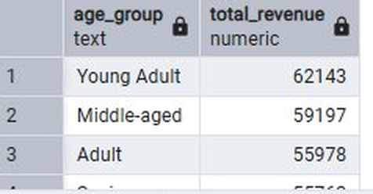

Dashboard in Power BI
An interactive dashboard was developed in Power BI Desktop to translate the SQL findings into accessible visual insights. The dashboard connects directly to the PostgreSQL database and provides dynamic filtering by subscription status, gender, product category, and shipping type. Key metrics displayed include total number of customers (3.9K), average purchase amount ($59.76), and average review rating (3.75).
Visualisations included in the dashboard:
- Donut chart — percentage of customers by subscription status (Yes 27% / No 73%)
- Bar charts — revenue and sales volume by product category
- Horizontal bar charts — revenue and sales count by age group
- KPI cards — aggregate metrics for quick executive overview

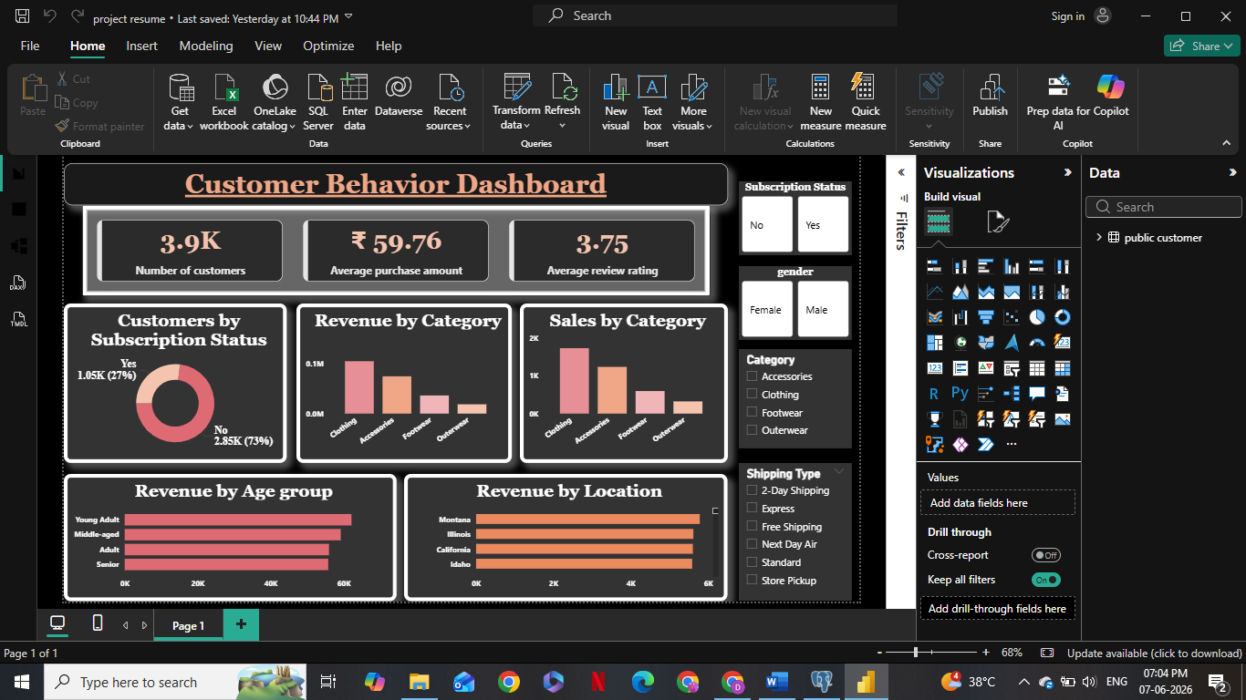

Business Recommendations
Based on the analytical findings across all ten SQL queries and the Power BI dashboard, the following strategic recommendations are proposed:
- Boost Subscriptions: With only 27% of customers currently subscribed, there is significant room for growth. Introducing exclusive subscriber benefits — such as early access, free shipping thresholds, or loyalty points — could improve conversion and retention rates.
- Customer Loyalty Programmes: The majority of customers (3,116 of 3,900) already fall into the Loyal segment. Structured reward programmes targeting the Returning segment (701 customers) could accelerate their transition to Loyal status, increasing lifetime value.
- Review Discount Policy: Several products — including Hat, Sneakers, and Coat — have discount rates approaching 50%. While discounts drive purchase volume, dependency at this level poses margin risk. A tiered or time-limited discount structure should be evaluated for these items.
- Product Positioning: Top-rated products (Gloves, Sandals, Boots) and category leaders (Blouse, Jewelry, Jacket) should be prominently featured in digital marketing campaigns to capital satisfaction.
- Targeted Marketing by Age and Shipping Preference: Young Adults generate the highest revenue ($62,143) despite not necessarily having the highest average spend, suggesting high transaction volume. Express shipping customers also demonstrate slightly higher average spend ($60.48 vs $58.46 for Standard), indicating a willingness to pay for convenience that could be leveraged through premium service bundle.

