Python HackerRank challenges
1. Given an integer, , perform the following conditional actions:
If is odd, print Weird
If is even and in the inclusive range of to , print Not Weird
If is even and in the inclusive range of to , print Weird
If is even and greater than , print Not Weird

soln.
if __name__ == '__main__':
n = int(input().strip())
if n%2!=0:
print("Weird")
else:
if 2<=n<=5:
print("Not Weird")
elif 6<=n<=20:
print("Weird")
else:
print("Not Weird")

2. The provided code stub reads two integers, and , from STDIN.
Add logic to print two lines. The first line should contain the result of integer division, a // b. The second line should contain the result of float division, a /b .
No rounding or formatting is necessary.

soln.
if __name__ == '__main__':
a = int(input())
b = int(input())
print(a//b)
print(float(a/b))

3. The provided code stub reads an integer, , from STDIN. For all non-negative integers , print i*i .
n = int(input())
for i in range(0,n):
print(i*i)

4. An extra day is added to the calendar almost every four years as February 29, and the day is called a leap day. It corrects the calendar for the fact that our planet takes approximately 365.25 days to orbit the sun. A leap year contains a leap day.

In the Gregorian calendar, three conditions are used to identify leap years:

The year can be evenly divided by 4, is a leap year, unless:
The year can be evenly divided by 100, it is NOT a leap year, unless:
The year is also evenly divisible by 400. Then it is a leap year.
This means that in the Gregorian calendar, the years 2000 and 2400 are leap years, while 1800, 1900, 2100, 2200, 2300 and 2500 are NOT leap years. Source

Task

Given a year, determine whether it is a leap year. If it is a leap year, return the Boolean True, otherwise return False.

Note that the code stub provided reads from STDIN and passes arguments to the is_leap function. It is only necessary to complete the is_leap function.

def is_leap(year):
if year%4==0:
if year%100==0:
if year%400==0:
return True
else:
return False
else:
return True
else:
return False
year = int(input())
print(is_leap(year))

5. The included code stub will read an integer, , from STDIN.
Without using any string methods, try to print the following:
Note that "" represents the consecutive values in between.
n = int(input())
for i in range(1,n+1):
print(i,end="")

6. 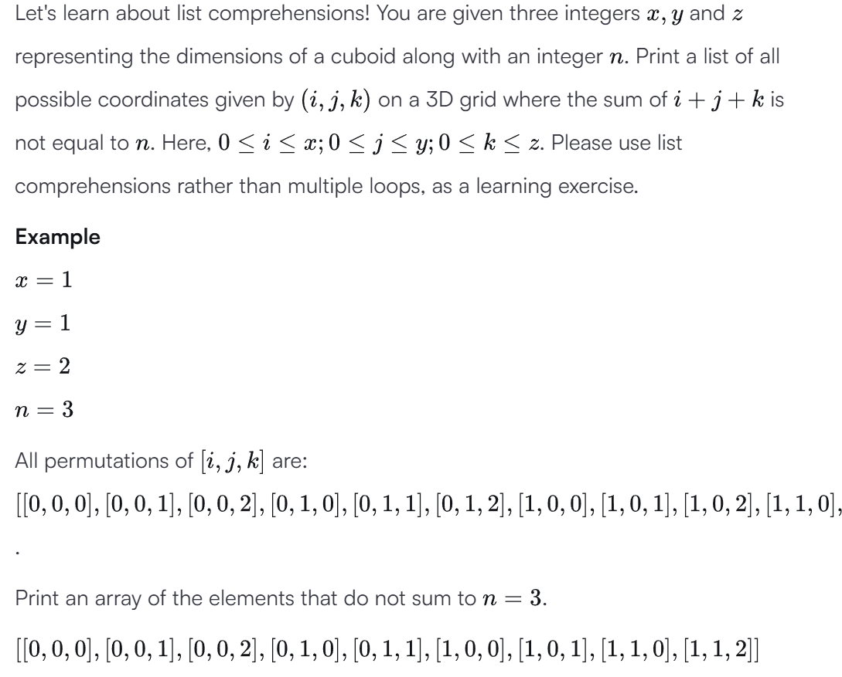
x = int(input())
y = int(input())
z = int(input())
n = int(input())

result = [[i, j, k]
for i in range(x + 1)
for j in range(y + 1)
for k in range(z + 1)
if i + j + k != n]
print(result)
7. Given the participants' score sheet for your University Sports Day, you are required to find the runner-up score. You are given scores. Store them in a list and find the score of the runner-up.
n = int(input())
arr = map(int, input().split())
x=list(set(arr))
x.sort()
print(x[-2])

8. Given the names and grades for each student in a class of students, store them in a nested list and print the name(s) of any student(s) having the second lowest grade.
students=[]
for _ in range(int(input())):
name = input()
score = float(input())
students.append([name,score])
x=sorted(set([student[1] for student in students]))
res=x[1]
names=[student[0] for student in students if student[1]==res]
names.sort()
for name in names:
print(name)
9. The provided code stub will read in a dictionary containing key/value pairs of name:[marks] for a list of students. Print the average of the marks array for the student name provided, showing 2 places after the decimal.
n = int(input())
student_marks = {}
for _ in range(n):
name, *line = input().split()
scores = list(map(float, line))
student_marks[name] = scores
query_name = input()
marks_list=student_marks[query_name]
res=sum(marks_list)/len(marks_list)
print(f"{res:.2f}")

