EE 735: ASSIGNMENT 1 REPORT
NAME: DIMPLE KOCHAR
ROLL NO.: 16D070010

Q1 a) I assumed that the dimensions of the box are (3000 X 120) nm (which seems large compared to plates of 600 nm length with a distance of 6 nm in between them. One plate was set at a voltage of 0.5 V and another -0.5 V. (When I used 1V,0V – equipotential lines weren’t well plot due to very small potentials around grounded plate).
vnew(i,j) = (v(i-1,j)+v(i+1,j)+v(i,j-1)+v(i,j+1))/4 using this and running iterations on it till change at every potential point is less than 0.1 (set by e<0.1 condition in code) we obtain convergence of the potential. Then, taking the gradient of V to get the electric field, we calculate the total charge using Gauss Law, and thus the capacitance.

Capacitance per unit width by solving the 2D Poisson equation = 0.94424 nF

Q1 b)

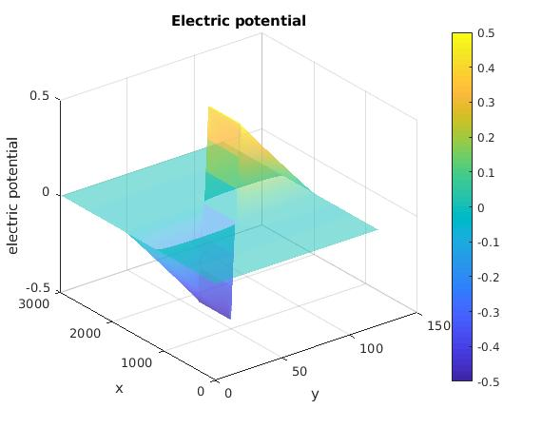

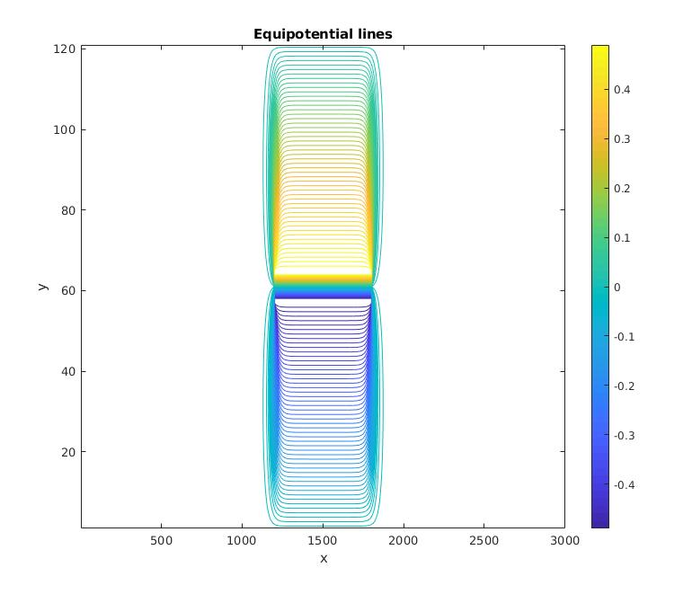
Q1 c)
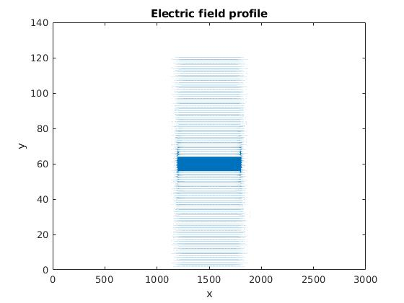
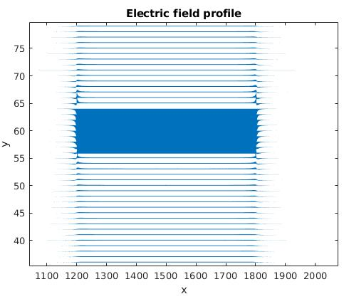

Q1 d) Simulated capacitance = 0.94424 nF
Theoretical capacitance = 0.88540 nF
Simulated capacitance is larger that theoretical due to fring effect. A voltage difference applied between the plates results in an electric field between them. This electric field exists not just directly between the plates, but extends some distance away, causing a fringing field. Fringe effect occurs when the electric field extends the area of the overlap.

Q2 a) Simulated Capacitance:

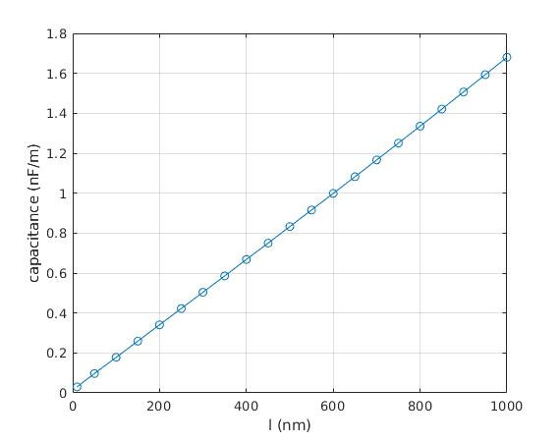

Q2 b) Parasitic Capacitance:
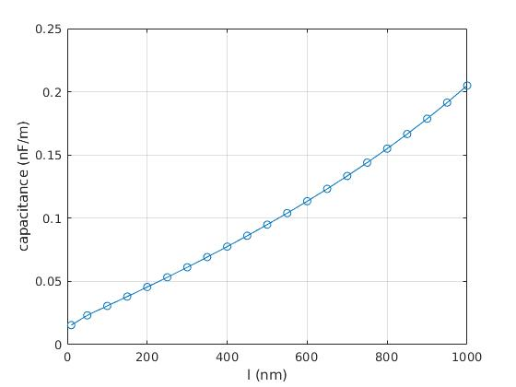

Data (in F):
l(nm) Capacitance simulated Capacitance Theoretical Parasitic Capacitance Percentage parasitic

10 3.01493407759743e-11 1.47566666666667e-11 1.53926741093077e-11 51.0547617730133
50 9.69449556912931e-11 7.37833333333334e-11 2.31616223579597e-11 23.8915188446880
100 1.78180468877079e-10 1.47566666666667e-10 3.06138022104121e-11 17.1813456342017
150 2.59366649701720e-10 2.21350000000000e-10 3.80166497017197e-11 14.6574934539348
200 3.40690808724457e-10 2.95133333333333e-10 4.55574753911234e-11 13.3720881880231
250 4.22178299498264e-10 3.68916666666667e-10 5.32616328315976e-11 12.6159096511820
300 5.03852959600053e-10 4.42700000000000e-10 6.11529596000532e-11 12.1370646802581
350 5.85720083441026e-10 5.16483333333333e-10 6.92367501076928e-11 11.8207915461830
400 6.67816033433613e-10 5.90266666666667e-10 7.75493667669458e-11 11.6123846814850
450 7.50142433058219e-10 6.64050000000000e-10 8.60924330582189e-11 11.4768115046142
500 8.32731982973245e-10 7.37833333333333e-10 9.48986496399119e-11 11.3960615876766
550 9.15629439818694e-10 8.11616666666667e-10 1.04012773152028e-10 11.3597017121493
600 9.98828998084219e-10 8.85400000000000e-10 1.13428998084219e-10 11.3561979379633
650 1.08237816958032e-09 9.59183333333334e-10 1.23194836246990e-10 11.3818663115459
700 1.16634139037888e-09 1.03296666666667e-09 1.33374723712209e-10 11.4353074333479
750 1.25070289596137e-09 1.10675000000000e-09 1.43952895961371e-10 11.5097595461086
800 1.33553155999994e-09 1.18053333333333e-09 1.54998226666610e-10 11.6057329762103
850 1.42087597495023e-09 1.25431666666667e-09 1.66559308283563e-10 11.7222974573412
900 1.50679095178992e-09 1.32810000000000e-09 1.78690951789915e-10 11.8590406703497
950 1.59333874731522e-09 1.40188333333333e-09 1.91455413981887e-10 12.0159893371381
1000 1.68059063850362e-09 1.47566666666667e-09 2.04923971836956e-10 12.1935685670258

Nature of plot: We can see that the slope of the parasitic capacitance plot is less than that of the simulated capacitance plot. This implies that difference between the simulated and theoretical capacitance decreases as the length of the plates increases. (Which I also checked by calculating the percentage as seen in the above data). This is because as the length of the plate decreases, fringing effect is more dominant and hence adds to the net capacitance. On doubling the length, the simulated capacitance is less than double the previous, as fringe effects do not double.

Q3 a) I assumed that the dimensions of the box are (600 X 600) nm (which seems large compared to plates nearly 20 X 20 nm in dimensions together. One plate was set at a voltage of 1 V and another 0 V
vnew(i,j) = (v(i-1,j)+v(i+1,j)+v(i,j-1)+v(i,j+1))/4 using this and running iterations on it till change at every potential point is less than 0.1 (set by e<0.1 condition in code) we obtain convergence of the potential. Then, taking the gradient of V to get the electric field, we calculate the total charge using Gauss Law, and thus the capacitance.

Capacitance per unit width by solving the 2D Poisson equation = 28.948 pF

Q3 b)

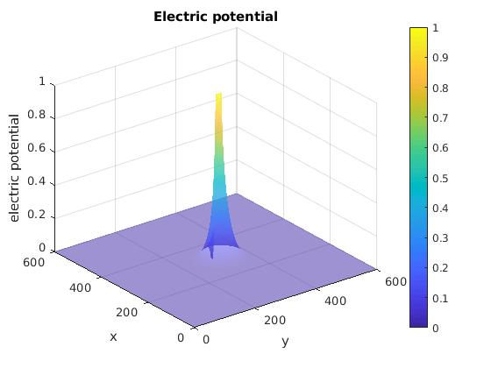

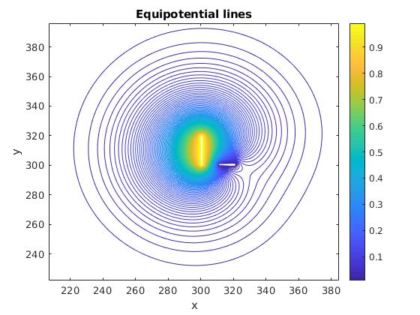

Q3 c)
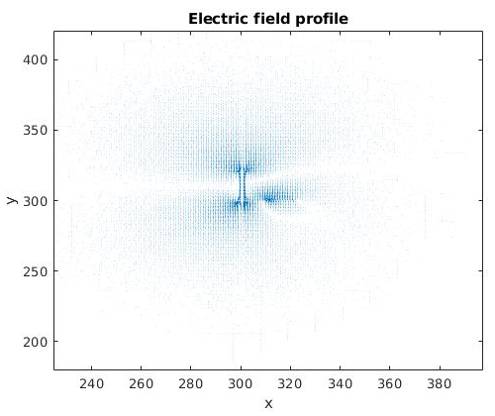
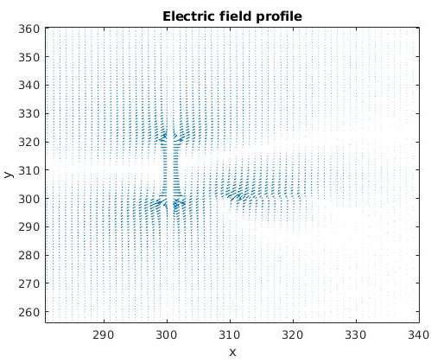

Q3 d) Emax = 0.2293 V/m. It is maximum at the lower end of the vertical plate, the side which is closer to the horizontal plate.

