EE 735: ASSIGNMENT 2 REPORT
NAME: DIMPLE KOCHAR
ROLL NO.: 16D070010

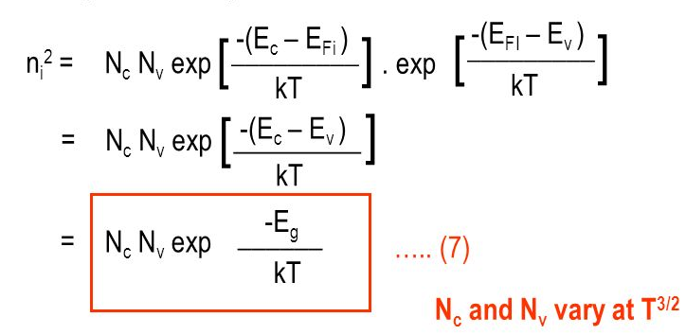

Using these formulae, we calculate n_{i} = 1.3766*10¹⁰ cm ⁻³
Grid spacing is 1nm

Q1. ABRUPT

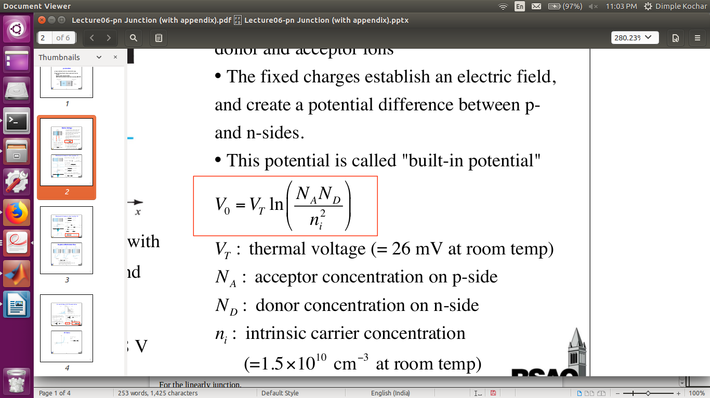

V₀ (the built in voltage) = 0.6984 V
using V_{T} = k_{B}T/q with
k_{B} = 1.38*10⁻²³
T = 300K
q = 1.6*10⁻¹⁹
N_{D} = 10¹⁶ cm ⁻³ , N_{A}= 10¹⁶ cm ⁻³

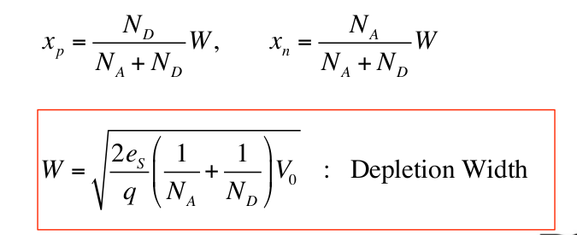

K_{Si} = 11.8
e_{s} = K_{si}*8.854*10⁻¹⁴
` x_{P} = x_{N} = 214 nm

roh is as follows:
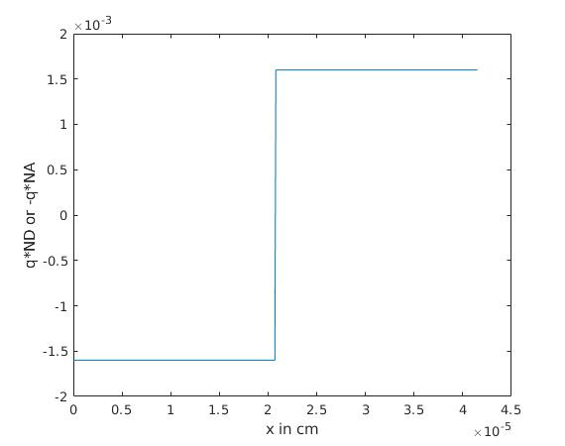

Q1a)
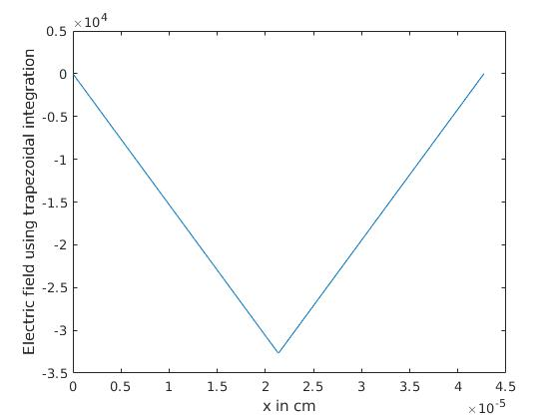
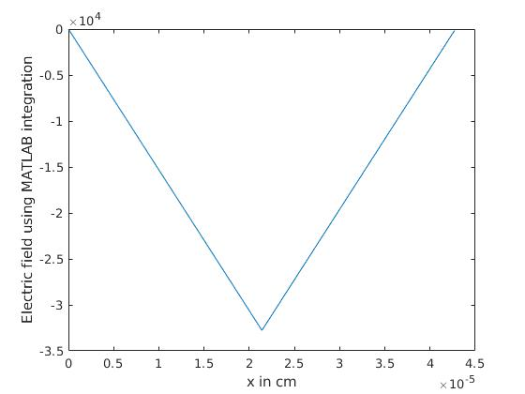
Numerical and MATLAB integration work similarly. At the rightmost edge, numerical integration shows a slight error by being non-zero. On changing grid spacing, this error reduces.

Q1b)
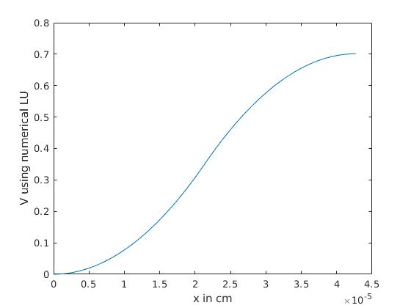
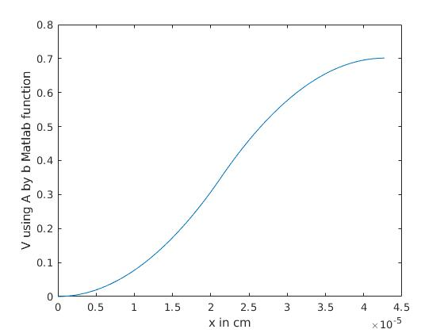
Using central difference discretization scheme, solved the Poisson equation with depletion approximation. We see that we get the correct built in potential. LU decomposition matrices obtained were nearly equal from numerical and MATLAB methods

Q1. LINEAR

x_{n} = ((3*e_{S}/(q*(N_{A}+N_{D})))*(2*k*T/q)*ln(0.5*(N_{A}+N_{D})/n_{i}))^{0.5} for a linear graded system.
Using the parameters as used in abrupt, we obtain
x_{P} = x_{N} = 262 nm

roh is as follows:

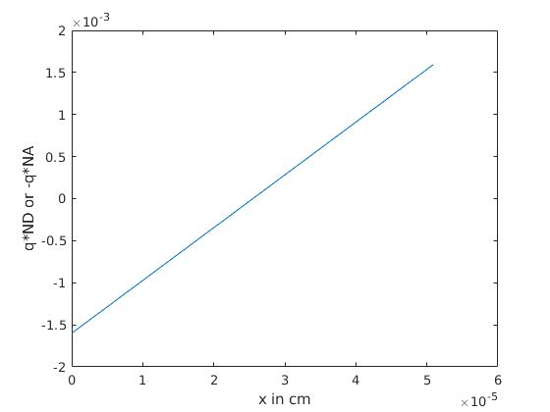

Q1a)

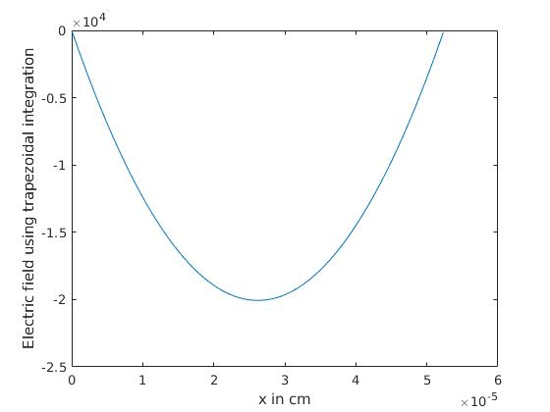
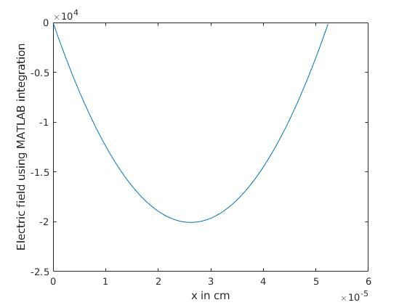
Numerical and MATLAB integration work similarly.

Q1b)
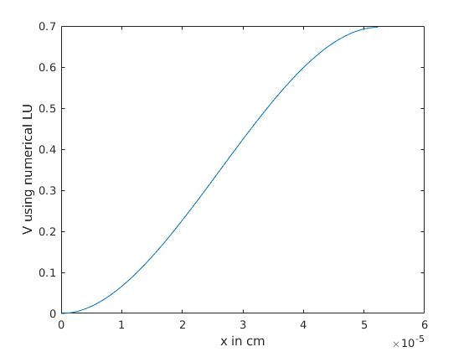
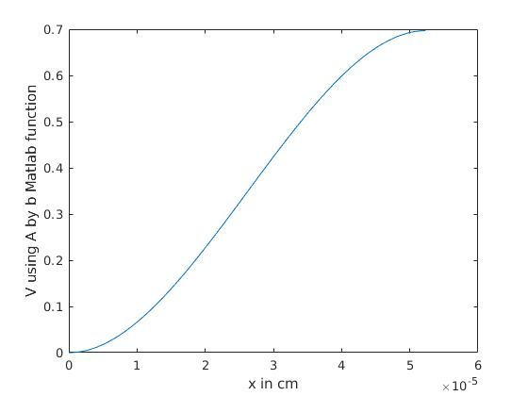
Using central difference discretization scheme, solved the Poisson equation with depletion approximation. LU decomposition matrices obtained were nearly equal from numerical and MATLAB methods.
The built in potential is given as
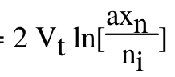

where V_{T} = k_{B}T/q and a = (N_{D} + N_{A})/(x_{n}+x_{p}) = N_{D} /x_{n} due to symmetry resulting in the same built in potential as the abrupt case.

Q2. Doping concentrations N_{D} = 10¹⁶ cm ⁻³ , N_{A}= 2*10¹⁵ cm ⁻³ . Used Newton Raphson method to solve the charge neutrality equation for finding the fermi energy E_{F}.

Taking E_{V} = 0; E_{D} = E_{C} – 0.045 eV; E_{A} = E_{V} + 0.045eV at 300K
and solving the equation, we obtain E_{F} = 0.8895 eV

