EE 735: ASSIGNMENT 2 REPORT
NAME: DIMPLE KOCHAR
ROLL NO.: 16D070010

Q1. I keep length of ntype = length of ptype = 200nm
p-type is from 0-200 nm and 200-400 nm is ntype in the xgrid.
N_{D} = 10¹⁶ cm ⁻³ , N_{A}= 10¹⁶ cm ⁻³
For the abrupt junction,
in 0-200(x_{P}) nm, we say that roh = -q*N_{A} and 200-400(x_{P} + x_{N})nm, we say that roh = q*N_{D}

For the abrupt graded junction, roh is as follows:

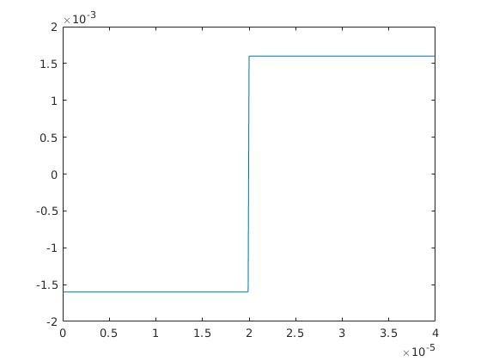

For the linearly junction,
in 0-200(x_{P}) nm, we say that roh = -(q*N_{A}/x_{P})*x; and 200-400(x_{P} + x_{N})nm, we say that roh = -(q*N_{D}/x_{N})*(x_{N} + x_{p} - x);

For the linearly graded junction, roh is as follows:

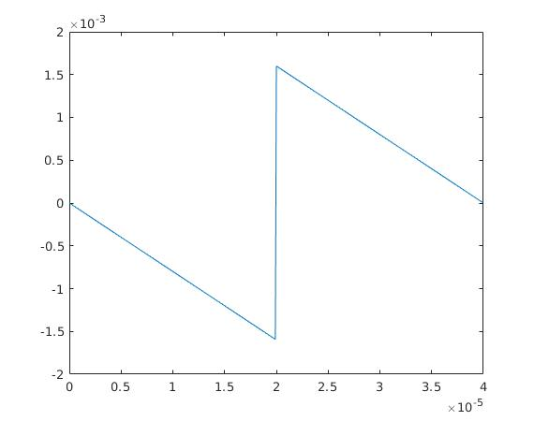

Q1 a) Electric field profile by solving the Gauss Law using numerical integration techniques
such as Trapezoidal method

i) Abrupt junction

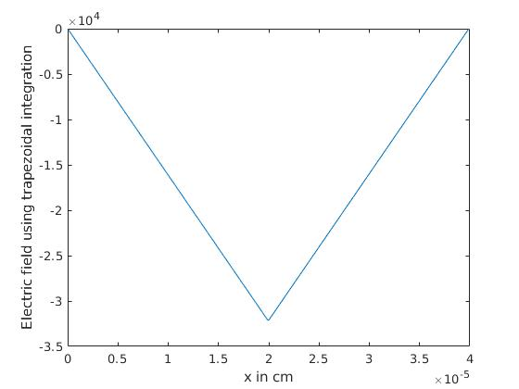
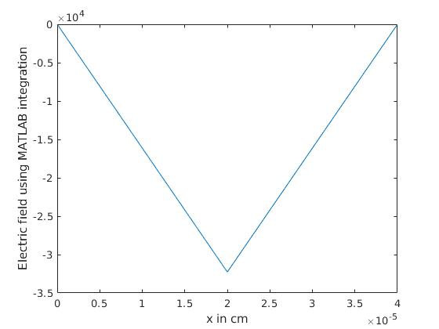
ii) Linearly graded junction
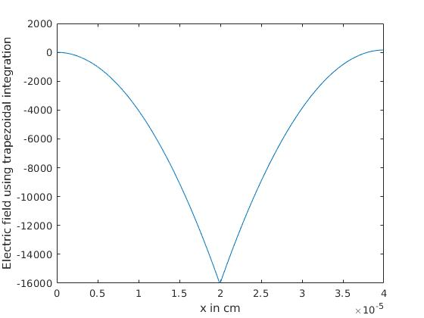
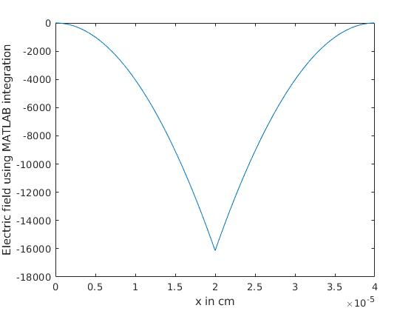
In case (i), numerical and MATLAB integration work similarly.
A slight difference can be seen in case (ii) where electric field doesn’t come out to be exactly zero at x=400nm boundary using the numerical integration technique.

Q1 b) Using central difference discretization scheme, solved the Poisson equation with depletion approximation.

i) Abrupt junction

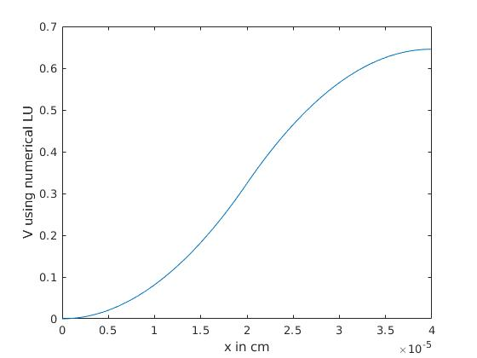
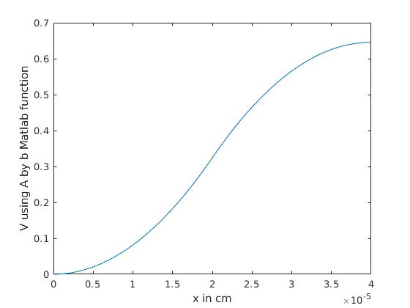
ii) Linearly graded junction

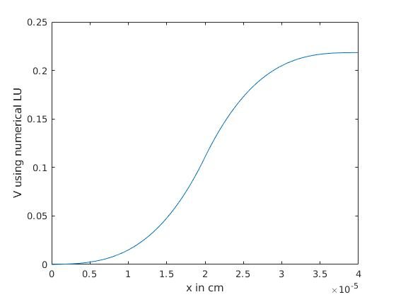
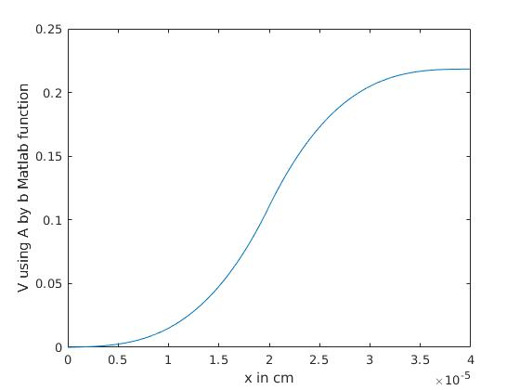
LU decomposition matrices obtained were nearly equal from numerical and MATLAB methods

Q2. Doping concentrations N_{D} = 10¹⁶ cm ⁻³ , N_{A}= 2*10¹⁵ cm ⁻³ . Used Newton Raphson method to solve the charge neutrality equation for finding the fermi energy E_{F}.

Taking E_{V} = 0; E_{D} = E_{C} – 0.045 eV; E_{A} = E_{V} + 0.045eV at 300K
and solving the equation, we obtain E_{F} = 0.8895 eV

