EE 735: ASSIGNMENT 3 REPORT
NAME: DIMPLE KOCHAR
ROLL NO.: 16D070010
Q1. Abrupt

a) Potential (V) b) Electric Field (E)
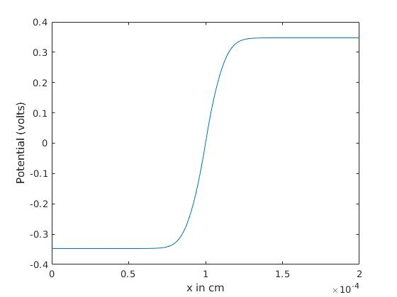
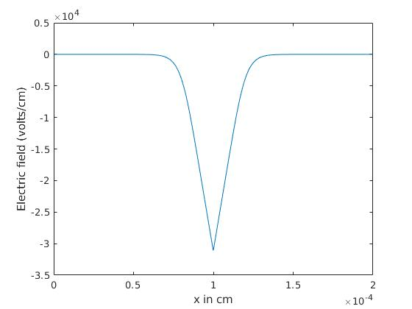
c) Charge concentration (ρ/q) d) Electron (n) concentration
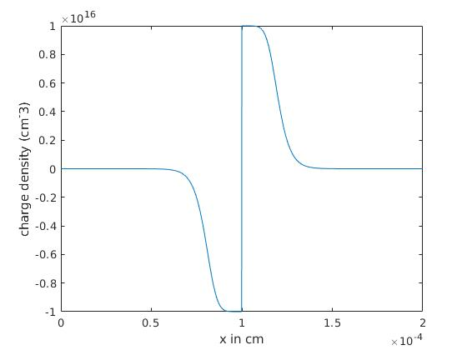
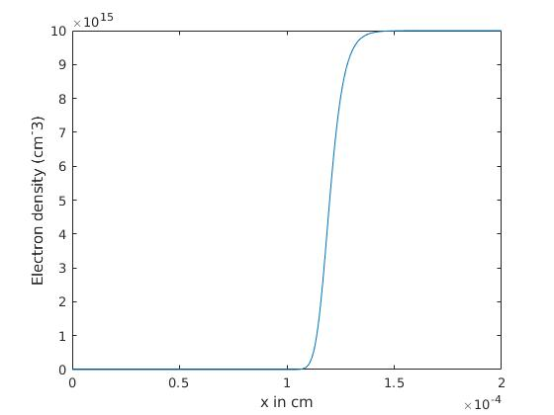
d) Hole (p) concentrations e) Energy band diagram
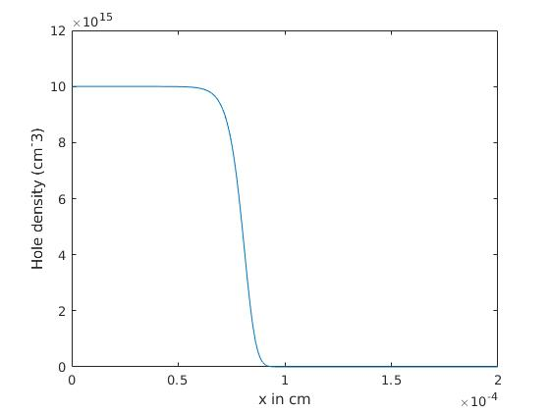
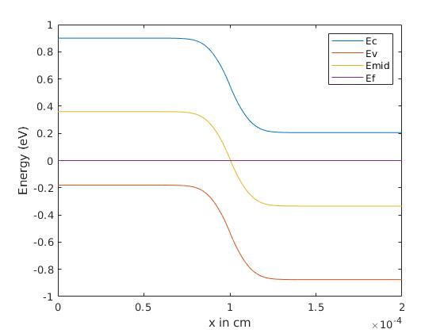

Q1. Linear

a) Potential (V) b) Electric Field (E)
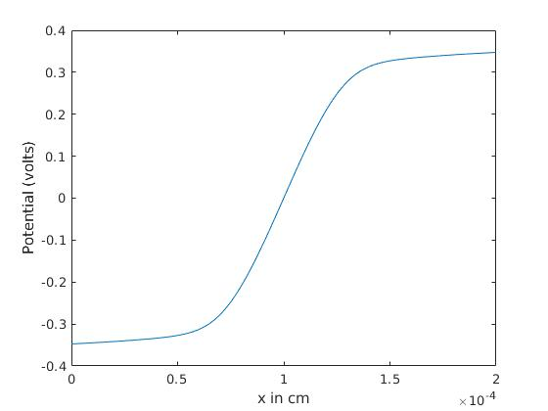
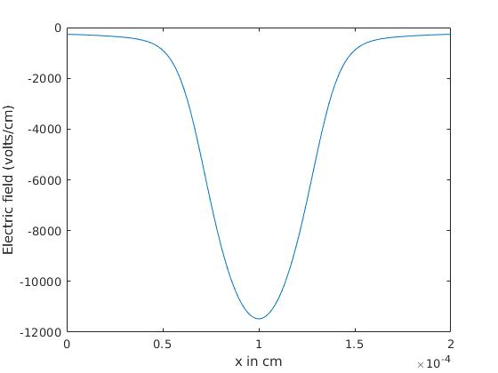
c) Charge concentration (ρ/q) d) Electron (n) concentration
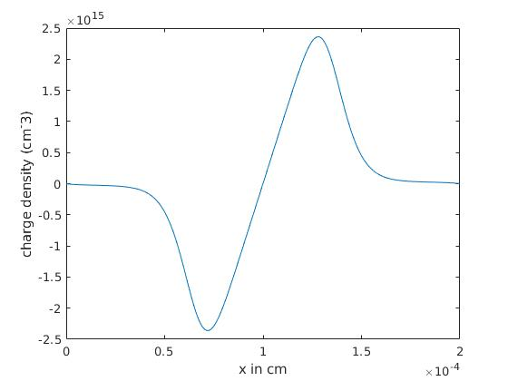
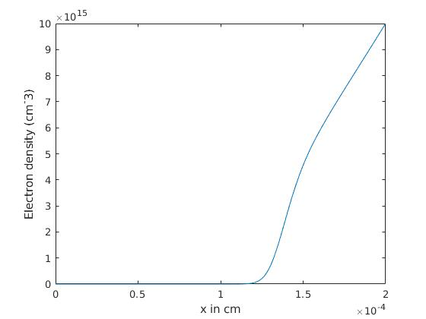
d) Hole (p) concentrations e) Energy band diagram
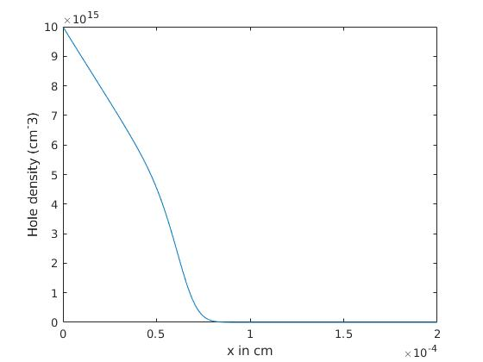
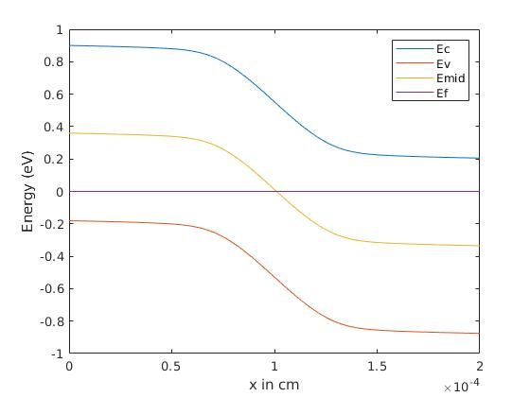

Assignment 2 potential graphs:
Abrupt Linear
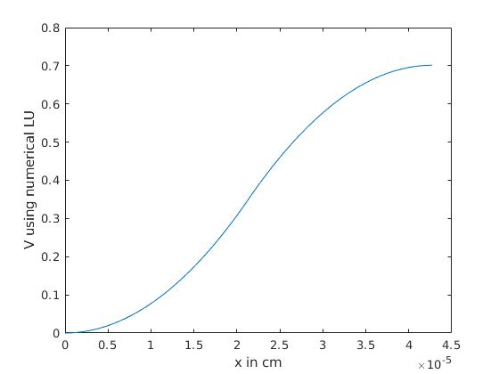
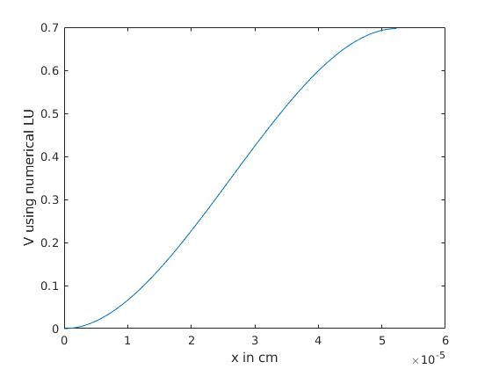
The depletion approximation potential and the numerical one match a lot, with very high accuracy. Higher values of doping make the depletion aproximation to be more accurate.

Q2.
a) Potential (V) b) Electric Field (E)
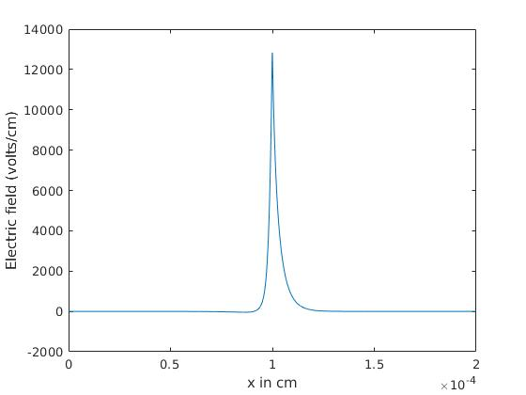
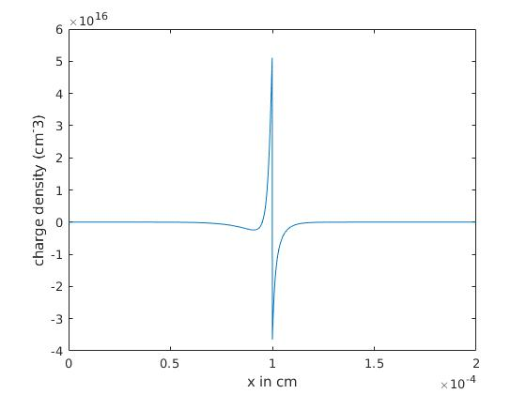
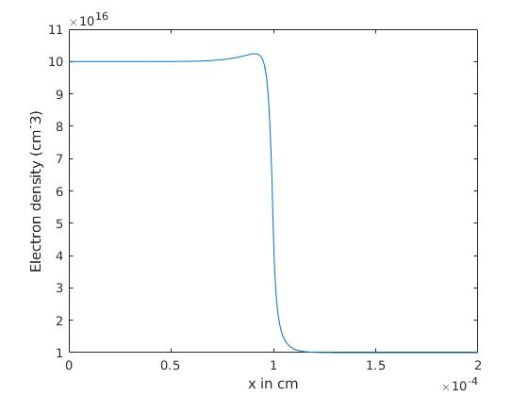
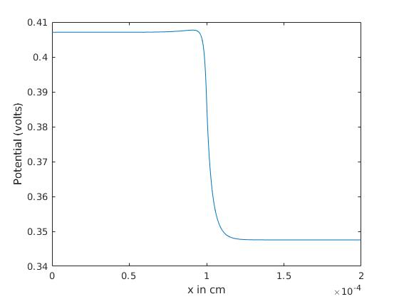
c) Charge concentration (ρ/q) d) Electron (n) concentration
d) Hole (p) concentrations e) Energy band diagram
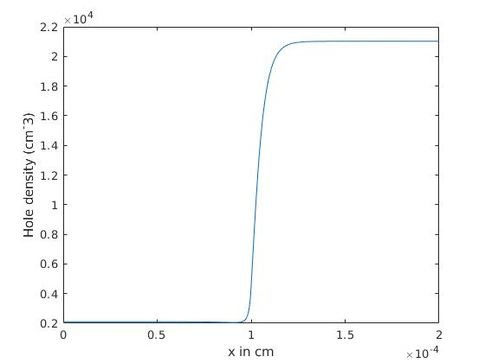
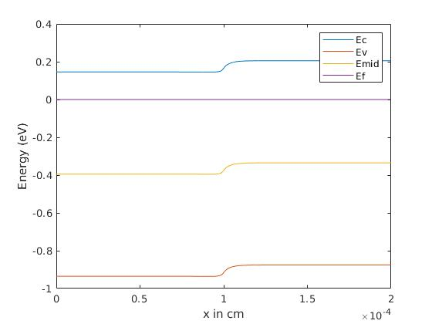
On comparing E vs x to Q1, we find that that Q2 has a sharper (in a small region) positive field which is opposite to the more spread out, negative field in Q1. Also, Q1 field is about 10 times that of Q2 field at the maximum. Electrons will flow from the n+ region and accumulate in the n-type region. However, since the carrier concentration must be continuous, the carrier density in the n-type region is smaller that the doping concentration of the n+ region, and the n+ region is not completely depleted. Hence, a very small voltage drop is seen, and hence the field differences.

Q3. for l_{p} = 10⁻⁶ cm⁻³
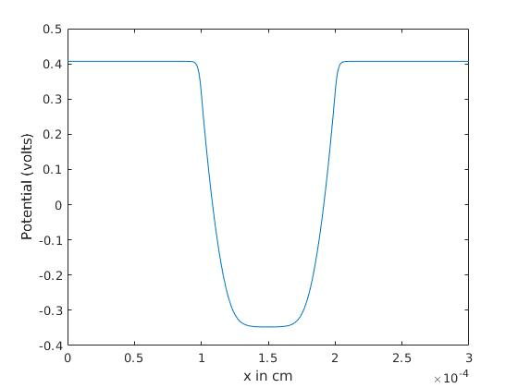
a) Potential (V) b) Electric Field (E)
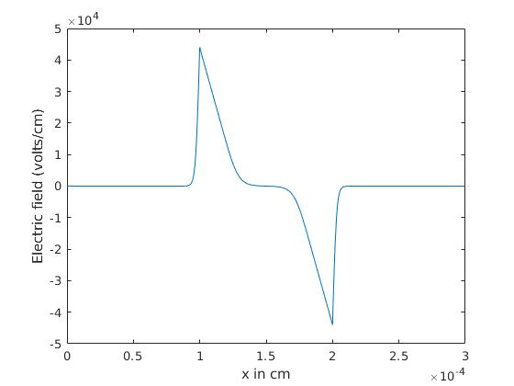

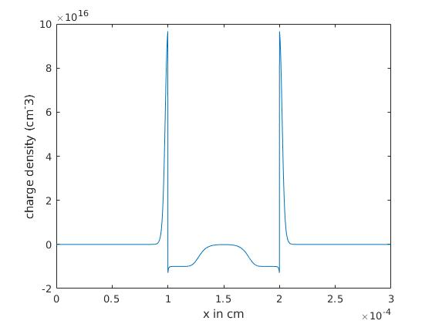
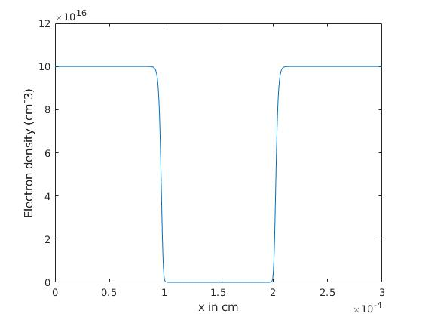
c) Charge concentration (ρ/q) d) Electron (n) concentration
d) Hole (p) concentrations e) Energy band diagram
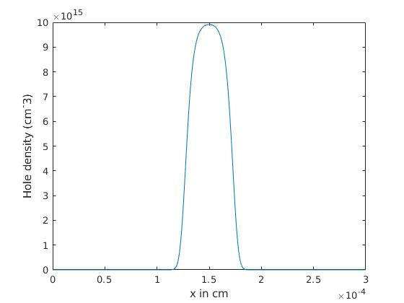
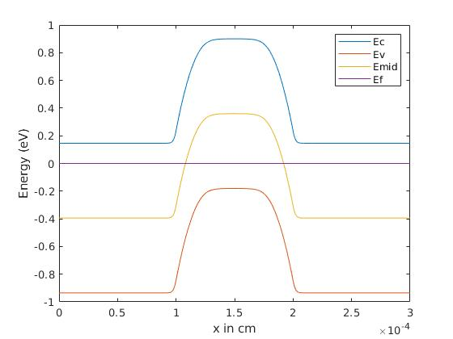
Comparison of potentials for different values of l_{p}
l_{p} = 0.9*10⁻⁶ cm⁻³ l_{p} = 0.8*10⁻⁶ cm⁻³
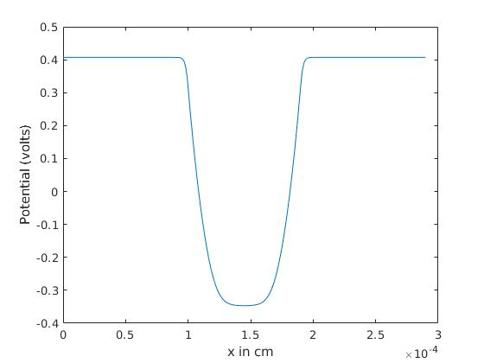
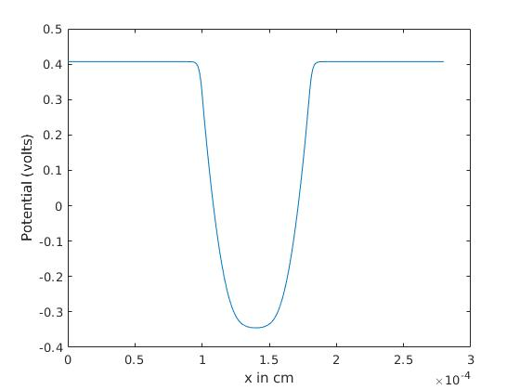
l_{p} = 0.7*10⁻⁶ cm⁻³ l_{p} = 0.6*10⁻⁶ cm⁻³
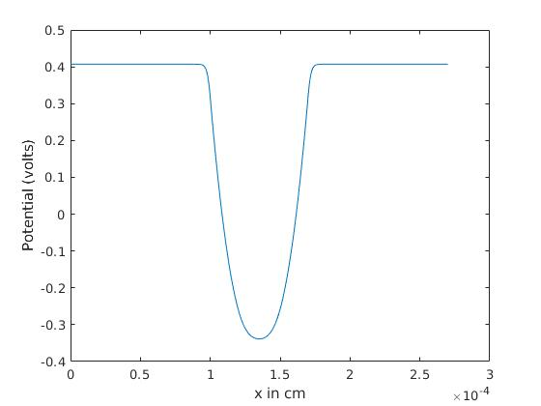
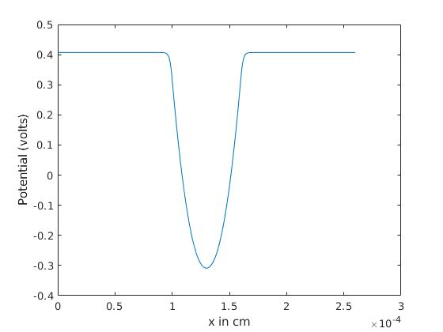
The voltage drop of the p region decrease as the length of p region is decreased.
This is because less the p region, less is the number of holes and hence we see a lower drop due to holes not being able to counter and depletion width becoming less and less.

