EE 735: ASSIGNMENT 4 REPORT
NAME: DIMPLE KOCHAR
ROLL NO.: 16D070010

Note: Analytical solutions of all problems are at end. All concentrations (meaning density) are in cm⁻³ and x is in cm in plots.

Q1 a)
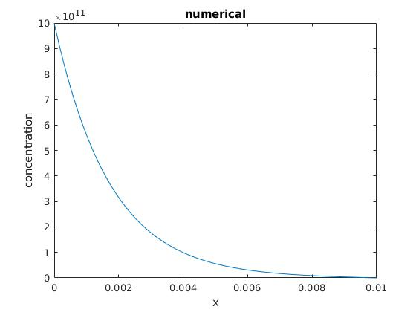
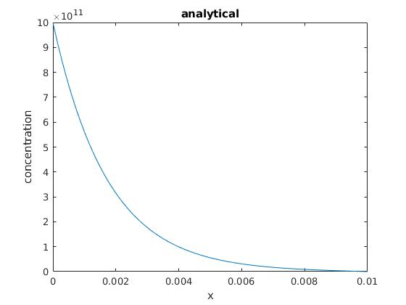

Comparing these two plots by plotting them together, we see that they superimpose each other

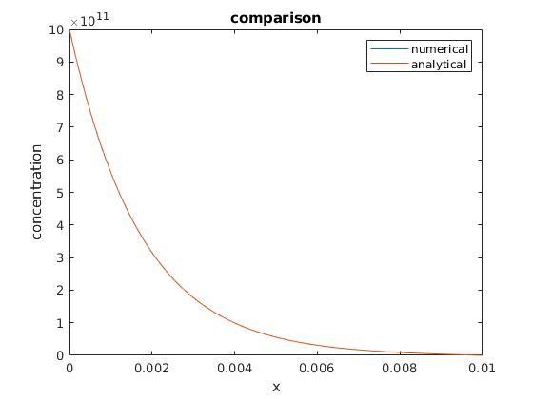

flux at A = -1.72709*10¹⁶
flux at B = -1.07696*10¹⁴
flux from A to B =
flux at B – flux at A =
1.71632*10¹⁶

Q1 b)

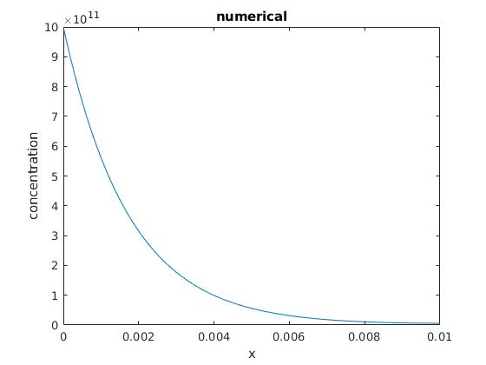
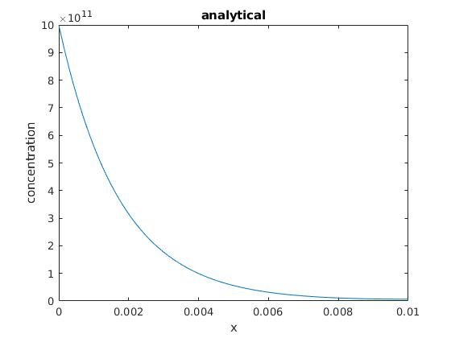
Comparing these two plots by plotting them together, we see that they superimpose each other

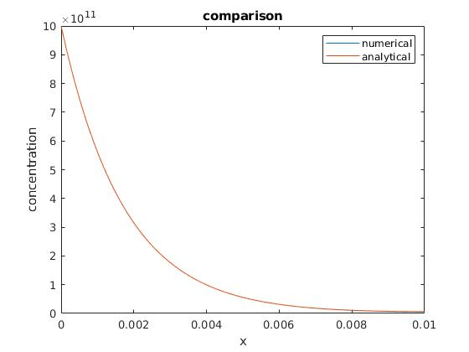

flux at A = -1.7270*10¹⁶
flux at B = -5.8944*10¹²
flux from A to B =
flux at B – flux at A =
1.72643*10¹⁶

Using this boundary results in nearly same flux at A and same flux from A to B. However, flux at B changes due to this boundary condition as outgoing flux becomes a function of density at B.

Q1 c)

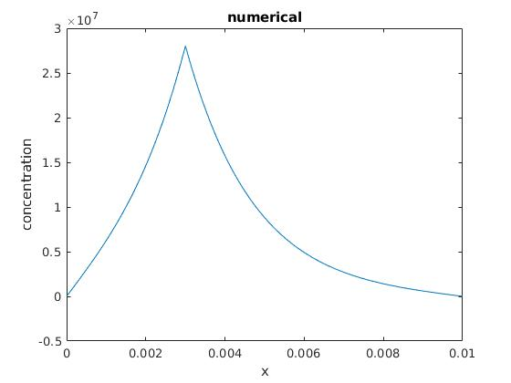
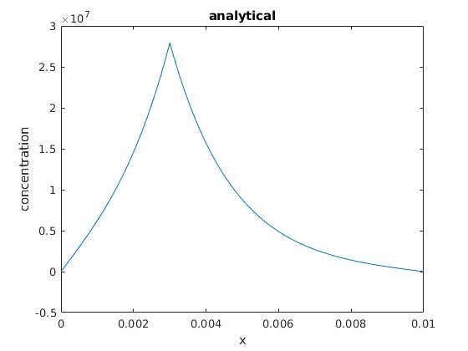
Comparing these two plots by plotting them together, we see that they superimpose each other

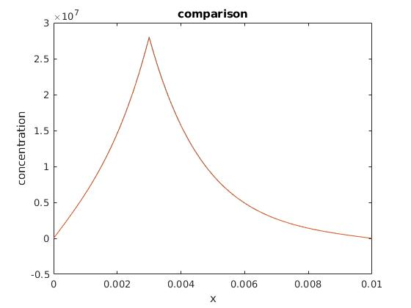
flux at A = 1.7736*10¹¹
flux at B =-1.7067*10¹⁰

Q2
We take N = 1001 gridpoints from x = 0 to 10⁻³ cm. So, h = 10⁻⁶ cm
This gives us p = 5*10⁻⁹ sec
Running for 1000 such time steps, means we run till = 5*10⁻⁶ sec

All 1001 graphs: Zoomed plot:
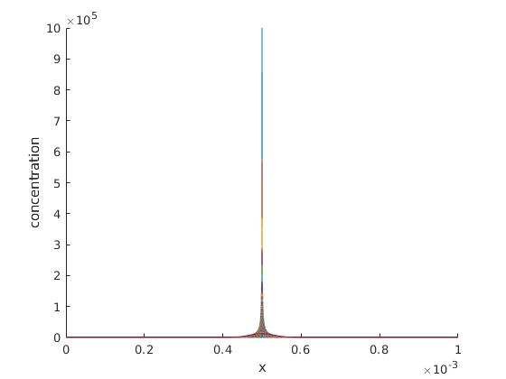
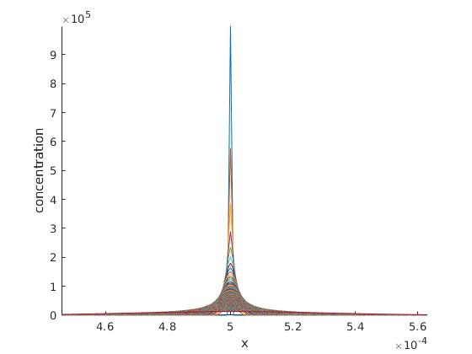
1st 10 plots: plots after 0.25us intervals (21 plots)
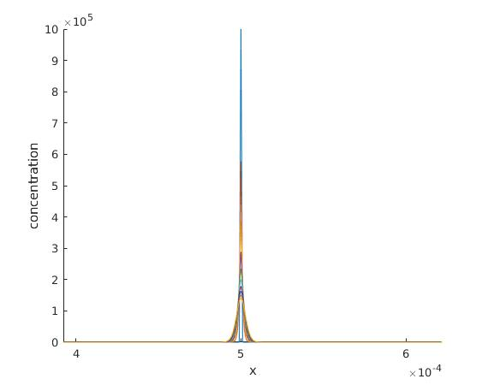
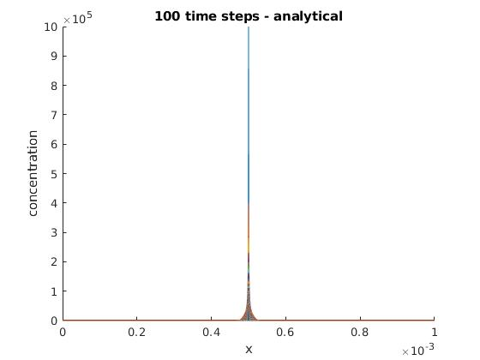
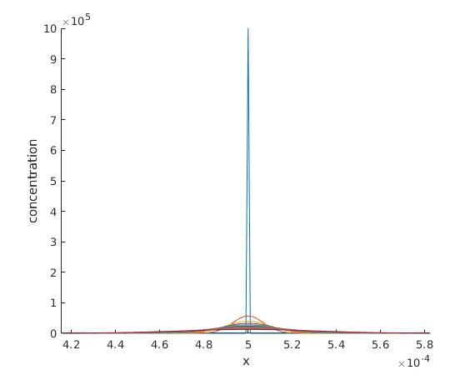
Comparison with analytical:
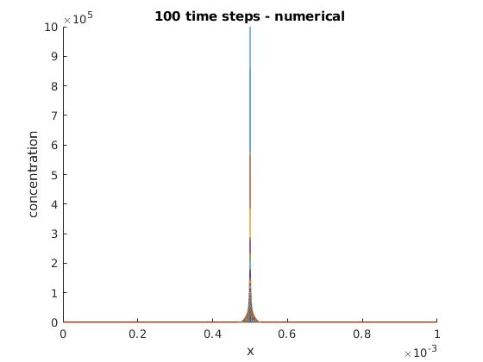

I don’t get exactly matched numbers, but their order is same as that of analytical.

As we see in our analytical solution, we have a gaussian profile with sigma² = 2*D*t, i.e. profile has a variance which is time dependent. As time passes and variance increases, we see the graph has flattened more which is expected due to diffusion. Increasing D too results in faster flattening as compared to this graph.

Q3.

We take N = 101 gridpoints from x = 0 to 10⁻² cm. So, h = 10⁻⁴ cm
This gives us p = 1.6667*10⁻¹⁰ sec
Running for 1000 such time steps, means we run till = 1.6667*10⁻⁷ sec

Plotting all 1001 plots and comparing with analytical:(1st plot all 0-inital)
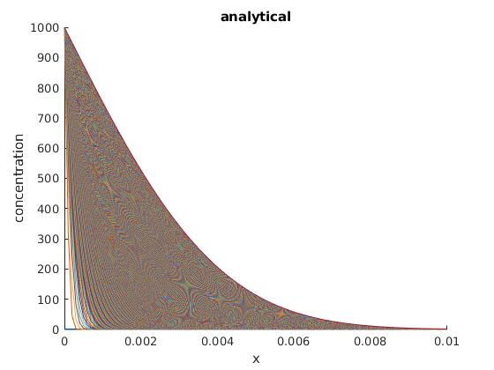
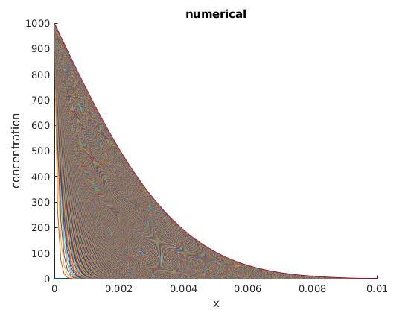
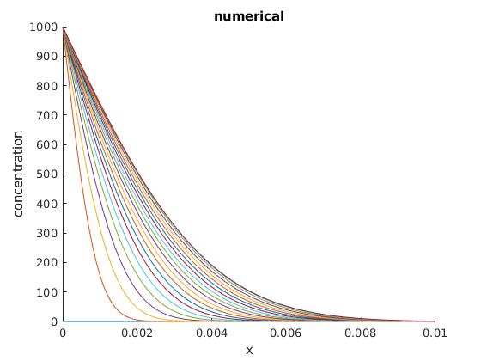
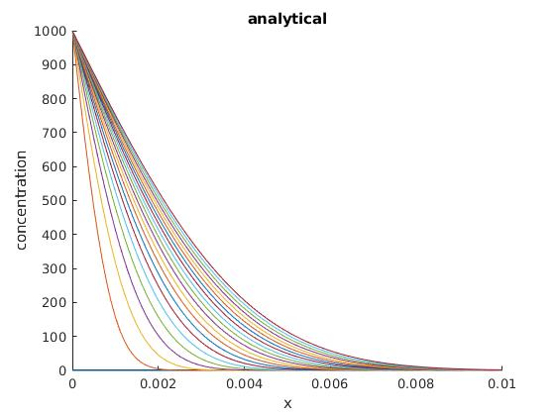
plots after 2.5ms intervals (21 plots) (1st plot all 0-inital)

1st 10 plots:
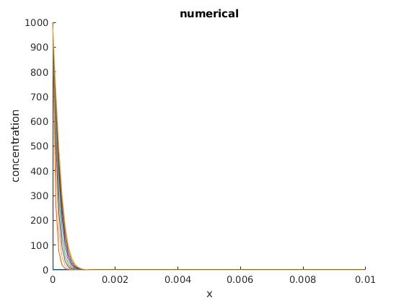
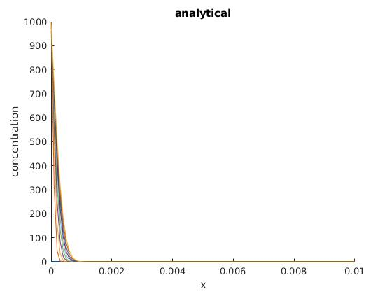
Q4.
Ea = 3.69 eV, D₀ = 10.5 cm²/sec
Keeping neumann boundary conditions at right boundary and keeping left boundary at n=0 (using neumann boundary at left boundary also doesn’t change thermal budget

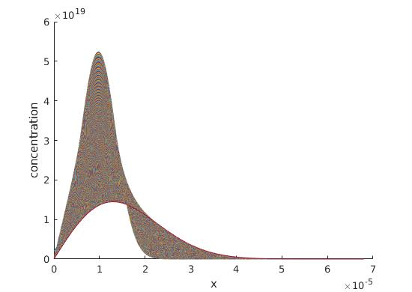
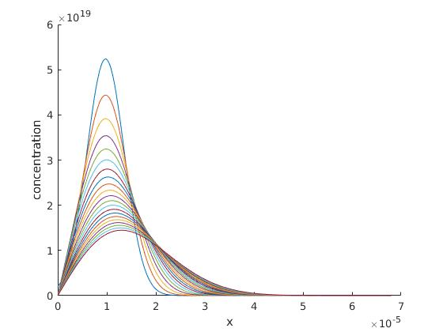
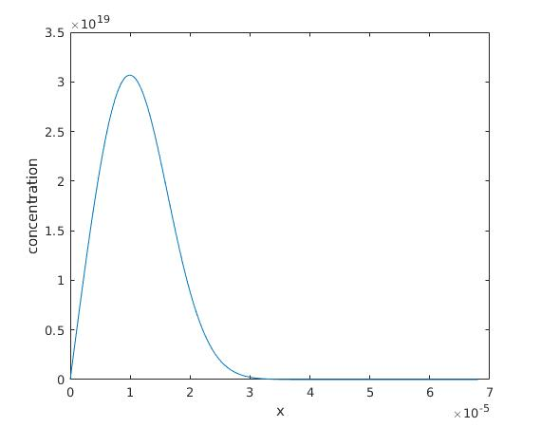
Thermal Budget = 1.36408*10⁻¹¹ cm²

At 1000 degrees celsius, when slope roll off is 40nm/decade at junction depth:

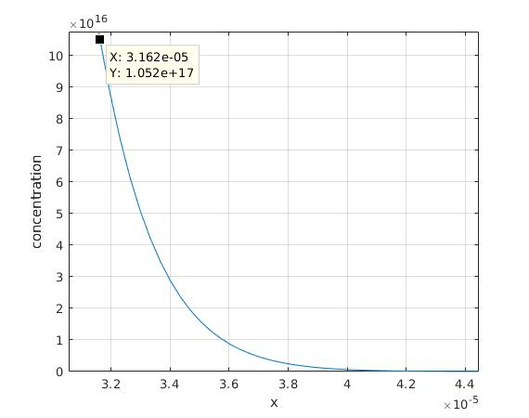
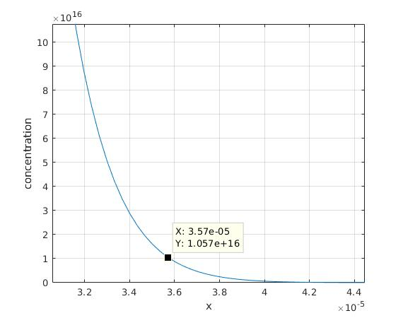
(slight error in answer due to numerical inaccuracies)

time (sec) D (cm²/sec) Temperacture (celsius)
512.0253 2.6641*10⁻¹⁴ 1000
1.4132*10¹² 9.6526*10⁻²⁴ 500
0.0392 3.4804*10⁻¹⁰ 1500

