EE 735: ASSIGNMENT 5 REPORT
NAME: DIMPLE KOCHAR
ROLL NO.: 16D070010
Q1.
Device structure:
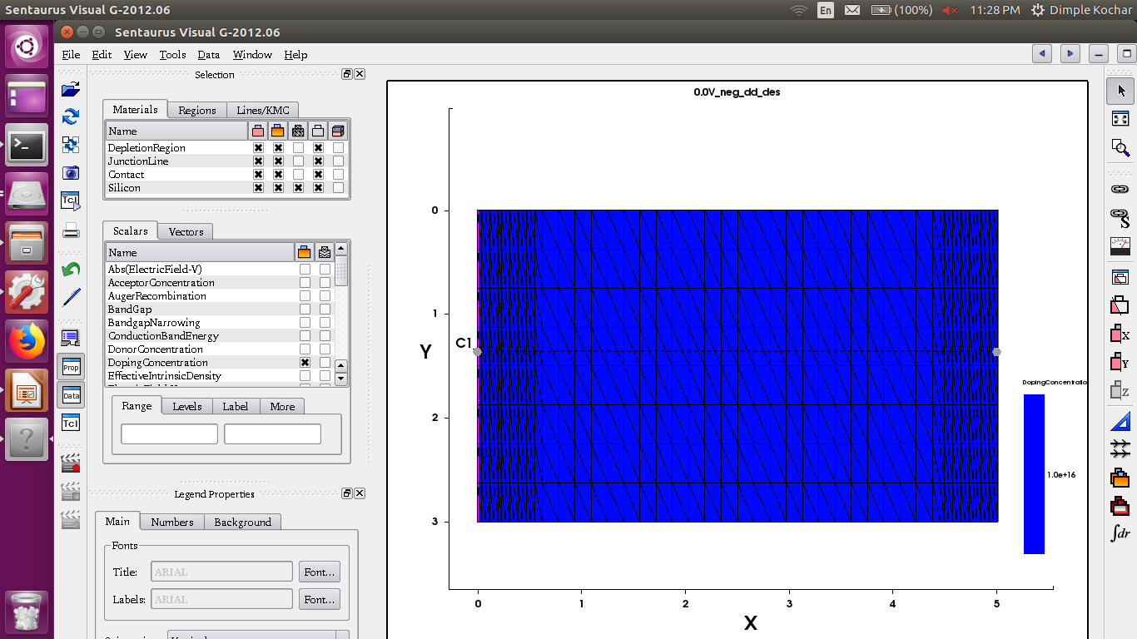
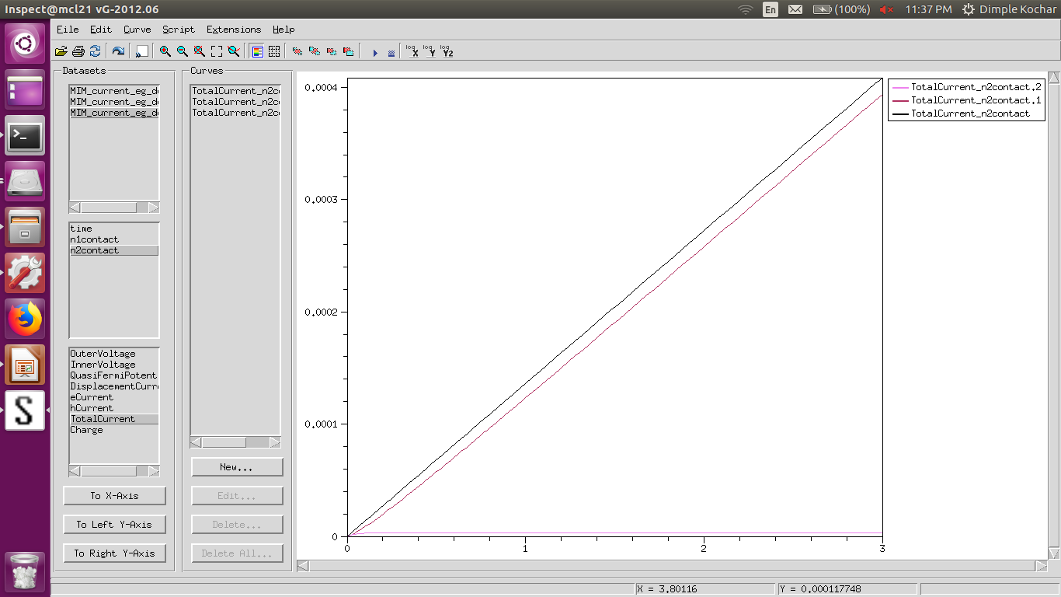

All 3 currents

Q1 a) both contacts are ohmic
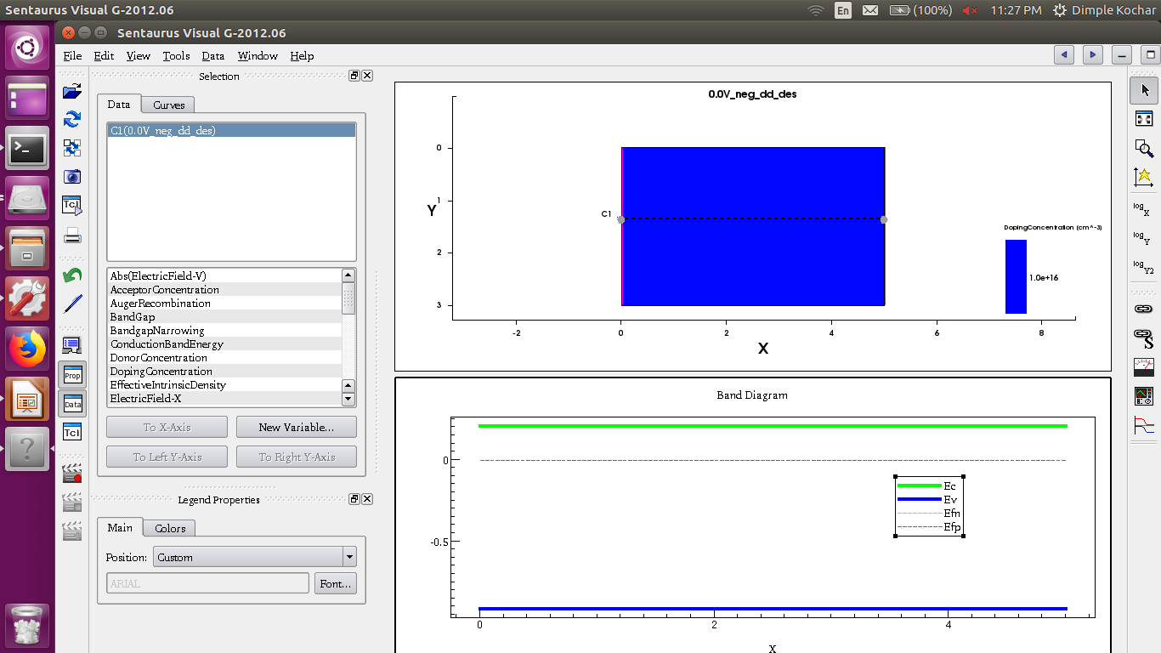
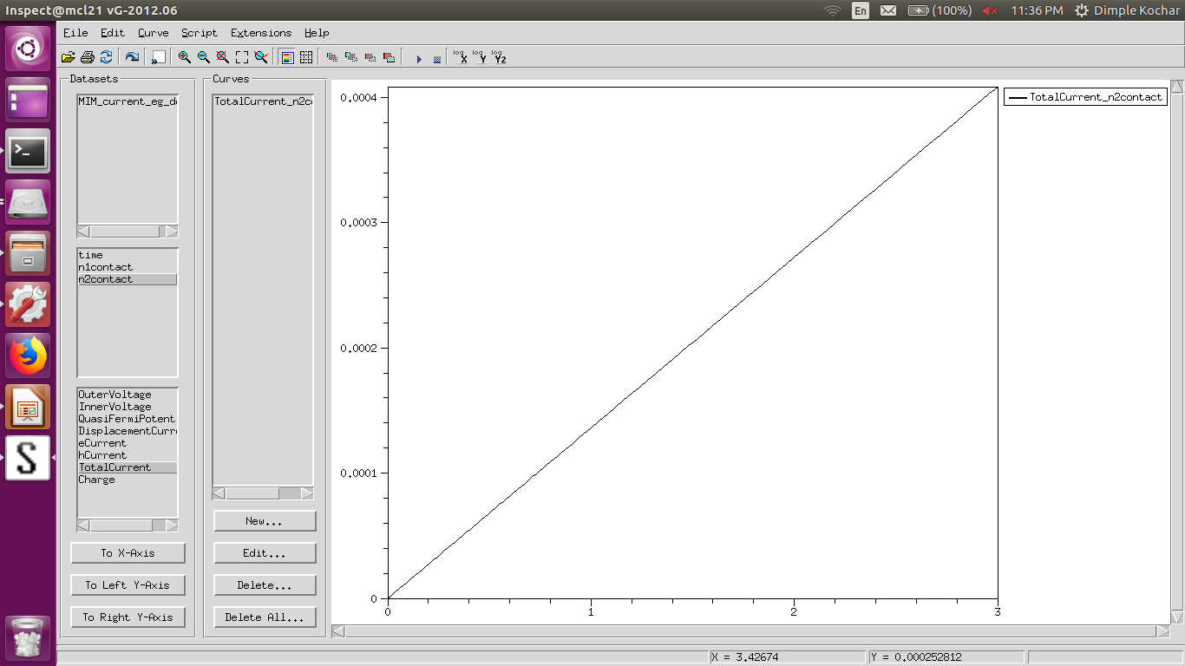

We have a simple bar with two ohmic contacts. Thus, it follows ohm’s laws. Hence, I is proportional to V.

b) left contact is ohmic and right contact is schottky (φ_{B} = 0.3 eV)

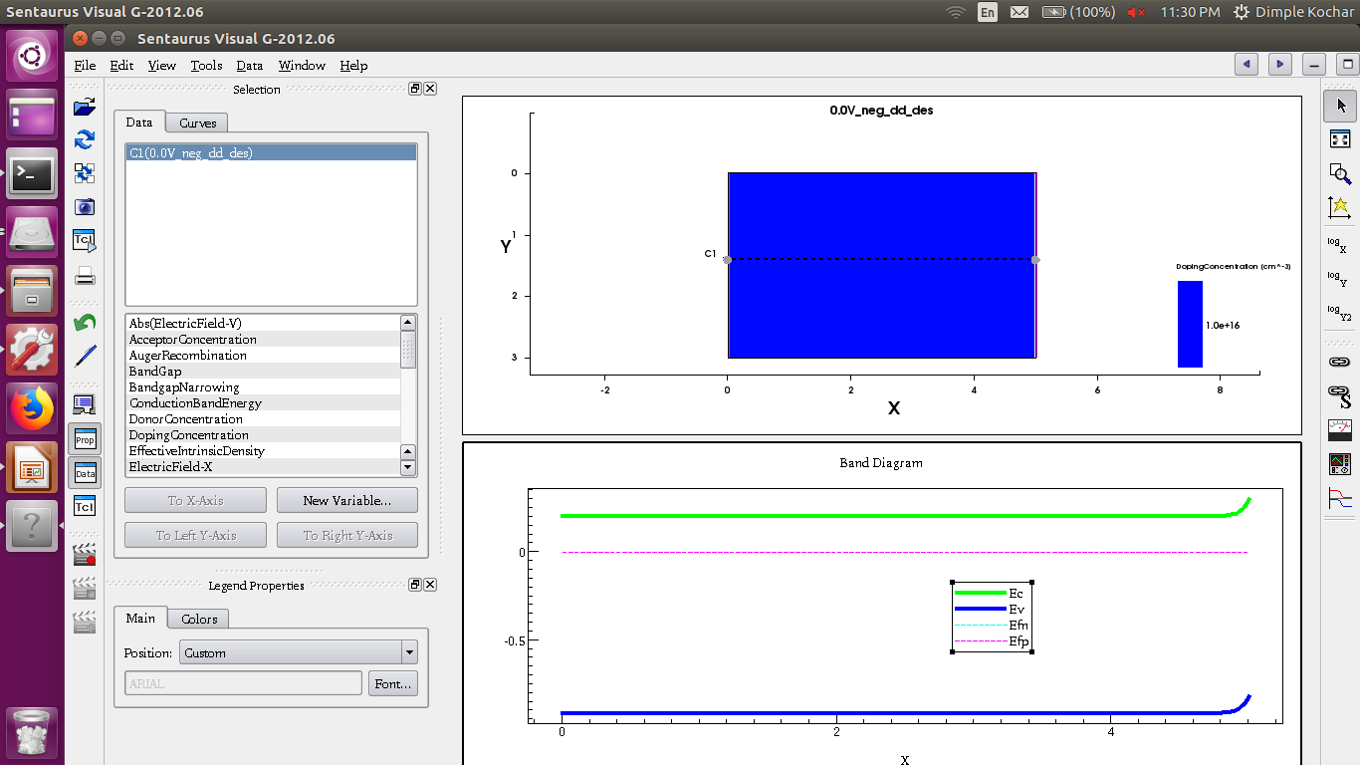
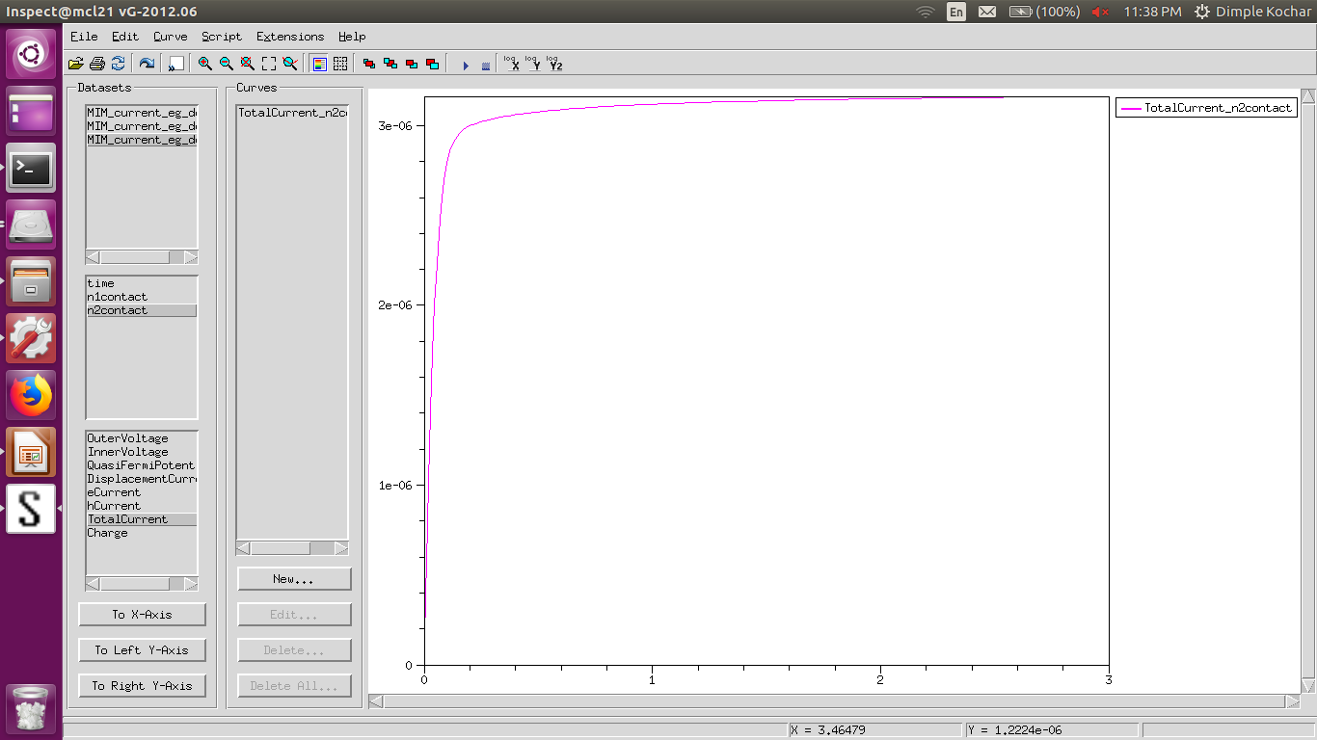
This is basically application of negative voltage at the schottky contact i.e. reverse biasing. Hence, current increases initially and then saturates with increasing voltage.

c) left contact is schottky (φ_{B} = 0.3 eV) and right contact is ohmic

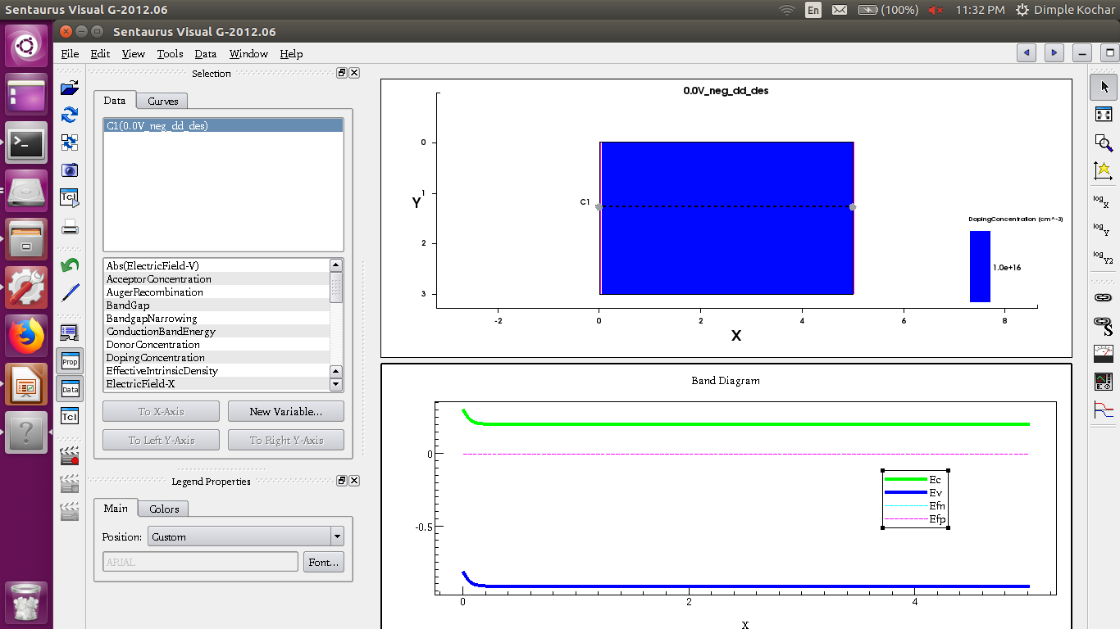

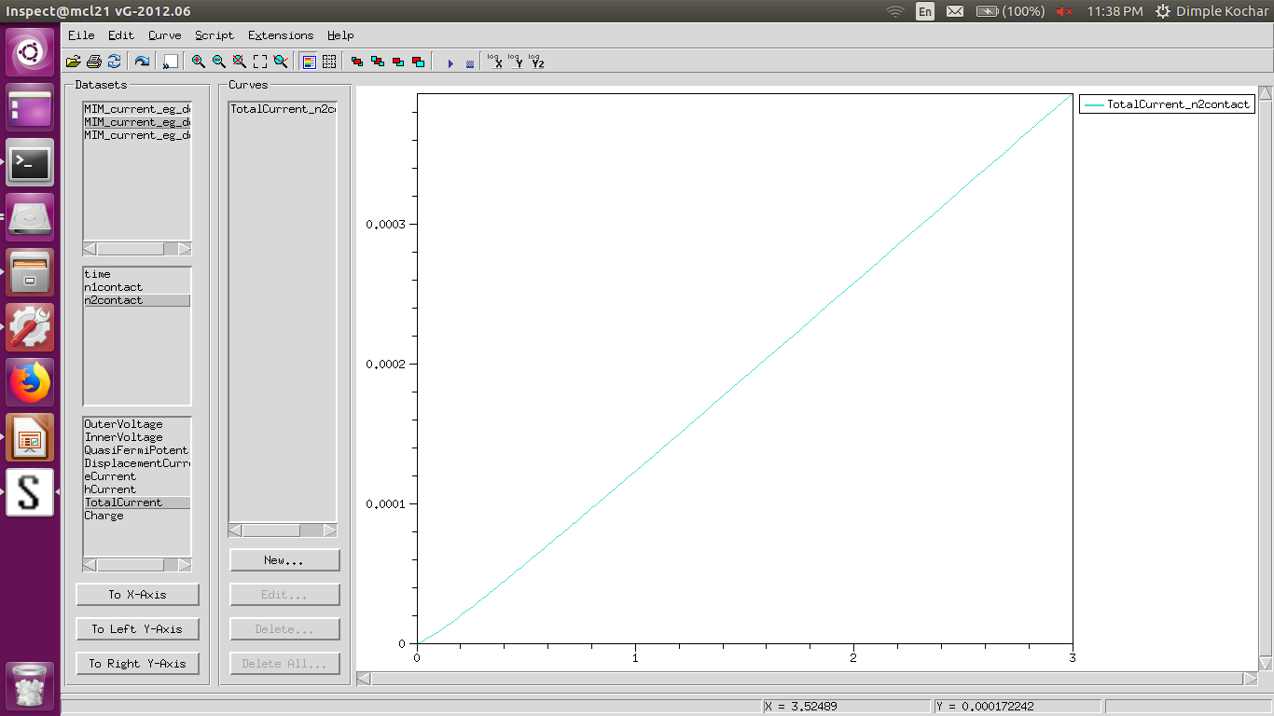

The schottky barrier is under a forward bias as opposed to part (b) where it was in reverse bias. As voltage increases the barrier height decreases. At lower voltages, the IV curve is exponential but as voltage increases the barrier height is very small and hence, it becomes almost like part (a). So we see that the IV curve is increases almost linearly with voltage.

Q2
Device structure:
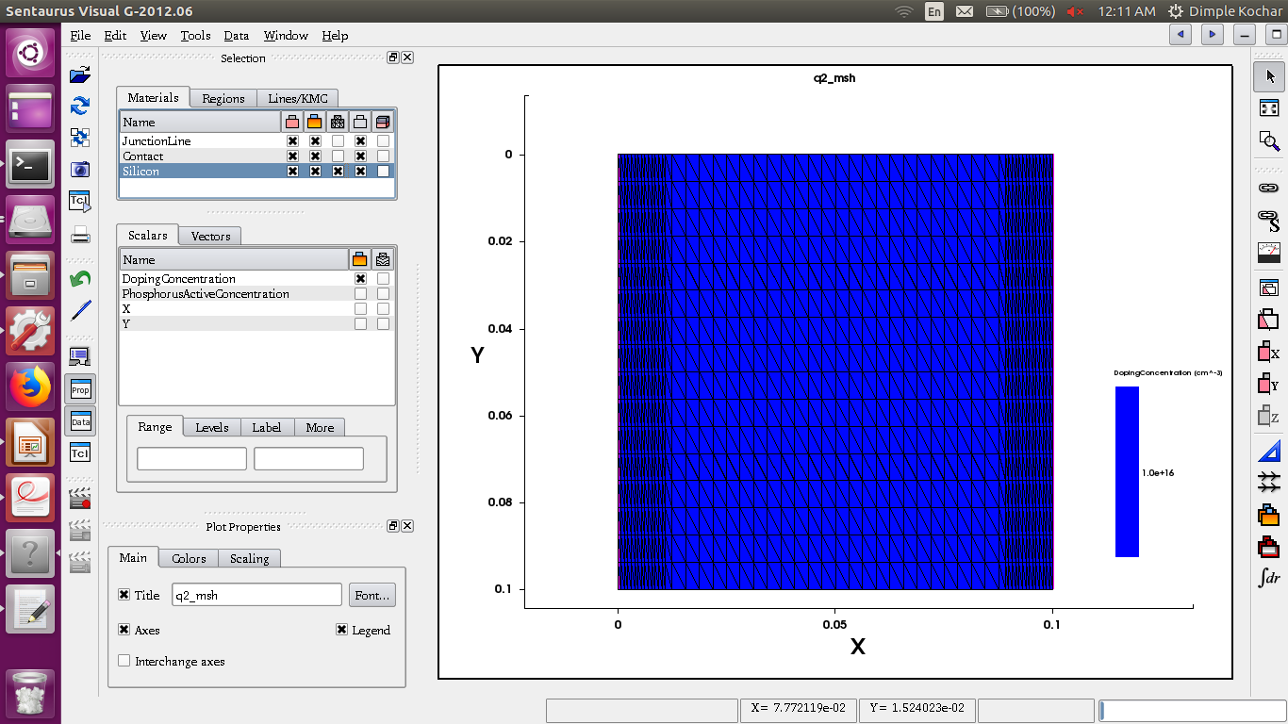
All 3 currents:
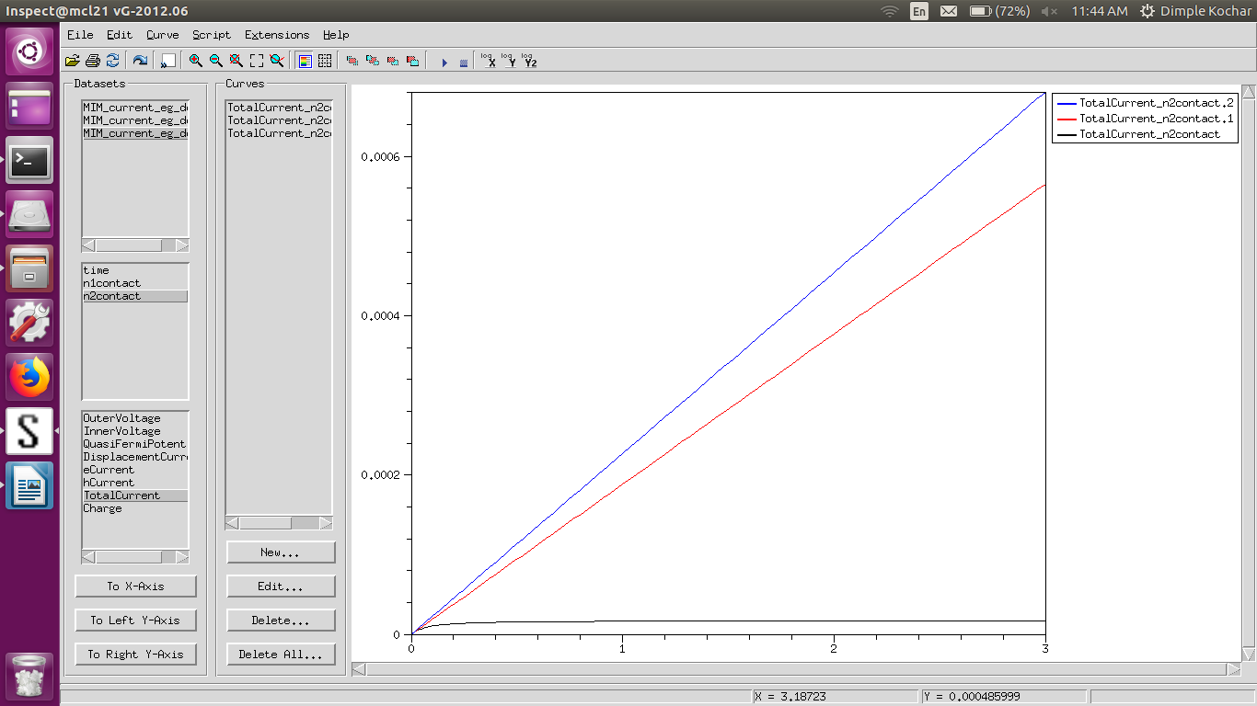

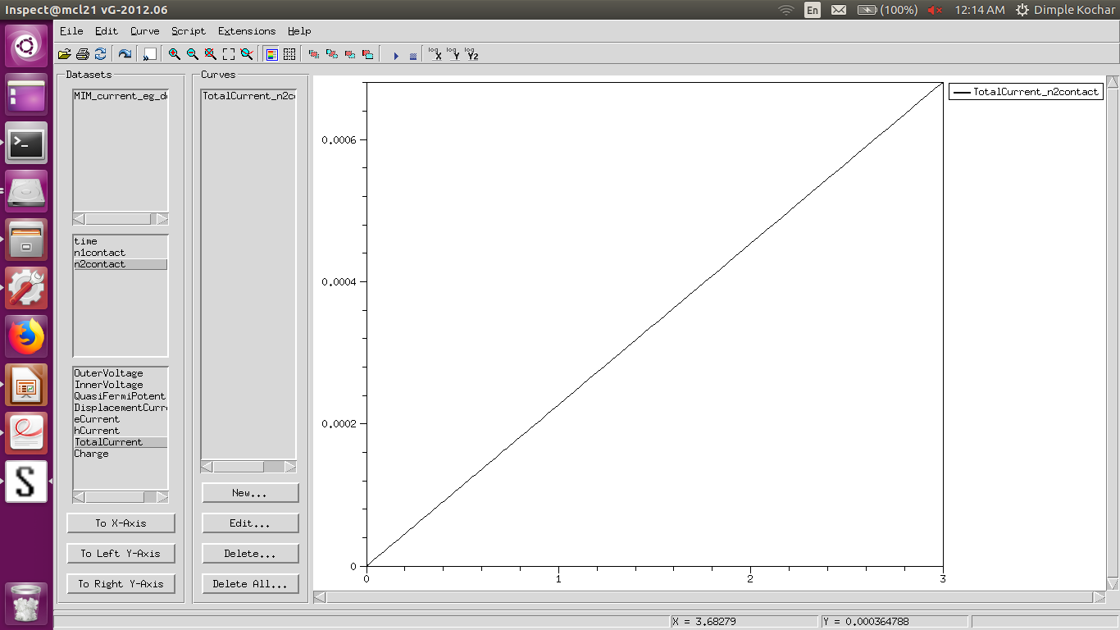
a) constant mobilty

Conductivity is proportional to the product of mobility and carrier concentration. In this model, as mobility is constant, hence conductance is constance. Thus the IV curve is linear.

b) doping dependence
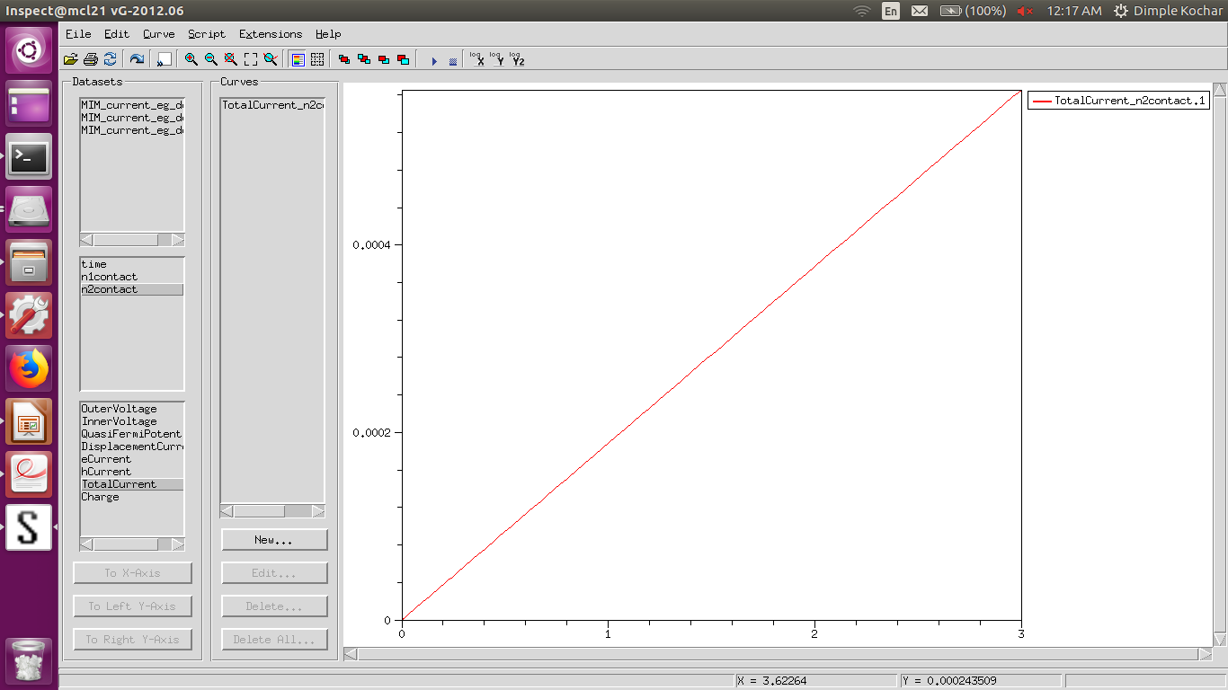
The current magnitude decreases as compared to part (a) but the curve is still linear. This is because conductance decreases as mobility decreases. Mobility decreases when we take doping in account using the relation:
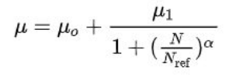

c) high-field saturation
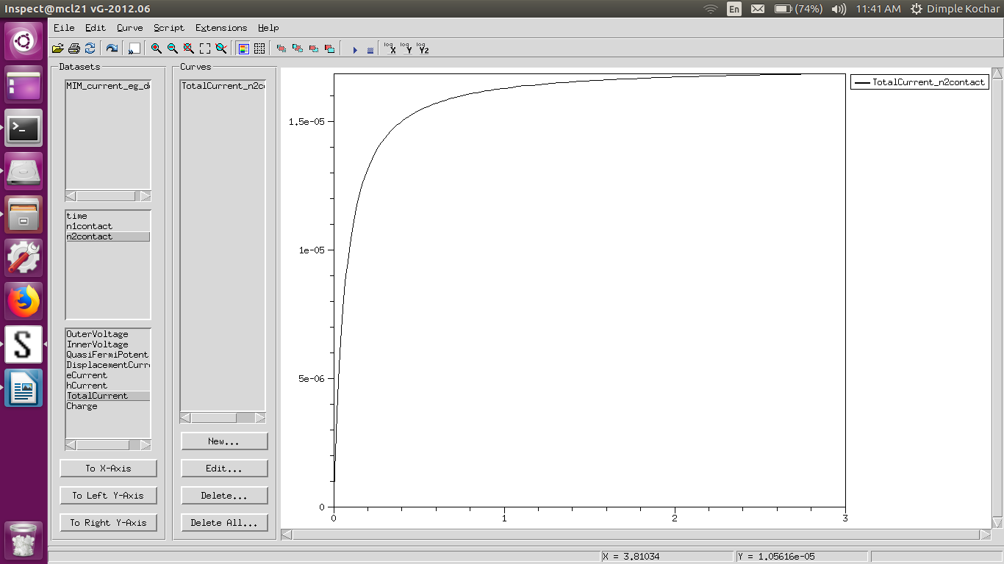
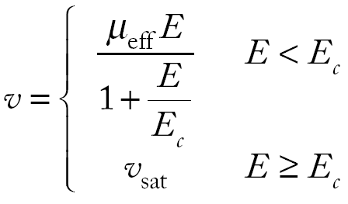

where (approximated relation)

At high electric fields, we therefore see a velocity saturation. As current is directly proportional to drift velocity of electrons, hence it saturates as voltage increases.

Q3)

Device structure:

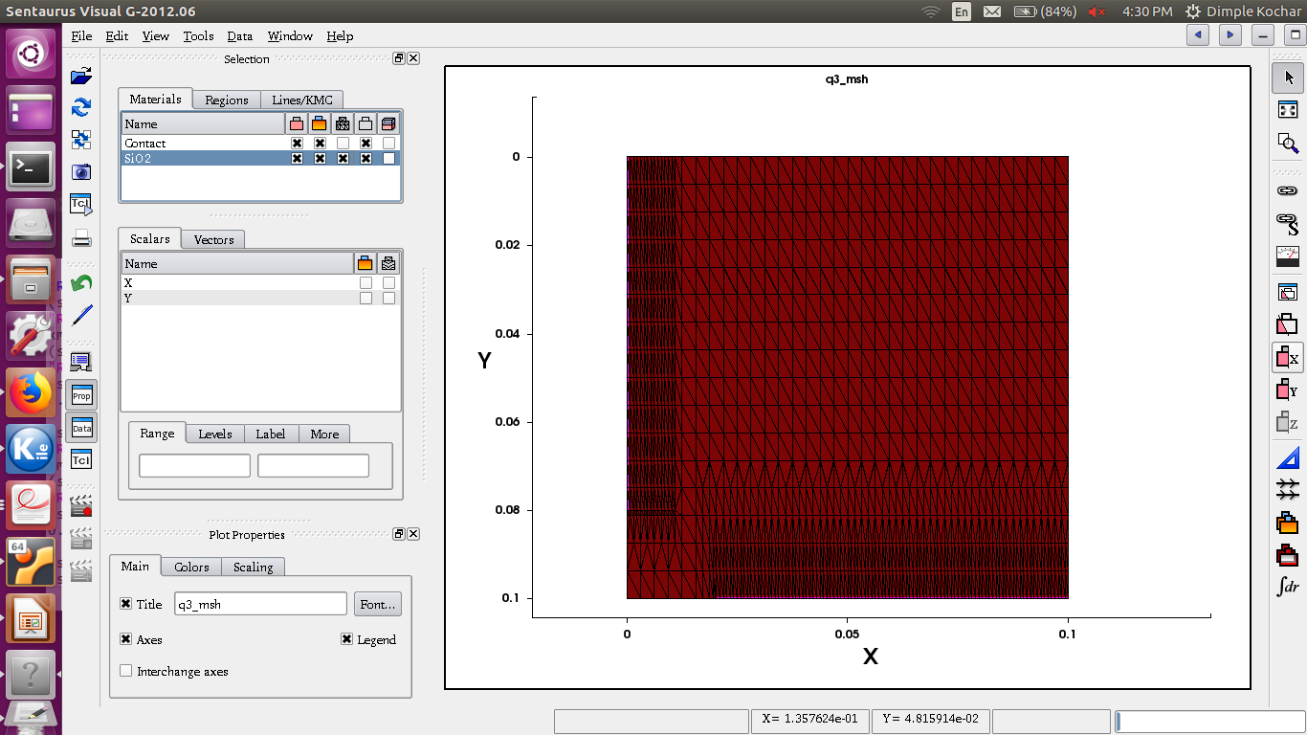
Electric field vector:

By grid scaling:
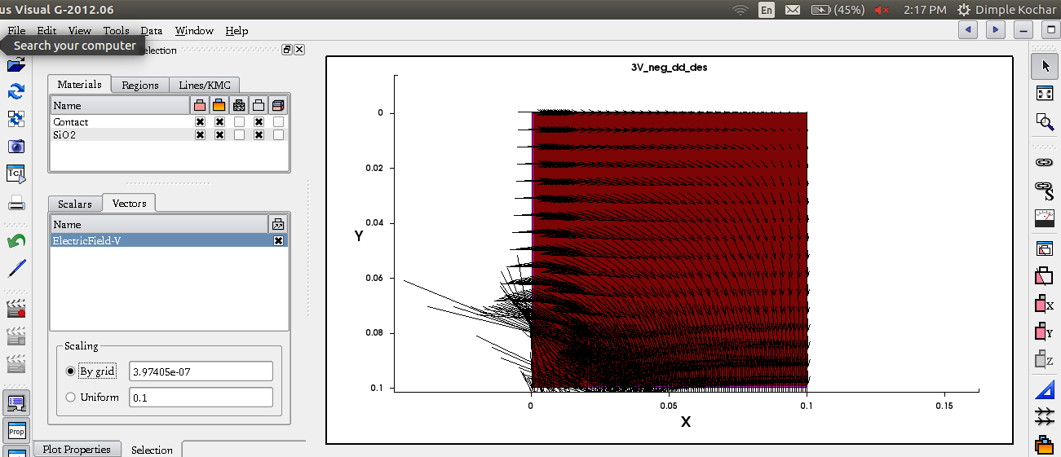

By uniform scaling:

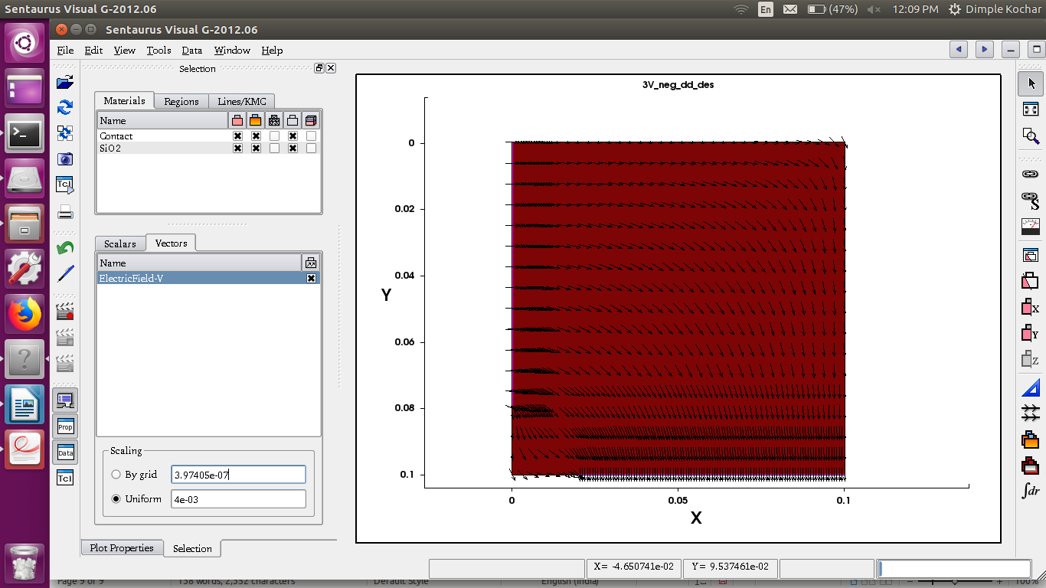

Current:

