EE 735: ASSIGNMENT 6 REPORT
NAME: DIMPLE KOCHAR
ROLL NO.: 16D070010

(Note depletion width and electric field are measured by placing mouse cursor between points where electric field becomes zero and subtracting the coordinates, so values are approximate. However, they do give a comparison)

Q1. (Taking both SRH and Auger recombination)
Device structure:
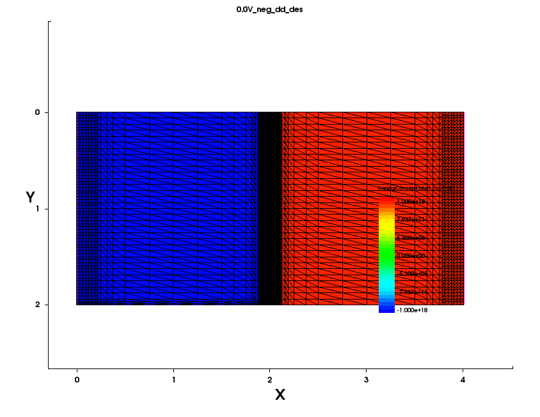
a)
(um)
(um)
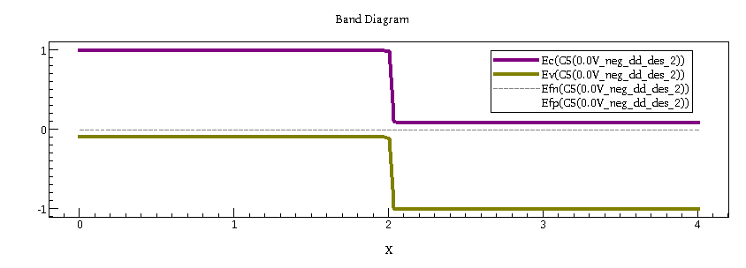
Potential
(eV)
(um)
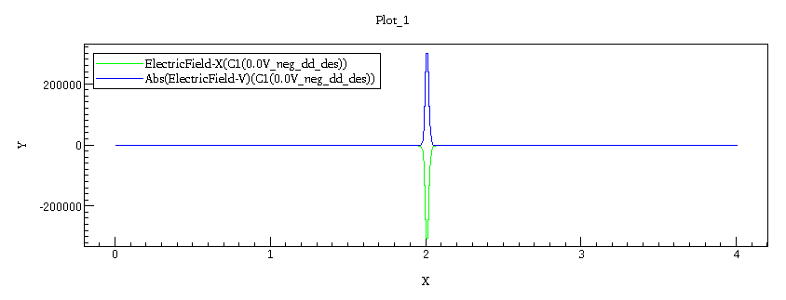
(um)
Electric field
(V/cm)

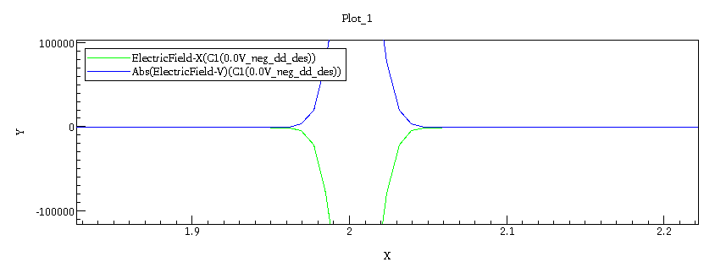
On zooming the electric field plot, we see
(um)
Electric field
(V/cm)
Depletion Width of around 0.086 um

b)
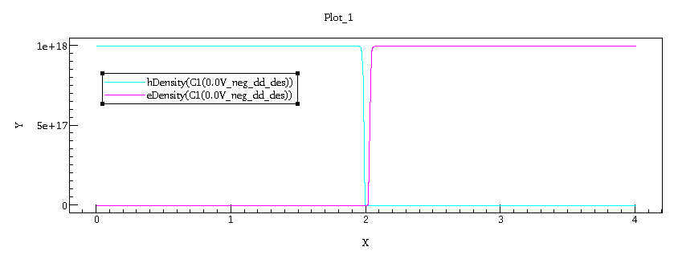
(um)
Q2.
Density (cm⁻³)
a)
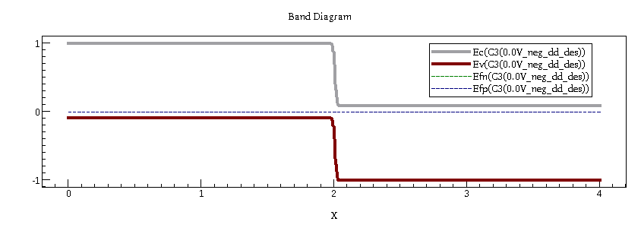
0V
Potential (eV)
(um)

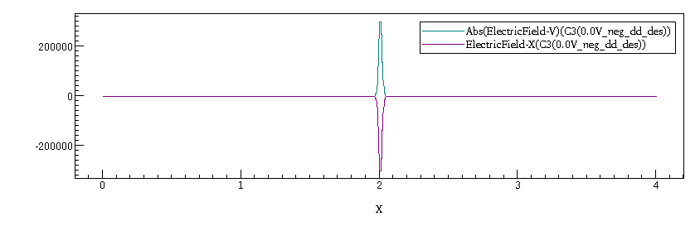
(um)
Electric field
(V/cm)
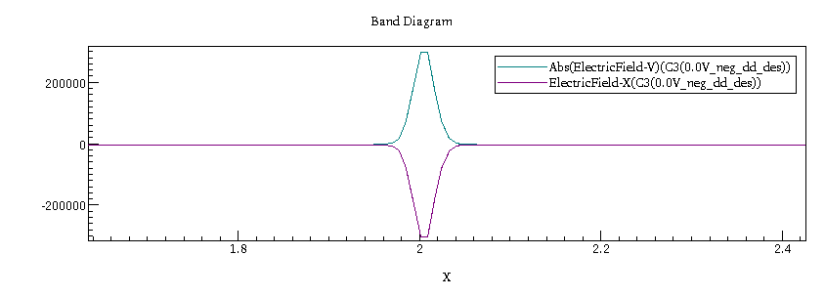
On zooming,
On zooming the electric field plot, we see
(um)
Electric field
(V/cm)
Depletion Width of around 0.11535 um
Max electric field = 3*10⁵ V/cm

-5V – Reverse bias
Potential (eV)

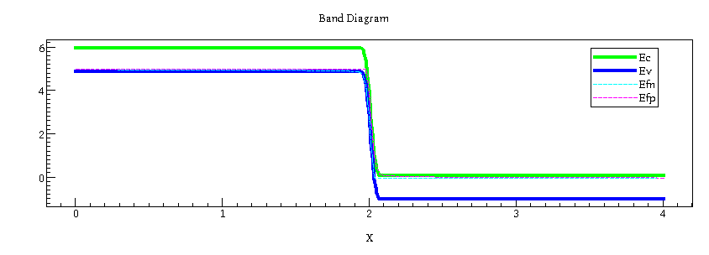

(um)
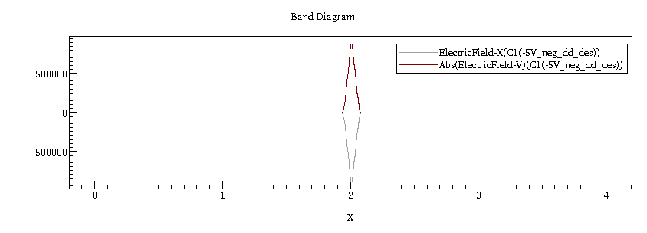
(um)
Electric field
(V/cm)

On zooming the electric field plot, we see
Depletion Width of around 0.1569 um
Max Electric Field = 9*10⁵ V/cm
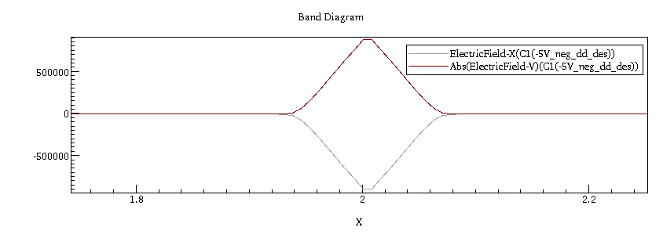
(um)
Electric field
(V/cm)

0.5V – Forward bias
Potential (eV)
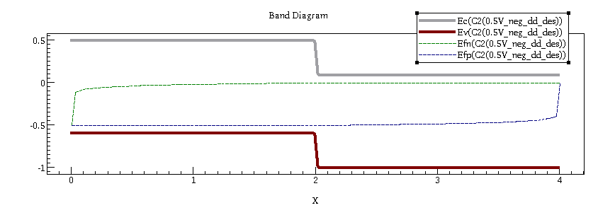
(um)

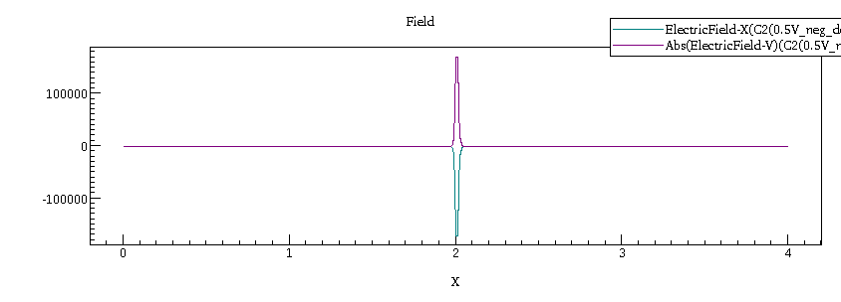
(um)
Electric field
(V/cm)
Electric field
(V/cm)
Electric field
(V/cm)

On zooming the electric field plot, we see
Depletion Width of around 0.0955 um
Max Electric Field = 1.8*10⁵ V/cm

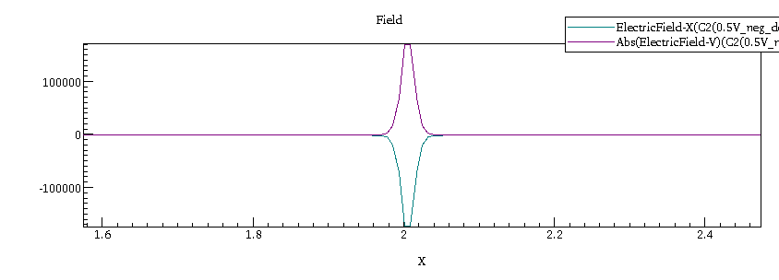
Depletion width and electric field both decreases as we go from reverse bias (-5V), to unbiased (0V) to forward bias (0.5V). When we apply a negative voltage, it results in the free charge being pulled away from the junction resulting in the depletion layer width being increased. Also, as direction of applied voltage is the same as that of the potential barrier, the potential drop across the junction increases. As a result, magnitude of electric field increases. The diffusion of holes and electrons across the junction decreases. Hence, depletion layer becomes thick. On the other side, forward bias voltage opposes the barrier voltage, hence the potential drop across the junction decreases. As a result, magnitude of electric field decreases. So, the diffusion of holes and electrons across the junction increases. Hence, the depletion width decreases.
(um)
Electric field
(V/cm)

b)
Linear scale: Log scale:
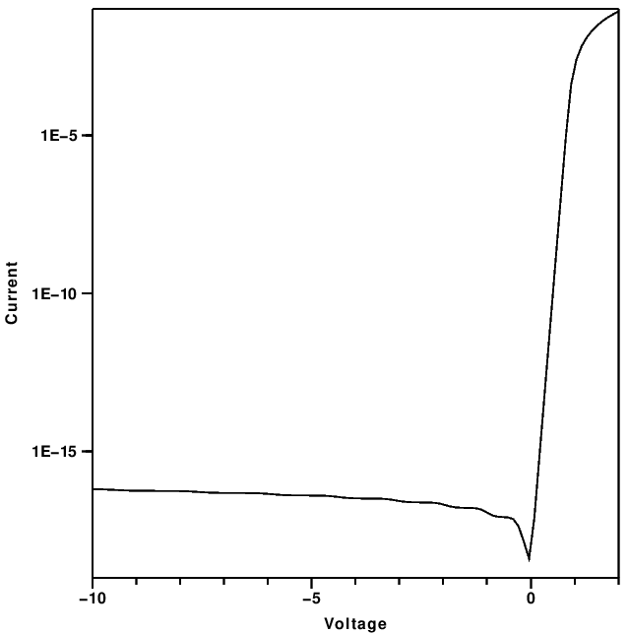
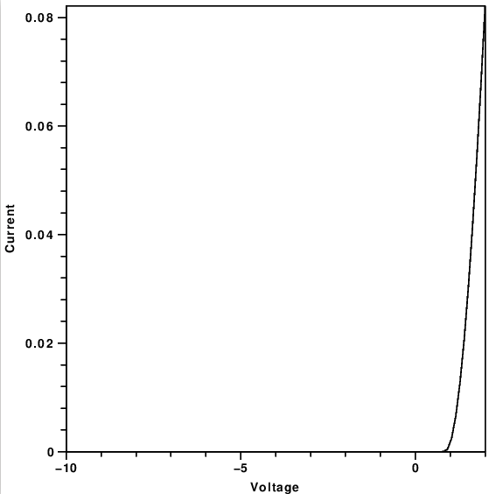

(A)
(A)

(V)
(V)

Reverse bias : -10V to 0V
As direction of applied voltage is the same as that of the potential barrier, the potential drop across the junction increases. So, the number of electrons that have enough energy to overcome the barrier reduces, hence current reduces and after a certain voltage it saturates. This saturation current is caused by diffusion of minority carriers (electrons from p-side to n-side and holes from n-side to p-side).
Forward bias : 0V to 0.5V As direction of applied voltage is opposite as that of the potential barrier, the potential drop across the junction deccreases. Hence, more electrons cross the barrier so current increases exponentially.

Q3
a)
1.
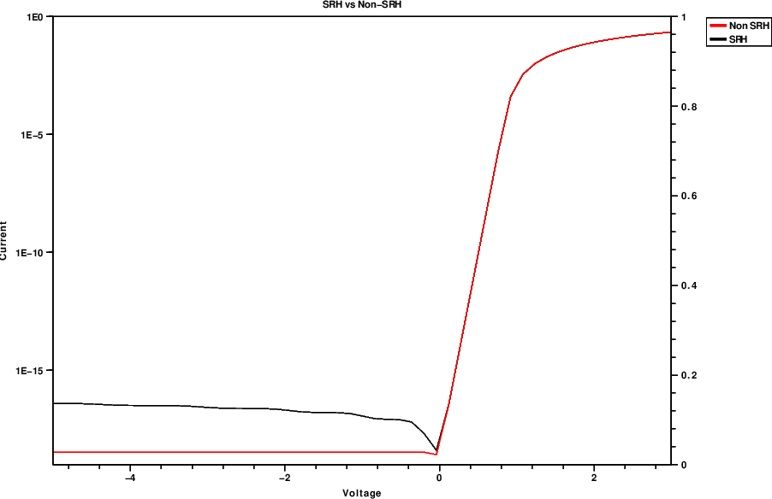
(A)
(V)

If we don’t have SRH recombination, we see almost zero curent as opposed to a small current which saturates as voltage increases qhen we have SRH recombination. This current is due to trap-assisted recombination in the depletion region. This current is fed by diffusion of minority carriers toward junction (supplied by thermal generation). Intuitively, the reverse saturation current is caused by thermally generated electron-hole pairs. As soon as the pair is created, the electric field in the depletion region separates the pair and the pair becomes the reverse bias current.

2.
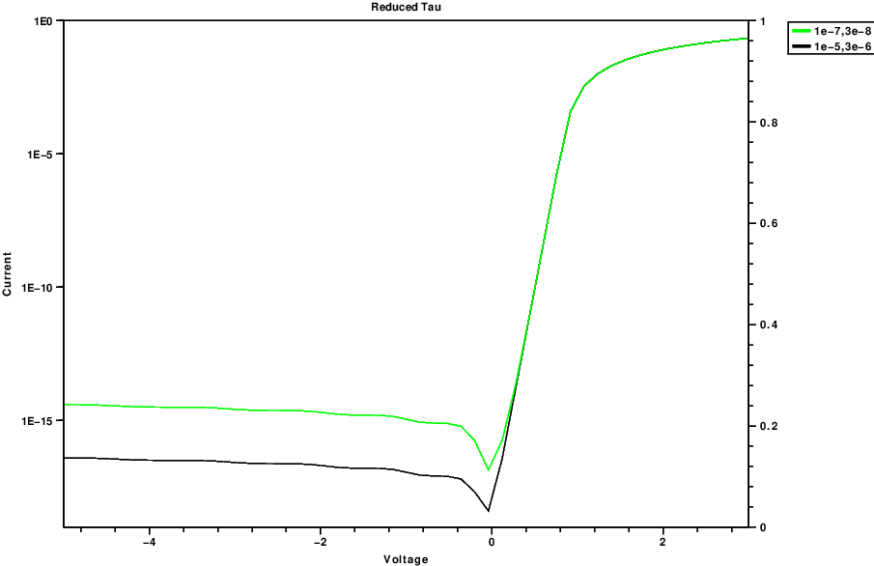

On decreasing the carrier lifetime, we see an increase in the current at reverse bias. This is because reverse bias current is due to minority carrier recombination (as explained above), and lesser the time constant (taumax) more the rate of recombination, and thus more current.

3.
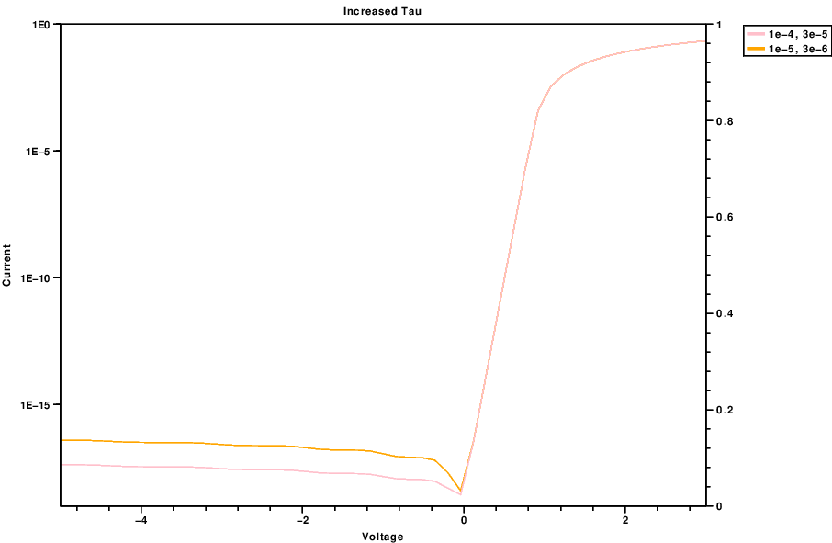

On increasing the carrier lifetime, we see a decrease in the current at reverse bias. This is because reverse bias current is due to minority carrier recombination (as explained above), and more the time constant (taumax) less the rate of recombination, and thus less current.

b)
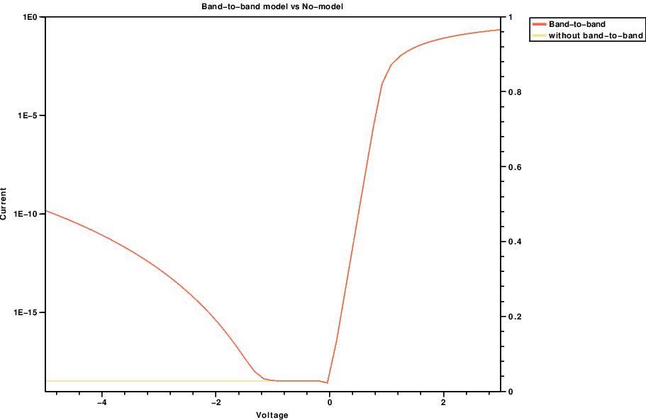
1.

If we don’t have band-to-band recombination, we see almost zero curent as opposed to a small current when we have band to band recombination. This current is due to trap-assisted recombination in the depletion region. This current is fed by diffusion of minority carriers toward junction (supplied by thermal generation). Intuitively, the reverse saturation current is caused by thermally generated electron-hole pairs. As soon as the pair is created, the electric field in the depletion region separates the pair and the pair becomes the reverse bias current.

2. Schenk model
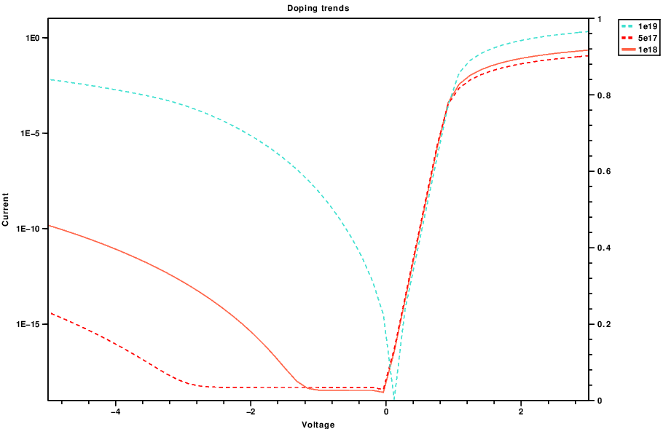
3.

The process of carrier recombination is directly proportional to the amount of available electrons and holes.
The recombination/generation current due to band-to-band recombination/generation is obtained by integrating the net recombination rate U_{b-b} given by b(np-n_{i}²). The carrier densities increase due to doping and hence we see a larger reverse bias current for higher doping densities.

