EE 735: ASSIGNMENT 7 REPORT
NAME: DIMPLE KOCHAR
ROLL NO.: 16D070010
A.
Q1.
a) implant energy (use 10, 20 and 40keV)
Dose = 5e14 cm⁻³
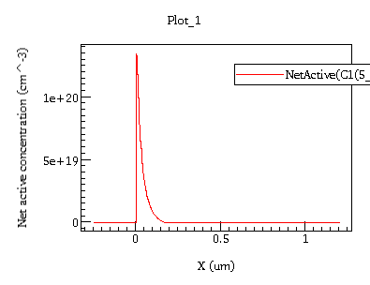
10 keV

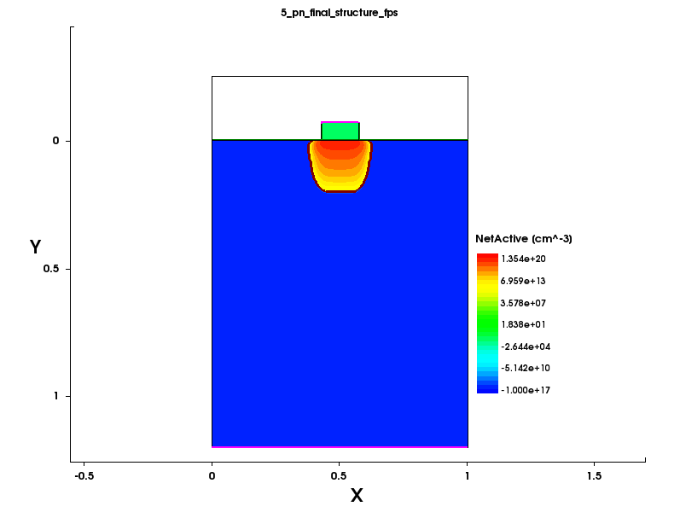

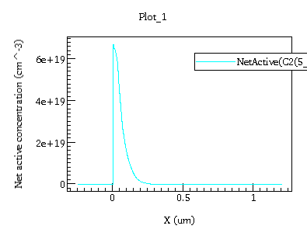
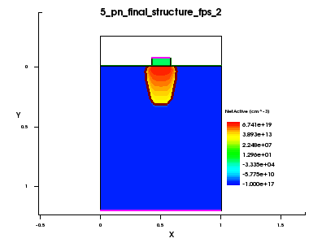
20 keV
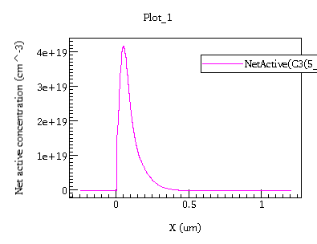
40 keV
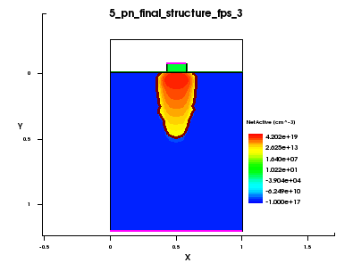

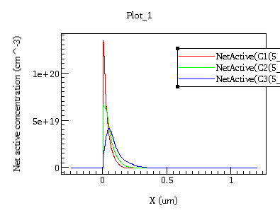
i) Peak concentration goes down with increase in energy. This is because for the same dose, more particles have the energy to penetrate deeper in the device, as can be seen from the device diagrams above. Hence, the peak concentration decreases as the dopant is more spread out throughout.

ii) Junction depth is controlled by ion energy. We see it increases with energy which can be seen from the device diagrams above, as more energy allows the dopant to penetrate deeper in the device.

b) implant dose (use 1E14, 5E14 and 1E15 cm ⁻³)
Energy = 20 keV
1e14 cm ⁻³
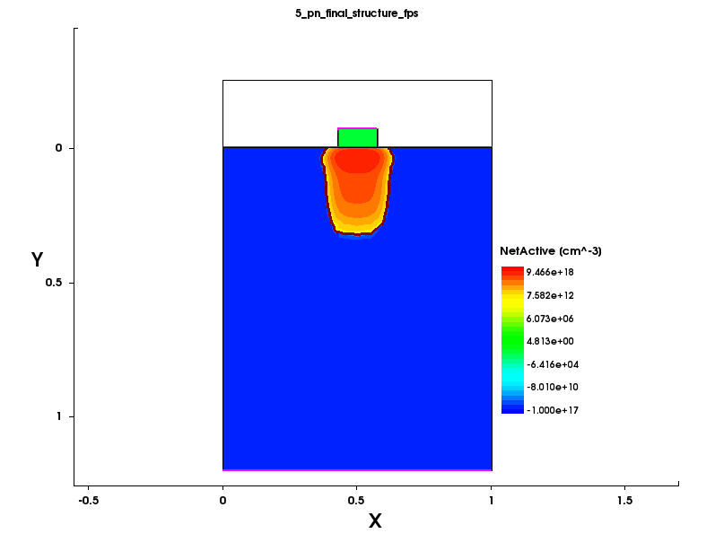
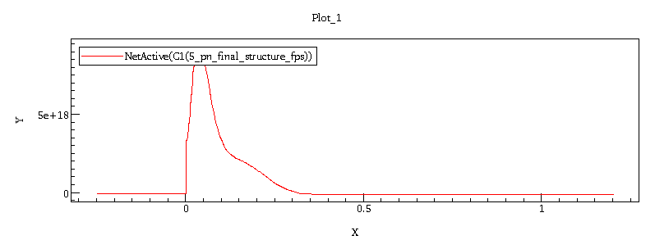

5e14 cm ⁻³

1e15 cm ⁻³
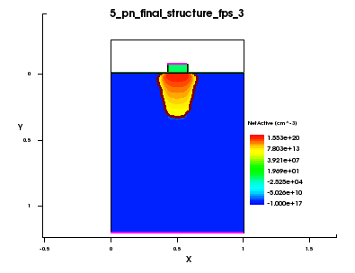
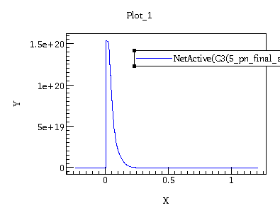
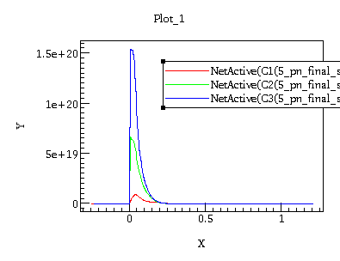

i) Peak concentration increases with dose. This is intuitive as more the dose, more the particles and since the implantation energy is same, the peak concentration for higher dose will be higher.

ii) Junction depth is controlled by ion energy. Hence, we see that it remains nearly the same for all doses. Intuitively, since all the doses have the same energy, they all can penetrate only upto a certain depth.

Q2. Arsenic shape is more rectangular and less irregular than phosphorus as diffusivity of arsenic is less and so less lateral diffusion.
a) implant energy (use 10, 20 and 40keV)
Dose = 5e14 cm⁻³
10 keV
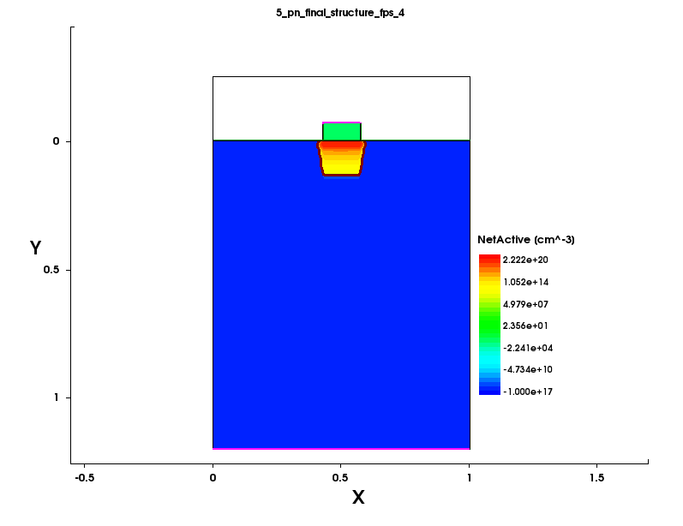
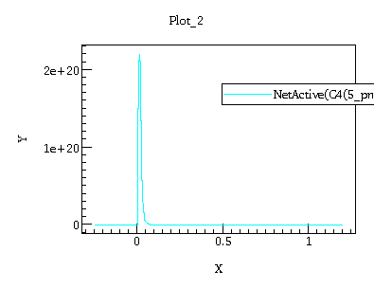

20 keV

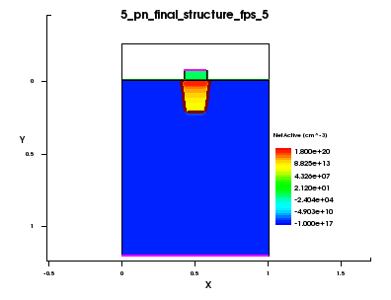
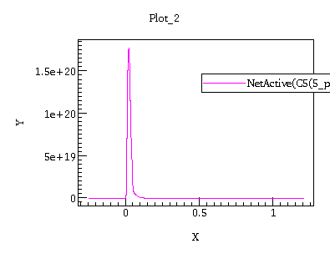
40 keV
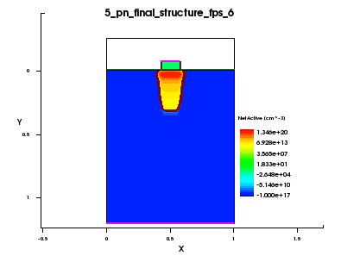
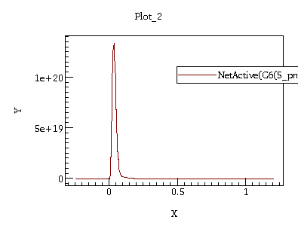
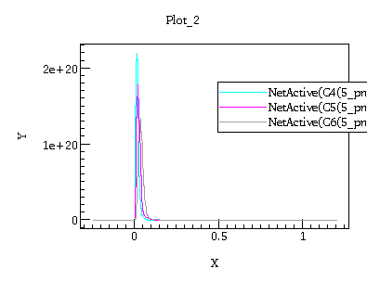
i) Peak concentration goes down with increase in energy. However, it is higher than as compared to phosphorus. This is because phosphorous diffusivity in Si is high (see below figure). So, in the same time phosphorus diffusion is more than arsenic, hence peak concentration of arsenic is more.

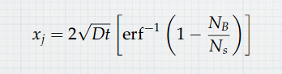
ii) Junction depth is controlled by ion energy. Hence, increases with energy. However, it is less as compared to phosphorus. This is because arsenic is larger than phophorus, more bulky. Hence, for a same energy phosphorus and arsenic, phosphorus penetrates deeper.

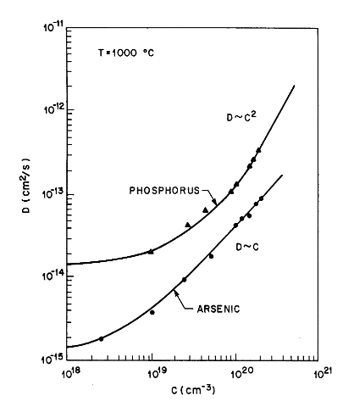
Mathematically, junction depth is defines as above for Gaussian. We can see it depends on D (Diffusivity). Since arsenic diffusivity is less than phosphorus, so junction depth is less.

Extrinsic diffusivities of arsenic and
phosphorus in silicon as a function
of dopant concentration.

b) implant dose (use 1E14, 5E14 and 1E15 cm ⁻³)
Energy = 20 keV
1e14 cm ⁻³
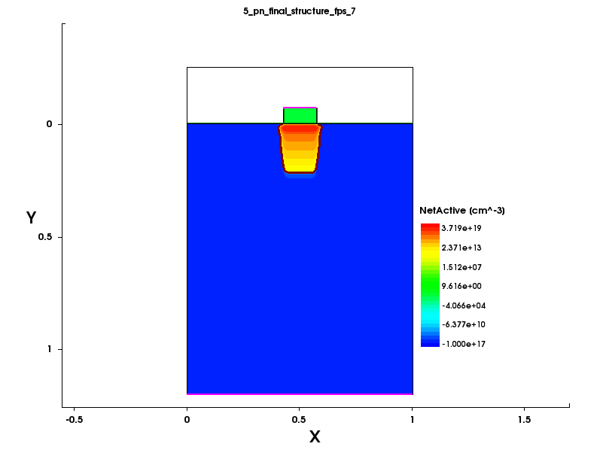
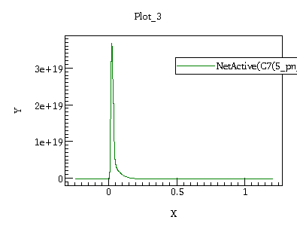

5e14 cm ⁻³
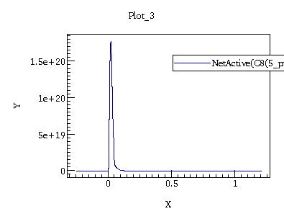
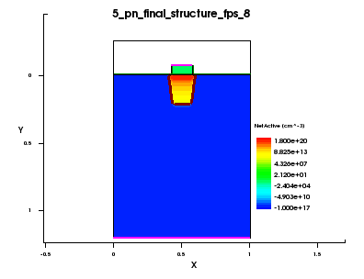
1e15 cm ⁻³
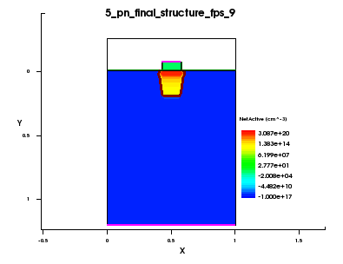
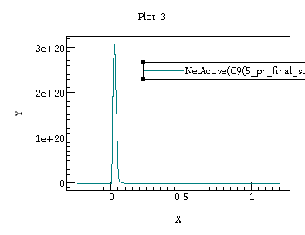
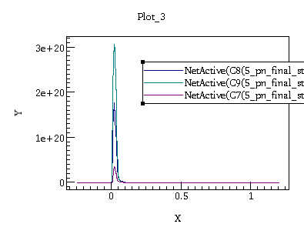

i) Peak concentration increases with dose. However, it is more than phosphorus. This is because phosphorous diffusivity in Si is high. So, in the same time phosphorus diffusion is more than arsenic, hence peak concentration of arsenic is more.

ii) Junction depth is controlled by ion energy. Hence, we see that it remains nearly the same for all doses. However, it is less as compared to phosphorus. This is because arsenic is larger than phophorus, more bulky. Hence, for a same energy phosphorus and arsenic, phosphorus penetrates deeper. Mathematically, junction depth is defined as for Gaussian.
We can see it depends on D (Diffusivity). Since arsenic diffusivity is less than phosphorus, so junction depth is less.
Q3.

Keeping an implant mask of 100 nm (0.45 – 0.55 um) gives a width of ~150nm due to straggle and all.
Fixing the temperature at 1060 degree celsius, and time as 9 sec (thermal budget) for ~100nm junction depth

We get-
i) energy = 4.3 keV, dose = 4.8e12 – peak concentration is slightly higher but more uniformity.
ii) energy = 4.3 keV, dose = 4.5e12 – peak concentration is lesser but slightly less uniformity.

i) ii)
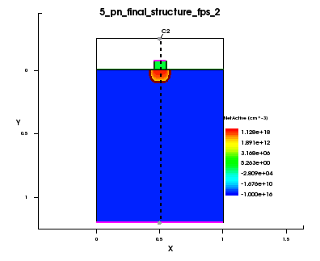
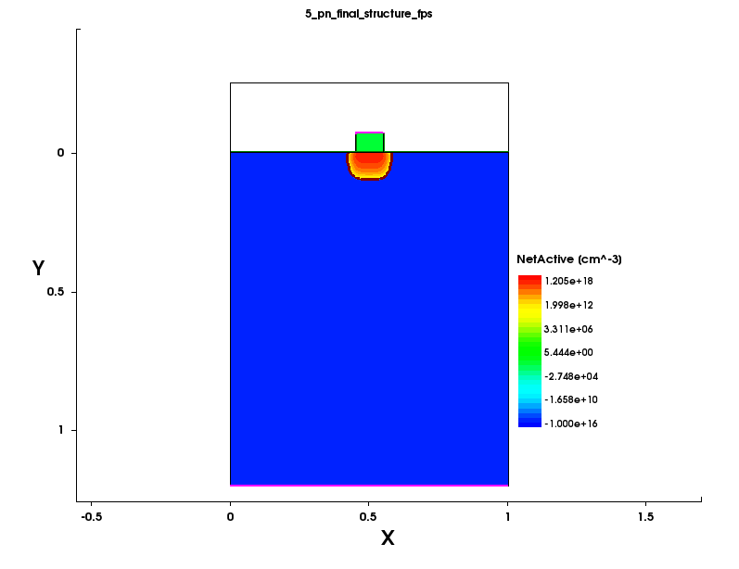
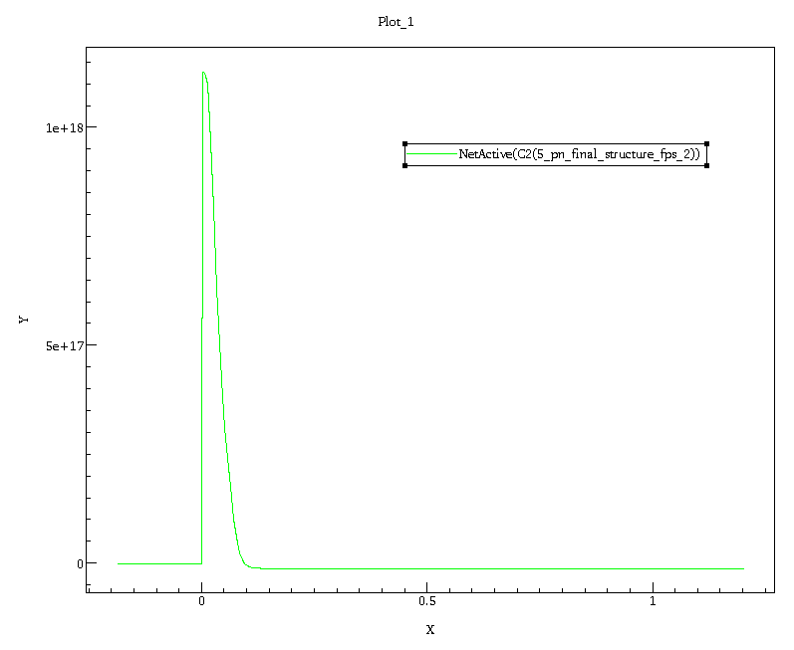
linear:
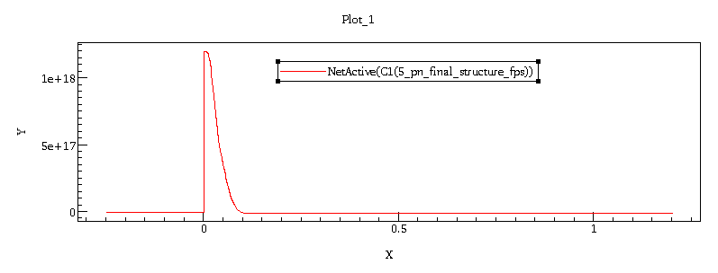

log:
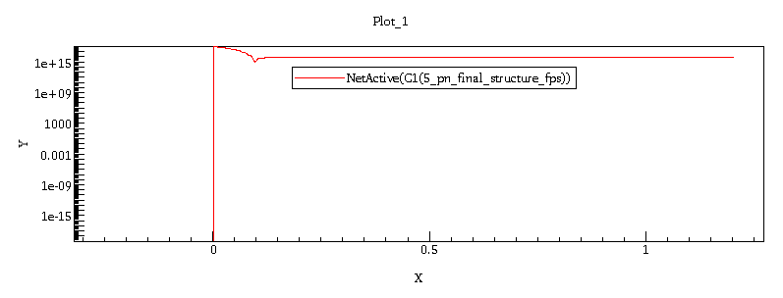
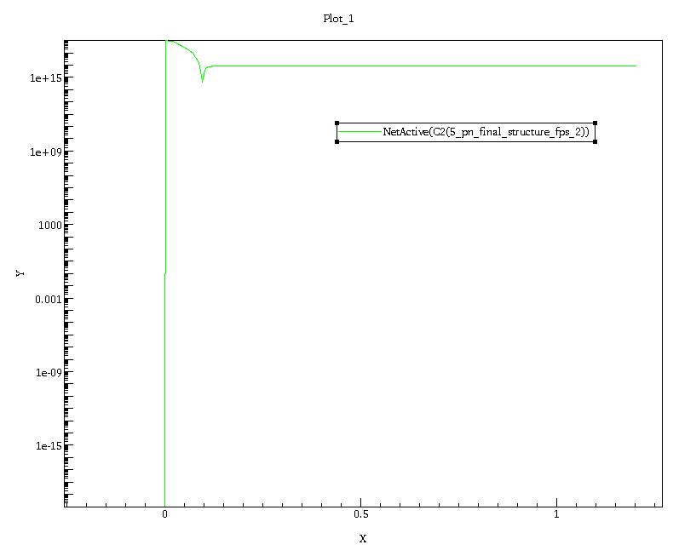

These values were obtained by some hit and trial and looking at the plots of straggle and range vs energy and extrapolating for initial guess. Since we have 100 nm mask, we expect an increase of 25 nm on each side (150 nm width).
Keeping peak concentration around 1.1*10¹⁸ cm⁻³ (to get uniform doping of 1e18) and using this
dose = Q = sqrt(2*pi)*straggle*(peak concentration) we get dose of around 7*10¹² cm⁻². After more hit and trials, the above results were obtained.
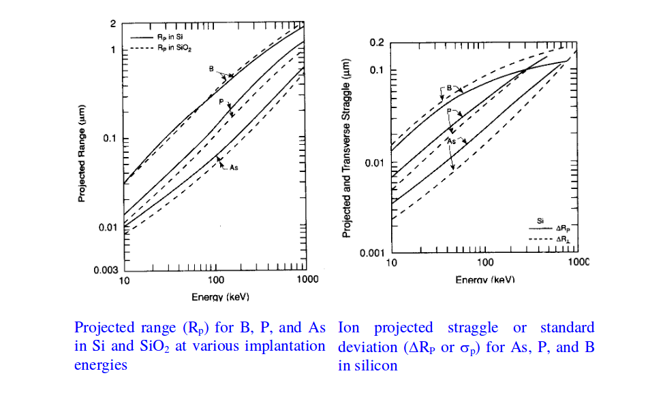

B.
Q1. (assuming all effects – srh, nad to band and avalanche)

2 V – Forward Bias
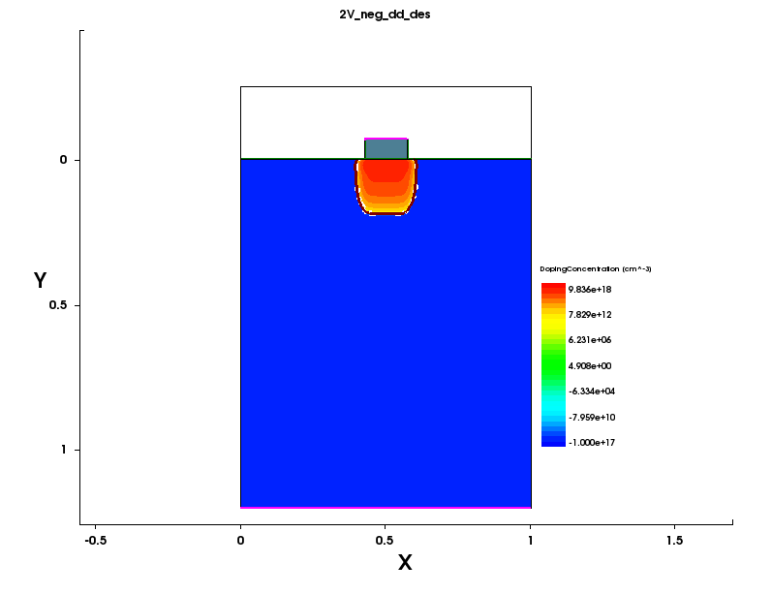

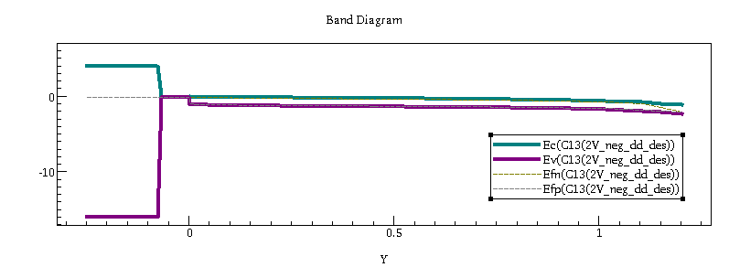
-5 V – Reverse Bias
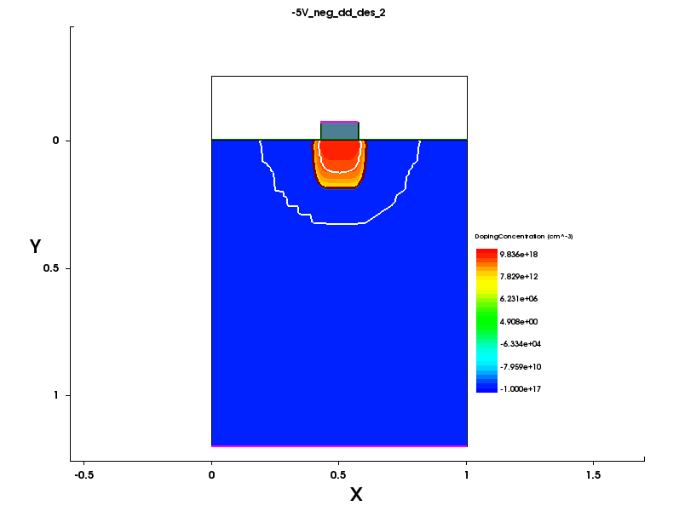

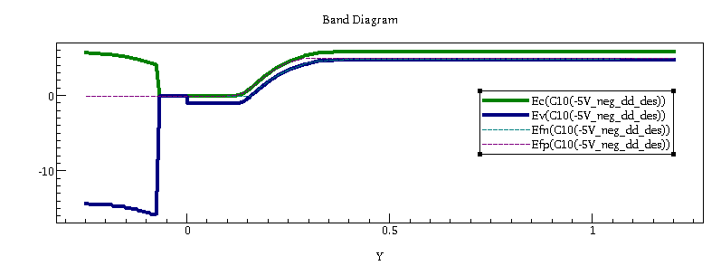
Q2.

Q3.

a) Band-to-band tunnelling b) SRH

c) Avalanche

(Note: in code provided it was Avalanche, whereas according to sdevice manual it was eAvalanche, hence I have used that. Using avalanche gave plot same as that using no recombination method)

‘Avalanche’: ‘Recombination(eAvalanche(CarrierTempDrive) hAvalanche(Okuto)’

d) Comparison

Avalanche current is equal to the current when there is no other phenomena is present. The avalanche generates holes as well as electrons. Avalanche multiplication current-multiplying phenomenon that occurs in a semiconductor photodiode that is reverse-biased just below its breakdown voltage. However, we are not reverse biasing it to as much reverse voltage. Hence, we see almost null effect.

Band-to-band recombination depends on the density of available electrons and holes. Since both carrier types need to be available in the recombination process, the rate is expected to be proportional to the product of n and p.
The recombination/generation current due to band-to-band recombination/generation is obtained by integrating the net
recombination rate U_{b-b} given by b(np-n_{i}² ). Hence, we see a reverse bias current as compared to the case when it’s not present and has almost null reverse bias current.

If we don’t have SRH recombination, we see almost zero curent as opposed to a small current which saturates as voltage increases when we have SRH recombination. This current is due to trap-assisted recombination in the depletion region. This current is fed by diffusion of minority carriers toward junction (supplied by thermal generation). Intuitively, the reverse saturation current is caused by thermally generated electron-hole pairs. As soon as the pair is created, the electric field in the depletion region separates the pair and the pair becomes the reverse bias current.

