EE 735: ASSIGNMENT 8 REPORT
NAME: DIMPLE KOCHAR
ROLL NO.: 16D070010

Q1.

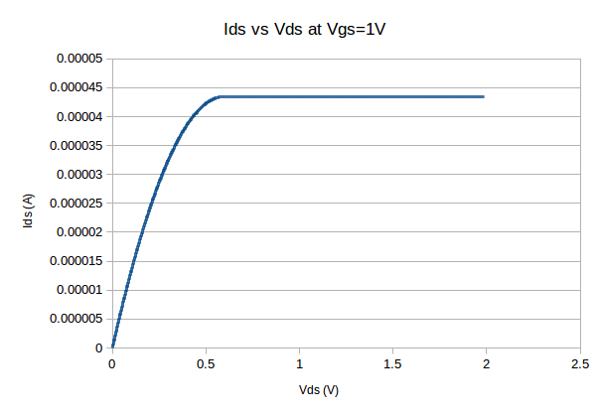

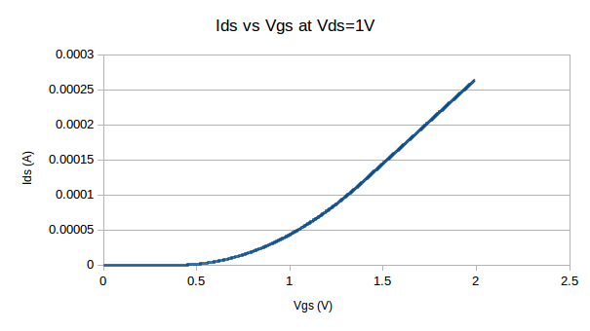

Q2. lambda = 0.045 gives an exact match to the data provided.

Q3.

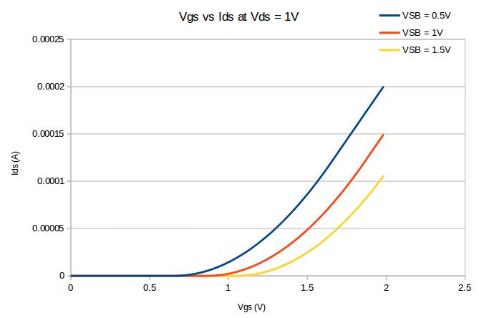

Q4.

