**DIMPLES. HERILL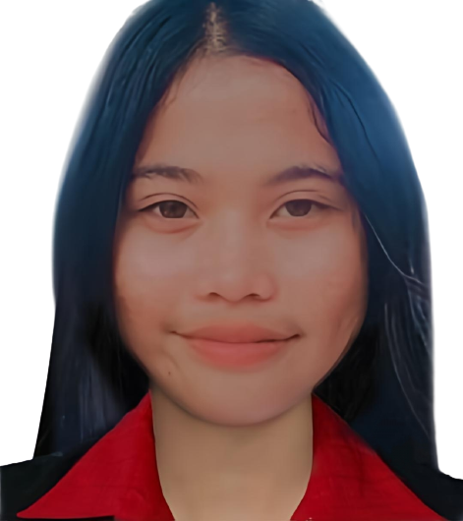A**

**Address:**San Jose Sico,Batangas City

**Contact No:** 09391839226

**Email:** herilladimple@gmail.com

**CAREER OBJECTIVES**

To pursue a challenging career in the field of Information and Communication Technology with constant learning and contribution to an organization which provides challenging work environment and allows me to grow professionally and as an individual.

**EDUCATION**

Primary Education(Elementary)

Bagong Silang Elementary School,Batangas City

San Jose Sico Batangas City

A.Y. 2013-2014

Secondary Education(High School)

Paharang National High School,Batangas City

Paharang Batangas City

A.Y. 2017-2O18

Techvoc with specialization in ICT

Paharang Integrated School,Batangas City

Paharang Batangas City

A.Y. 2019-2020

**PERSONAL BACKGROUND**

**Nickname:** Dimple

**Birth date**: March 15, 2002

**Age:** 20 years old

**Civil Status:** Single

**Height:** 157

**Weight:** 43 kilos

**Citizenship:** Filipino

**Religion:** Roman Catholic

**Father:**Rizaldy D. Herilla

**Mother:** Zoraida S. Herilla

**TECHNICAL SKILLS**

* Assembling/Disassembling System Unit
* Installing Operating System
* Set up Computer Network

**PERSONAL SKILLS**

* Good listener
* Hardworking and Responsible
* Positive thinker
* Confident and willing to learn

**REFERENCES**

* Elpedia Garcia

Teacher in T.L.E

Paharang Integrated School

* Rico DelMundo

Supervisor

Fortune Republic

* Marlyn Velasco

Secretary

ENRO Batangas

I hereby certify that the above information is true and correct the best of my knowledge and belief.

DIMPLE S. HERILLA

Applicant