Software Requirements Specification (SRS)
Project: Point of Sale (POS) Simulator
Version: 1.0
Authors: Narayana S, Mithun Naik, Dimpu Kumar, Darshan H V
Date: 02-09-2025
Status: Draft

Revision History
Version | Date | Author | Change summary
1.0 | 02-09-2025 | Narayana S  Mithun Naik,  Dimpu Kumar,  Darshan H V | Initial draft of SRS for POS Simulator

1. Introduction

1.1 Purpose
This document provides the Software Requirements Specification (SRS) for a Point of Sale (POS) Simulator. It defines functional and non-functional requirements, interfaces, and acceptance criteria for the development of a software simulator that mimics a retail POS system for educational and testing purposes.

1.2 Scope
The POS Simulator covers cashier functions including product scanning, cart management, discounts, tax calculation, payment processing (mock cash, card, and UPI), receipt generation, and inventory updates. It will also support manager overrides, refunds, and reporting functions. The system excludes actual payment gateway integration and physical hardware interactions beyond mock interfaces.

1.3 Audience
Developers, QA Engineers, SE Course Evaluators, and Students.

1.4 Definitions
POS: Point of Sale
FR: Functional Requirement
NFR: Non-Functional Requirement
RTM: Requirements Traceability Matrix

2. Overall Description

2.1 Product Perspective
The POS Simulator is a software-only system designed for academic and demonstration use. It emulates cashier operations and backend data management typically found in retail POS terminals.

2.2 Major Product Functions
- Scan/add product to cart
- Apply discounts and calculate taxes
- Process mock payments (cash, card, UPI)
- Generate and print receipts (PDF)
- Manage inventory updates
- Support refunds and voids
- Manager override for restricted actions
- Generate sales and day-end reports

2.3 User Roles and Characteristics
- Cashier: Basic computer knowledge, performs daily sales.
- Manager: Authorizes overrides, checks reports.
- Administrator: Configures products, taxes, discounts.

2.4 Operating Environment
Desktop application or web-based system running on Windows/Linux with SQLite/MySQL database.

2.5 Constraints
- Mock payment APIs only (no real transactions)
- Offline-first but sync required for persistence
- Must run in lab environments without special hardware

3. External Interface Requirements

3.1 User Interfaces
Graphical user interface with product search bar, cart view, checkout screen, and reporting dashboard.

3.2 Hardware Interfaces
Simulated barcode input, simulated receipt printing (PDF).

3.3 Software Interfaces
Database: SQLite/MySQL. Mock Payment API for approval/decline responses.

3.4 Communications
Internal APIs for cart, checkout, and payment. No external internet connectivity required.

4. System Features
Req ID | Requirement | Type | Priority | Source/Stakeholder | Acceptance Criteria / Test Case Ref | Comments / Dependencies
POS-F-001 | The system shall allow adding products by barcode or manual entry. | Functional | High | Cashier | TC-001: Product appears in cart | Must validate against inventory
POS-F-002 | The system shall maintain a cart with multiple items and quantities. | Functional | High | Cashier | TC-002: Items and quantities tracked | Data persisted to DB
POS-F-003 | The system shall calculate subtotal, taxes, and discounts in real time. | Functional | High | Cashier/Manager | TC-003: Calculation matches rules | Tax/discount rules configurable
POS-F-004 | The system shall support item-level and order-level discounts. | Functional | Medium | Manager | TC-004: Discount correctly applied | Operator manager override needed
POS-F-005 | The system shall validate stock availability before checkout. | Functional | High | Cashier/Admin | TC-005: Checkout blocked if OOS | Sync with inventory before checkout
POS-F-006 | The system shall process mock payments via cash, card, and UPI. | Functional | High | Cashier | TC-006: Payment status returned | Integration with mock payment API
POS-F-007 | The system shall generate receipts in PDF format. | Functional | Medium | Cashier | TC-007: PDF generated for receipt | PDF library required
POS-F-008 | The system shall record each sale transaction in the database. | Functional | High | Admin | TC-008: Sale record persisted | Must not lose data on failure
POS-F-009 | The system shall support refund and void operations. | Functional | Medium | Manager | TC-009: Refund/void flow is correct | Only manager can refund/void
POS-F-010 | The system shall allow manager override for restricted actions. | Functional | Medium | Manager | TC-010: Override required for restrict. | Refers to high/large discount cases
POS-F-011 | The system shall update inventory after each sale or refund. | Functional | High | Admin | TC-011: Inventory changes match sale/refund | Must sync with central inventory
POS-F-012 | The system shall generate daily sales reports. | Functional | Medium | Manager/Admin | TC-012: Report matches sale history | PDF/CSV format as needed
POS-F-013 | The system shall allow searching sales history. | Functional | Low | Manager/Admin | TC-013: Search returns correct data | Search UI required
POS-F-014 | The system shall support user roles (cashier, manager, admin). | Functional | High | All | TC-014: Roles enforced in operations | RBAC in authentication module
POS-F-015 | The system shall provide error messages for failed operations. | Functional | High | All | TC-015: Error appears on failure | Must follow usability guidelines

5. Non-Functional Requirements
Req ID | Requirement | Type | Priority | Source/Stakeholder | Acceptance criteria / Test case ref | Comments / Dependencies
POS-NF-001 | The system shall respond to checkout operations within 2 seconds (90% of cases). | Non-Functional | High | Cashier/Customer | AC-POS-NF-001: Checkout completes ≤2s in 90% test runs. Test: TC-Perf-01 | Requires performance testing
POS-NF-002 | The system shall ensure 99% availability in lab usage conditions. | Non-Functional | High | Admin | AC-POS-NF-002: Uptime logs show ≥99% availability in test environment. Test: TC-Avail-01 | Requires monitoring setup
POS-NF-003 | The system shall maintain data consistency across sales and inventory records. | Non-Functional | High | Admin | AC-POS-NF-003: No mismatches found in DB after 100 test transactions. Test: TC-Data-01 | Depends on DB integrity
POS-NF-004 | The system shall provide audit logs of user operations. | Non-Functional | Medium | Admin/Auditor | AC-POS-NF-004: All operations logged with timestamp & user ID. Test: TC-Audit-01 | Requires log storage
POS-NF-005 | The system shall be usable by beginners with a simple UI and tooltips. | Non-Functional | Medium | Cashier/Customer | AC-POS-NF-005: Usability survey ≥80% success rate for new users. Test: TC-UI-01 | Requires usability testing

5.1 Security

5.1.1 Security Objectives
- Ensure only authorized users (cashier, manager, admin) can access restricted functions.
- Protect transaction integrity and prevent tampering with records.

5.1.2 Security Requirements
Req ID | Requirement | Type | Priority | Source/Stakeholder | Acceptance criteria / Test case ref | Comments / Dependencies
POS-SR-001 | The system shall require login with username and password/PIN. | Security | High | Admin | AC-POS-SR-001: System requires valid credentials before access. Test: TC-Login-01 | Requires user DB
POS-SR-002 | The system shall enforce role-based access control for different operations. | Security | High | Admin/Manager | AC-POS-SR-002: Cashier cannot perform manager-only tasks. Test: TC-Role-01 | Needs role definitions
POS-SR-003 | The system shall encrypt stored user credentials. | Security | High | Admin/Security Officer | AC-POS-SR-003: User credentials stored with strong encryption. Test: TC-Encrypt-01 | Requires encryption library
POS-SR-004 | The system shall restrict refunds and overrides to managers only. | Security | Medium | Manager | AC-POS-SR-004: Refund attempt by cashier is blocked. Test: TC-Refund-01 | Depends on role control
POS-SR-005 | The system shall log all failed login attempts. | Security | Medium | Admin | AC-POS-SR-005: Failed logins recorded with timestamp. Test: TC-Log-01 | Requires log storage

6. Quality attributes & Acceptance tests
- High-priority functional requirements must be fully tested.
- NFRs must be measured under lab conditions.
- RTM must show all requirements are linked to test cases.

7. UML Use Case Diagram
Two UML diagrams should be created:
- Cashier operations (scan, cart, checkout, payment)
- Manager operations (override, refund, reports).
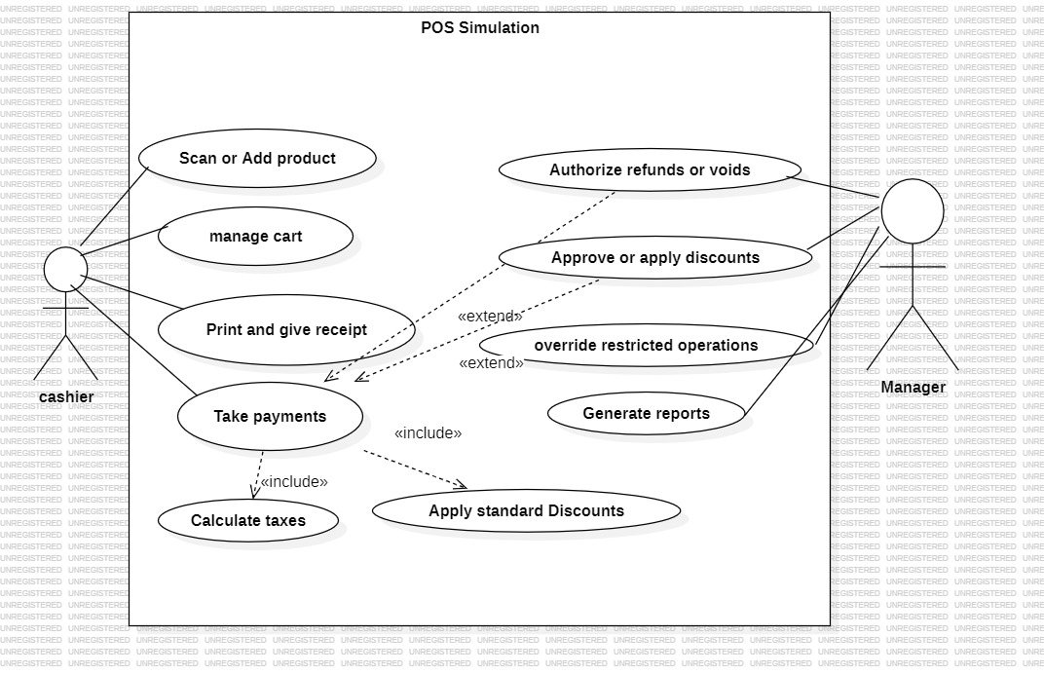

8. Requirements Traceability Matrix (RTM)
Req ID | Requirement Short | Design Spec Ref | Module | Test Case(s)
POS-F-001 | The system shall allow adding products by barcode or manual entry. | Section 4 | CartModule | TC-001
POS-F-002 | The system shall maintain a cart with multiple items and quantities. | Section 4 | CartModule | TC-002
POS-F-003 | The system shall calculate subtotal, taxes, and discounts in real time. | Section 4 | CartModule | TC-003
POS-F-004 | The system shall support item-level and order-level discounts. | Section 4 | CartModule | TC-004
POS-F-005 | The system shall validate stock availability before checkout. | Section 4 | CartModule | TC-005

