POS Simulator

Sprint Planning Overview

Sprint 1 – Core POS Features
Duration: 1–2 weeks (you can choose based on your project plan)
Total User Stories: 6
Total Estimated Story Points: 34
User Stories:
- PS-1: Add products to cart using barcode/manual entry.
- PS-2: Maintain a cart with multiple items & quantities.
- PS-3: Auto-calculate subtotal, discounts & taxes.
- PS-4: Validate stock availability before checkout.
- PS-5: Process mock payments (cash, card, UPI).
- PS-6: Generate a PDF receipt & record sale in DB.
Goal of Sprint 1:
Deliver the core cashier workflow until a full checkout process is operational.

Sprint 2 – Manager, Admin & Security
Duration: 1–2 weeks
Total User Stories: 8
Total Estimated Story Points: 47
User Stories:
- PS-7: Refunds & void transactions.
- PS-8: Authorization for restricted actions (discount levels).
- PS-9: Auto-update inventory after sales/refunds.
- PS-10: Generate daily reports & search sales history.
- PS-11: Role-based access control.
- PS-12: Manage staff accounts & permissions.
- PS-13: Monitor low-stock alerts.
- PS-14: Export reports (CSV/PDF).
Goal of Sprint 2:
Add managerial controls, reporting features, and security mechanisms.
Jira Screenshots:
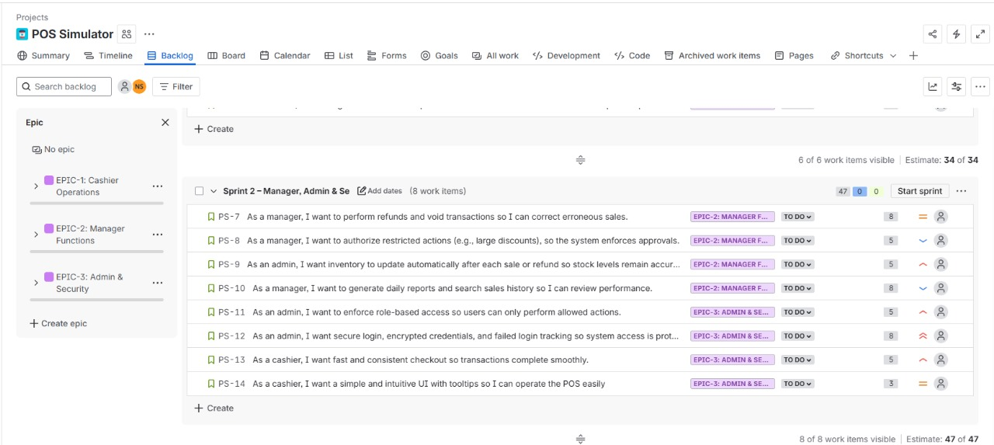
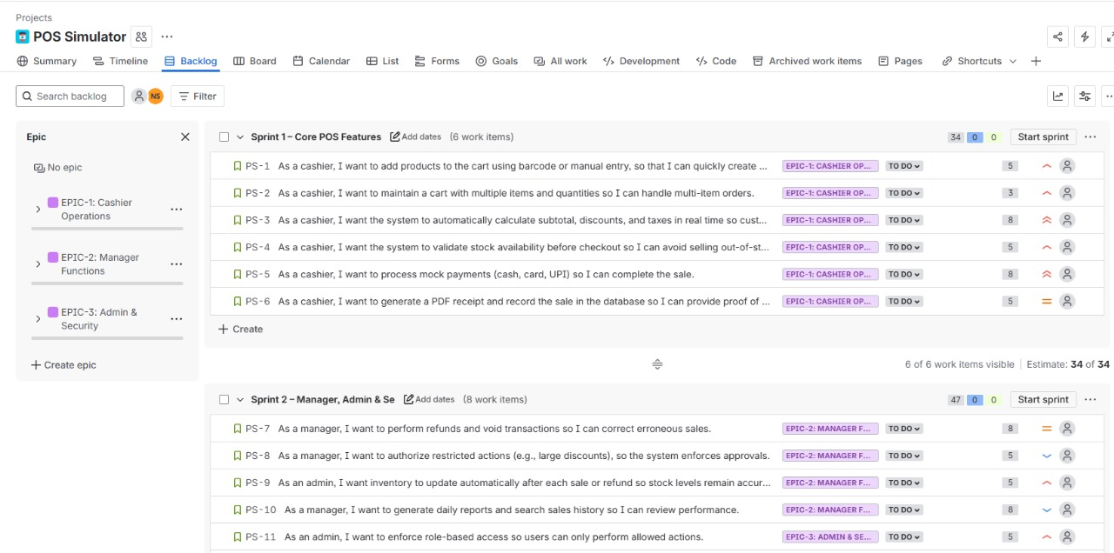
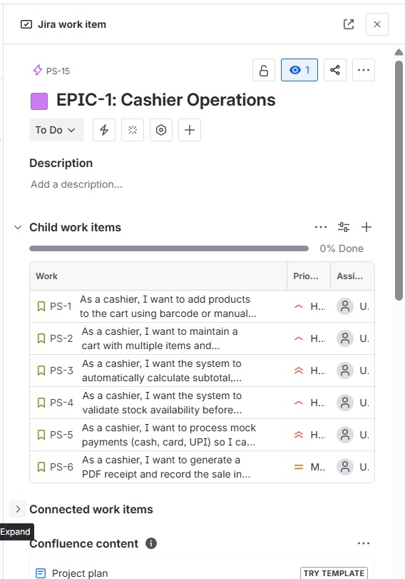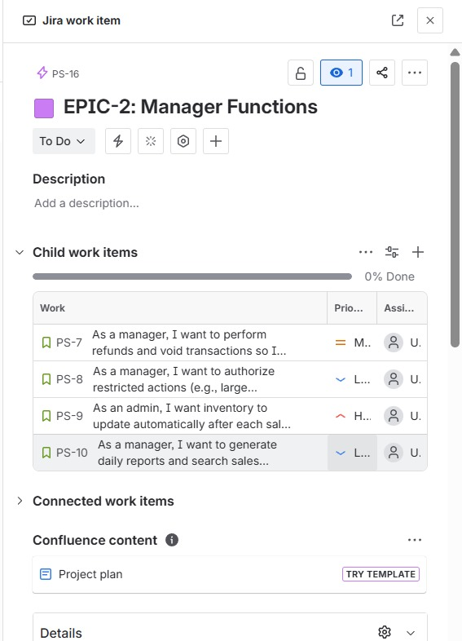
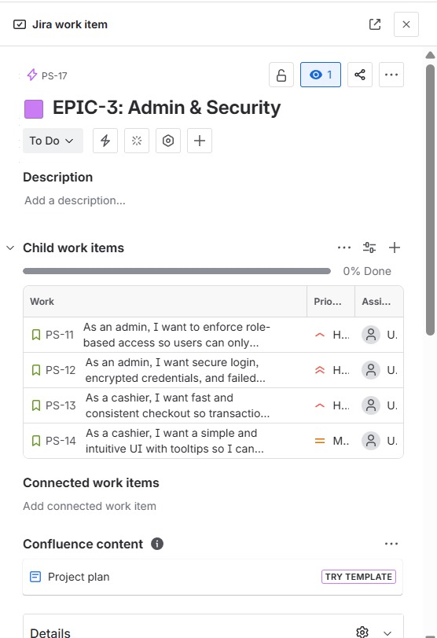
Sprint 1 Started 1/11/2025 – 7/11/2025
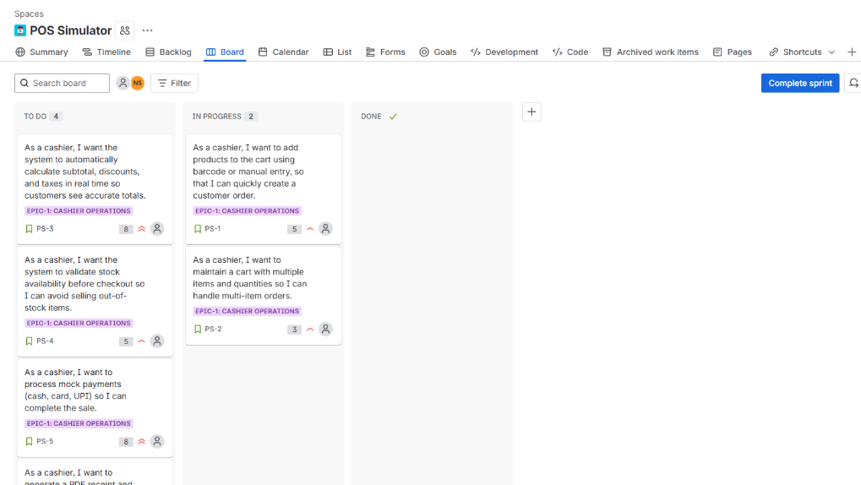
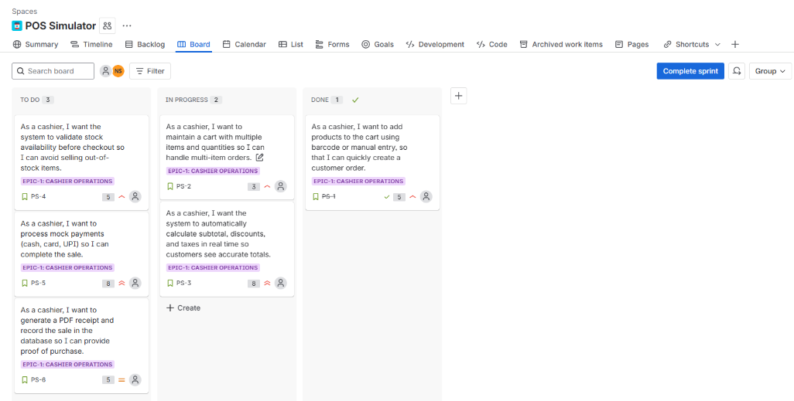
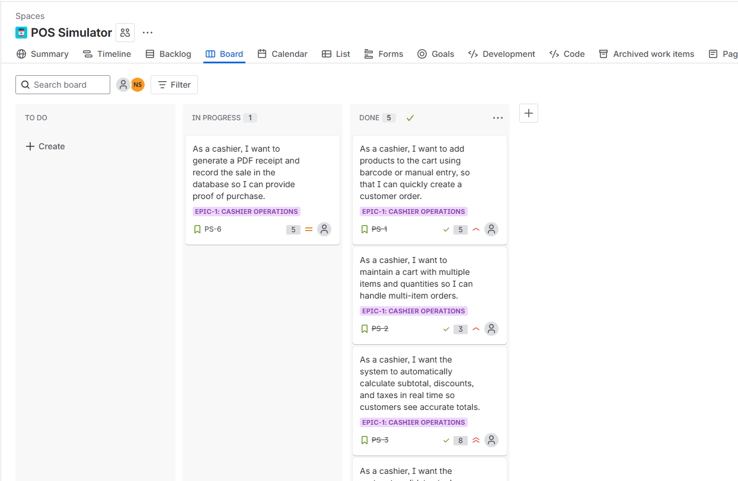
All tasks of sprint 1 done
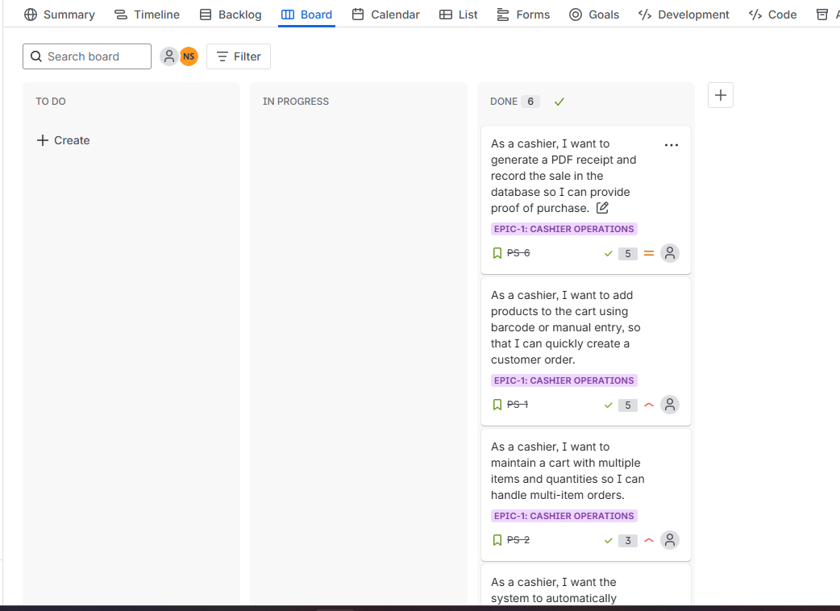
Sprint 1 completed
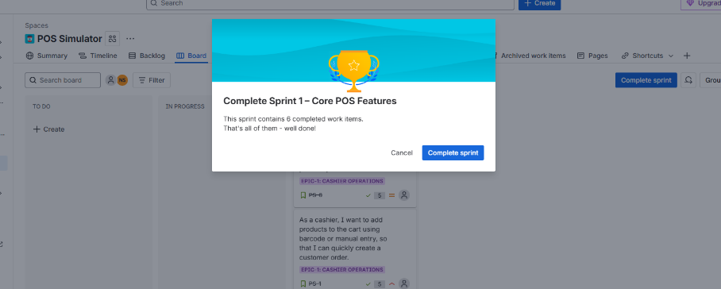
Sprint 2 Started
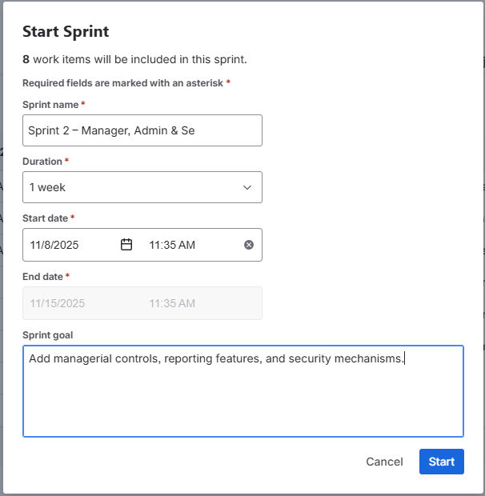
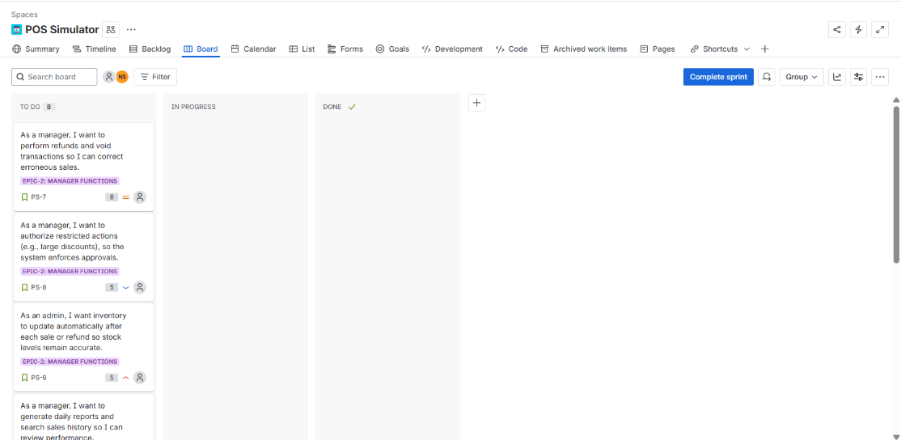
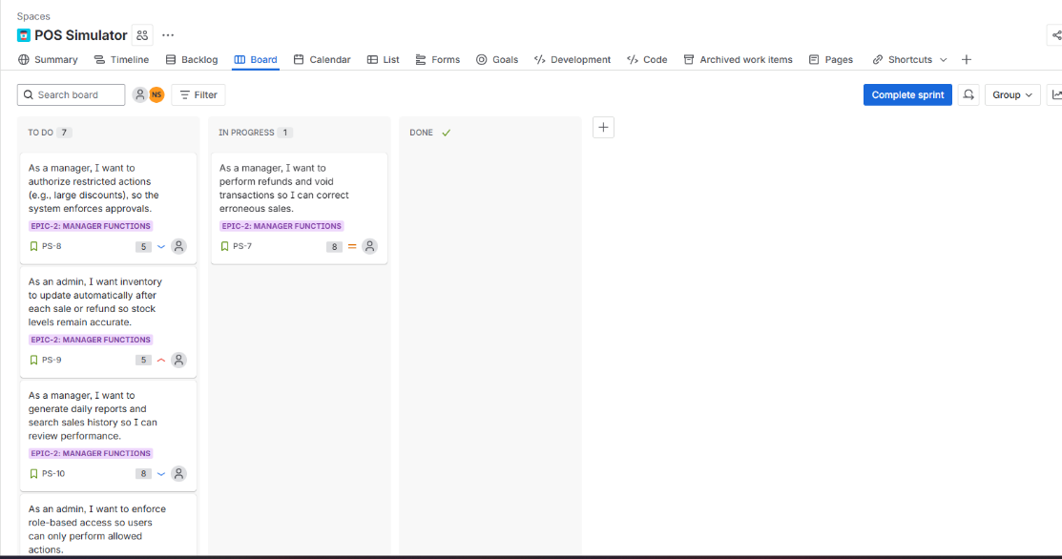
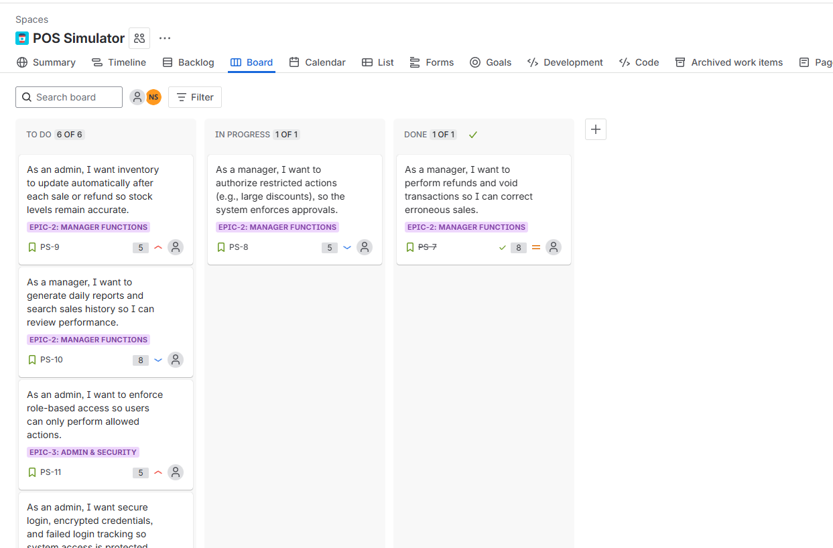
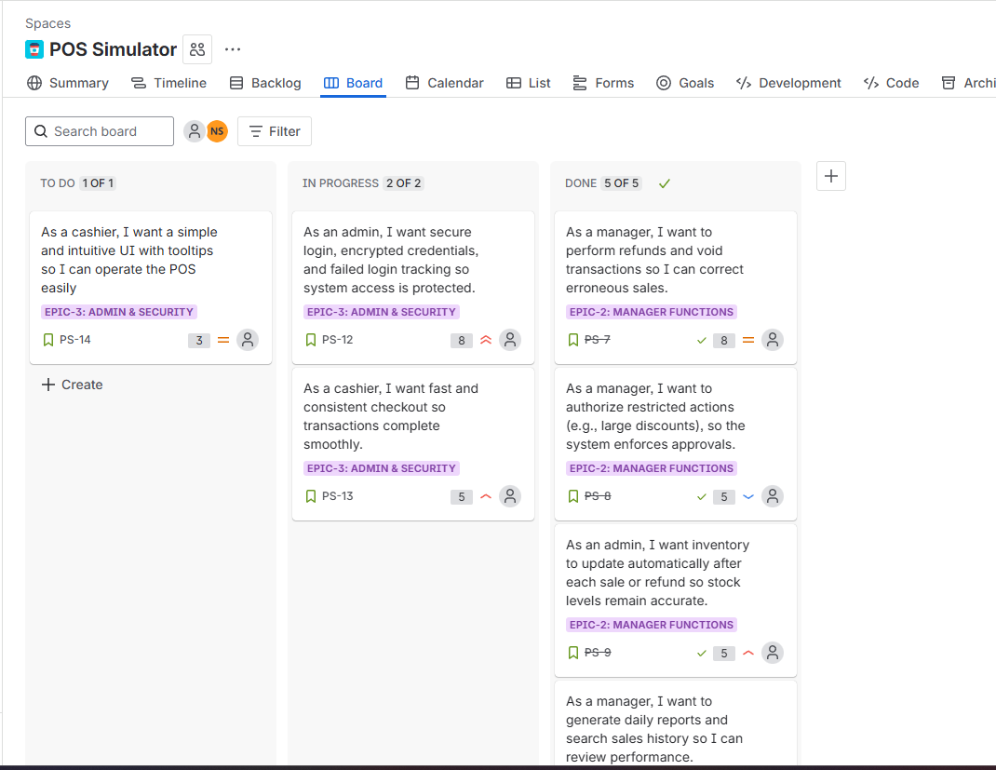
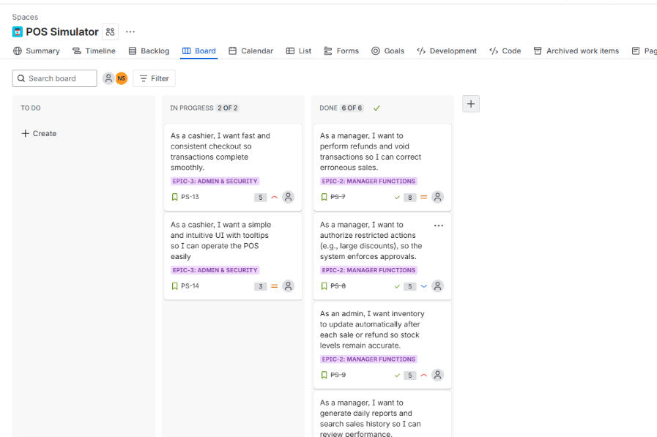
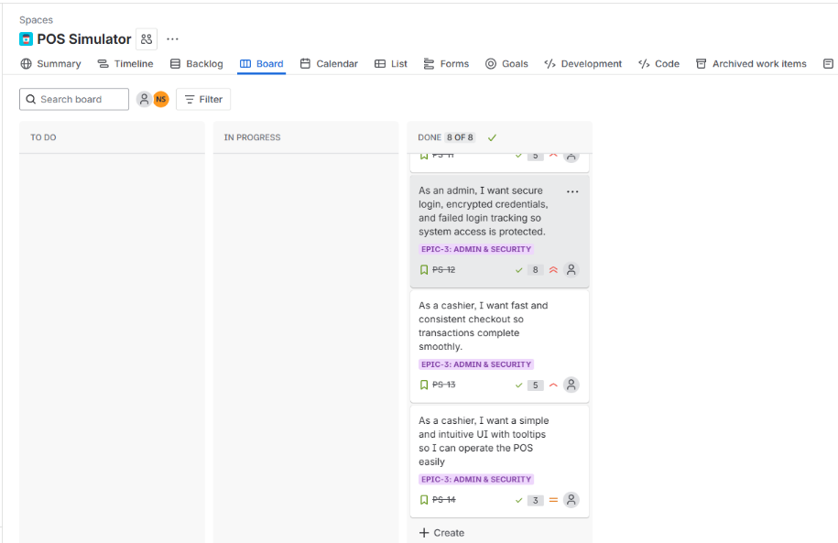
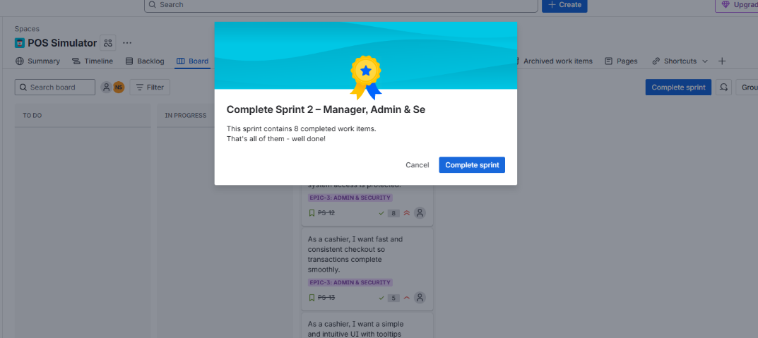
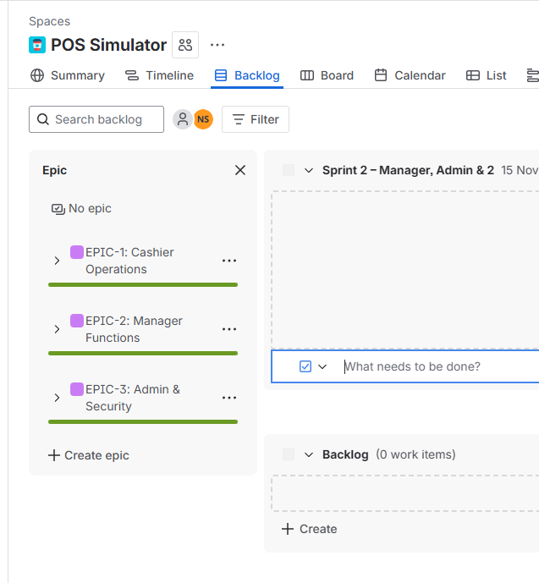
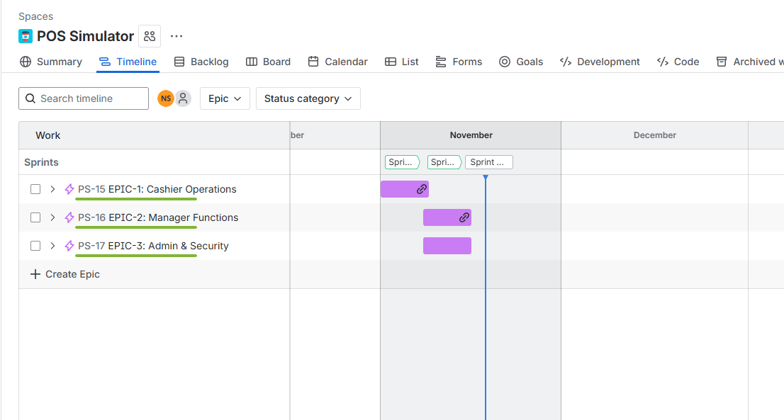
Velocity report
