Your temporary usage period for IBM SPSS Statistics will expire in 5141 days.

FREQUENCIES VARIABLES=X1 X2 X3 X4 Y
/STATISTICS=STDDEV VARIANCE RANGE MINIMUM MAXIMUM MEAN
/HISTOGRAM NORMAL
/ORDER=ANALYSIS.

Frequencies

Notes
Output Created |  | 03-DEC-2021 12:22:42
Comments
Input | Active Dataset | DataSet0
Input | Filter | <none>
Input | Weight | <none>
Input | Split File | <none>
Input | N of Rows in Working Data File | 100
Missing Value Handling | Definition of Missing | User-defined missing values are treated as missing.
Missing Value Handling | Cases Used | Statistics are based on all cases with valid data.
Syntax |  | FREQUENCIES VARIABLES=X1 X2 X3 X4 Y  /STATISTICS=STDDEV VARIANCE RANGE MINIMUM MAXIMUM MEAN  /HISTOGRAM NORMAL  /ORDER=ANALYSIS.
Resources | Processor Time | 00:00:02,55
Resources | Elapsed Time | 00:00:01,20

[DataSet0]

Statistics
 |  | X1 | X2 | X3 | X4 | Y
N | Valid | 100 | 100 | 100 | 100 | 100
N | Missing | 0 | 0 | 0 | 0 | 0
Mean |  | 21.35 | 10.94 | 17.22 | 15.81 | 20.97
Std. Deviation |  | 2.520 | 2.206 | 2.236 | 2.264 | 3.047
Variance |  | 6.351 | 4.865 | 5.002 | 5.125 | 9.282
Range |  | 10 | 10 | 9 | 10 | 13
Minimum |  | 15 | 5 | 11 | 10 | 12
Maximum |  | 25 | 15 | 20 | 20 | 25

Frequency Table

X1
 |  | Frequency | Percent | Valid Percent | Cumulative Percent
Valid | 15 | 2 | 2.0 | 2.0 | 2.0
Valid | 16 | 1 | 1.0 | 1.0 | 3.0
Valid | 17 | 4 | 4.0 | 4.0 | 7.0
Valid | 18 | 5 | 5.0 | 5.0 | 12.0
Valid | 19 | 9 | 9.0 | 9.0 | 21.0
Valid | 20 | 17 | 17.0 | 17.0 | 38.0
Valid | 21 | 17 | 17.0 | 17.0 | 55.0
Valid | 22 | 13 | 13.0 | 13.0 | 68.0
Valid | 23 | 9 | 9.0 | 9.0 | 77.0
Valid | 24 | 5 | 5.0 | 5.0 | 82.0
Valid | 25 | 18 | 18.0 | 18.0 | 100.0
Valid | Total | 100 | 100.0 | 100.0

X2
 |  | Frequency | Percent | Valid Percent | Cumulative Percent
Valid | 5 | 2 | 2.0 | 2.0 | 2.0
Valid | 6 | 1 | 1.0 | 1.0 | 3.0
Valid | 7 | 2 | 2.0 | 2.0 | 5.0
Valid | 8 | 5 | 5.0 | 5.0 | 10.0
Valid | 9 | 15 | 15.0 | 15.0 | 25.0
Valid | 10 | 20 | 20.0 | 20.0 | 45.0
Valid | 11 | 15 | 15.0 | 15.0 | 60.0
Valid | 12 | 17 | 17.0 | 17.0 | 77.0
Valid | 13 | 9 | 9.0 | 9.0 | 86.0
Valid | 14 | 7 | 7.0 | 7.0 | 93.0
Valid | 15 | 7 | 7.0 | 7.0 | 100.0
Valid | Total | 100 | 100.0 | 100.0

X3
 |  | Frequency | Percent | Valid Percent | Cumulative Percent
Valid | 11 | 1 | 1.0 | 1.0 | 1.0
Valid | 13 | 6 | 6.0 | 6.0 | 7.0
Valid | 14 | 4 | 4.0 | 4.0 | 11.0
Valid | 15 | 9 | 9.0 | 9.0 | 20.0
Valid | 16 | 23 | 23.0 | 23.0 | 43.0
Valid | 17 | 13 | 13.0 | 13.0 | 56.0
Valid | 18 | 6 | 6.0 | 6.0 | 62.0
Valid | 19 | 15 | 15.0 | 15.0 | 77.0
Valid | 20 | 23 | 23.0 | 23.0 | 100.0
Valid | Total | 100 | 100.0 | 100.0

X4
 |  | Frequency | Percent | Valid Percent | Cumulative Percent
Valid | 10 | 1 | 1.0 | 1.0 | 1.0
Valid | 11 | 2 | 2.0 | 2.0 | 3.0
Valid | 12 | 5 | 5.0 | 5.0 | 8.0
Valid | 13 | 6 | 6.0 | 6.0 | 14.0
Valid | 14 | 14 | 14.0 | 14.0 | 28.0
Valid | 15 | 17 | 17.0 | 17.0 | 45.0
Valid | 16 | 18 | 18.0 | 18.0 | 63.0
Valid | 17 | 14 | 14.0 | 14.0 | 77.0
Valid | 18 | 9 | 9.0 | 9.0 | 86.0
Valid | 19 | 8 | 8.0 | 8.0 | 94.0
Valid | 20 | 6 | 6.0 | 6.0 | 100.0
Valid | Total | 100 | 100.0 | 100.0

Y
 |  | Frequency | Percent | Valid Percent | Cumulative Percent
Valid | 12 | 1 | 1.0 | 1.0 | 1.0
Valid | 14 | 2 | 2.0 | 2.0 | 3.0
Valid | 15 | 3 | 3.0 | 3.0 | 6.0
Valid | 16 | 4 | 4.0 | 4.0 | 10.0
Valid | 17 | 3 | 3.0 | 3.0 | 13.0
Valid | 18 | 6 | 6.0 | 6.0 | 19.0
Valid | 19 | 11 | 11.0 | 11.0 | 30.0
Valid | 20 | 13 | 13.0 | 13.0 | 43.0
Valid | 21 | 7 | 7.0 | 7.0 | 50.0
Valid | 22 | 15 | 15.0 | 15.0 | 65.0
Valid | 23 | 11 | 11.0 | 11.0 | 76.0
Valid | 24 | 10 | 10.0 | 10.0 | 86.0
Valid | 25 | 14 | 14.0 | 14.0 | 100.0
Valid | Total | 100 | 100.0 | 100.0

Histogram

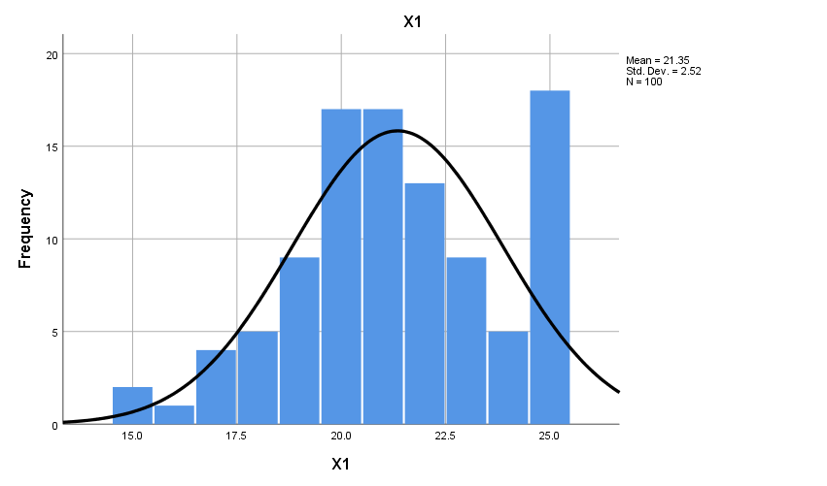

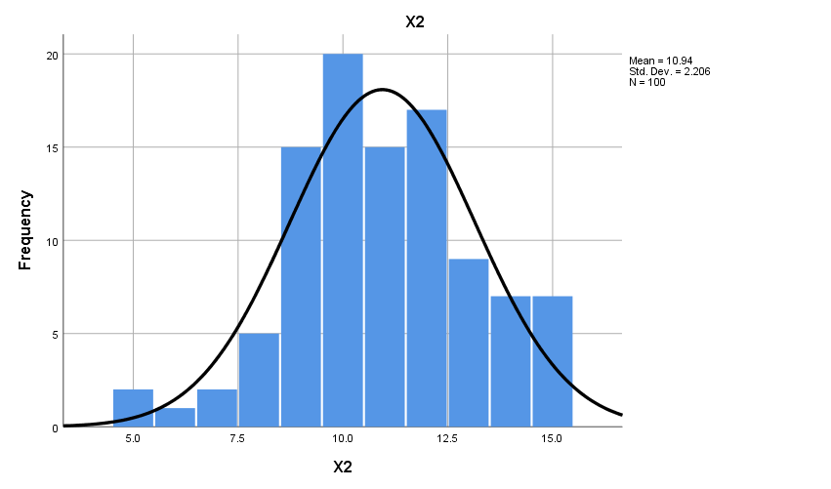

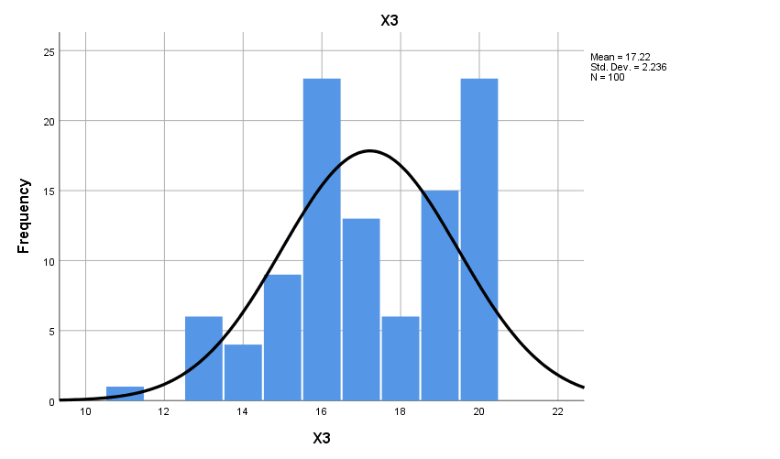

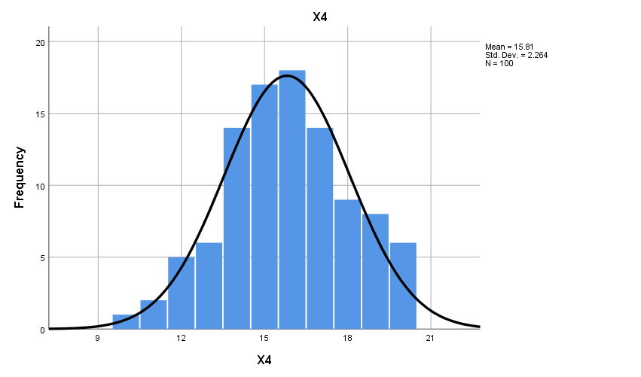

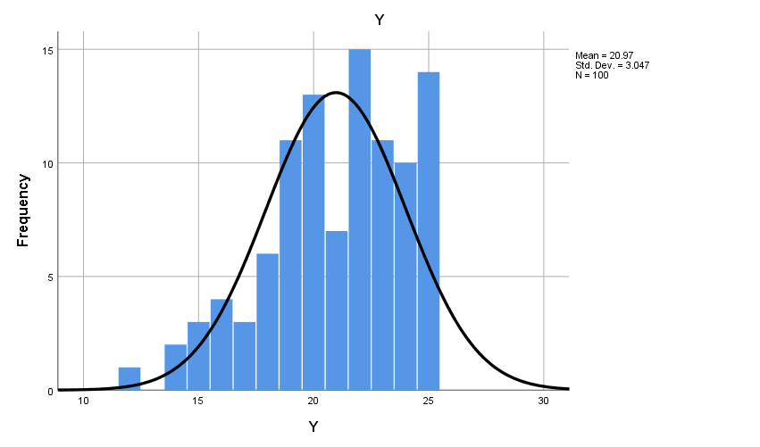

DESCRIPTIVES VARIABLES=X1 X2 X3 X4 Y
/STATISTICS=MEAN STDDEV VARIANCE RANGE MIN MAX.

Descriptives

Notes
Output Created |  | 03-DEC-2021 12:30:46
Comments
Input | Active Dataset | DataSet0
Input | Filter | <none>
Input | Weight | <none>
Input | Split File | <none>
Input | N of Rows in Working Data File | 100
Missing Value Handling | Definition of Missing | User defined missing values are treated as missing.
Missing Value Handling | Cases Used | All non-missing data are used.
Syntax |  | DESCRIPTIVES VARIABLES=X1 X2 X3 X4 Y  /STATISTICS=MEAN STDDEV VARIANCE RANGE MIN MAX.
Resources | Processor Time | 00:00:00,00
Resources | Elapsed Time | 00:00:00,00

Descriptive Statistics
 | N | Range | Minimum | Maximum | Mean | Std. Deviation | Variance
X1 | 100 | 10 | 15 | 25 | 21.35 | 2.520 | 6.351
X2 | 100 | 10 | 5 | 15 | 10.94 | 2.206 | 4.865
X3 | 100 | 9 | 11 | 20 | 17.22 | 2.236 | 5.002
X4 | 100 | 10 | 10 | 20 | 15.81 | 2.264 | 5.125
Y | 100 | 13 | 12 | 25 | 20.97 | 3.047 | 9.282
Valid N (listwise) | 100

DESCRIPTIVES VARIABLES=X1.1 X1.2 X1.3 X1.4 X1.5 X1 X2.1 X2.2 X2.3 X2 X3.1 X3.2 X3.3 X3.4 X3 X4.1
X4.2 X4.3 X4.4 X4 Y.1 Y.2 Y.3 Y.4 Y.5 Y
/STATISTICS=MEAN STDDEV VARIANCE RANGE MIN MAX.

Descriptives

Notes
Output Created |  | 03-DEC-2021 12:35:06
Comments
Input | Active Dataset | DataSet0
Input | Filter | <none>
Input | Weight | <none>
Input | Split File | <none>
Input | N of Rows in Working Data File | 100
Missing Value Handling | Definition of Missing | User defined missing values are treated as missing.
Missing Value Handling | Cases Used | All non-missing data are used.
Syntax |  | DESCRIPTIVES VARIABLES=X1.1 X1.2 X1.3 X1.4 X1.5 X1 X2.1 X2.2 X2.3 X2 X3.1 X3.2 X3.3 X3.4 X3 X4.1  X4.2 X4.3 X4.4 X4 Y.1 Y.2 Y.3 Y.4 Y.5 Y  /STATISTICS=MEAN STDDEV VARIANCE RANGE MIN MAX.
Resources | Processor Time | 00:00:00,00
Resources | Elapsed Time | 00:00:00,00

Descriptive Statistics
 | N | Range | Minimum | Maximum | Mean | Std. Deviation | Variance
X1.1 | 100 | 2 | 3 | 5 | 4.35 | .592 | .351
X1.2 | 100 | 3 | 2 | 5 | 4.14 | .752 | .566
X1.3 | 100 | 2 | 3 | 5 | 4.40 | .620 | .384
X1.4 | 100 | 3 | 2 | 5 | 4.26 | .691 | .477
X1.5 | 100 | 3 | 2 | 5 | 4.20 | .711 | .505
X1 | 100 | 10 | 15 | 25 | 21.35 | 2.520 | 6.351
X2.1 | 100 | 3 | 2 | 5 | 3.71 | .891 | .794
X2.2 | 100 | 3 | 2 | 5 | 3.89 | .803 | .644
X2.3 | 100 | 4 | 1 | 5 | 3.34 | .901 | .813
X2 | 100 | 10 | 5 | 15 | 10.94 | 2.206 | 4.865
X3.1 | 100 | 2 | 3 | 5 | 4.44 | .574 | .330
X3.2 | 100 | 3 | 2 | 5 | 4.25 | .716 | .513
X3.3 | 100 | 3 | 2 | 5 | 4.36 | .674 | .455
X3.4 | 100 | 3 | 2 | 5 | 4.17 | .739 | .547
X3 | 100 | 9 | 11 | 20 | 17.22 | 2.236 | 5.002
X4.1 | 100 | 4 | 1 | 5 | 3.36 | .882 | .778
X4.2 | 100 | 3 | 2 | 5 | 4.20 | .711 | .505
X4.3 | 100 | 3 | 2 | 5 | 4.36 | .674 | .455
X4.4 | 100 | 3 | 2 | 5 | 3.89 | .803 | .644
X4 | 100 | 10 | 10 | 20 | 15.81 | 2.264 | 5.125
Y.1 | 100 | 2 | 3 | 5 | 4.44 | .686 | .471
Y.2 | 100 | 3 | 2 | 5 | 4.32 | .737 | .543
Y.3 | 100 | 4 | 1 | 5 | 3.94 | .862 | .744
Y.4 | 100 | 4 | 1 | 5 | 4.03 | .797 | .635
Y.5 | 100 | 2 | 3 | 5 | 4.24 | .683 | .467
Y | 100 | 13 | 12 | 25 | 20.97 | 3.047 | 9.282
Valid N (listwise) | 100

