MongoDB

1. Creating a Database:

SYNTAX:
use Database_name

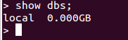
Before creating the database:

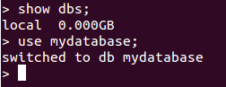
After creating Database:

New Database is created or it opens the Database if it is existing.
But the database won't be show when we type show dbs command because there is no document inserted.

SYNTAX:
db.move.insert({“Key_name”:”Value”})
show dbs

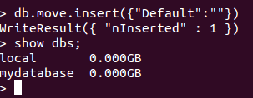

2. Delete Database:

SYNTAX:
use databasename
db.dropDatabase()
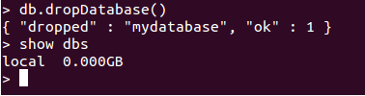

3. Create Collection:

Collections are Similar to tables in Database.

SYNTAX:
db.createCollection(name,options)

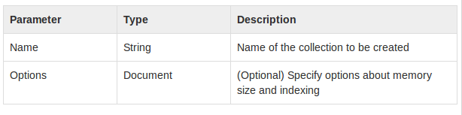
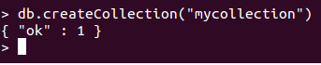

To See Collections:

SYNTAX:
show collections

4. Insertion of Document(Data/Row):

SYNTAX:
db.Collection_name.insert({key:values}) or
db.Collection_name.insert({key:values},{key:value})

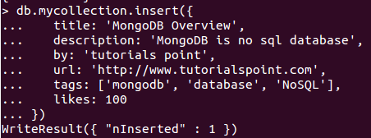

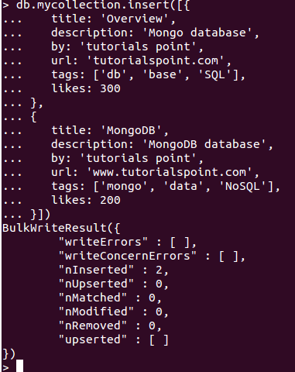

Drop Document(Row):

SYNTAX:
db.Collection_name.remove({key:value})

5. DELETE Collection:

SYNTAX:
db.Collection_name.drop()

6. UPDATE Document in Collection:

SYNTAX:
db.Collection_name.update({key:value},{key:newValue, key: Value,...})

