Files I’ve Included:

full_city_data_DATA603.csv: Has each of the cities with some curated emissions values and the walkability data averaged from the block groups that overlap them. I recommend working with this one.

city_blockgroup_pairs_DATA603.csv: Has the data in more granular detail. Each row is a block group or portion of a block group fully contained within the bounds of a city. It has both the block ID and the city ID. The values haven’t been averaged into one overall city value yet. This is useful if you want to get a more detailed distribution of the walkability values’ ranges within a city. You probably won’t need to use this one.

A Few Things to Remember:

-Energy use is measured by City. City borders are irregular, sometimes overlap each other, and are completely unrelated to the borders of block groups and counties.

-It is easier to work with the cities as the basis, since we can construct their walkability from block-group-to-city overlap without worrying about the block groups overlapping each other.

-Walkability Data is measured by Block Group. These are groups of blocks used for the US census purposes. They are larger than blocks and smaller than counties. They are organized.

-Vehicle pollution (as we’re measuring it here) is a combination of gasoline and diesel fuel.

-Per Capita = Per Person. In other words, the total value divided by the population of that city or area.

-A note on CO2e (CO2 equivalent)
CO2 vs. CO2e: What is the difference and why does it matter? | TechTarget

Importing into Google Colab (Recommended):
When you have the code in a Google Colab file, the files you reference can be updated without you needing to personally redownload them each time.

I’ve used my own file path for Google Drive, but if you’re accessing it from a shared folder, then your path may be a little different. If you view the drive folder from inside Colab, you can right click the file and select ‘Copy File Path.’
The Code:

import pandas as pd
from google.colab import drive
drive.mount('/content/drive')

citydf = pd.read_csv('/content/drive/MyDrive/UMBC/603_GroupProject_Shared/full_city_data_DATA603.csv')
print (citydf.head())

The Columns For full_city_data_DATA603.csv:
(The dataframe city_blockgroup_pairs_DATA603.csv uses similar column names.)
—-----------------------------------------------------------------
NAME: City name

NAMELSAD: The city name but it has ‘city’ or ‘town’ at the end

Change to State_Abbr: State name abbreviation

city_id: The city’s numerical ID

city_state_name: City Name, State Abbreviation (Austin, TX)

population: City population

house_units: Number of occupied housing units in the city.

miles_driven_pC: The average miles each resident has driven

agg_vehi_consum_pC: the gas + diesel gallons consumed per capita. I’m not sure if this is useful since they both have different emission amounts per gallon.

gasoline_consum_pC: the gasoline gallons consumed per capita.

diesel_combined_pC: the diesel gallons consumed per capita.

agg_vehi_emitGHG_pC: emissions per-capita for the vehicle categories: gasoline + diesel . Measured in metric tons of CO2 equivalent (mtons of CO2e)

agg_nonvehi_emitGHG_pC: emissions per-capita for the nonvehicle categories: residential/commercial/industry uses of electricity/natural gas (6 columns overall.) Measured in metric tons of CO2 equivalent (mtons of CO2e)

agg_combined_emitGHG_pC: emissions per-capita for combined vehicle and nonvehicle categories (8 columns overall.) Measured in metric tons of CO2 equivalent (mtons of CO2e)

driveGasoline_emitGHG_pC: emissions per-capita for gasoline. Measured in metric tons of CO2 equivalent (mtons of CO2e)

driveDiesel_emitGHG_pC: emissions per-capita for diesel. Measured in metric tons of CO2 equivalent (mtons of CO2e)

Everything after this point was added in from the block group based walkability data. The stuff before it is from the city based energy use data.

wlk_NatWalkInd_avg: National Walk Index for the city. I think it goes 1-20. Averaged by citizen experience, not by land area. So a city that was half empty space and half walkable and populated would have the same score as a city that was completely walkable and populated.

wlk_PeopleCounted : People tallied from the city’s block groups. In areas of partial overlap, I took the block group population and multiplied it by the overlap area over the block group’s full area. Maybe be a slightly different value than the

wlk_Workers: Workers tallied from the same city blocks. Same calculations as with wlk_PeopleCounted.

wlk_CountHU: Housing units tallied from the same city blocks. Occupied and unoccupied. Same calculations as with wlk_PeopleCounted.

wlk_HH: Households (occupied housing units) tallied from the same city blocks. Same calculations as with wlk_PeopleCounted.

wlk_D2A_EPHHM_avg: Employment & Household Entropy. This measures "Mix of Uses." A high score means a mix of jobs and housing in the same area.

wlk_D2B_E8MIXA_avg: Employment Entropy. Measures the diversity of job types (retail, office, service). More diversity usually means more reasons to walk.

wlk_D3B_avg: Street Intersection Density. High density means small blocks and more route choices, which is better for pedestrians.

wlk_D4A_avg: Distance to Transit. Measures how close the block group is to the nearest transit stop (bus, rail, etc.)

wlk_D2A_Ranked_avg: Measured as a value between 1-20. Otherwise the same as wlk_D2A_EPHHM_avg. Employment & Household Entropy. This measures "Mix of Uses." A high score means a mix of jobs and housing in the same area.

wlk_D2B_Ranked_avg: Measured as a value between 1-20. Otherwise the same as wlk_D2B_E8MIXA_avg. Employment Entropy. Measures the diversity of job types (retail, office, service). More diversity usually means more reasons to walk.

wlk_D3B_Ranked_avg: Measured as a value between 1-20. Otherwise the same as wlk_D3B_avg. Employment & Household Entropy. Street Intersection Density. High density means small blocks and more route choices, which is better for pedestrians.

wlk_D4A_Ranked_avg: Measured as a value between 1-20. Otherwise the same as wlk_D4A_avg. Distance to Transit. Measures how close the block group is to the nearest transit stop (bus, rail, etc.)

Note: When it comes to the score-vs-ranked version of walkability, I think it’s actually the score (non-ranked) version of the values that is used to calculate the overall walkability value. (Score values are the raw weighted values.) I’m not sure how they did the weighting, but it’s probably online.

Walkability Equation:
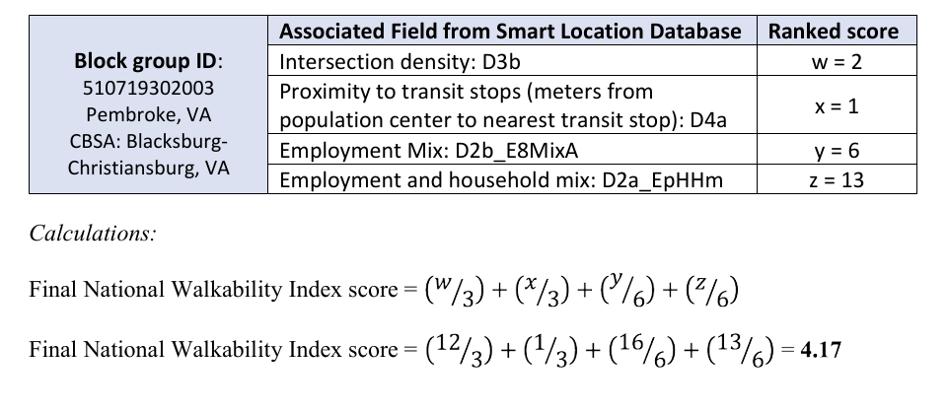
For more info:
https://www.epa.gov/smartgrowth/national-walkability-index-user-guide-and-methodology
https://www.gis.cancer.gov/research/WalkIndex_Codebook.pdf

That’s all for now. I’ll add more later on if there’s anything you guys want more details on.

Good Luck!
-Steven

