How ML Works in AI Sports Platform

The Big Picture
The platform has 3 layers of AI/ML that work together in a self-improving cycle:
Layer 1 (Browser): Real-time rep counting using MediaPipe in JavaScript -- rule-based, instant feedback.
Layer 2 (Server): Deep video re-analysis using OpenCV + MediaPipe -- extracts 30+ quality features.
Layer 3 (ML Models): Three trained models -- Form Classifier, Rep Calibrator, Verdict Learner -- that improve over time.
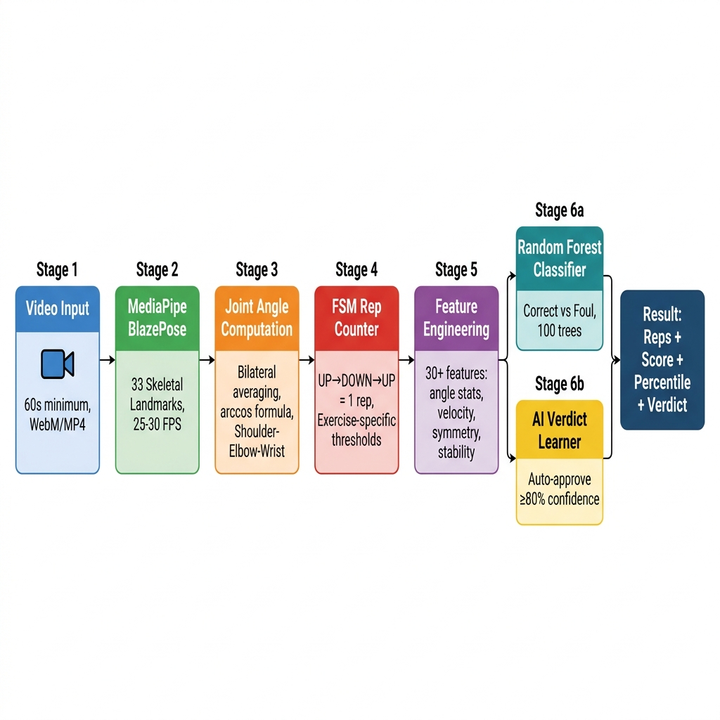
Fig. 1: AI Analysis Pipeline Overview

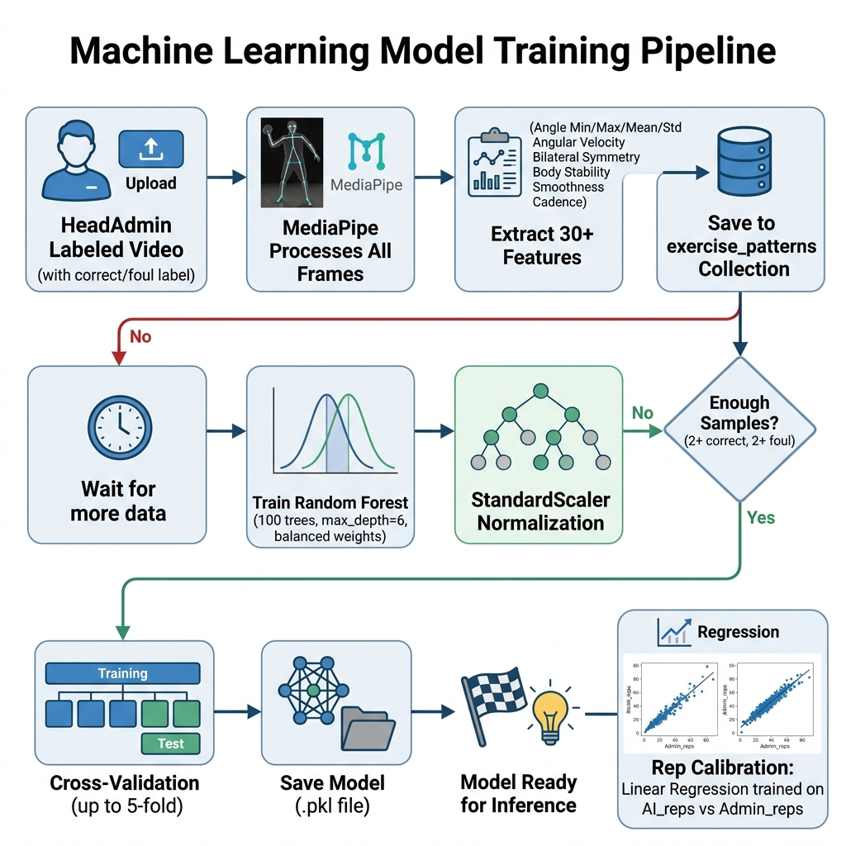
Fig. 2: ML Model Training Pipeline

Layer 1: Real-Time Rep Counting (Browser)
Files: src/hooks/usePoseDetection.ts + src/hooks/useRepCounter.ts
How it works:
1. Athlete opens camera -- MediaPipe Pose runs in the browser (JavaScript)
2. It detects 33 body landmarks in real-time (shoulders, elbows, hips, knees, etc.)
3. The system calculates the joint angle at the key point for each exercise:
- Pushups: Elbow angle (Shoulder -> Elbow -> Wrist)
- Sit-ups: Hip angle (Shoulder -> Hip -> Knee)
- Pull-ups: Elbow angle (Shoulder -> Elbow -> Wrist)
4. A state machine counts reps:
START -> Wait for "UP" position (angle > threshold)
UP -> angle drops below "DOWN" threshold -> "DOWN"
DOWN -> angle rises above "UP" threshold -> "UP" = +1 REP
Note: This is NOT ML -- it is rule-based angle detection. Fast but not always accurate. The server re-verifies independently.

Layer 2: Server-Side Video Analysis
File: server/services/video_analysis.py
Step 1: Extract Pose Data
Opens the video file with OpenCV. Runs MediaPipe Pose on every ~12th frame (samples at ~12 FPS). Tracks bilateral angles (averages left + right side for accuracy).
Step 2: Count Reps (Same State Machine)
if phase == "up" and angle < down_threshold:
phase = "down"
elif phase == "down" and angle > up_threshold:
phase = "up"
rep_count += 1
Step 3: Compute Quality Features
The server extracts 30+ features from the video:
Category | Features
Angle Stats | min, max, mean, std, range, median, IQR of primary joint angle
Body Alignment | body_line angle, hip_sag angle
Bilateral Symmetry | left-right difference (mean, max)
Dynamics | angular velocity (speed), angular acceleration (jerkiness)
Quality Scores | smoothness, shoulder stability, cadence regularity
Visibility | what % of body landmarks are visible
Rep Timing | duration of each rep (mean, std, min, max)

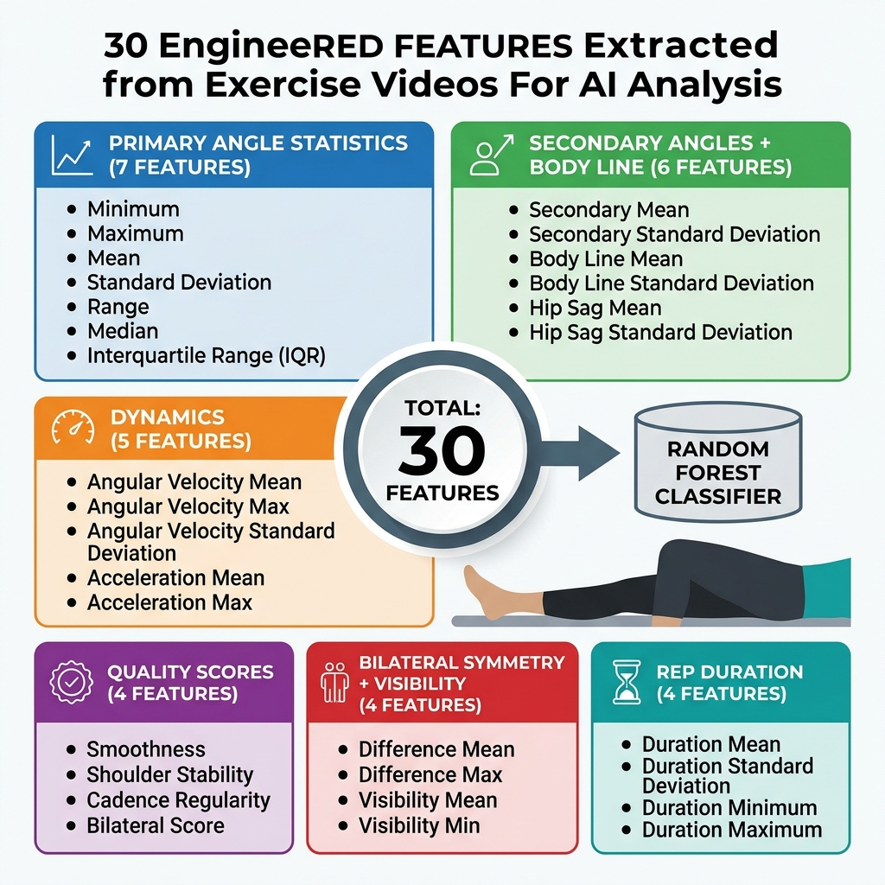
Fig. 3: 30 Engineered Features by Category

Step 4: Compare Against Trained Reference Patterns
If HeadAdmin has uploaded training videos, the server compares against reference patterns:
# Check if angle range is within trained acceptable limits
if min_angle < trained_min_range or min_angle > trained_max_range:
flags.append("unusual_min_angle")
form_score -= 0.10
# Check range-of-motion completeness
if angle_range < trained_rom_minimum:
flags.append("insufficient_rom")
form_score -= 0.15
Step 5: ML Classification (if model exists)
Passes the 28 features through the trained Random Forest Classifier to get a form prediction.
Step 6: Generate Verdict
# Verdict logic:
if critical_flags: -> "flag" (video unreadable, too short)
elif form_flags >= 3: -> "flag" (too many form issues)
elif form_score < 0.5: -> "flag" (terrible form)
elif confidence >= 0.7: -> "pass" (looks good!)
else: -> "flag" (uncertain, let admin review)

Layer 3: ML Models (The Actual Machine Learning)

Model A: Form Classifier
File: server/ai_training/classifier.py
Algorithm: Random Forest (100 trees, max depth 6)
Purpose: Classify exercise form as "correct" or "foul"
Training Data Source: HeadAdmin uploads labeled videos
HeadAdmin uploads video -> Labels it "correct" or "foul"
-> trainer.py extracts 28 features from the video
-> Saved to exercise_patterns collection
-> After >=2 correct AND >=2 foul samples -> Random Forest trains
28 Input Features:
FEATURE_NAMES = [
'primary_angle_min', 'primary_angle_max', 'primary_angle_mean',
'primary_angle_std', 'primary_angle_range', 'primary_angle_median',
'primary_angle_iqr',
'secondary_angle_mean', 'secondary_angle_std',
'body_line_mean', 'body_line_std',
'hip_sag_mean', 'hip_sag_std',
'bilateral_diff_mean', 'bilateral_diff_max',
'angular_velocity_mean', 'angular_velocity_max',
'angular_accel_mean',
'smoothness', 'shoulder_stability', 'cadence_regularity',
'bilateral_score',
'visibility_mean', 'visibility_min',
'rep_duration_mean', 'rep_duration_std',
'rep_duration_min', 'rep_duration_max',
]
Output: correct (1) or foul (0) + confidence probability

Model B: Rep Calibrator
File: server/ai_training/classifier.py (line 206)
Algorithm: Linear Regression
Purpose: Correct AI rep counting bias
When HeadAdmin provides expected rep count, the system learns:
AI counted 8 reps -> Admin says actually 10
AI counted 16 reps -> Admin says actually 15
-> Linear model: corrected = 0.95 x ai_reps + 1.2
Needs: >=3 samples with expected_reps to train

Model C: Verdict Learner
File: server/services/ai_verdict.py
Algorithm: Random Forest (50 trees, max depth 5)
Purpose: Learn from admin approve/flag decisions to auto-approve future submissions
Admin approves submission -> Save features + "approved" label
Admin flags submission -> Save features + "flagged" label
-> After 10+ labeled reviews -> Random Forest trains automatically
-> Every 5 new reviews -> Model retrains
12 Input Features:
[confidence, verified_reps, form_score, num_flags,
has_poor_visibility, has_few_frames, has_short_video,
score, is_pushups, is_situps, is_pullups,
score_vs_reps_diff]
Auto-Approve: If model is >=80% confident, the submission is auto-approved without admin review.

Complete Flow: What Happens When an Athlete Submits a Test
1. Athlete records video in browser (camera + MediaPipe real-time counting)
2. Browser sends POST /api/tests/submit with video file + browser-counted score
3. Flask API uploads video to Google Drive, receives file_id
4. Server runs full MediaPipe analysis on video (OpenCV frame extraction)
5. MediaPipe returns: {reps, form_score, flags, quality features}
6. Server loads reference_patterns from MongoDB (if HeadAdmin has trained)
7. ML models run: predict_form(28 features) + calibrate_reps(ai_count)
8. ML returns: {correct/foul prediction, confidence probability}
9. AI Verdict Learner runs: predict_verdict(12 features)
10. If auto_decision=true and confidence>=80%: submission auto-approved
11. Otherwise: submission set to "pending" for admin manual review
12. Result saved to MongoDB (test_results + submissions collections)
13. Athlete receives result: score, percentile, rating, AI verdict
14. If auto_decision=false: admin reviews, decision feeds back to Verdict Learner
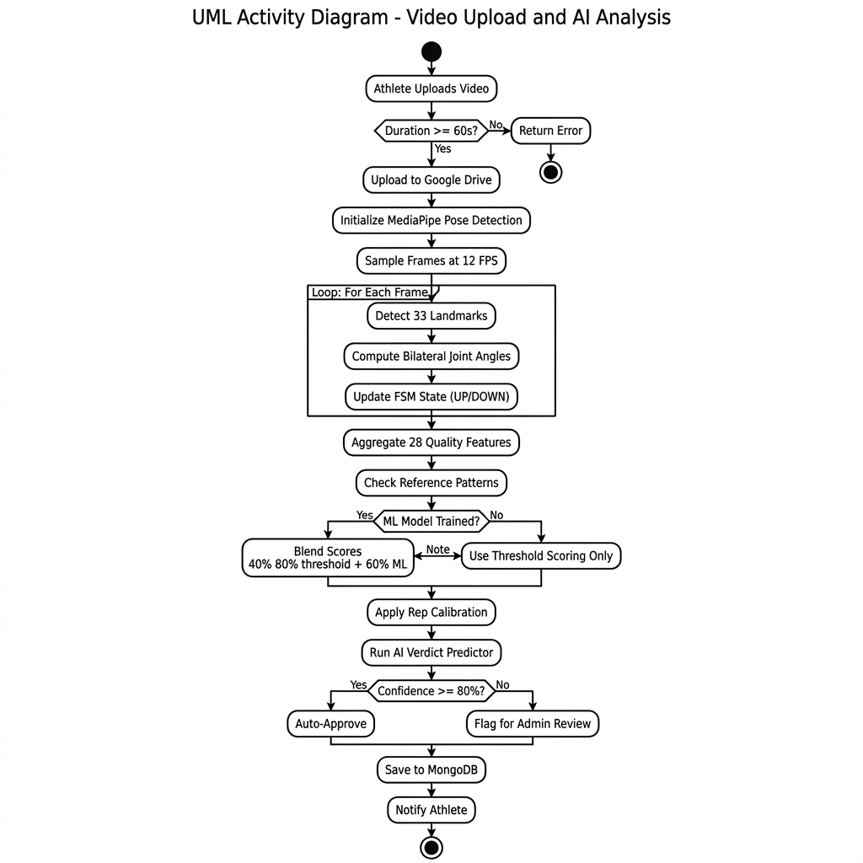
Fig. 4: Complete Video Analysis Activity Flow

Summary Table
Model | Algorithm | Input | Output | Trains When
Rep Counter | Rule-based FSM | Joint angles | Rep count | N/A (rules)
Form Classifier | Random Forest (100 trees) | 28 pose features | correct/foul + confidence | HeadAdmin uploads >=2 correct + >=2 foul
Rep Calibrator | Linear Regression | AI rep count | Corrected count | >=3 samples with expected_reps
Verdict Learner | Random Forest (50 trees) | 12 analysis features | approve/flag + auto | Admin reviews >=10 submissions
Reference Patterns | Statistical thresholds | Correct training videos | Angle/quality thresholds | Every HeadAdmin upload

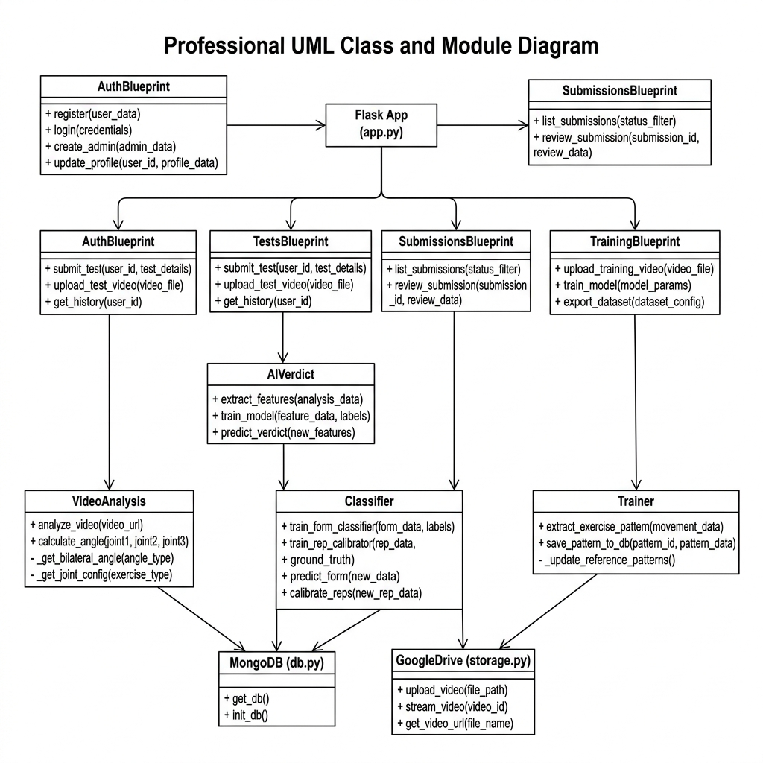
Fig. 5: Backend Module Architecture

