

Software Requirements Specification
For

AI Based Sports Platform For Analysis And Ranking

Date: 14 March 2026

Prepared by

Specialization | SAP ID | Name
AIML | 500124397 | Shashank Dimri
AIML | 500126591 | Arsh Rathi
AIML | 500119770 | Ujjawal Gupta
AIML | 500123193 | Aayush Piplani

AI Cluster
School Of Computer Science
UNIVERSITY OF PETROLEUM & ENERGY STUDIES,
DEHRADUN – 248007. Uttarakhand

REVISION HISTORY

Date | Change | Reason for Changes | Mentor Signature
14/03/2026 | Initial Draft | First Version

TABLE OF CONTENTS

No. | Topic | Page
 | Table of Content
 | Revision History
1 | Introduction
 | 1.1 Purpose of the Project
 | 1.2 Target Beneficiary
 | 1.3 Project Scope
 | 1.4 References
2 | Project Description
 | 2.1 Reference Algorithm
 | 2.2 Characteristic of Data
 | 2.3 SWOT Analysis
 | 2.4 Project Features
 | 2.5 User Classes and Characteristics
 | 2.6 Design and Implementation Constraints
 | 2.7 Design Diagrams
 | 2.8 Assumptions and Dependencies
3 | System Requirements
 | 3.1 User Interface
 | 3.2 Software Interface
 | 3.3 Database Interface
 | 3.4 Protocols
4 | Non-Functional Requirements
 | 4.1 Performance Requirements
 | 4.2 Security Requirements
 | 4.3 Software Quality Attributes
5 | Other Requirements
 | Appendix A: Glossary
 | Appendix B: Analysis Model
 | Appendix C: Issues List

1. INTRODUCTION

1.1 Purpose of the Project
The purpose of this project is to design and develop an AI-powered sports performance evaluation platform that enables athletes to undergo standardized fitness assessments remotely using video analysis and computer vision technologies.
Traditional sports talent identification processes require athletes to physically visit specialized testing centers where trained coaches manually assess their physical capabilities. This approach is often expensive, time-consuming, geographically limited, and inaccessible to athletes living in rural or economically disadvantaged areas.
The proposed system addresses these limitations by providing a web-based platform where athletes can record or upload videos of standardized fitness tests including push-ups, sit-ups, and vertical jumps. These videos are then analyzed using Artificial Intelligence, Computer Vision, and Pose Estimation algorithms to automatically measure performance metrics such as repetition count, movement quality, and jump height.
The system aims to:
- Enable remote sports performance evaluation
- Provide objective and consistent measurement
- Support large-scale talent identification
- Reduce the cost and logistical challenges associated with traditional testing methods
This project aligns with the Smart India Hackathon 2025 problem statement on AI-based sports talent identification and aims to democratize access to professional sports assessment.

1.2 Target Beneficiary
The platform benefits multiple stakeholders within the sports ecosystem:

Athletes:
Young athletes can evaluate their fitness performance without visiting physical testing centers. This particularly benefits rural athletes who lack access to professional facilities.
Sports Organizations:
Organizations such as the Sports Authority of India (SAI) can use the system to identify talented athletes across a wider geographic area.
Coaches and Trainers:
Coaches can analyze performance metrics and identify promising athletes using objective AI-based analysis.

Talent Scouts:
Scouts can use the platform to filter and shortlist athletes based on standardized performance benchmarks.
Educational Institutions:
Schools and universities can use the system to monitor students' physical fitness levels.

1.3 Project Scope
The proposed system is a web-based AI platform for automated sports fitness assessment. The system will allow athletes to:
- Register and create personal profiles
- Record or upload fitness test videos
- Submit videos for AI-based analysis
- Receive automated performance results
- Compare performance with age-group benchmarks
The platform currently focuses on three standardized fitness tests:
1. Push-ups – Upper body strength assessment
2. Sit-ups – Core strength assessment
3. Vertical Jump – Lower body explosive power measurement
The system categorizes athletes into the following age groups:
- Under-14
- Under-17
- Under-21
Each athlete's performance is evaluated using AI-based pose detection and motion analysis. Results are stored in a database and displayed through an interactive dashboard. Future versions may support additional fitness tests such as Shuttle Run, Endurance Run, Sprint Tests, and Athlete Ranking Systems.

1.4 References
- G. Bradski, “The OpenCV Library,” Dr. Dobb's Journal of Software Tools, vol. 25, no. 11, pp. 120–123, 2000.

- Google AI, “MediaPipe Solutions Guide,” 2024. Available: https://ai.google.dev/edge/mediapipe/solutions/guide

- R. Khurana, S. Zhang, and J. Canny, “GymCam: Detecting, Recognizing and Tracking Simultaneous Exercises in Unconstrained Scenes,” Proceedings of the ACM on Interactive, Mobile, Wearable and Ubiquitous Technologies, vol. 2, no. 4, Article 172, 2018.

- C. Lugaresi et al., “MediaPipe: A Framework for Building Perception Pipelines,” arXiv preprint arXiv:1906.08172, 2019.

- Ministry of Education, Government of India, “Smart India Hackathon 2025 – Problem Statement 25073,” 2025. Available: https://www.sih.gov.in/sih2025PS

- D. Smilkov et al., “TensorFlow.js: Machine Learning for the Web and Beyond,” Proceedings of Machine Learning and Systems, vol. 1, pp. 309–321, 2019.

- Sports Authority of India, “National Talent Identification and Development Scheme: Fitness Test Protocols,” 2023. Available: https://sai.gov.in/

- D. Zecha, M. Einfalt, and R. Lienhart, “Kinematic Pose Rectification for Performance Analysis in Sports,” Proceedings of the IEEE Conference on Computer Vision and Pattern Recognition (CVPR) Workshops, 2019.

- S. Dill et al., “Accuracy Evaluation of 3D Pose Estimation with MediaPipe Pose for Physical Exercises,” 2023.

- J. W. Kim et al., “Human Pose Estimation Using MediaPipe Pose and Optimization Method Based on a Humanoid Model,” Applied Sciences, vol. 13, 2023.

2. PROJECT DESCRIPTION

2.1 Reference Algorithm
The core functionality of the system is based on Pose Estimation and Computer Vision algorithms. The AI system processes uploaded videos using the following steps:

Step 1 – Video Input: Athletes record or upload videos performing standardized fitness exercises in .mp4 or .webm format.
Step 2 – Frame Extraction: The system extracts frames from the uploaded video using OpenCV at the optimal sampling rate for each exercise type.
Step 3 – Pose Detection: Each frame is processed using MediaPipe Pose which detects 33 human body landmarks, including shoulders, elbows, wrists, hips, knees, and ankles.
Step 4 – Feature Extraction: The coordinates of detected landmarks are used to calculate joint angles, body movement patterns, and position changes over time.
Step 5 – Exercise Recognition: The system identifies exercise repetitions by analyzing joint movement patterns. Push-ups: elbow angle threshold; Sit-ups: torso angle relative to hips; Vertical Jump: hip landmark displacement from ground.
Step 6 – Performance Evaluation: The extracted metrics are compared with age-specific benchmark values from SAI standards.
Step 7 – Result Generation: Performance results are generated, scored, and stored in the database for display on the athlete dashboard.

2.2 Characteristic of Data
The system processes video-based motion data captured by athletes during fitness tests.

Data Source:
Primary Data: Athlete-uploaded videos recorded using smartphone cameras during fitness test execution.
Secondary Data: Fitness benchmark values from Sports Authority of India National Talent Identification and Development Scheme guidelines.

Data Types:
- Video files (.mp4 / .webm) – Minimum 480p resolution, 25 FPS
- Frame sequences extracted via OpenCV
- Pose landmark coordinates (33 points, x/y/z with visibility score)
- Derived performance metrics: joint angles, rep count, jump height

Data Processing:
Video frames are analyzed using computer vision techniques including pose landmark detection, joint angle calculation, motion tracking, and movement threshold detection. These numerical features are used to calculate exercise repetitions and movement quality scores.

2.3 SWOT Analysis
Table 1: SWOT Analysis – AI-Based Sports Platform
STRENGTHS  • Low-cost sports evaluation system  • Scalable remote testing platform  • Eliminates need for physical testing centers  • Objective AI-based performance analysis  • Supports large-scale talent identification | WEAKNESSES  • Accuracy depends on video quality  • Incorrect camera angles may affect pose detection  • Requires internet connectivity  • Limited to three exercises in current version
OPPORTUNITIES  • Integration with government sports initiatives (Khelo India)  • Large-scale national athlete database  • Expansion to multiple sports disciplines  • Rural outreach through digital literacy programs | THREATS  • Video manipulation and spoofing by users  • Environmental factors such as poor lighting  • Variations in camera positioning  • Dependency on third-party AI libraries

2.4 Project Features
The platform includes the following major features:
1. Athlete Registration and Authentication
2. Video Recording and Upload System
3. AI-Based Exercise Detection using MediaPipe Pose
4. Automated Repetition Counting via Joint Angle State Machine
5. Age-Based Performance Evaluation and Percentile Ranking
6. Athlete Performance Dashboard with Trend Visualization
7. Secure Data Storage in MongoDB
8. Administrative Monitoring System for Coaches and Officials

2.5 User Classes and Characteristics
Table 2: User Classes and Characteristics
User Class | Description | Access Rights
Athlete | Primary users who upload videos and receive performance analysis results. Mainly young sportspersons aged 10–21. | Register, login, upload videos, view AI analysis results, access personal dashboard
Coach / Trainer | Analyze athlete performance and provide training guidance. May manage multiple athlete profiles. | View athlete submissions and performance metrics; provide feedback notes
System Administrator | Responsible for maintaining system operations and monitoring database records. | Full system access: user management, database monitoring, AI model updates

2.6 Design and Implementation Constraints
Hardware Constraints:
- Smartphone camera required for video recording
- Stable internet connection required for video upload
- Minimum device specification: 2 GB RAM, Android 8.0 / iOS 13

Software Constraints:
- Frontend developed using React.js 18.2 with TailwindCSS 3.3
- Backend implemented using Python Flask 3.0
- AI models implemented using MediaPipe and OpenCV-Python
- Database implemented using MongoDB 6.0
- Video storage implemented using MinIO (S3-compatible)

Security Constraints:
- User authentication required using JWT (JSON Web Token)
- Secure storage of user data with encrypted passwords (bcrypt)
- HTTPS/TLS 1.3 for all client-server communications

2.7 Design Diagrams
The following UML and system design diagrams describe the architecture and behaviour of the AI-Based Sports Platform. These diagrams describe the interaction between system components and users.

Use Case Diagram:
The Use Case Diagram illustrates the interaction between the three primary actors (Athlete, Coach/Official, and System Administrator) and the key system functions including registration, video upload, AI analysis, result viewing, and administrative management.

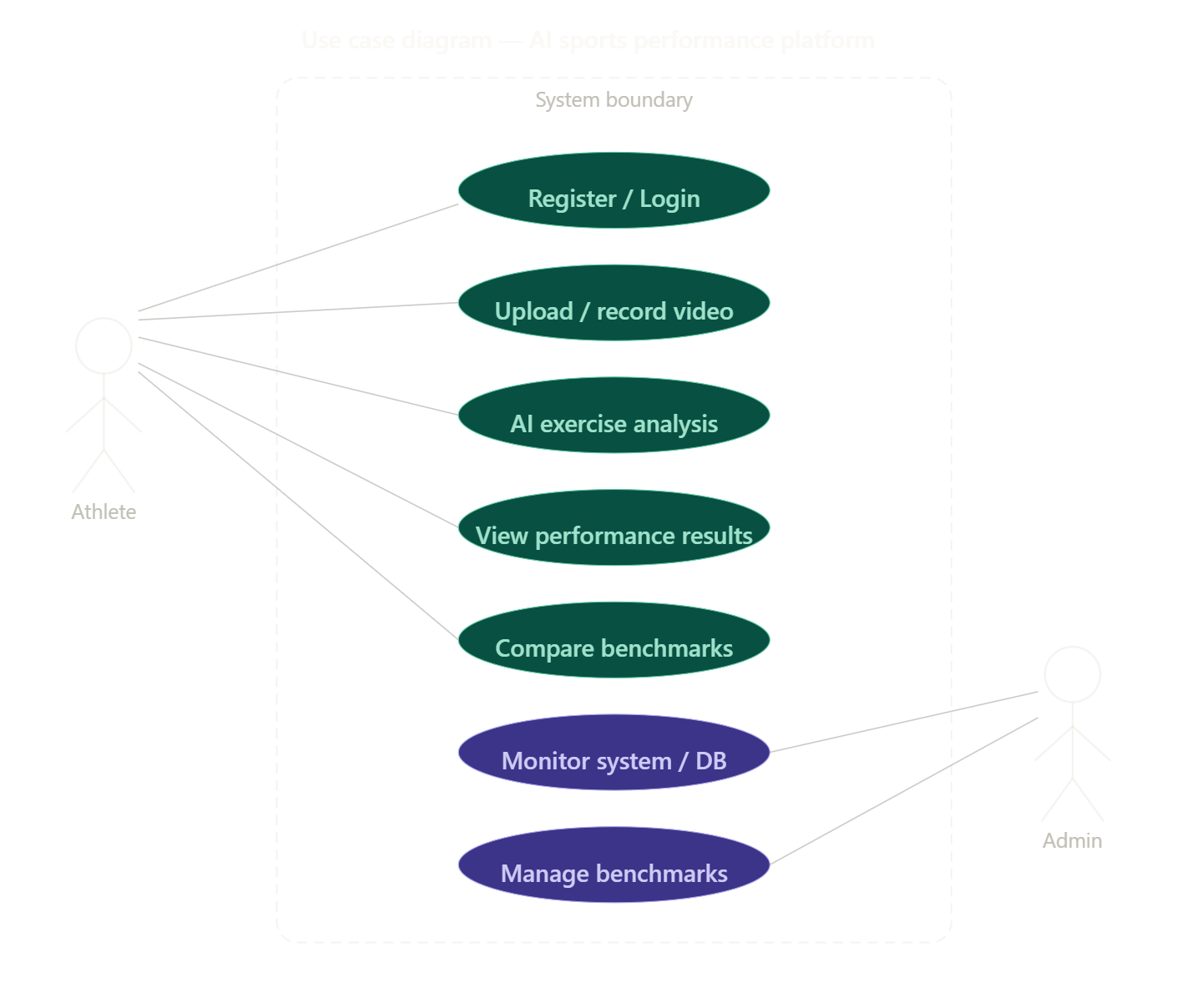
Figure 1: Use Case Diagram – AI-Based Sports Platform

Activity Diagram:
The Activity Diagram illustrates the sequential workflow of the system from athlete video submission through frame extraction, pose detection, feature extraction, rep counting, performance evaluation, to final result generation and storage.

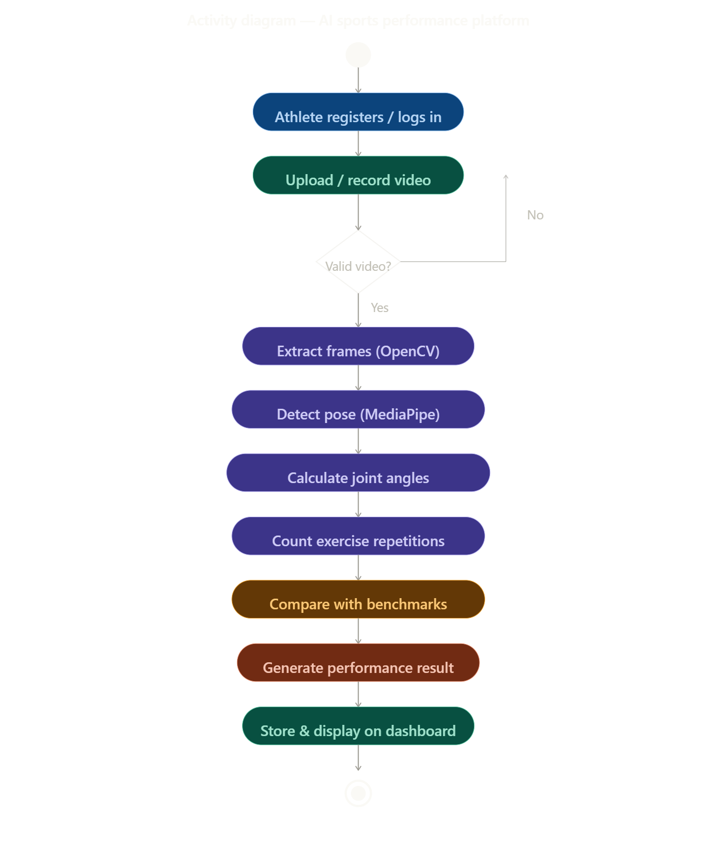
Figure 2: Activity Diagram – Exercise Analysis Workflow

Sequence Diagram:
The Sequence Diagram depicts the time-ordered message flow between the Athlete, Browser (Frontend), Flask Backend, AI Analysis Engine, and MongoDB Database during the video submission and analysis process.

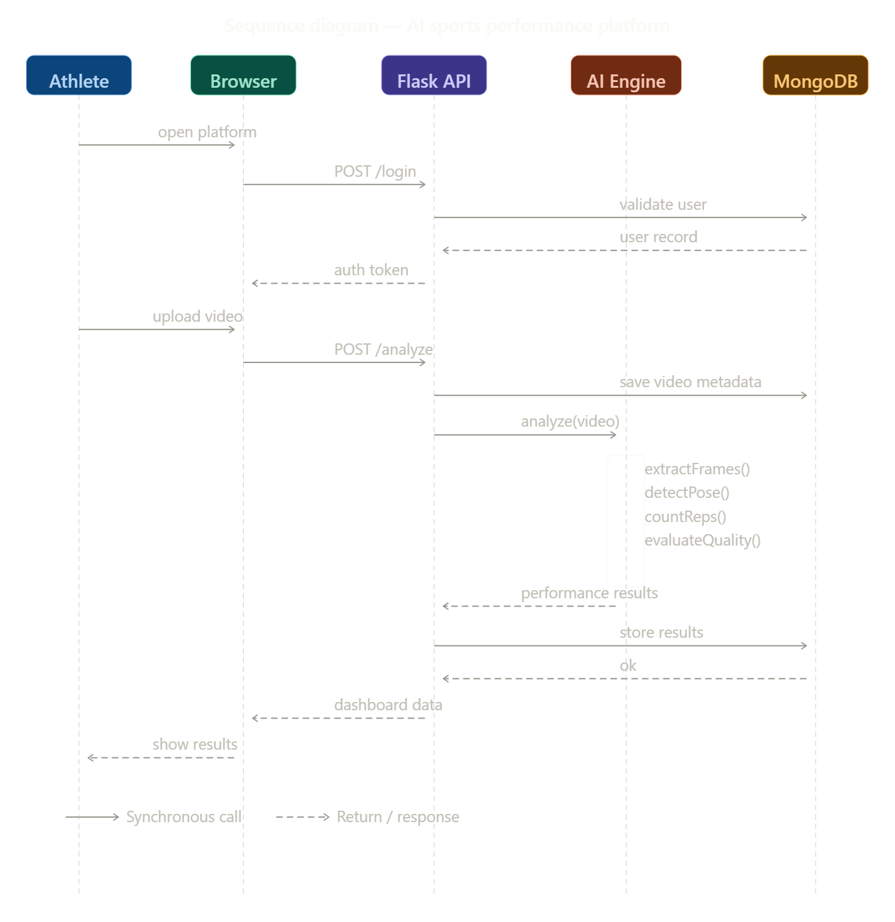
Figure 3: Sequence Diagram – Video Submission and AI Analysis

Class Diagram:
The Class Diagram defines the key data entities of the system including Athlete, TestSubmission, AnalysisResult, SAIBenchmark, and OfficialUser, along with their attributes, methods, and relationships.

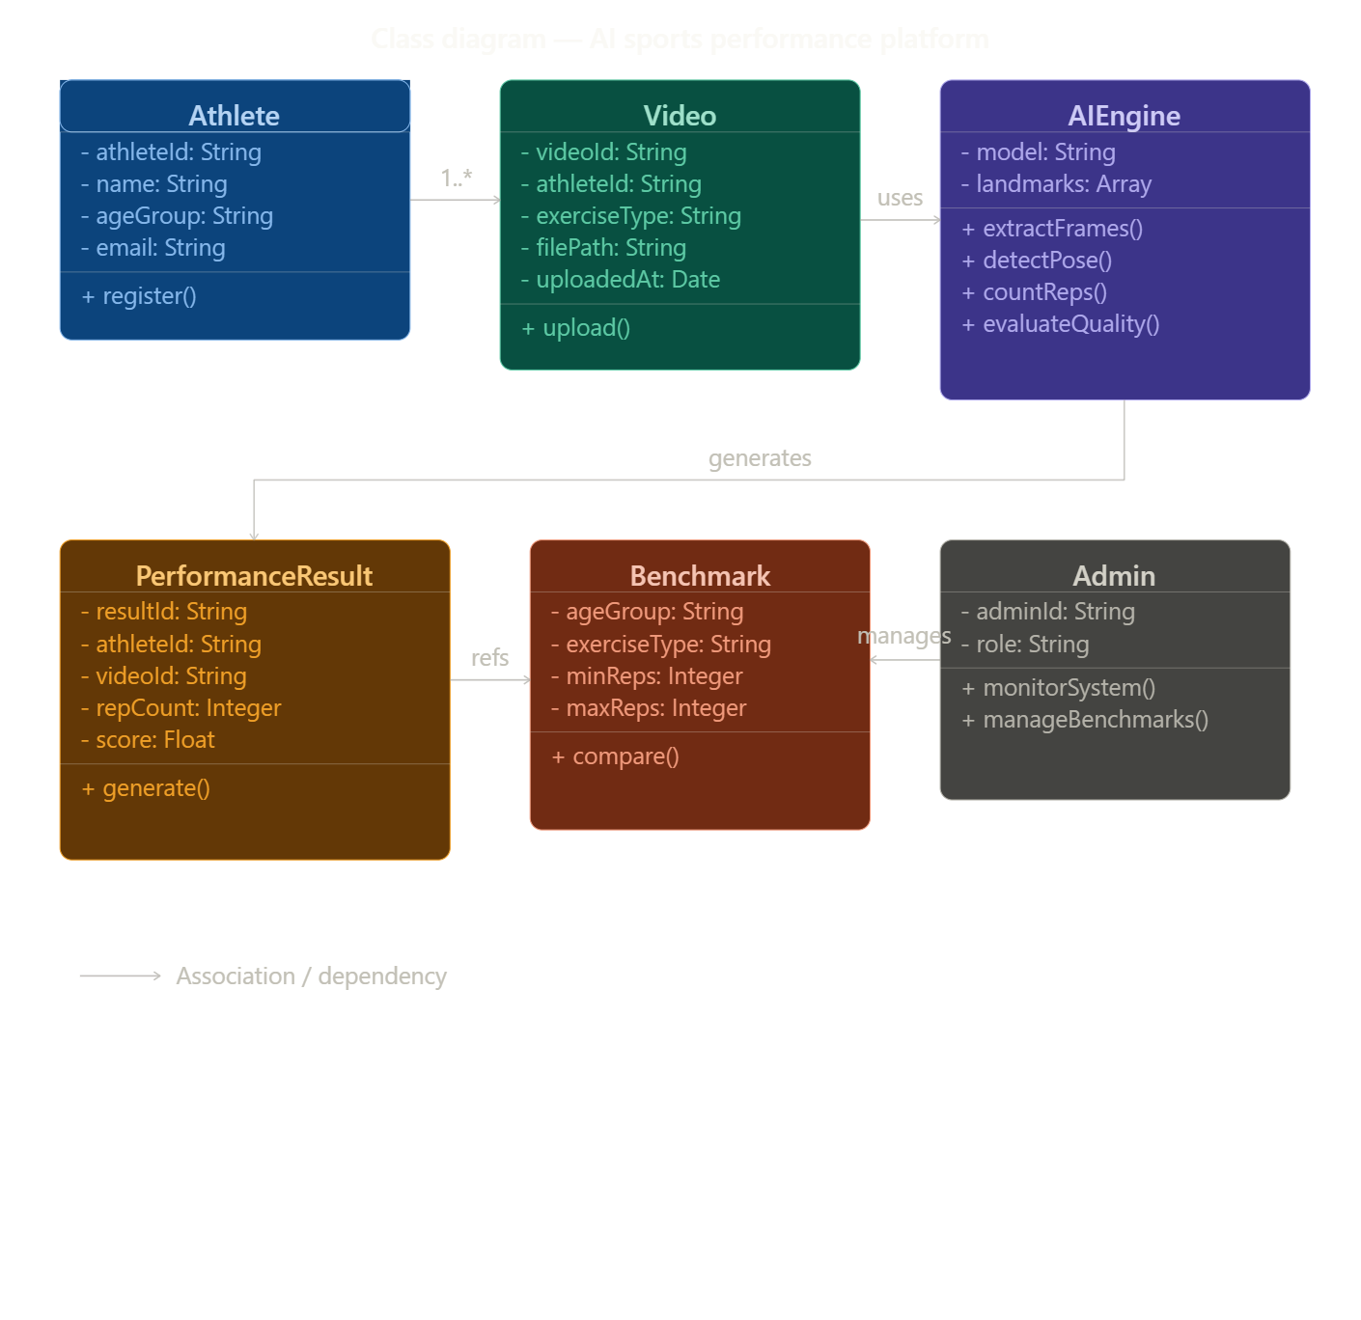
Figure 4: Class Diagram – System Data Model

Data Flow Diagram:
The Data Flow Diagram (DFD) Level 1 illustrates the flow of data between external entities (Athlete, Official), internal processes (Authentication, Video Upload, AI Analysis, Benchmark Comparison, Dashboard Rendering), and data stores (MongoDB, MinIO, Redis).

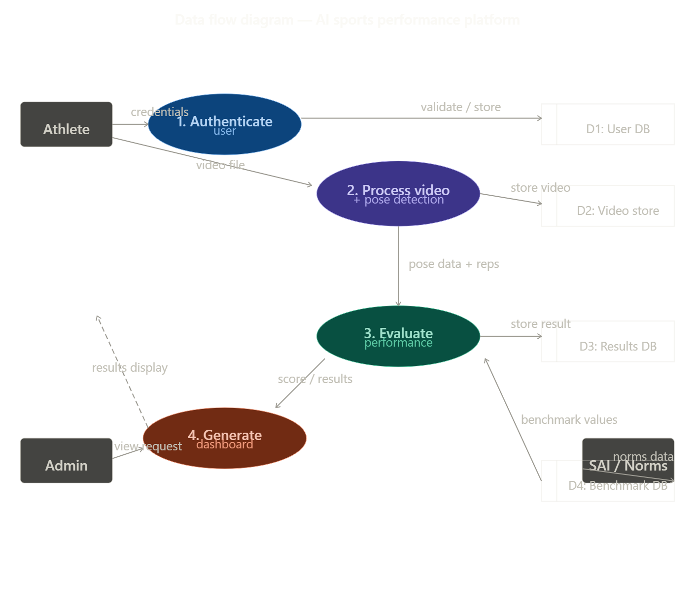
Figure 5: Data Flow Diagram (Level 1)

State Diagram:
The State Diagram describes the lifecycle of a video submission through its various states: Uploaded, Processing, Analyzed, Flagged, and Completed, along with the transitions triggered by system events and AI processing outcomes.

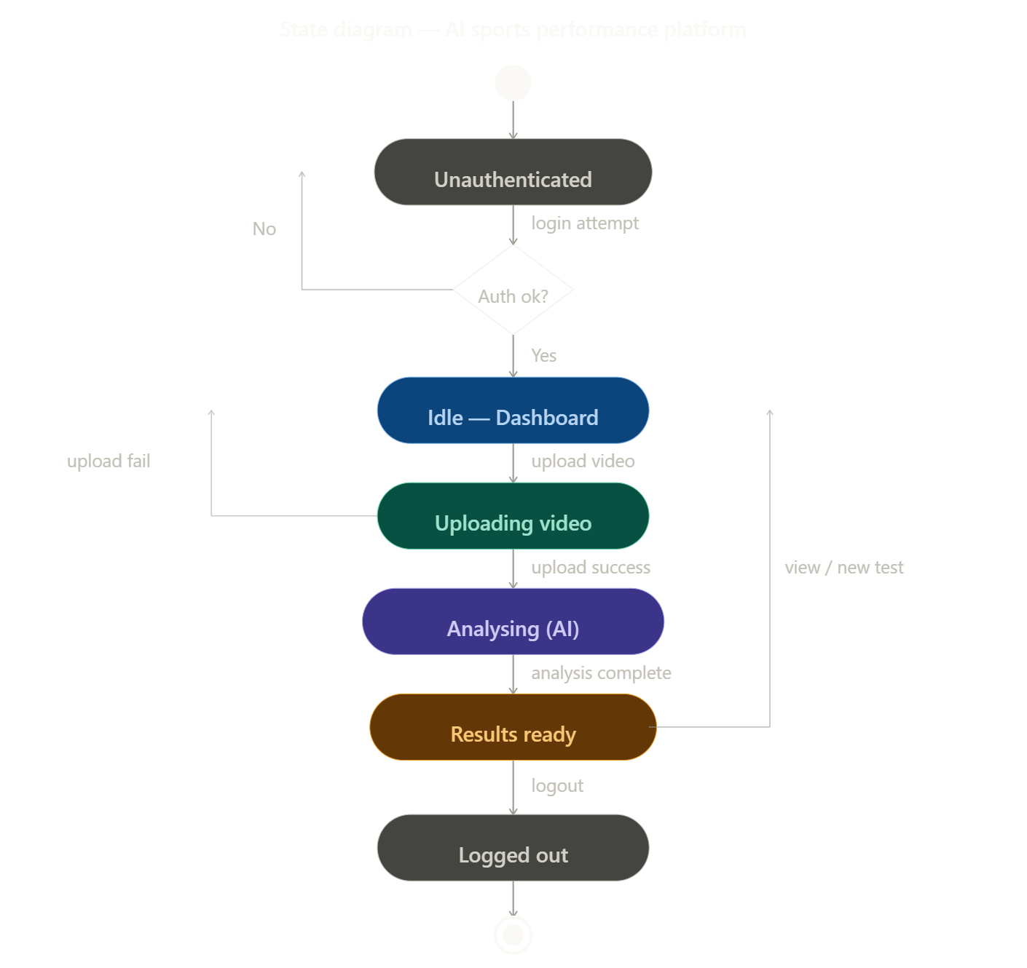
Figure 6: State Diagram – Video Submission Lifecycle

2.8 Assumptions and Dependencies
Assumptions:
- Users record videos with the full body visible and the camera positioned at an appropriate distance
- The camera remains stable during recording to allow consistent pose tracking
- Internet connectivity is available for video upload and result retrieval
- Adequate lighting is present during video recording for accurate landmark detection

Dependencies:
- MediaPipe Pose Detection framework (Google) – BlazePose model for 33-landmark detection
- TensorFlow.js library – WebGL-accelerated in-browser neural network inference
- OpenCV Computer Vision framework – video frame extraction and quality assessment
- MongoDB – document database for athlete profiles and analysis results
- MinIO – S3-compatible object storage for video files

3. SYSTEM REQUIREMENTS

3.1 User Interface
The system provides a web-based graphical user interface where athletes can register, login, record or upload videos, view performance analysis, and access their personal dashboard. The interface is responsive and compatible with both desktop and mobile devices.

Athlete Interface Screens:
- Landing Page: Project introduction with registration and login entry points
- Registration and Login: JWT-authenticated form capturing name, age, gender, district, and contact details
- Exercise Selection Dashboard: Card-based display of the three available fitness tests with setup instructions
- Video Recording Screen: Live camera feed with real-time MediaPipe skeleton overlay, countdown timer, and recording controls
- Performance Dashboard: Historical test results, trend graphs, and percentile rank display

Administrator Interface:
- Admin Panel: Athlete submission review, approval or flagging of videos, and performance report generation
- Leaderboard View: Athlete rankings filterable by age group and exercise type

3.2 Software Interface
The frontend communicates with the backend using REST APIs. The main system modules and their interfaces are:
Table 3: Software Interface – System Modules
Module | Technology | Responsibility
Frontend | React.js 18.2 + TailwindCSS 3.3 | User interface, video recording, real-time pose overlay
AI Engine | MediaPipe Pose + OpenCV + TensorFlow.js | Frame analysis, landmark detection, rep counting
Backend Server | Python Flask 3.0 + Flask-JWT-Extended | REST API, authentication, job orchestration
Object Storage | MinIO (S3-compatible) | Video file storage and retrieval
Database | MongoDB 6.0 + PyMongo 4.5 | Athlete profiles, submissions, analysis results
Cache / Queue | Redis 7.2 | Session caching and asynchronous job queue

3.3 Database Interface
MongoDB 6.0 is used as the primary database. The database stores the following collections:
Table 4: MongoDB Collections
Collection | Key Fields
athletes | _id, name, age, gender, district, state, mobileNumber, passwordHash, createdAt
submissions | _id, athleteId, exerciseType, videoPath, timestamp, status (pending/processing/completed/flagged)
analysisResults | _id, submissionId, exerciseType, repCount, avgJointAngle, performanceScore, percentileRank
saiBenchmarks | _id, exerciseType, ageGroup, gender, percentiles {p25, p50, p75, p90, p95}
officialUsers | _id, name, employeeId, region, role, passwordHash, lastLogin
systemLogs | _id, userId, action, timestamp, ipAddress, details

MinIO Object Storage: Video files stored with key pattern {athleteId}/{submissionId}/{timestamp}.mp4 with 12-month lifecycle retention and AES-256 server-side encryption.

3.4 Protocols
- Communication Protocol: All client-server communications use HTTPS over TLS 1.3 with HTTP/2 for multiplexed request handling.
- Authentication Protocol: JWT (JSON Web Token) with RS256 signing. Access tokens expire in 15 minutes; refresh tokens expire in 7 days.
- Video Upload Protocol: Chunked multipart HTTP upload to Flask API, which proxies to MinIO. Chunk size: 5 MB. Resumable uploads supported.
- Real-Time Notification Protocol: WebSocket (Socket.IO) for pushing AI analysis completion events to the athlete's browser.
- Security Protocol: CSRF protection via SameSite cookie policy. Rate limiting: 100 requests per minute per user. Input validation and NoSQL injection prevention on all endpoints.

4. NON-FUNCTIONAL REQUIREMENTS

4.1 Performance Requirements
The system should meet the following performance targets:
- Video Processing: Server-side AI analysis must complete within 60 seconds for a 60-second exercise video. On-device inference must maintain a minimum of 25 FPS on modern devices.
- Response Time: All standard API endpoints must respond within 2 seconds under normal load conditions.
- Concurrent Users: System must support a minimum of 100 simultaneous users with active video uploads and analysis jobs without performance degradation.
- Availability: The platform must achieve 99.5% uptime during active evaluation periods.
- Scalability: Architecture supports horizontal scaling of Flask workers via Docker containers behind an Nginx load balancer.

4.2 Security Requirements
The following security measures are implemented:
- User Authentication: JWT-based authentication on all protected endpoints. Account lockout after 5 failed login attempts.
- Data Encryption: All data in transit encrypted via TLS 1.3. Video files encrypted at rest using AES-256. Passwords hashed with bcrypt (cost factor 12).
- Secure Storage of User Data: Athlete PII stored in encrypted MongoDB collections. Athletes can request deletion of their video data.
- Encrypted Communication: HTTPS enforced for all client-server communication. HTTP requests redirected to HTTPS via Nginx.
- Input Validation: All API inputs validated and sanitized. MIME-type and magic-byte verification applied to all video uploads.

4.3 Software Quality Attributes
Table 5: Software Quality Attributes
Attribute | Description
Reliability | Asynchronous AI processing decouples video upload from analysis. Retry logic with exponential backoff for failed operations.
Scalability | Horizontal scaling of Flask workers via Docker; MongoDB sharding configurable for 1M+ athlete records.
Maintainability | Modular React component architecture; Flask Blueprints by domain; 80% code coverage target with Pytest and Jest.
Usability | Mobile-first responsive design; onboarding tutorial with animated exercise guides; plain-language error messages.
Portability | Dockerized deployment on any Linux server; PWA compatible with Chrome, Firefox, and Safari on Android and iOS.
Correctness | AI rep-counting accuracy within ±5% of human expert, validated against labeled test dataset.
Testability | All API endpoints covered by Pytest integration tests; end-to-end testing using Playwright for key user flows.
Interoperability | RESTful JSON API supports future integration with third-party sports management systems.

5. OTHER REQUIREMENTS

The following additional requirements apply to the system:

Future Improvements:
- Additional Fitness Tests: Shuttle run, endurance run, sprint tests, and pull-up assessment modules.
- AI-Based Athlete Ranking System: Composite score computation and national leaderboard across all five SAI fitness tests.
- Integration with National Sports Databases: API connection to SAI NTIDS and Khelo India program data systems.
- Mobile Application Development: Native Android and iOS apps for improved camera access and offline functionality.
- Multi-Language Support: Hindi and regional language interface translations for wider accessibility.

Legal and Compliance Requirements:
- Compliance with Indian Information Technology Act, 2000 regarding storage and processing of personally identifiable information.
- Parental consent requirement for athletes under 18 years of age at registration.
- Athlete video data must not be shared with third parties without explicit written consent.

APPENDIX A: GLOSSARY

Table 6: Glossary of Terms and Abbreviations
Term / Abbreviation | Definition
AI | Artificial Intelligence – simulation of human intelligence by computer systems
ML | Machine Learning – subset of AI enabling systems to learn from data
API | Application Programming Interface – defines how software components interact
PWA | Progressive Web Application – web app with native-app capabilities including offline access
MediaPipe | Open-source framework by Google for real-time human pose detection using ML
TensorFlow.js | JavaScript ML library enabling AI model inference directly in web browsers
OpenCV | Open Source Computer Vision Library – used for video processing and frame extraction
JWT | JSON Web Token – compact URL-safe token for authentication
REST | Representational State Transfer – architectural style for web APIs using HTTP
MongoDB | NoSQL document-oriented database storing data in JSON-like flexible documents
MinIO | S3-compatible open-source object storage for binary files such as videos
Redis | In-memory data store used for caching and message brokering
Flask | Lightweight Python web micro-framework for building REST APIs
React.js | JavaScript library for building component-based user interfaces
SAI | Sports Authority of India – national body for sports infrastructure and talent identification
SIH | Smart India Hackathon – national-level hackathon organized by Ministry of Education
HTTPS | Hypertext Transfer Protocol Secure – encrypted version of HTTP using TLS
ROM | Range of Motion – the extent of movement measurable at a body joint
Pose Estimation | Computer vision technique detecting key human body joint positions in images or video
Joint Angle | Angle at a body joint computed from landmark coordinates using the dot product formula

APPENDIX B: ANALYSIS MODEL

This appendix presents the key analytical models and data structures underpinning the AI-Based Sports Platform system design.

B.1 Pose Detection Model
The system uses the MediaPipe BlazePose model which detects 33 three-dimensional body landmarks per frame (x, y, z coordinates plus visibility score). The following landmarks are critical for exercise analysis:
Table 7: Key MediaPipe Landmarks by Exercise
Exercise | Key Landmarks | Feature Extracted
Push-Up | Shoulder (11/12), Elbow (13/14), Wrist (15/16) | Elbow flexion angle – rep counted when angle drops below threshold
Sit-Up | Shoulder (11/12), Hip (23/24), Knee (25/26) | Torso inclination angle – rep counted on full up/down cycle
Vertical Jump | Hip (23/24), Knee (25/26), Ankle (27/28) | Vertical hip displacement in cm – peak displacement = jump height

B.2 Joint Angle Calculation Formula
Joint angles are computed using the dot product of vectors formed by three landmark coordinates. For joint B formed by points A, B, and C:

angle = arccos ( (BA · BC) / ( |BA| × |BC| ) )

where BA and BC are vectors from joint B to adjacent landmarks A and C. The angle is expressed in degrees and used as the primary feature for exercise state detection and rep counting.

B.3 Performance Scoring Model
Each exercise generates a raw metric (rep count, time in seconds, or jump height in centimetres). The performance score is derived as:
- Performance Score (0–100) = Percentile rank of the athlete's metric within the SAI benchmark distribution for their age group and gender.
- Composite Score = Weighted average of performance scores across all completed exercises (default: equal weight 33.3% per exercise for three-test platform).

B.4 System Architecture Diagrams
The six UML and system design diagrams presented in Section 2.7 collectively describe the complete system architecture. For reference, the diagrams and their analytical purpose are summarized below:
Table 8: Design Diagrams Summary
Fig. | Diagram Type | Analytical Purpose
1 | Use Case Diagram | Identifies actors (Athlete, Coach/Official, Admin) and all system use cases including registration, video upload, AI analysis, and administration.
2 | Activity Diagram | Shows the sequential workflow from video input through frame extraction, pose detection, feature extraction, rep counting, to result generation.
3 | Sequence Diagram | Depicts the time-ordered message flow between Athlete, Browser, Flask API, AI Engine, MinIO, MongoDB, and notification service.
4 | Class Diagram | Defines data entities (Athlete, TestSubmission, AnalysisResult, SAIBenchmark, OfficialUser) with attributes, methods, and associations.
5 | Data Flow Diagram | Illustrates data flows between external entities and internal processes (authentication, upload, analysis, benchmarking, dashboard) and data stores.
6 | State Diagram | Describes the lifecycle of a video submission: Uploaded → Processing → Analyzed → Completed (or Flagged), with triggering events and guards.

APPENDIX C: ISSUES LIST

The following table lists open issues, known limitations, and items requiring further investigation during development:

Table 9: Open Issues List
Issue ID | Description | Mitigation | Status
ISS-01 | Improving pose detection accuracy in low-quality or low-resolution videos | Apply adaptive frame resolution; fallback to server-side analysis with quality warning | Open
ISS-02 | Handling poor lighting conditions that reduce landmark detection confidence | Implement brightness normalization preprocessing; user guidance overlay for lighting | Open
ISS-03 | Scaling the system for a large number of simultaneous users (100+) | Horizontal Flask worker scaling via Docker; Redis job queue for AI analysis jobs | In Progress
ISS-04 | Video format incompatibility between iOS Safari (.mp4) and Android Chrome (.webm) | Server-side FFmpeg transcoding; MIME-type detection in MediaRecorder API | Open
ISS-05 | SAI official benchmark data not yet obtained for all age groups | Using SAI NTIDS published guidelines as estimates; formal data request submitted | Open
ISS-06 | Shuttle run line detection in unmarked environments | Explore colour-marker detection; GPS-assisted timing as fallback option | Not Started
ISS-07 | Anti-cheating timestamp verification for devices with incorrect system clocks | NTP server time cross-verification at submission | Not Started

Note: This issues list is maintained as a living document. Issues will be updated with resolution notes as they are addressed during the remaining development phases.

