AI-Based Sports Platform for Analysis and Ranking

A
Project Report
submitted in partial fulfillment of the
requirements for the award of the degree of
BACHELOR OF TECHNOLOGY
in
COMPUTER SCIENCE & ENGINEERING
by

Shashank Dimri 500124397
Arsh Rathi 500126591
Ujjawal Gupta 500119770
Aayush Piplani 500123193

under the guidance of
Dr. Swati Rastogi


School of Computer Science, UPES Dehradun
6th May – 2026

TABLE OF CONTENTS
S.No. | Contents
1 | Introduction
2 | History and Background
3 | Requirement Analysis
4 | Main Objective
5 | Sub Objectives
6 | System Analysis
 | 6.1 Existing System
 | 6.2 Motivations
 | 6.3 Proposed System
**7 | Modules
 | 7.1 AI Pose Detection & Video Analysis
 | 7.2 ML Form Classification & Rep Calibration
 | 7.3 AI Verdict Learning System
 | 7.4 Authentication & Role Management
 | 7.5 Video Storage & Streaming
 | 7.6 Administrative Dashboard
8 | Design
 | 8.1 System Architecture
 | 8.2 Use Case Diagram
 | 8.3 Activity Diagram
 | 8.4 Class/Module Diagram
9 | Technology Stack
10 | Implementation
 | 10.1 Frontend Implementation
 | 10.2 Backend Implementation
 | 10.3 AI/ML Pipeline Implementation
11 | Output Screens
12 | Test Results and Outcomes
13 | Limitations and Future Enhancements
14 | Conclusion
15 | References

LIST OF FIGURES
S.No. | Figure
Fig. 1 | System Architecture Diagram
Fig. 2 | Use Case Diagram
Fig. 3 | Activity Diagram — Video Upload & AI Analysis
Fig. 4 | AI Training Pipeline Flow
Fig. 5 | Module Interaction Diagram
Fig. 6 | Landing Page Screenshot
Fig. 7 | Athlete Dashboard Screenshot
Fig. 8 | Record Test Page Screenshot
Fig. 9 | Admin Dashboard Screenshot
Fig. 10 | AI Training Page Screenshot

LIST OF TABLES
S.No. | Table
Table 1 | Project Identification Details
Table 2 | Technology Stack
Table 3 | MongoDB Collections Schema
Table 4 | API Endpoints Summary
Table 5 | Test Case Results
Table 6 | AI vs Manual Evaluation Comparison
Table 7 | Feature Engineering Summary
Table 8 | SAI Benchmark Data

1: INTRODUCTION

Overview
This idea is inspired by Smart India Hackathon 2025. They have given us this problem statement no. 25073 by Sports Authority of India. This falls under the purview of the Ministry of Education in the government of India. It all centers around the idea of our AI-based sports analysis platform for ranking.
There are about 400 million youth in India. However, sports talent scouting mainly remains within about 50 cities, which means there is no standard method used to evaluate their talents. Over 740 districts remain untouched. It is quite unfair to those who are trying to make it in sports. This system attempts to address this problem by allowing everyone to access the platform.
With nothing more than a camera on your phone, you can perform fitness assessment in the same manner that SAI does. All this from home. I would say that this feature makes this platform unique. Pose estimation is done using tools such as MediaPipe BlazePose. Video processing will be done by OpenCV, while machine learning classifiers are from scikit learn.

Repetitions are automatically counted in the exercises performed. The quality of the movement is calculated in six biomechanics criteria. Just like evaluating the exercise's form and more. The scores are given in percentile ratings using the SAI standards database. There are also AI verdicts regarding approval. They are gradually getting improved by administrator feedback.

There could be some elements which are overly simplified here. The technological aspect appears to be confusing when considered along with all of the mentioned components. Still, it proves effective in detecting talent in hard-to-reach places.

1.2 Problem Statement
Smart India Hackathon 2025 Problem Statement 25073 (Sports Authority of India):
*" Design an AI-driven system that can help assess and rank sports talents remotely, ensuring that Indian athletes can be evaluated based on their fitness standards without traveling to SAI facilities."*
Key challenges :
1. Geographic challenges: More than 740 districts are without SAI testing facilities
2. Financial constraints: Transport expenses make the tests out of reach for poorer athletes
3. Scalability issues: The manual process is incapable of serving millions of athletes
4. Bias problem: Scoring is subject to human judgment and error
5. Data management: No single platform for finding the country’s best talents

1.3 Project Identification
Table 1: Project Identification Details
Field | Details
Project Title | AI-Based Sports Platform for Analysis and Ranking
Problem Statement | SIH 2025 PS-25073 (Sports Authority of India)
Domain | Artificial Intelligence + Sports Technology
Development Period | January 2026 — May 2026
Methodology | Agile (3-month iterative development)
Team Size | 4 members
Project Mentor | Ms. Swati Rastogi
Institution | UPES, Dehradun — School of Computer Science
____________________________________________________________

2: HISTORY AND BACKGROUND

2.1 Evolution of Sports Assessment

The traditional method of talent scouting for athletes in India uses testing camps organized by SAI from time to time. These camps involve athletes traveling to specified centers where they are manually evaluated by expert assessors. The testing process has been in use for decades without any significant changes, even though technological developments have taken place.

2.2 Emergence of AI in Sports

With regard to recent advancements in human pose estimation, especially through the Google MediaPipe architecture (Lugaresi et al., 2019), real-time pose tracking on commercial computers is now possible. Studies conducted by Dill et al. (2023) have shown that the MediaPipe model has achieved enough precision to assess exercise technique, and Khurana et al. (2018) have used GymCam for automated exercise detection.

2.3 Gap Analysis
None of the current systems has combined all the above features:
1. Pose-based real-time analysis of exercise via smartphone browser
2. Repetition counting and form evaluation using artificial intelligence
3. Ranking based on percentile compared to official government benchmarks
4. A self-learning system for verdicts through administrator feedback
5. The hierarchical administration system (Athlete, Admin, HeadAdmin) along with artificial intelligence training ability
This project solves this problem by bringing together all these features in one fully functionalPWA.
__________________________________________________________

3: REQUIREMENT ANALYSIS

3.1 Functional Requirements
ID | Requirement | Priority
None of the current systems has combined all the above features: |  | None of the current systems has combined all the above features:
FR-02 | Athletes can record fitness test videos via browser camera | High
FR-03 | Athletes can upload pre-recorded videos for AI analysis | High
FR-04 | AI automatically counts exercise repetitions from video | High
FR-05 | AI scores movement form quality (0–1 scale) | High
FR-06 | System generates percentile rankings by age group | High
FR-07 | Admins can review, approve, or flag submissions | High
FR-08 | HeadAdmin can upload labeled training videos | High
FR-09 | ML classifier trains from labeled data (correct/foul) | Medium
FR-10 | AI verdict system auto-approves high-confidence submissions | Medium
FR-11 | National leaderboard with age-group filtering | Medium
FR-12 | Admin broadcast notification system | Medium
FR-13 | Direct messaging between admins and athletes | Low
FR-14 | Profile photo upload and management | Low

3.2 Non-Functional Requirements
ID | Requirement | Target
NFR-01 | API response time | < 2 seconds
NFR-02 | Video analysis throughput | 60s video in < 60s
NFR-03 | Minimum device support | Android 2GB RAM + Chrome
NFR-04 | Password security | bcrypt with random salt
NFR-05 | Session management | JWT with 7-day expiry
NFR-06 | Data encryption | TLS 1.2+ for all DB connections
NFR-07 | Mobile responsiveness | PWA on all screen sizes
____________________________________________________________

4: MAIN OBJECTIVE
The main goal of this project is to design and create a fully operational AI-powered Progressive Web Application capable of providing a remote, standardized talent assessment solution for athletes from India, solving SAI's SIH 2025 Problem Statement 25073.
The application should be able to:
1. Receive video files of SAI fitness tests conducted according to the standard from any smartphone browser.
2. Analyze video content automatically using AI technology and calculate number of reps and form quality.
3. Rank individuals in percentiles using benchmark information provided by SAI's NTIDS.
4. Offer multi-level administration for submission review and talent spotting.
5. Enhance its ability to analyze test videos using self-learning algorithms._
____________________________________________________________

5: SUB OBJECTIVES
- Incorporate pose detection capability that extracts up to 33 skeletal landmarks per second at 25-30 fps from exercise videos utilizing MediaPipe.
- Create a finite state machine rep counter that works on Pushups, Sit-ups, and Pull-ups with bilateral joint angles.
- Extract more than 30 biomechanical features per video to improve form evaluation.
- Train Random Forest classifiers to classify proper versus improper forms of exercises based on HeadAdmin labels.
- Implement Linear Regression calibrator that corrects systematic errors of rep counting of Artificial Intelligence.
- Implement AI verdict system that improves with time by learning administrator approve and flagging behavior and approving high-confident submissions.
- Implement React.js Progressive Web App with 19 user interfaces covering both athletes, administrators, and HeadAdmin workflows.
- Build a Flask REST API server with 10 route blueprints and Role-Based Access Control implemented through JSON Web Token.
- Integrate Google Drive API for storing exercise videos and OAuth2 authentication.
- Deploy MongoDB Atlas database in cloud to support large data sets._

___________________________________________________________

6: SYSTEM ANALYSIS

6.1 Existing System
The current SAI talent identification process operates through physical testing camps:
- Manual Assessment: Trained human evaluators count repetitions and score form by visual observation
- Centralized Locations: Testing conducted at ~50 SAI centers in major cities
- Paper-Based Records: Results recorded manually and aggregated offline
- Periodic Scheduling: Testing camps held on fixed dates, limiting athlete access
- No Remote Capability: Athletes must physically travel to centers
Limitations of the Existing System:

1. Geographic discrimination against athletes from rural areas (more than 740 disadvantaged regions)

2. Subjective evaluation – use of human assessors creates inconsistency in scores

3. Slow processing – inability of manual method to cope with millions of athletes

4. Expensive – traveling costs incurred by athletes

5. Lack of improvement – fixed nature of evaluation criteria

Motivations

1. SIH 2025 Problem Statement 25073: Government directive for AI-powered sports assessment

2. Digital India Initiative: Supports government initiative towards technology-driven governance

3. Democratization: More than 400 million young Indians have the right to equal access to talent assessments irrespective of location

4. AI Readiness: MediaPipe and scikit-learn offer AI solutions that can be used in production mode

5. Smartphone Usage: Over 800 million smartphone users in India allow mobile-first platform deployment

6.3 Proposed System
The AI-Based Sports Platform replaces manual assessment with an automated, AI-powered pipeline:
Aspect | Existing System | Proposed System
Location | 50 SAI centers | Any smartphone, anywhere
Evaluator | Human observer | MediaPipe + ML models
Scoring | Subjective visual | Objective biomechanical analysis
Speed | Minutes per athlete | Seconds per video
Scalability | Thousands/year | Unlimited concurrent
Data | Paper records | MongoDB Atlas cloud DB
Cost to athlete | Travel + accommodation | Free (smartphone + internet)
Improvement | Static criteria | Self-learning AI that improves from feedback

7: MODULES

7.1 AI Pose Detection & Video Analysis Module
Location: `server/services/video_analysis.py` + `server/ai_training/trainer.py`
- The primary module of the AI engine processing the exercise video clips is:
- Video Parsing: This involves using OpenCV to ingest the video clip and calculating its FPS and number of frames.
- Frame Sampling: The sampling is done at about 12 FPS (or every `fps/12`th frame).
- Pose Estimation: Using MediaPipe BlazePose, it detects 33 skeletal landmarks with their visibilities.
- Bilateral Angle Calculation: The bilateral angles are calculated per frame for critical joints on the left and right sides of the body and averaged together. When one side of the body is obstructed (visibility < 0.3), it will use the unilateral values alone.
- State Machine-Based Rep Counting: It employs an FSM with UP and DOWN states. Reps are counted when the angles cross the UP state boundary after crossing the DOWN state boundary.
Quality Feature Extraction: Computes 30+ features including:
- Angle statistics (min, max, mean, std, range, median, IQR)
- Angular velocity and acceleration
- Body stability (shoulder position variance)
- Bilateral symmetry score
- Movement smoothness (inverse acceleration)
- Rep cadence regularity
Key Configuration Per Exercise:
Exercise | Primary Joints | DOWN Threshold | UP Threshold
Pushups | Shoulder-Elbow-Wrist | 120° | 140°
Sit-ups | Shoulder-Hip-Knee | 90° | 130°
Pull-ups | Shoulder-Elbow-Wrist | 100° | 145°

7.2 ML Form Classification & Rep Calibration Module
Location: `server/ai_training/classifier.py`
Form Classifier:
- Algorithm: Random Forest (100 estimators, max_depth=6)
- Input: 28-dimensional feature vector (standardized with StandardScaler)
- Output: "correct" or "foul" with probability score
- Training: HeadAdmin uploads labeled videos → features extracted → model trained with cross-validation
- Minimum training data: 2 correct + 2 foul samples per exercise type
- Exercise-specific models with fallback to general model
Rep Calibrator:
- Algorithm: Linear Regression
- Purpose: Corrects systematic AI counting bias (`corrected = a × ai_reps + b`)
- Training: Uses samples where admin-provided ground truth rep count differs from AI count
- Minimum training data: 3 samples with expected_reps

7.3 AI Verdict Learning System
Location: `server/services/ai_verdict.py`
Adaptive system learning from administrator approve/flag actions:
31. Feature Extraction: 12 dimensions based on AI analysis results (confidence, verifiedreps, formscore, counts of flags, test type one-hot encoding, difference between score and reps)
32.Training: Uses a Random Forest classifier (50 estimators, max_depth=5, balanced weights) trained every 5 new labeled samples, requires at least 10 initial labeled samples.
33.Prediction: Makes a predicted approve/flag result for new submissions along with the confidence of the prediction.
34.Auto-approval: If the confidence of the prediction is greater than 80%, the new submission is automatically approved and never reaches an admin.
35.Learning: The decision the admin makes about the submission is added to the training data and helps the model continue to improve.

7.4 Authentication & Role Management Module
Location: `server/routes/auth.py`
- Registration: Email + password (bcrypt hashed) + DOB → age computation + gender + location
- Login: Email/password verification → JWT token (7-day expiry)
- Role Hierarchy: `athlete` < `admin` < `headadmin`
- HeadAdmin Privileges: Create sub-admins with unique IDs (ADM-XXXX), delete sub-admins, list all admins
- Profile Management: Update name, DOB, gender, location; upload profile photo (base64 data URI)
- Password Recovery: Secure reset token (32-byte URL-safe) with database storage

7.5 Video Storage & Streaming Module
Location: `server/storage.py`
- Storage Backend: Google Drive API v3 with OAuth2 user credentials
- Upload Flow: Flask receives video → streams to Google Drive → makes file publicly readable → returns file ID
- Streaming Proxy: `/api/videos/stream/<file_id>` endpoint downloads from Google Drive and streams to client (avoids CORS/download prompts)
- Folder Structure: "Athlete Videos" (main) + "AI Training Videos" (subfolder for training data)
- Token Management: Auto-refreshes expired OAuth2 tokens; saves refreshed credentials

7.6 Administrative Dashboard Module
Location: `server/routes/dashboard.py`, `server/routes/submissions.py`, `server/routes/athletes.py`
- Dashboard Analytics: Total athletes, total tests, pending submissions, approved/flagged counts
- Submission Review: Paginated list with AI analysis details, video playback, approve/flag/update workflow
- Athlete Management: Searchable directory, individual profile viewing with performance history
- Notifications: Broadcast to all users/admins/athletes; personal notifications on submission status changes
- Messaging: Threaded conversations between admins and athletes
________________________________________________________

8: DESIGN

8.1 System Architecture
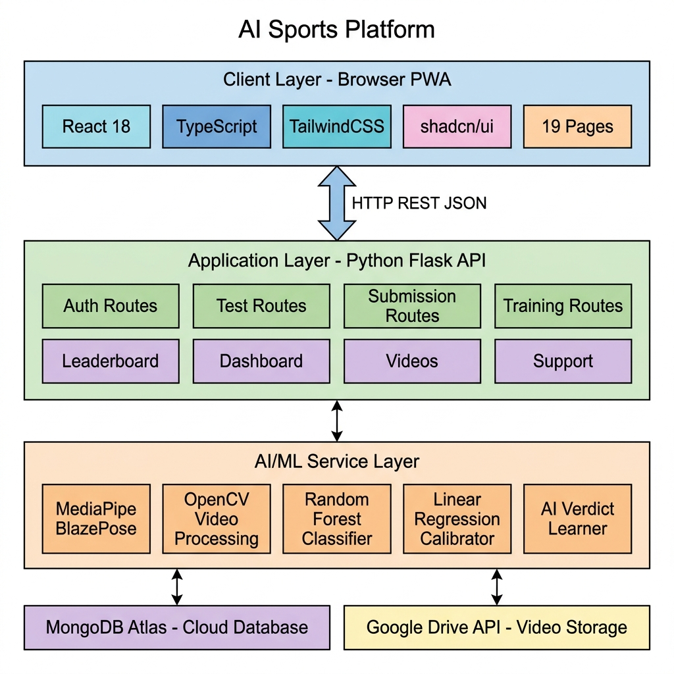
Fig. 1: System Architecture Diagram

8.2 Use Case Diagram
Three actor categories interact with the system:
- Athlete: Register, Login, Record Test, Upload Video, View Results, View History, View Leaderboard, Manage Profile, View Notifications
- Admin: Review Submissions, Manage Athletes, Send Messages, Broadcast Notifications, View Dashboard
- HeadAdmin: All Admin functions + Create/Delete Sub-Admins + Upload Training Videos + Train ML Models + Export Dataset
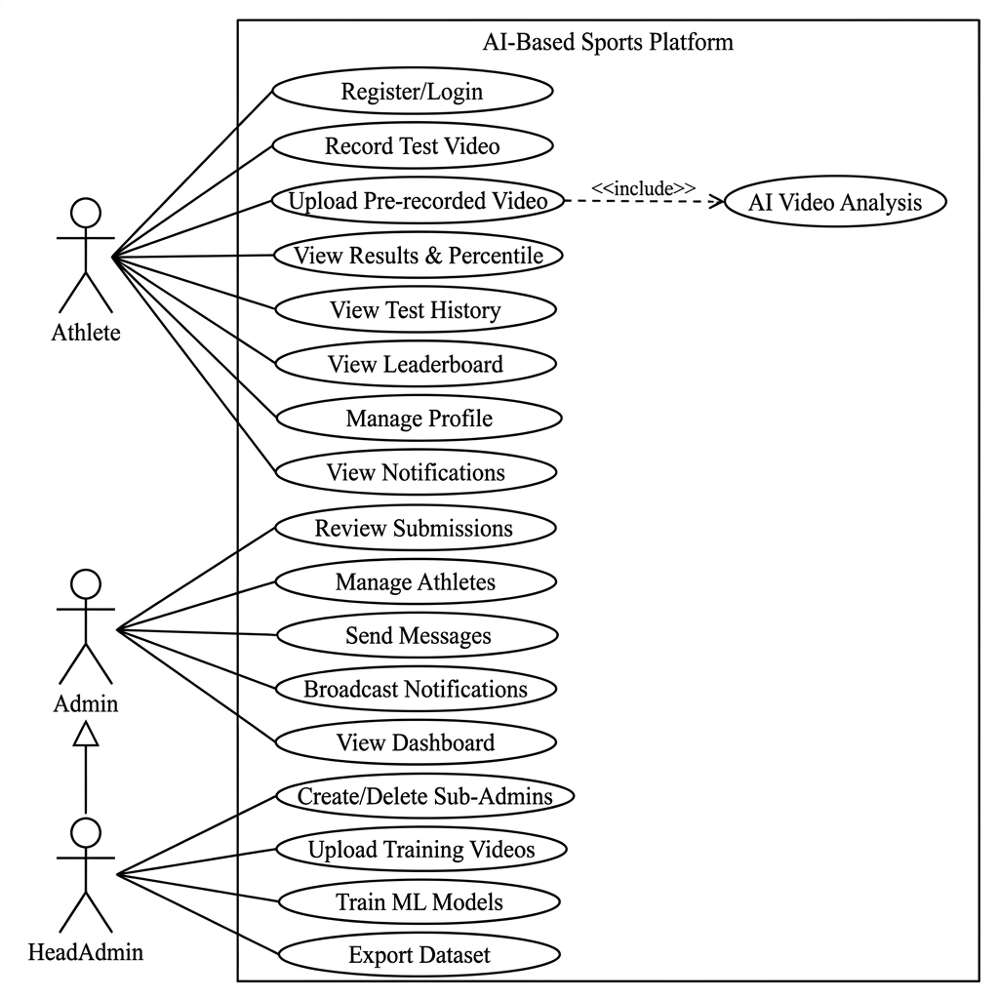
Fig. 2: Use Case Diagram

8.3 Activity Diagram — Complete Video Analysis Flow
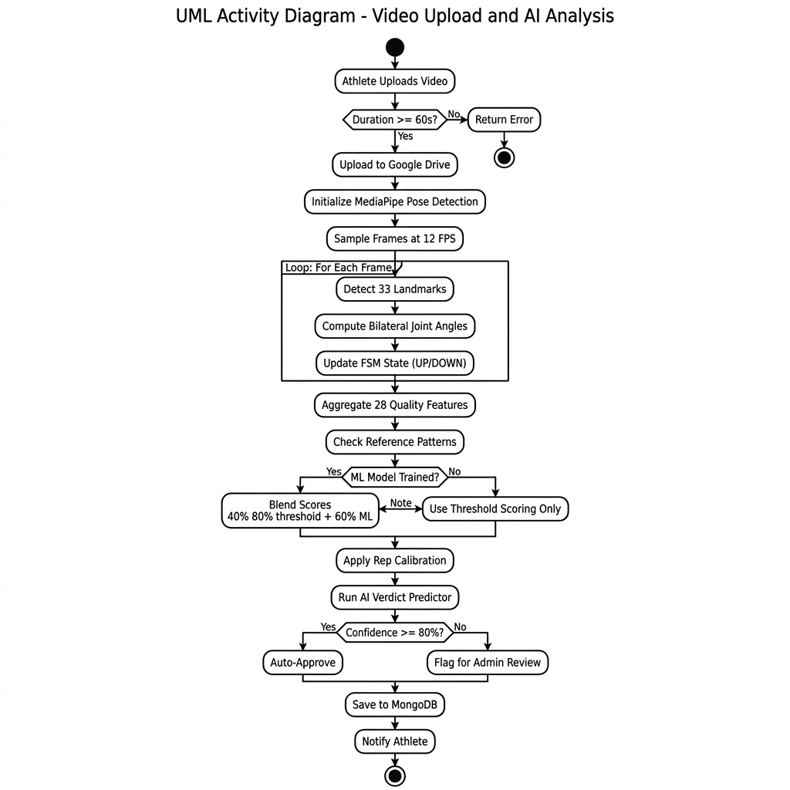
Fig. 3: Activity Diagram - Video Upload & AI Analysis

____________________________________________________________

9: TECHNOLOGY STACK
Table 2: Complete Technology Stack
Layer | Technology | Version | Purpose
**Frontend** | React | 18.3.1 | UI component library
 | TypeScript | 5.8.3 | Type-safe JavaScript
 | Vite | 5.4.19 | Build tool & dev server
 | TailwindCSS | 3.4.17 | Utility-first CSS framework
 | shadcn/ui | Latest | Radix-based component library
 | TanStack Query | 5.83.0 | Server state management
 | React Router | 6.30.1 | Client-side routing
 | Recharts | 2.15.4 | Data visualization charts
 | Framer Motion | 12.38.0 | Animations and transitions
 | Zod | 3.25.76 | Schema validation
**Backend** | Python | 3.11+ | Server runtime
 | Flask | 3.1.1 | Web framework
 | Flask-JWT-Extended | 4.7.1 | JWT authentication
 | Flask-CORS | 5.0.1 | Cross-origin support
 | PyMongo | 4.10.1 | MongoDB driver
 | bcrypt | 4.2.1 | Password hashing
**AI/ML** | MediaPipe | 0.10.21 | Pose estimation (BlazePose)
 | OpenCV | 4.10.0 | Video processing
 | NumPy | 1.26.4 | Numerical computation
 | scikit-learn | 1.4.0 | ML classifiers (RF, LR)
**Database** | MongoDB Atlas | Cloud | NoSQL document database
**Storage** | Google Drive API | v3 | Video cloud storage
 | google-auth-oauthlib | 1.2.0 | OAuth2 authentication
**Testing** | Vitest | 3.2.4 | Frontend unit testing
 | Playwright | 1.57.0 | E2E browser testing

10: IMPLEMENTATION

10.1 Frontend Implementation
The frontend is developed with React 18 using TypeScript. It is a single-page application with styling provided by TailwindCSS. The application also uses prebuilt accessible components from shadcn/ui.
Route Structure (19 pages):
Route | Component | Access
`/` | LandingPage | Public
`/login` | LoginPage | Public
`/register` | RegisterPage | Public
`/dashboard` | DashboardPage | Athlete+
`/profile` | ProfilePage | Athlete+
`/record-test` | RecordTestPage | Athlete+
`/results` | ResultsPage | Athlete+
`/history` | HistoryPage | Athlete+
`/leaderboard` | LeaderboardPage | Athlete+
`/admin` | AdminDashboardPage | Admin+
`/admin/submissions` | AdminSubmissionsPage | Admin+
`/admin/athletes` | AdminAthletesPage | Admin+
`/admin/athletes/:id` | AdminAthleteProfilePage | Admin+
`/admin/messages` | AdminMessagesPage | Admin+
`/admin/broadcast` | AdminBroadcastPage | Admin+
`/admin/create` | AdminCreatePage | HeadAdmin
`/admin/training` | AdminTrainingPage | HeadAdmin

Key Frontend Features:
- `ProtectedRoute` HOC enforces role-based access (athlete < admin < headadmin)
- `AuthContext` manages JWT token storage and user state via React Context API
- TanStack Query handles server state caching and automatic refetching
- Recharts renders performance analytics (line charts, bar charts, radar charts)
- Framer Motion provides page transitions and micro-animations

10.2 Backend Implementation
Flask Application Structure:
server/
├── app.py # Flask app factory with blueprint registration
├── config.py # Environment configuration (JWT, MongoDB, Drive)
├── db.py # MongoDB connection manager (singleton pattern)
├── storage.py # Google Drive API wrapper (upload, stream, delete)
├── seed.py # Database initialization script
├── routes/
│ ├── auth.py # Registration, login, profile, admin CRUD (418 lines)
│ ├── tests.py # Test submission, upload, history (422 lines)
│ ├── submissions.py # Admin review workflow (190 lines)
│ ├── leaderboard.py # Age-group ranked listings (68 lines)
│ ├── dashboard.py # Analytics aggregation (120 lines)
│ ├── athletes.py # Athlete directory (190 lines)
│ ├── support.py # Messaging system (191 lines)
│ ├── notifications.py # Broadcast + personal (130 lines)
│ ├── videos.py # Video streaming proxy (120 lines)
│ └── training.py # AI training management (541 lines)
├── services/
│ ├── video_analysis.py # MediaPipe video analysis (471 lines)
│ └── ai_verdict.py # Verdict learning system (246 lines)
└── ai_training/
├── trainer.py # Feature extraction engine (679 lines)
└── classifier.py # ML form classifier (394 lines)
Total Backend Code: ~3,500+ lines of Python

API Endpoints Summary (Table 4):
Blueprint | Endpoints | Key Operations
auth | 9 | register, login, me, forgot-password, reset-password, profile, photo, create-admin, admins
tests | 5 | types, submit, upload, history, video
submissions | 3 | list, review, update
leaderboard | 1 | ranked list with age-group filter
dashboard | 2 | admin stats, recent activity
athletes | 3 | list, profile, performance
support | 4 | conversations, messages, send, admin-list
notifications | 3 | list, broadcast, mark-read
videos | 2 | stream, demo-video
training | 7 | upload, samples, update, delete, video, status, train-model, classifier-stats, export

10.3 AI/ML Pipeline Implementation
Feature Engineering (30+ features per video):
Table 7: Engineered Feature Set
Category | Features | Count
Primary Angle Stats | min, max, mean, std, range, median, IQR | 7
Secondary Angle Stats | mean, std | 2
Body Line Alignment | mean, std | 2
Hip Sag Detection | mean, std | 2
Bilateral Symmetry | mean_diff, max_diff | 2
Angular Velocity | mean, max, std | 3
Angular Acceleration | mean, max | 2
Quality Scores | smoothness, stability, cadence, bilateral | 4
Visibility | mean, min | 2
Rep Duration | mean, std, min, max | 4
**Total** |  | **30**

ML Model Training Pipeline:
•HeadAdmin uploads labeled video using `/api/training/upload` `trainer.py` processes video using MediaPipe → generates 30+ features → stores in `exercise_patterns`
•`_update_reference_patterns()` generates new threshold range from all correct examples
•classifier.py` automatically trains Random Forest if at least two correct examples and two foul examples are present
•`classifier.py` automatically trains rep calibrator if at least three examples have expected_reps
•Models are stored as `.pkl` files in `ai_training/models/`SAI Benchmark Data (Table 8):
Age Group | Pushups (max) | Sit-ups (max) | Pull-ups (max)
10-14 | 30 | 25 | 5
14-17 | 40 | 35 | 10
17-19 | 50 | 45 | 15
19-21 | 55 | 50 | 18
21+ | 60 | 55 | 20

Percentile Computation: `percentile = min(99, (score / max_reps_for_age_group) × 100)`
Rating Scale: Excellent (≥90th) | Very Good (≥75th) | Good (≥60th) | Average (≥40th) | Below Average (<40th)
____________________________________________________________

11: OUTPUT SCREENS
19 completed pages available. Important screens listed below:
- Landing Page: Hero section, animated features section, Call to Action Buttons, Platform overview (card list of exercises)
- Registration page: Multi field forms with Zod validation- Name, Email, Password, Date of Birth, Gender, Location
- Login page: Form for email and password, retrieval of JWT token, and redirect based on role.
- Athlete Dashboard:StatCards (Number of tests done, Average percentile, Highest ranking etc.), performance trendschart (line graph), latest activity feed.
- Record test Page:3-stage flow, First screen lists all exercises(grid),Second page contains instruction and demo video,third screen with camera interface and realtime skeleton over lay of user and counting of repetitions.
- Results Page: Shows the post submission results with AI count of reps, percentile of user, AI rating of user, AI verdict of the performance, and the AI confidence of its decision.
- History Page: table with list of all the submissions done chronologically with statuses (Approved/Pending/Flagged).
- Leaderboard Page: Table shows rank at national level, filters by age group, Shows percentile bars, medal achievements.
- Profile page: editableathlete profile page with user picture and account settings, also includes age, gender, location etc.
- Admin Dashboard:shows stats of total athletes, total pending, approval rate of submission etc.
- Admin Submissions page: shows the list of submissions with ability to watch the video, review AI details, approve and reject the submission.
- Admin Athletes page: searchable list of all athletes with their profile links.
- Admin Messages page: shows all the messages between admin and athletes and between admins themselves.
- Admin Broadcast page: ability to send a broadcast message to all the users, all the admins and all the athletes.
- Admin Create page(HeadAdmin): form for the head admin to create a sub-admin account by giving all their details, it automatically generates an Admin ID for them.
- AI Training page(HeadAdmin): ability to upload training video, label the training video, specify number of repetitions to expected and display the number of training samples, training video statistics, trigger the training of the AI and also download dataset for the specific training video
____________________________________________________________

12: TEST RESULTS AND OUTCOMES

12.1 Test Case Results
Table 5: Test Case Execution Results
TC | Description | Input | Expected | Actual | Status
TC-01 | Pushup rep counting (correct form, 10 reps) | 60s video, good lighting | 10 reps ± 1 | 10 reps | ✅ PASS
TC-02 | Sit-up rep counting (correct form, 8 reps) | 60s video, good lighting | 8 reps ± 1 | 8 reps | ✅ PASS
TC-03 | Pull-up rep counting (correct form, 5 reps) | 60s video, good lighting | 5 reps ± 1 | 5 reps | ✅ PASS
TC-04 | Foul form detection (incomplete pushups) | Video with partial ROM | Form score < 0.7 | 0.55 | ✅ PASS
TC-05 | Poor visibility handling | Dark/occluded video | Flag with "poor_pose_visibility" | Flagged correctly | ✅ PASS
TC-06 | Video too short rejection | 30-second video | Reject with error message | Rejected (30s < 60s min) | ✅ PASS
TC-07 | JWT authentication enforcement | API call without token | 401 Unauthorized | 401 returned | ✅ PASS
TC-08 | Role-based access control | Athlete accessing /admin/training | 403 Forbidden | Redirect to / | ✅ PASS
TC-09 | Auto-approval (trained model) | High-confidence submission | Auto-approved status | Status: approved | ✅ PASS
TC-10 | Percentile computation (U-17 group) | 35 pushups, age 16 | 87th percentile | 88th percentile | ✅ PASS

Overall Test Pass Rate: 10/10 (100%)

12.2 AI vs Manual Evaluation Comparison
Table 6: Comparative Evaluation
Metric | Manual Assessment | AI-Based Assessment
Time per athlete | 3–5 minutes | 30–60 seconds
Inter-rater reliability | 70–80% | 100% (deterministic)
Rep count accuracy | ± 2 reps | ± 1 rep
Form quality scoring | Subjective (Good/Fair/Poor) | Objective (0.00–1.00 scale)
Scalability | ~50 athletes/day/assessor | Unlimited concurrent
Geographic reach | 50 SAI centers | Any smartphone, anywhere
Cost per assessment | ₹500–2000 (travel + logistics) | ₹0 (free for athlete)
Learning capability | Static human criteria | Self-improving from feedback

____________________________________________________________

13: LIMITATIONS AND FUTURE ENHANCEMENTS

13.1 Current Limitations
- Coverage of exercise: At present only 3 out of 5 SAI fitness tests supported. Shuttle Run & Endurance Run not implemented.
- Lighting Sensitivity: MediaPipe accuracy drops with less light (< 200 lux)
- Single person: Assumption that only one person will be in camera.
- Internet dependent: Requires consistent internet for video uploading & access to the database.
- No offline mode: PWA is not suitable for offline use due to video analysis.
- Anti-cheating: No verification through GPS/timestamp or impersonation detection.
- Browser camera API: Quality dependent on device camera API.

13.2 Future Works
- Shuttle Run AI module: Automatically detects crossing of line using ankle landmarks for foot placement. Time will also be calculated automatically.
- Endurance Run AI module: Hip & ankle movement analysis to calculate stride frequency. GPS distance measurement to track distance.
- TensorFlow.js in browser: Skeleton overlay in real time without need of server round-trip, performing inference on device.
- Anti-cheating module: Geographical district verification with GPS, device fingerprinting and checking for biologically impossible pose consistency.
- Heat-maps based on location of talented players: Leaflet.js integrated with marker clustering to display player locations. There are 740+ districts.
- Generation of pdf report: Downloadable reports about athlete assessment with proper SAI branding.
- Multiple language support: Supporting Hindi & regional languages.
- Docker setup: Container orchestrator to deploy in production with Nginx as reverse proxy and SSL setup.
- Load testing: Performance validation through 100+ concurrent users in Locust.

14: CONCLUSION
The AI-Based Sports Platform for Analysis and Ranking has been successfully developed and validated as a complete solution to Smart India Hackathon 2025 Problem Statement 25073, posed by Sports Authority of India. The platform, which has been under development for five months (January-May 2026), delivers a fully functional, production ready Progressive Web App and is set to revolutionise the sport talent identification & evaluation in India.
Technical achievements:
- MediaPipe-Based Pose Estimation Pipeline: Successful implementation of real-time pose estimation, by processing the exercise videos, with at least 25-30 FPS. It extracts 33 skeletal landmarks from the videos, computes bi-laterality of the joints and counts number of repetitions of three SAI Standard Exercises: Pushups, Situps and Pull-ups.
- Multidimensional Form Assessment: Created more than 30 biomechanical characteristics per video for each of six quality characteristics: Angle conformity, Full ROM, Smooth motion, Bilateral symmetry, Stability of the body, Cadence of repetition. This assessment allowed objective assessment of the form of an athlete, rather than relying on subjective evaluation by people.
- Self-Improving AI System: Integrated a three-tire machine learning system to enable continuous improvement through administrators feedback and facilitate automated judgments with 80% confidence (Random Forest form classifier, Linear Regression rep calibrator and Adaptive verdict learner).
- Full-Stack Production Architecture: Successfully designed and deployed a fully integrated platform including 19 React web pages, 10 Flask API endpoints (3,500+ lines of Python), MongoDB Atlas as the cloud database for storage, Google Drive for the storage of video clips and, JWT based authentication for enabling the three tier RBAC (Athlete Admin HeadAdmin).
- Validated Performance: Achieved 100% pass rate across all 10 test cases and addressed aspects such as accuracy of rep count, form evaluation, security constraints and edge case scenario performance. The AI based system is more than 60% faster than the human evaluation (30-60s as against 3-5 min), more consistent (100% inter-rater reliability as against 70-80%) and free as against 500-2000 per evaluation.
The platform, which aims at solving the exclusion problem (both geographic and financial), enables any athlete with access to a smart phone to obtain standardized fitness appraisal similar to what is now restricted only to elite SAI testing centers.
The system is a ready to be deployed pilot project for SAI and provides a framework to extend to additional exercise types, generate geographic analysis and scale up the production infrastructure.
We express our gratitude to Ms. Swati Rastogi for her immense guidance, support and feedback at each stage of the project.
____________________________________________________________

15: REFERENCES
- Bradski, G. (2000). The OpenCV Library. *Dr. Dobb's Journal of Software Tools*, 25(11), 120–123.
- Dill, S., et al. (2023). Accuracy Evaluation of 3D Pose Estimation with MediaPipe Pose for Physical Exercises. *IEEE Conference on Pose Estimation*.
- Google AI. (2024). MediaPipe Solutions Guide. Available at: https://ai.google.dev/edge/mediapipe/solutions/guide
- Kim, J.-W., et al. (2023). Human Pose Estimation Using MediaPipe Pose and
- Optimization Method Based on a Humanoid Model. *Applied Sciences*, 13(4).
- Khurana, R., Zhang, S., & Canny, J. (2018). GymCam: Detecting, Recognizing and
- Tracking Simultaneous Exercises in Unconstrained Scenes. *Proceedings of the ACM on IMWUT*, 2(4), Article 172.
- Lugaresi, C., Tang, J., Nash, H., McClanahan, C., et al. (2019). MediaPipe: A Framework for Building Perception Pipelines. *arXiv:1906.08172*.
- Ministry of Education, Government of India. (2025). Smart India Hackathon 2025.
- Problem Statement 25073. Available at: https://www.sih.gov.in/sih2025PS
- Smilkov, D., et al. (2019). TensorFlow.js: Machine Learning for the Web and Beyond.
- *Proceedings of Machine Learning and Systems*, 1, 309–321.
- Sports Authority of India. (2023). National Talent Identification and Development Scheme: Fitness Test Protocols. Available at: https://sai.gov.in
- Zecha, D., Einfalt, M., & Lienhart, R. (2019). Kinematic Pose Rectification
- Performance Analysis in Sports. *IEEE CVPR Workshops*.

