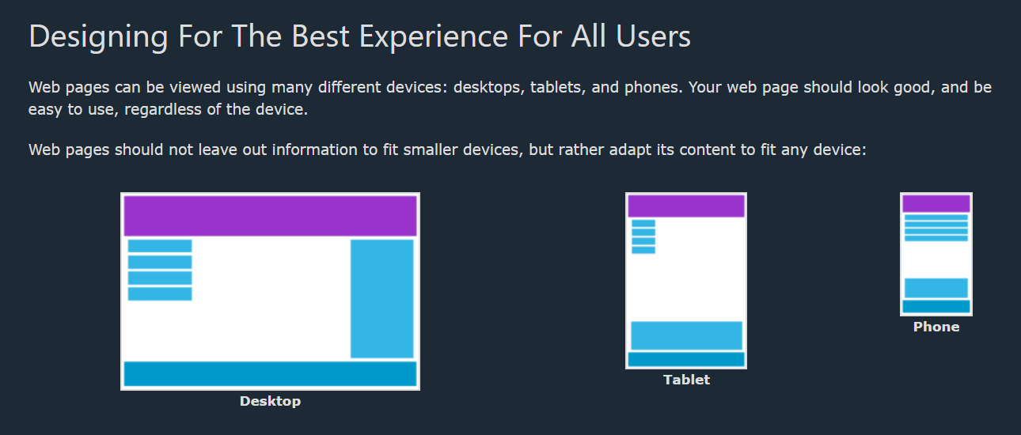

* Use **Flexbox** for layout.
* **Desktop:** Sidebar and content side by side.
* **Tablet (≤768px):** Sidebar above content.
* **Phone (≤480px):** Everything in one column.