ZUDOBOT
Chatbot Widget Installation Guide
How to install the script on any website — every technology & website builder
For developers and site owners — self-serve, no AI required
Version 1.0 • Updated 24 June 2026

Table of Contents

1. Overview
Zudobot Widget is a smart chat box you embed on any website by pasting a single script. It is a standard HTML <script> tag, so it works on every kind of site — hand-coded, modern frameworks, or website builders such as Wix, 10Web, Shopify and more — with no extra programming and no AI required.
The script to install (copy the whole block):
<script
src="https://zudobot.zudogu.com/widget.js"
data-tenant-id="6a106dfed08dc3595a17ae8e"
data-embed-key="49a77e4f6ce3386fc8a649786c57ba75"
data-key="49a77e4f6ce3386fc8a649786c57ba75"
data-api-url="https://zudobot.zudogu.com"
defer
></script>

ℹ️ Copy everything Copy the script exactly as shown. Do not change any values inside it — especially data-tenant-id and data-embed-key, which are the unique keys for each customer.

2. Key principles (the same everywhere)
- Where: place it just before the closing </body> tag, or inside <head>. Because of defer, the script loads after the page renders, so it never slows the site down.
- Once only: place it in a shared location (Footer, global header, or theme template) and the widget appears on every page automatically.
- No duplicates: install it only once per page; duplicates make the widget appear twice.
- Publish: most website builders (Wix, Webflow, Framer) require you to click Publish after pasting, or the change will not go live.
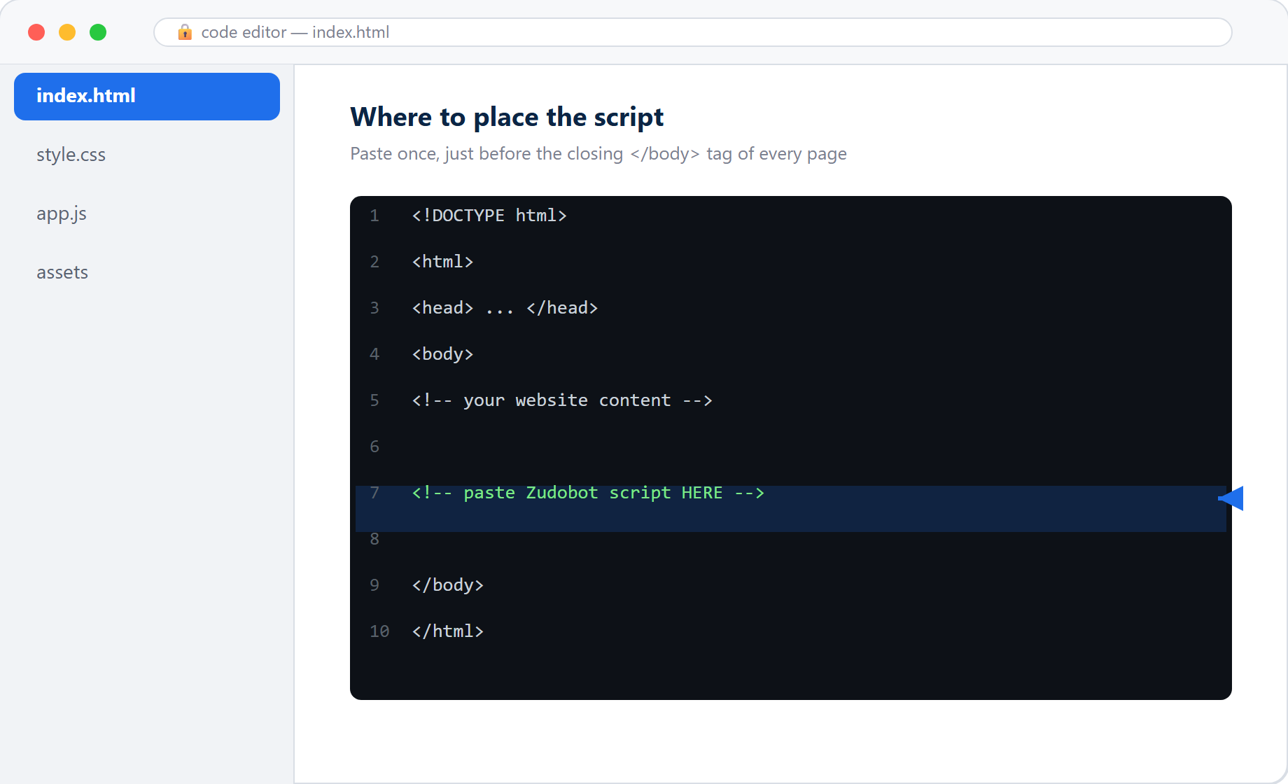
Figure 1: Where the script goes — just before the closing </body> tag

3. Quick reference: where to paste on each platform
Platform | Menu / location | Placement
Plain HTML | .html files sharing a layout | before </body>
WordPress | WPCode / Insert Headers and Footers plugin | Footer
10Web | Settings → Custom Code (or use WordPress method) | Footer
Wix | Settings → Custom Code | Body - end / All pages
Shopify | Themes → Edit code → theme.liquid | before </body>
Squarespace | Settings → Advanced → Code Injection | Footer
Webflow | Project Settings → Custom Code | Footer Code
Framer | Project Settings → Custom Code | End of <body>
GoDaddy/Weebly/Jimdo | Settings → Embed / Custom Code | Footer / Site-wide
React / Vue | public/index.html | before </body>
Next.js | app/layout.tsx (use <Script>) | inside <body>
Google Tag Manager | Custom HTML Tag + All Pages trigger | all pages

4. Step-by-step installation (by technology)

4.1 Plain HTML website
- Open index.html (and any other files sharing the layout)
- Paste the script just before the </body> tag
- Save the file and upload it to your server
...
<script
src="https://zudobot.zudogu.com/widget.js"
data-tenant-id="6a106dfed08dc3595a17ae8e"
data-embed-key="49a77e4f6ce3386fc8a649786c57ba75"
data-key="49a77e4f6ce3386fc8a649786c57ba75"
data-api-url="https://zudobot.zudogu.com"
defer
></script>
</body>
</html>

4.2 WordPress (incl. Elementor, Divi, WooCommerce)
Recommended — use a plugin (easiest and safest):
- Install and activate the “WPCode” or “Insert Headers and Footers” plugin
- Go to the Footer field (or Body/Footer Scripts)
- Paste the script and click Save / Update
Alternative — edit the theme directly: Appearance → Theme File Editor → footer.php, paste before </body>
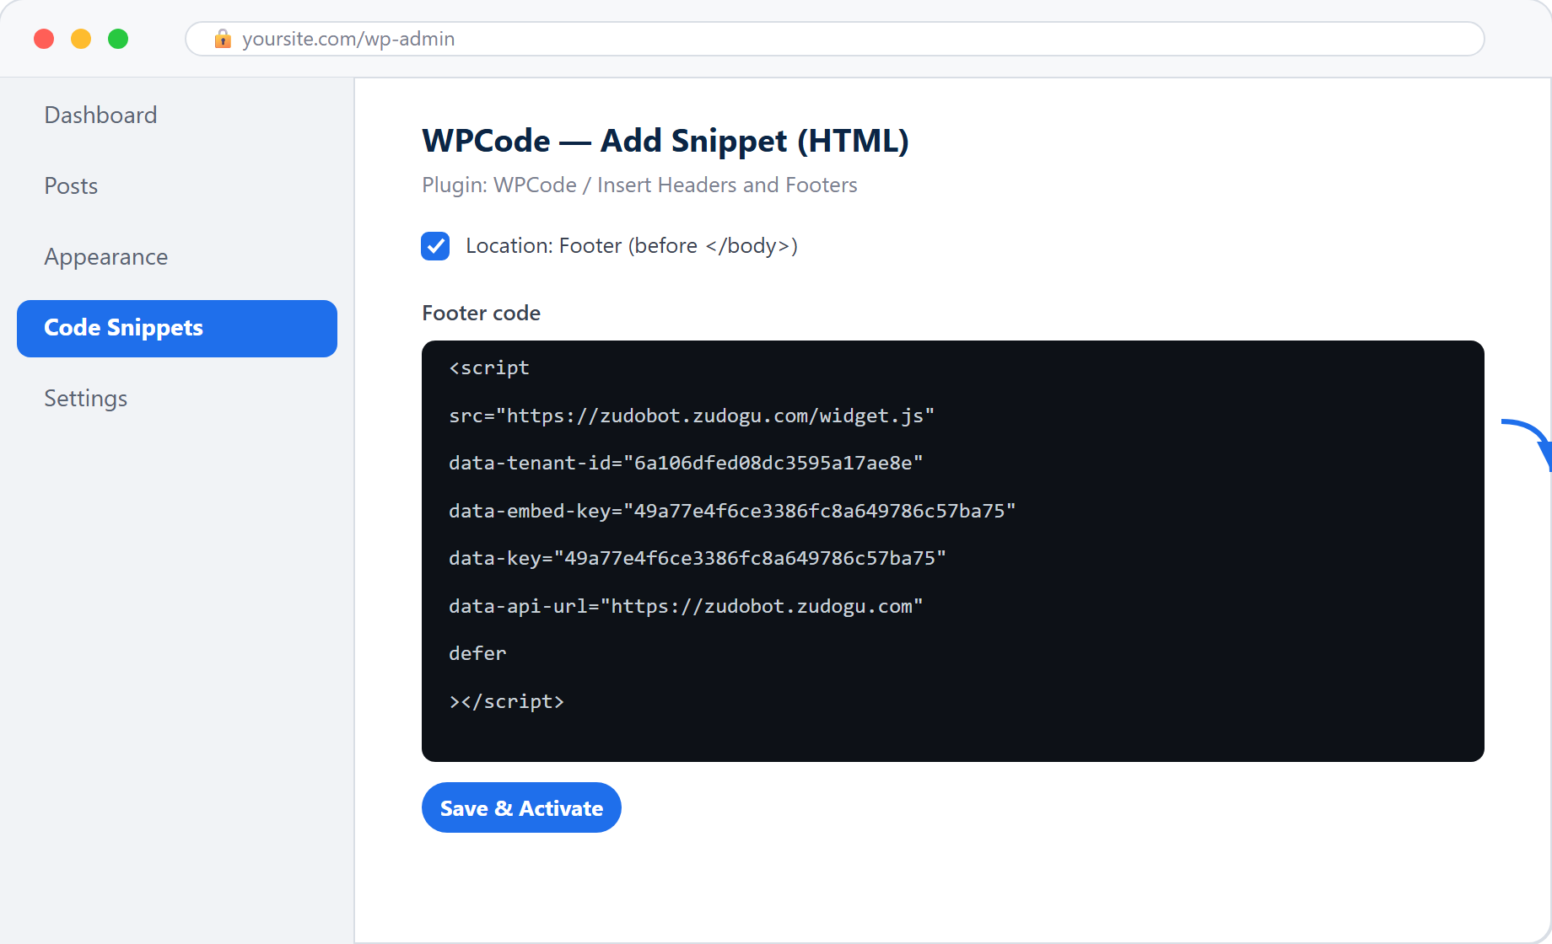
Figure 2: WordPress — paste into the Footer field of the WPCode plugin
⚠️ Tip If you edit theme files directly, use a child theme so your code survives theme updates — using a plugin is safer.

4.3 10Web
- If the site runs on WordPress (most 10Web sites do) → use the WordPress method in 4.2 (the WPCode plugin is recommended)
- Or go to Settings → Custom Code / Header & Footer scripts and paste it into the Footer section

4.4 Wix
- Go to Dashboard → Settings → Custom Code (or Tracking & Analytics)
- Click + Add Custom Code
- Paste the script into the code box
- Add Code to Pages → choose All pages
- Place Code in → choose Body - end
- Name it (e.g. “Zudobot”) and click Apply
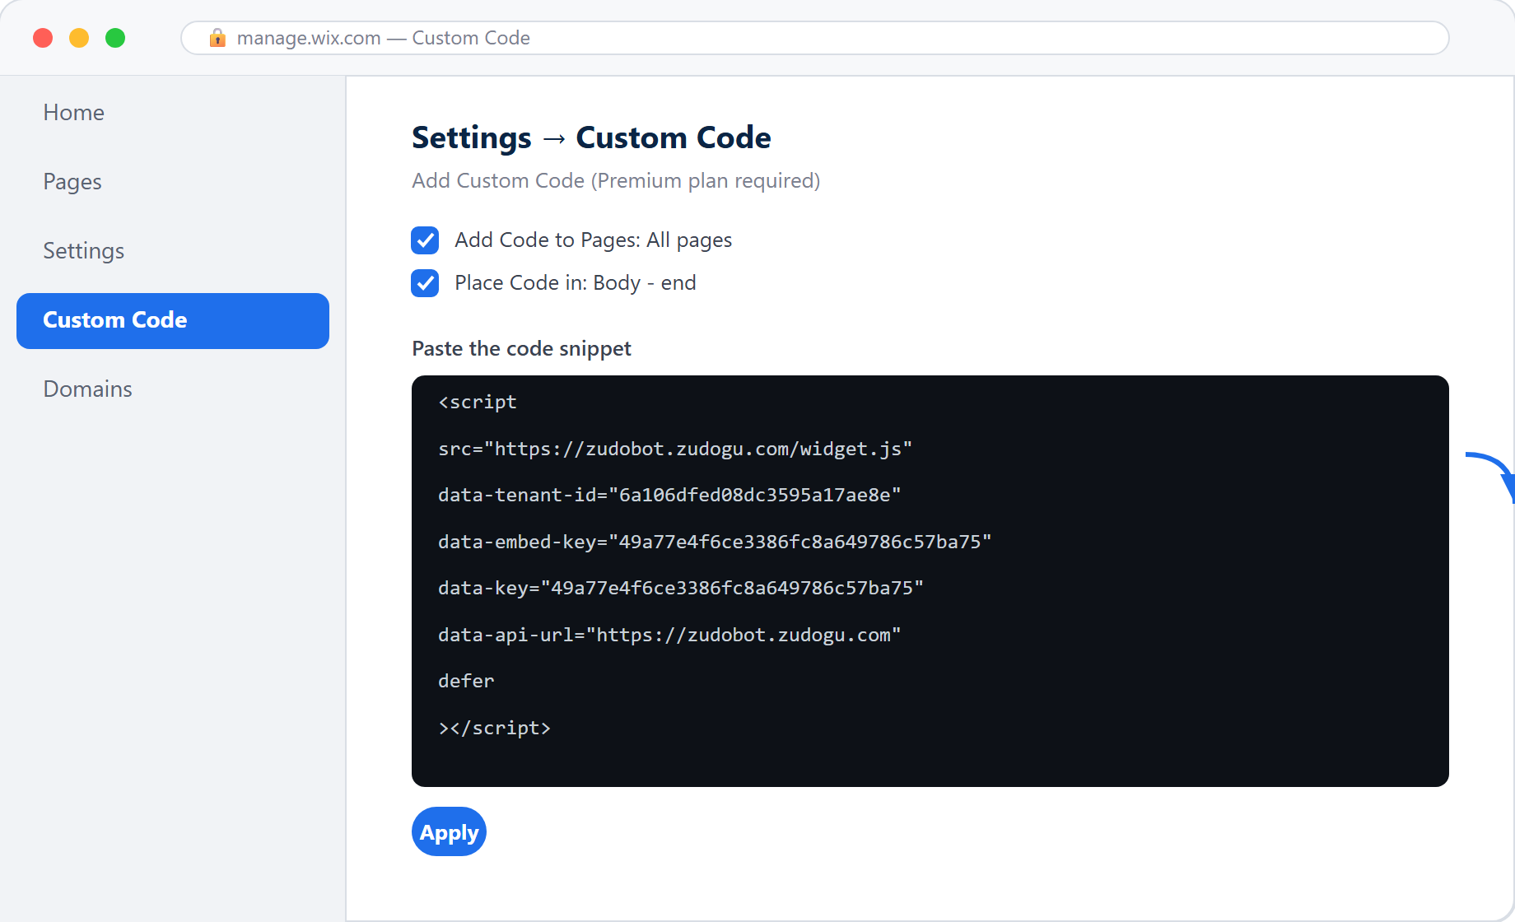
Figure 3: Wix — Custom Code: All pages + Body-end
⚠️ Free plan Wix free plans have no Custom Code menu — you must upgrade to a Premium plan before you can add the script.

4.5 Shopify
- Online Store → Themes → Edit code
- Open theme.liquid
- Paste the script before </body> and click Save
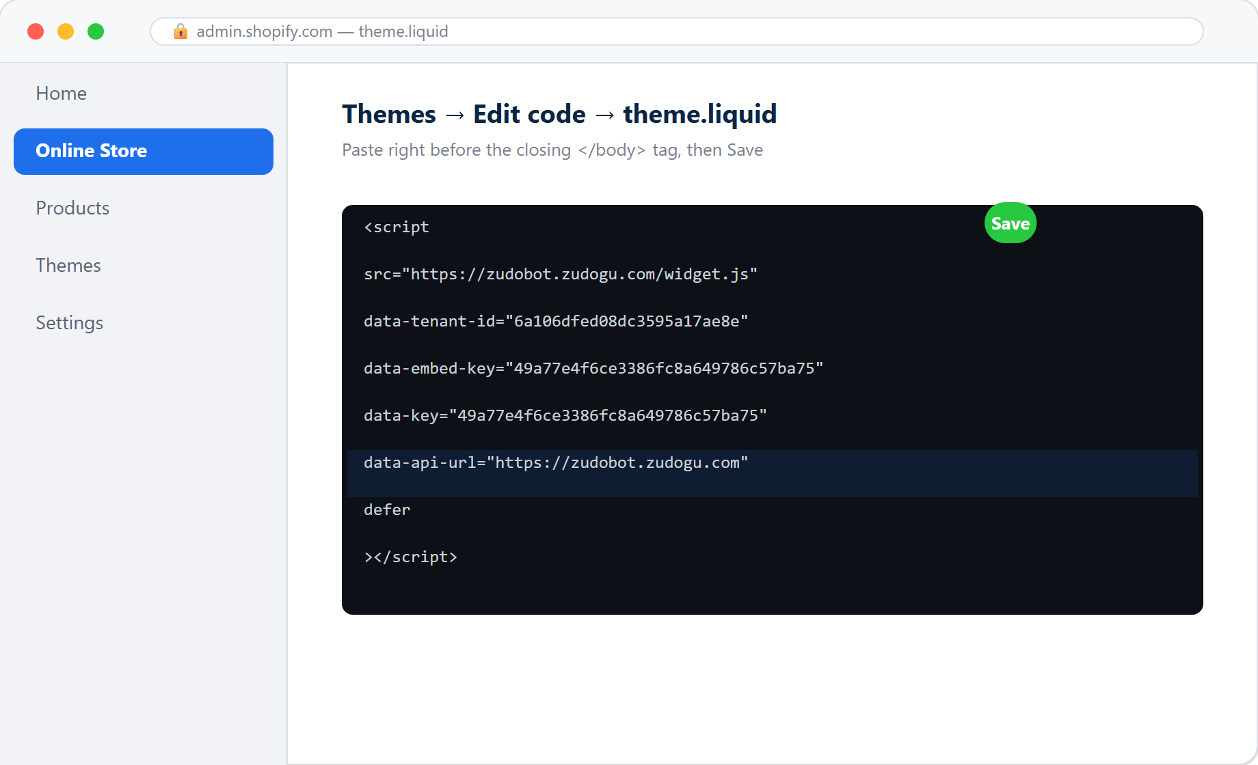
Figure 4: Shopify — edit theme.liquid, paste before </body>

4.6 Squarespace
- Settings → Advanced → Code Injection
- Paste the script into the Footer box and Save

4.7 Webflow
- Project Settings → Custom Code
- Paste the script into the Footer Code box
- Click Save Changes, then Publish
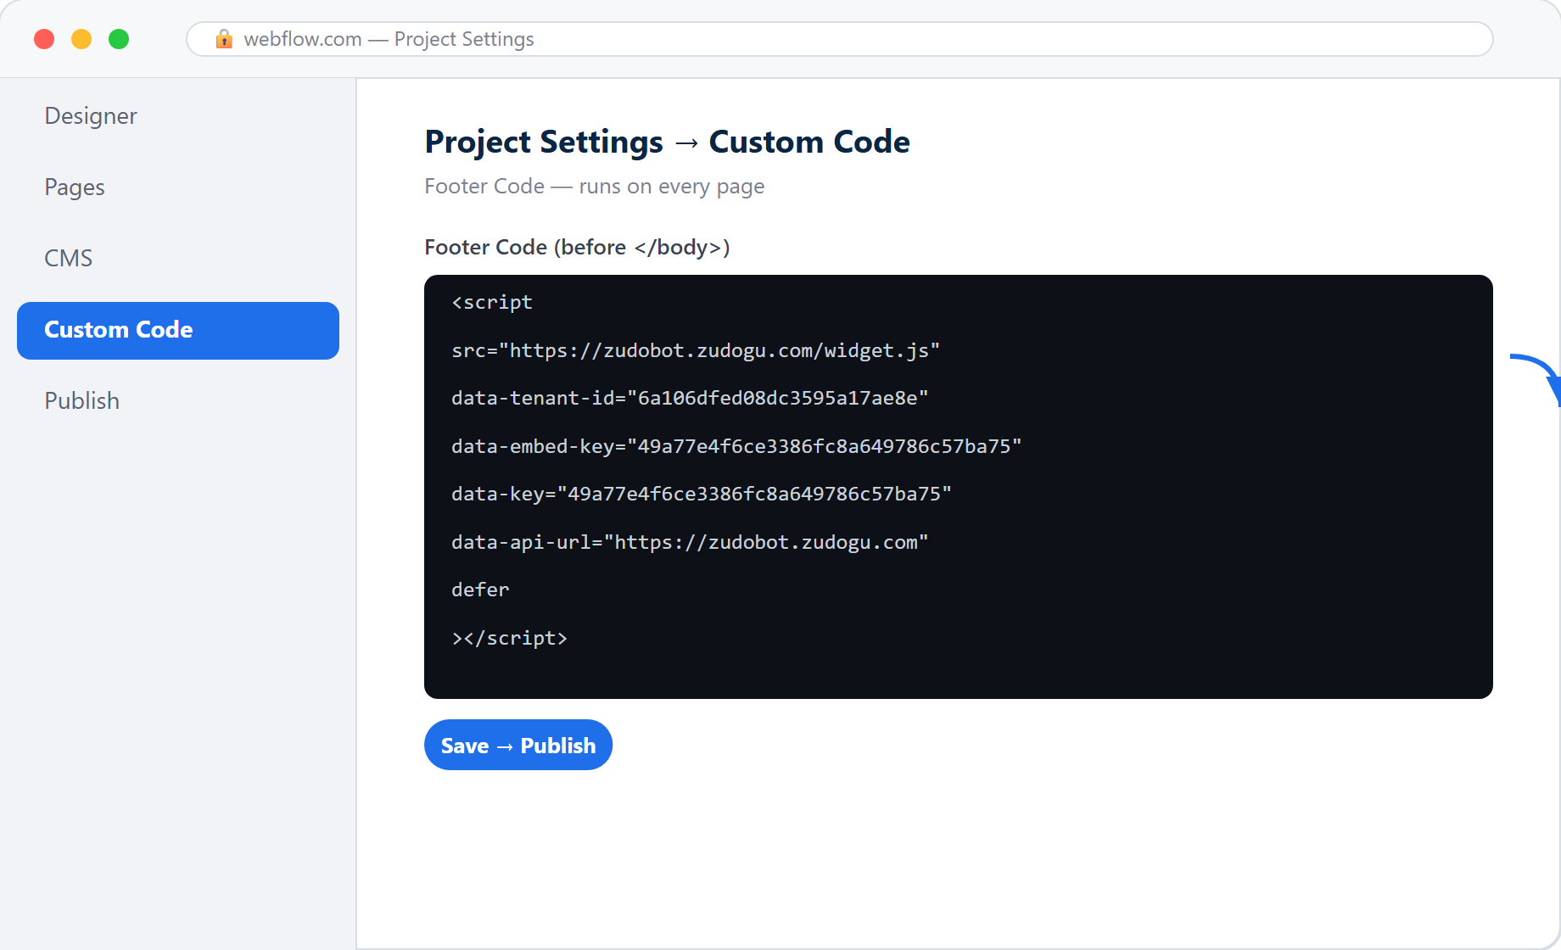
Figure 5: Webflow — Footer Code, then Publish

4.8 Framer
- Project Settings → General → Custom Code
- Paste into the End of <body> tag box
- Click Publish
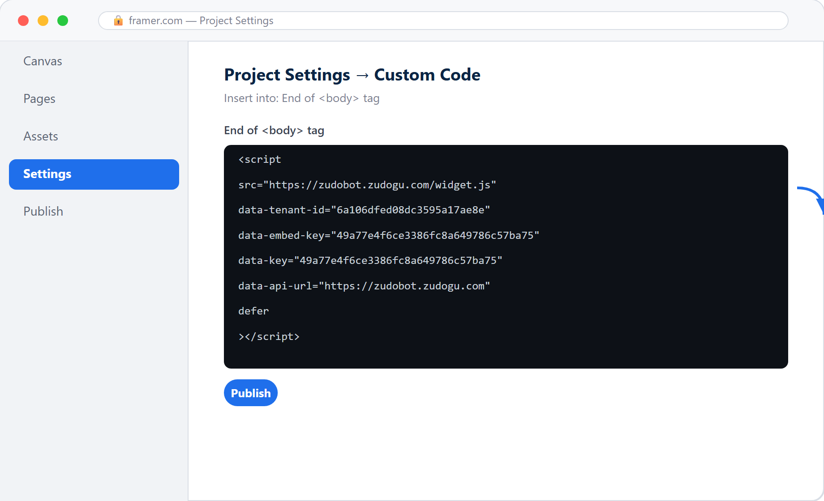
Figure 6: Framer — paste into the End of <body> tag

4.9 GoDaddy / Weebly / Jimdo / Webnode and other builders
Almost every builder has a place for custom code, usually under a menu like:
- Settings → Custom Code / Embed Code / Header & Footer Code
- Or use an “Embed Code / Custom HTML” element/widget placed in the footer of every page
Rule of thumb: look for Custom Code, Embed, HTML or Footer Scripts, then paste the script — always choose the Site-wide / all-pages option.

4.10 Custom-coded sites (React / Vue / Next.js)
React (Create React App): paste in public/index.html before </body>
Vue / Nuxt: paste in index.html or configure via app.head.script
Next.js (App Router): use the <Script> component in app/layout.tsx
import Script from 'next/script'

// place inside <body>
<Script
src="https://zudobot.zudogu.com/widget.js"
data-tenant-id="6a106dfed08dc3595a17ae8e"
data-embed-key="49a77e4f6ce3386fc8a649786c57ba75"
data-key="49a77e4f6ce3386fc8a649786c57ba75"
data-api-url="https://zudobot.zudogu.com"
strategy="afterInteractive"
/>

4.11 Google Tag Manager (any site running GTM)
- Create a new Tag → choose type Custom HTML
- Paste the whole script into the HTML box
- Set the Trigger to All Pages
- Click Submit, then Publish
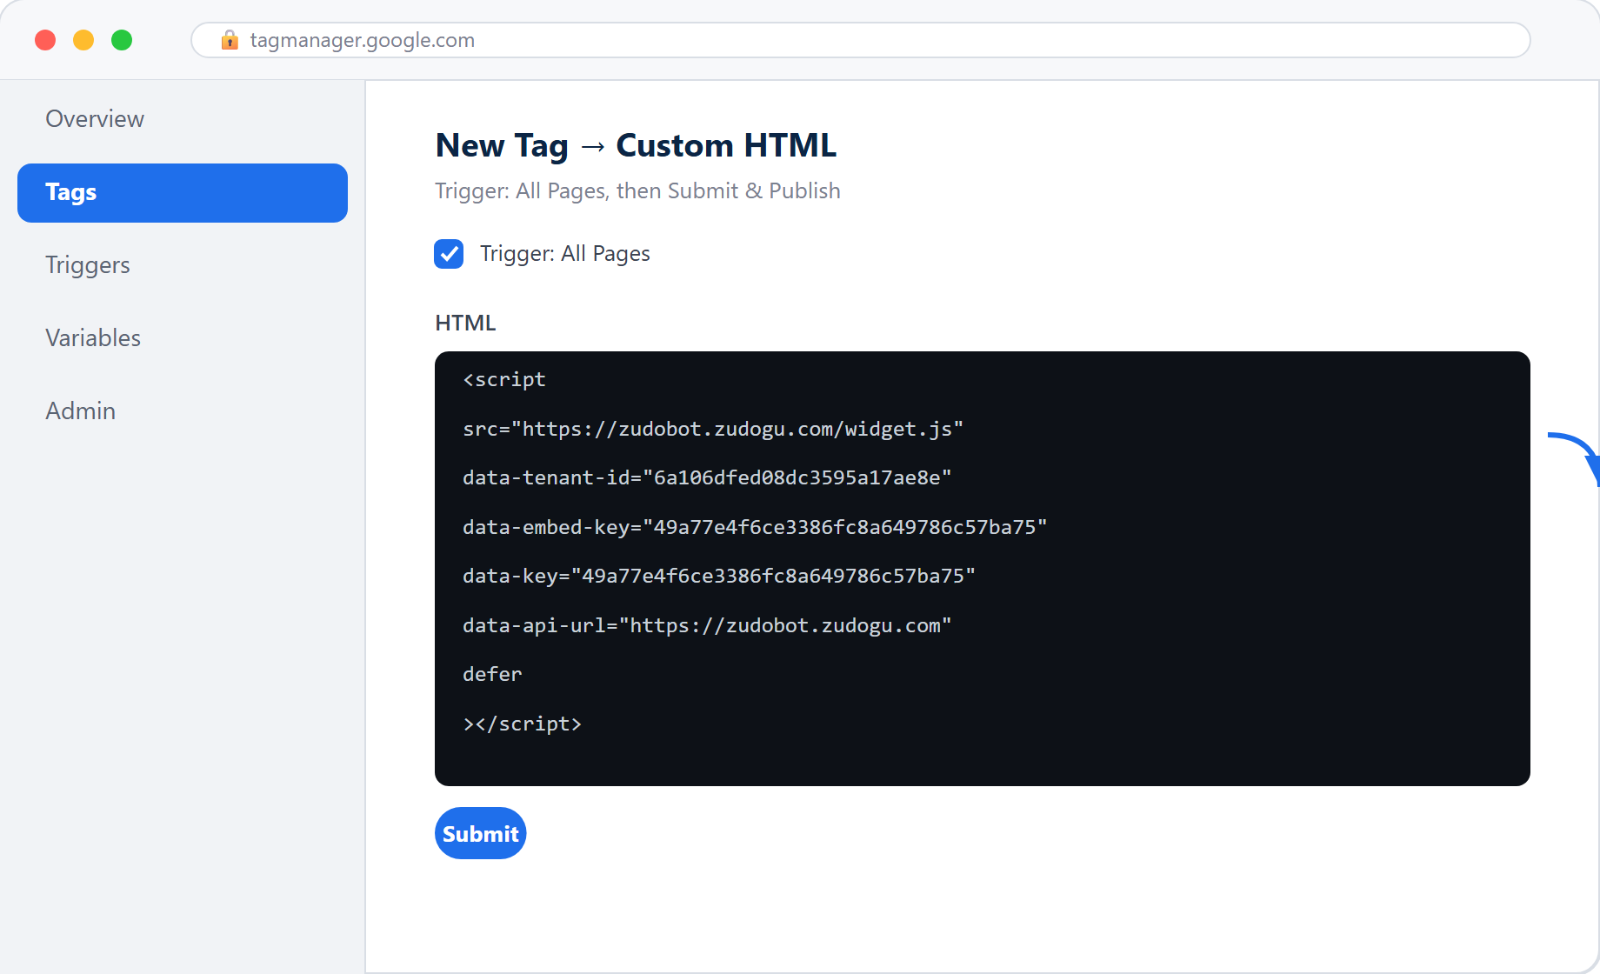
Figure 7: Google Tag Manager — Custom HTML + All Pages trigger

5. Verifying the installation
- Open the live website (not the editor) and wait 2-3 seconds
- The Zudobot chat button/box should appear in a corner
- If it does not show, press F12 → Console tab for errors, and check the Network tab to confirm widget.js loaded successfully (status 200)
- Clear the cache (Ctrl+F5) or open an Incognito window

6. Things to tell the customer / developer
Topic | Detail
Duplicates | Install once per page; duplicates make the widget appear twice
Don't edit data-* | data-tenant-id and data-embed-key are unique keys — copy as-is, never change them
Builder free plans | Wix / Squarespace free plans often lock Custom Code — upgrade first
Publish required | Webflow / Framer / Wix need a Publish after pasting, or nothing shows
HTTPS | Site should be https (the widget loads over https); all builders support this
Cache | If it doesn't show after install, clear site/CDN cache and hard-refresh (Ctrl+F5)

7. Frequently asked questions (FAQ)
Q: Do I need to write any code?
A: No. Just copy the whole script and paste it in the right place for your platform.
Q: Do I paste it on every page?
A: No. Paste it once in a shared location (Footer/Theme) and it appears on all pages automatically.
Q: Will the widget slow my site?
A: No. The defer attribute loads it after the page has finished rendering.
Q: Installed but nothing shows?
A: Check you clicked Publish, pasted in the right place, cleared the cache, then open Console (F12) for errors — see section 5.

Need more help? Contact the Zudobot team
https://zudobot.zudogu.com

