A Comparative Analysis of Human and AI-Based Emotion Recognition Under Image Degradation

Shehara Dineth Thappavarige

Mahdi Moaref Dezfooly

Abstraction
This study evaluates agreement between human emotion perception and AI-based facial emotion recognition under image degradation. A web-selected facial image dataset was processed into original, blurred, greyscale, and low-resolution versions, then evaluated by human participants and two AI models, FER and DeepFace. Human and AI outputs were normalized into seven-emotion distributions and compared using similarity, agreement, entropy, and robustness measures. MediaPipe blendshape features were also extracted to examine relationships between facial movement and emotion scores. Results showed that FER aligned more closely with pooled human ratings than DeepFace, while ambiguous and degraded images reduced stability in emotion interpretation. These findings suggest that, when ground-truth labels are uncertain, facial emotion recognition is better analyzed through human-AI agreement and interpretability rather than direct accuracy.
Keywords—component, formatting, style, styling, insert (key words)

Introduction
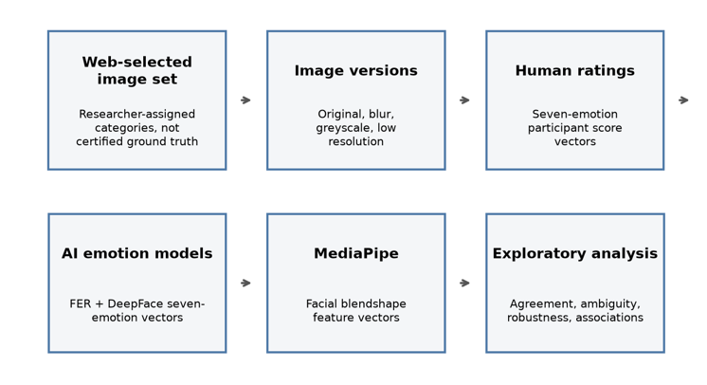
Facial expressions are an important part of human communication, allowing people to interpret emotions and social signals from visual cues. With recent advances in artificial intelligence, facial emotion recognition can also be performed automatically by models such as FER and DeepFace.
However, facial emotion recognition is not always objective. A single expression may be interpreted differently depending on ambiguity, image quality, and individual perception. This is especially important when using images collected from public web sources, since their emotion labels cannot be treated as certified ground truth.
This study compares human emotion ratings with FER and DeepFace outputs across original and degraded facial images. MediaPipe facial blendshape features are also used to explore how visible facial movements relate to emotion scores. Rather than measuring strict accuracy, the study focuses on agreement, disagreement, ambiguity, and robustness under image degradation.

Related works
Fig. 1
Facial emotion recognition has been widely studied in computer vision, particularly through datasets and benchmarks that classify facial expressions into basic emotion categories. Deep learning approaches have improved automatic expression recognition, but performance remains affected by image quality, facial pose, dataset bias, and the ambiguity of human expressions.
FER and DeepFace represent two practical AI-based approaches for analyzing facial images. While these systems can generate emotion probability scores and dominant emotion labels, their outputs should be interpreted with care when the input images do not come from a certified dataset.

Methodology

Overview
The study proposes an evaluation framework for analyzing the performance of two AI-based facial emotion recognition systems against human emotion perception compared under varying image quality conditions and facial landmark data. The methodology consists of six stages.
First, a facial image dataset is selected and prepared for analysis. Each image is preprocessed to generate four visual conditions. The processed images are analyzed using two facial emotion recognition models, while human participants evaluate the same set of images. In parallel facial landmarks are extracted and used to compute geometric facial features. Finally, all output data is compared through statistical analysis.

Dataset Selection
Facial images representing the seven basic emotion categories were collected from publicly available online sources. Images were manually selected to provide a range of facial expressions suitable for human and AI evaluation.
Care was taken to include images with clearly distinguishable emotions while also incorporating expressions that could produce ambiguity in recognition. Potentially ambiguous images were made marked through the file naming convention, allowing them to be analyzed separately.
Each selected image was assigned a reference label by the authors based on the intended facial expression depicted. These labels served as a common reference throughout the study for organizing the dataset facilitating the comparisons.

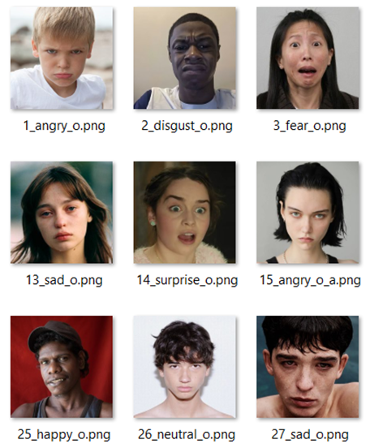
Fig. 2

Image Preprocessing
A python script was used to make three versions of the same image to allow for controlled comparisons. The original image is treated as a baseline without applying any modifications.
- Blurred:
Blurring was applied to simulate common image degradation in real-world scenarios. The transformation reduces visibility of fine facial features while maintaining the overall expression.
- Greyscale
This transformation was used to investigate the extent to which color cues contribute to emotion recognition by both AI models and human observers.
- Low Resolution
A low-resolution version of each image was generated by reducing the image resolution and subsequently resizing it back to its original dimensions. This transformation simulates image quality degradation caused by low-resolution cameras or image compression.

Prior to applying the image degradation techniques, all images were standardized to a fixed resolution of 256 × 256 pixels to ensure consistency across the dataset. Following preprocessing, each original image and its corresponding degraded versions were automatically assigned a standardized filename encoding the image identifier, emotion category, and preprocessing condition.
Fig. 3
Finally, the processed images were distributed into multiple evaluation sets using an automated script. The distribution algorithm ensured that each test set contained only one version of a given base image, preventing participants from viewing multiple degraded versions of the same facial expression and thereby reducing potential memory and carryover effects during the human evaluation.
For the AI model evaluations all processed and original images were kept in one directory.

AI-Based Emotion Recognition
The preprocessed images were evaluated by DeepFace and FER.

D.1. DeepFace

DeepFace was selected as one of the facial emotion recognition models due to its comprehensive framework for facial attribute analysis and its widespread use within the computer vision community [X]. The framework employs pretrained deep learning models to estimate probability distributions across the seven basic emotion categories (anger, disgust, fear, happiness, sadness, surprise, and neutral).
For each processed image, the model generated emotion probability scores, the dominant emotion prediction, and the corresponding processing time.

D.2. FER

FER was selected as the second facial emotion recognition model to provide a comparative baseline against DeepFace using an alternative pretrained emotion recognition framework [X]. The model performs facial emotion recognition by first detecting faces within an image and subsequently estimating probability distributions across the seven basic emotion categories and generating a dominant emotion.

All outputs were automatically exported to a structured CSV file together with image metadata, allowing direct comparison with the predictions produced by DeepFace, the facial landmark measurements obtained through MediaPipe, and the evaluations provided by human participants.

Human Evaluation Protocol
Human emotion perception data were collected using a custom-developed evaluation application. Participants were presented with one facial image at a time and asked to rate the intensity of each of the seven basic emotion categories using 0-10 scale.
The emotion categories correspond directly to those produced by the AI models, enabling consistent comparison between human and AI responses. For each image, the participant’s ratings, dominant emotion, and response time were automatically recorded and exported into an individual CSV file.

Facial Landmark Analysis
MediaPipe Face Landmarker [X] was used to extract facial blendshape coefficients from each original image. The extracted blenshape coefficients represent the activation of facial muscle movements associated with facial expressions and provide a quantitative description of facial geometry.
A subset of blendshape features relevant to emotion expression, including eyebrow movement, eye openness, mouth shape, jaw opening, cheek movement, and nose movement, was selected for analysis. The extracted feature values were recorded in a CSV file.

Performance Evaluation and Statistical Analysis
The emotion probability distribution generated by DeepFace and FER were compared with the normalized human emotion profiles. Human ratings were normalized by dividing each emotion score by the sum of all emotion scores assigned to the corresponding image, producing probability distributions comparable to the AI outputs.
Performance evaluation was conducted using cosine similarity, Mean Absolute Error (MAE), Jensen-Shannon Divergence, dominant emotion agreement, and entropy. In addition, image robustness was assessed by comparing the responses obtained from the degraded image versions with those of the corresponding original images.
Finally, Pearson correlation analysis was performed to investigate relationships between the extracted MediaPipe blendshape coefficients and the emotion distributions produced by both AI and the human participants

Results
The results are organized according to the objectives of the study, beginning with dataset validation, followed by the comparison of human and AI emotion perception, the effect of image degradation, and finally the relationship between facial landmarks and perceived emotions.

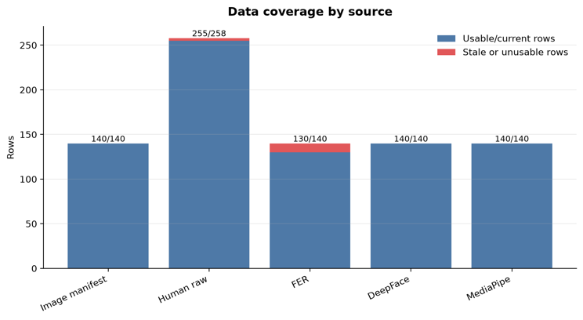
Dataset Coverage
Fig. 4

Before comparing the outputs of the human participants and AI models, the completeness of each data source was evaluated to ensure that sufficient data were available for meaningful analysis. As shown in figure 4, the image dataset consisted of 140 processed image versions, all of which were successfully analyzed by DeepFace and MediaPipe.
Human participants produced 255 individual response records, corresponding to multiple evaluations for each image. FER successfully processed 130 of the 140 images, with the remaining images excluded due to unsuccessful face detection. Overall, the dataset provided a high level of coverage across all sources, ensuring that the subsequent agreement, image degradation, and facial landmark analyses were performed using a consistent and representative set of observations.

Human-AI Agreement Analysis
As the facial images used were assigned reference labels rather than based on ground truth, the primary objective was to evaluate the level of agreement between human emotion perception and AI model predictions instead of conventional classification accuracy.

- Average Emotion Distribution

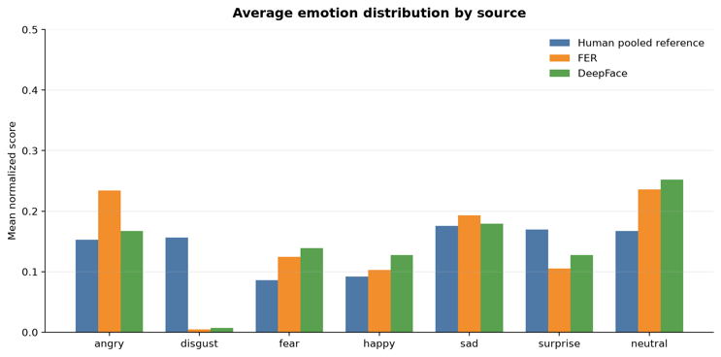
Fig. 5

Figure 5 compares the average normalized emotion distributions produced by the pooled human responses, FER, and DeepFace across all images. Overall, both AI models followed similar trends to the human responses; however, noticeable differences were observed in the weighting assigned to several emotion categories.
FER produced substantially higher average scores for anger, while both FER and DeepFace assigned considerably lower probabilities to disgust and surprise than those observed in the pooled human responses. Conversely, both models assigned higher probabilities to fear, happiness, and neutral, with DeepFace exhibiting the strongest tendency toward neutral predictions.
Among all emotion categories, sadness showed the closest agreement between the human participants and both AI models. These findings indicate that although the models generally identify similar emotional patterns, they differ in the confidence they assign to individual emotion categories.

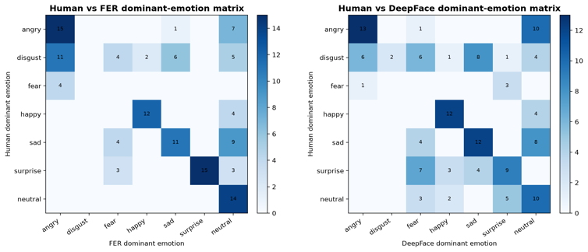
- Dominant Emotion Matrices
Fig. 6

Figure 6 presents the dominant-emotion matrices comparing the pooled human responses with the predictions produced by FER and DeepFace. The diagonal elements represent cases in which the dominant emotion identified by the AI model matched the dominant emotion obtained from the pooled human responses, while the off-diagonal elements indicate disagreement between the two.
Both models demonstrated strong agreement for anger, happiness, sadness, and neutral, as indicated by the prominent diagonal values. However, greater disagreement was observed for disgust, fear, and surprise, where predictions were more frequently distributed across multiple emotion categories. In particular, FER exhibited stronger agreement with the pooled human responses for anger, surprise, and neutral, whereas DeepFace showed increased confusion between surprise, fear, and neutral. These findings indicate that although both models successfully identified several dominant emotions, they differed in their interpretation of more ambiguous facial expressions.

Image Degradation

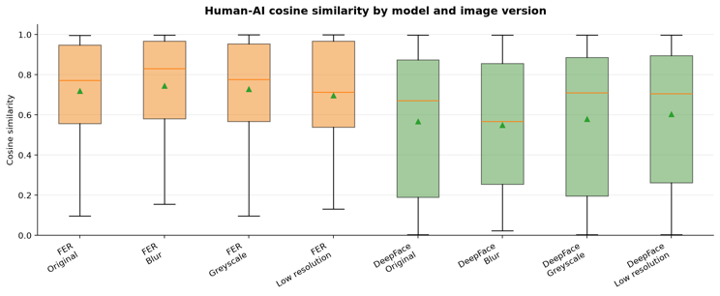
- Human-AI similarity across image modifications
Fig. 7

*higher cosine similarity values indicate closer agreement between AI-generated emotion probability distribution and the pooled human reference distribution.
Figure 7 shows that FER consistently achieved higher cosine similarity with human ratings rather than DeeFace across all image versions. FER exhibited median similarity values of approximately 0.70-0.80, whereas DeepFace produced lower median similarities, with greater variability across images.
Blur and greyscale modifications produced relatively small changes in similarity for both models. While low-resolution images showed the greatest reduction in agreement with human ratings

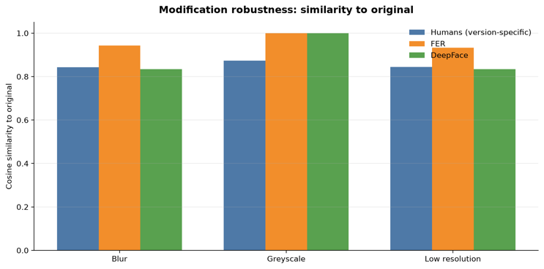
- Stability of emotion representations
Fig. 8

Greyscale images produced the highest similarity to the original images for both AI models, with similarity values approaching 1.0 (figure 8). Blur and low resolution modifications produced larger changes but still retained relatively high similarity.
Human ratings showed lower similarity than both AI models across all modifications, suggesting that participants were slightly more sensitive to visual degradation than the automated systems.
Overall, image degradation altered emotion representations only moderately, with greyscale having the smallest impact.

- Relationship between emotion change and robustness

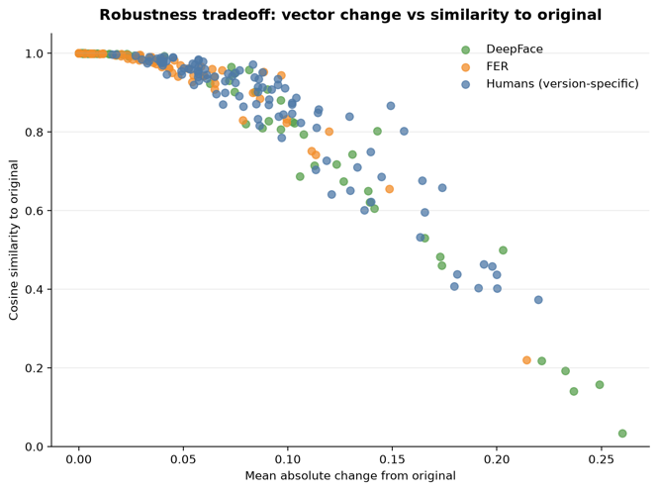
Fig. 9

The relationship between the magnitude of emotion profile change and similarity to the original image was examined for all modified images.
Across human ratings, FER, and DeepFace, larger changes in emotion vectors were consistently associated with lower similarity to the original image. This negative relationship indicates that greater changes in predicted emotion distributions corresponded to reduced robustness. Although FER generally exhibited smaller changes than DeepFace, the same overall trend was observed across all three datasets.
These findings demonstrate that similarity to the original image decreases progressively as image modifications produce larger changes in perceived emotion.

Emotion Ambiguity

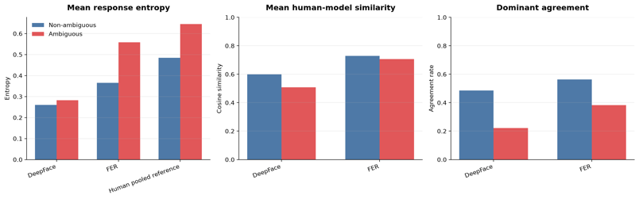
- Effect of ambiguity on agreement
Fig. 10

Ambiguous images exhibited substantially higher response entropy than non-ambiguous images for both human participants and AI models. Human-model cosine similarity was consistently lower for ambiguous images, with the largest reduction observed for DeepFace.
Dominant emotion agreement also declined considerably under ambiguous conditions. These results indicate that increasing ambiguity reduced agreement between human observers and AI emotion recognition models. file name for this description.

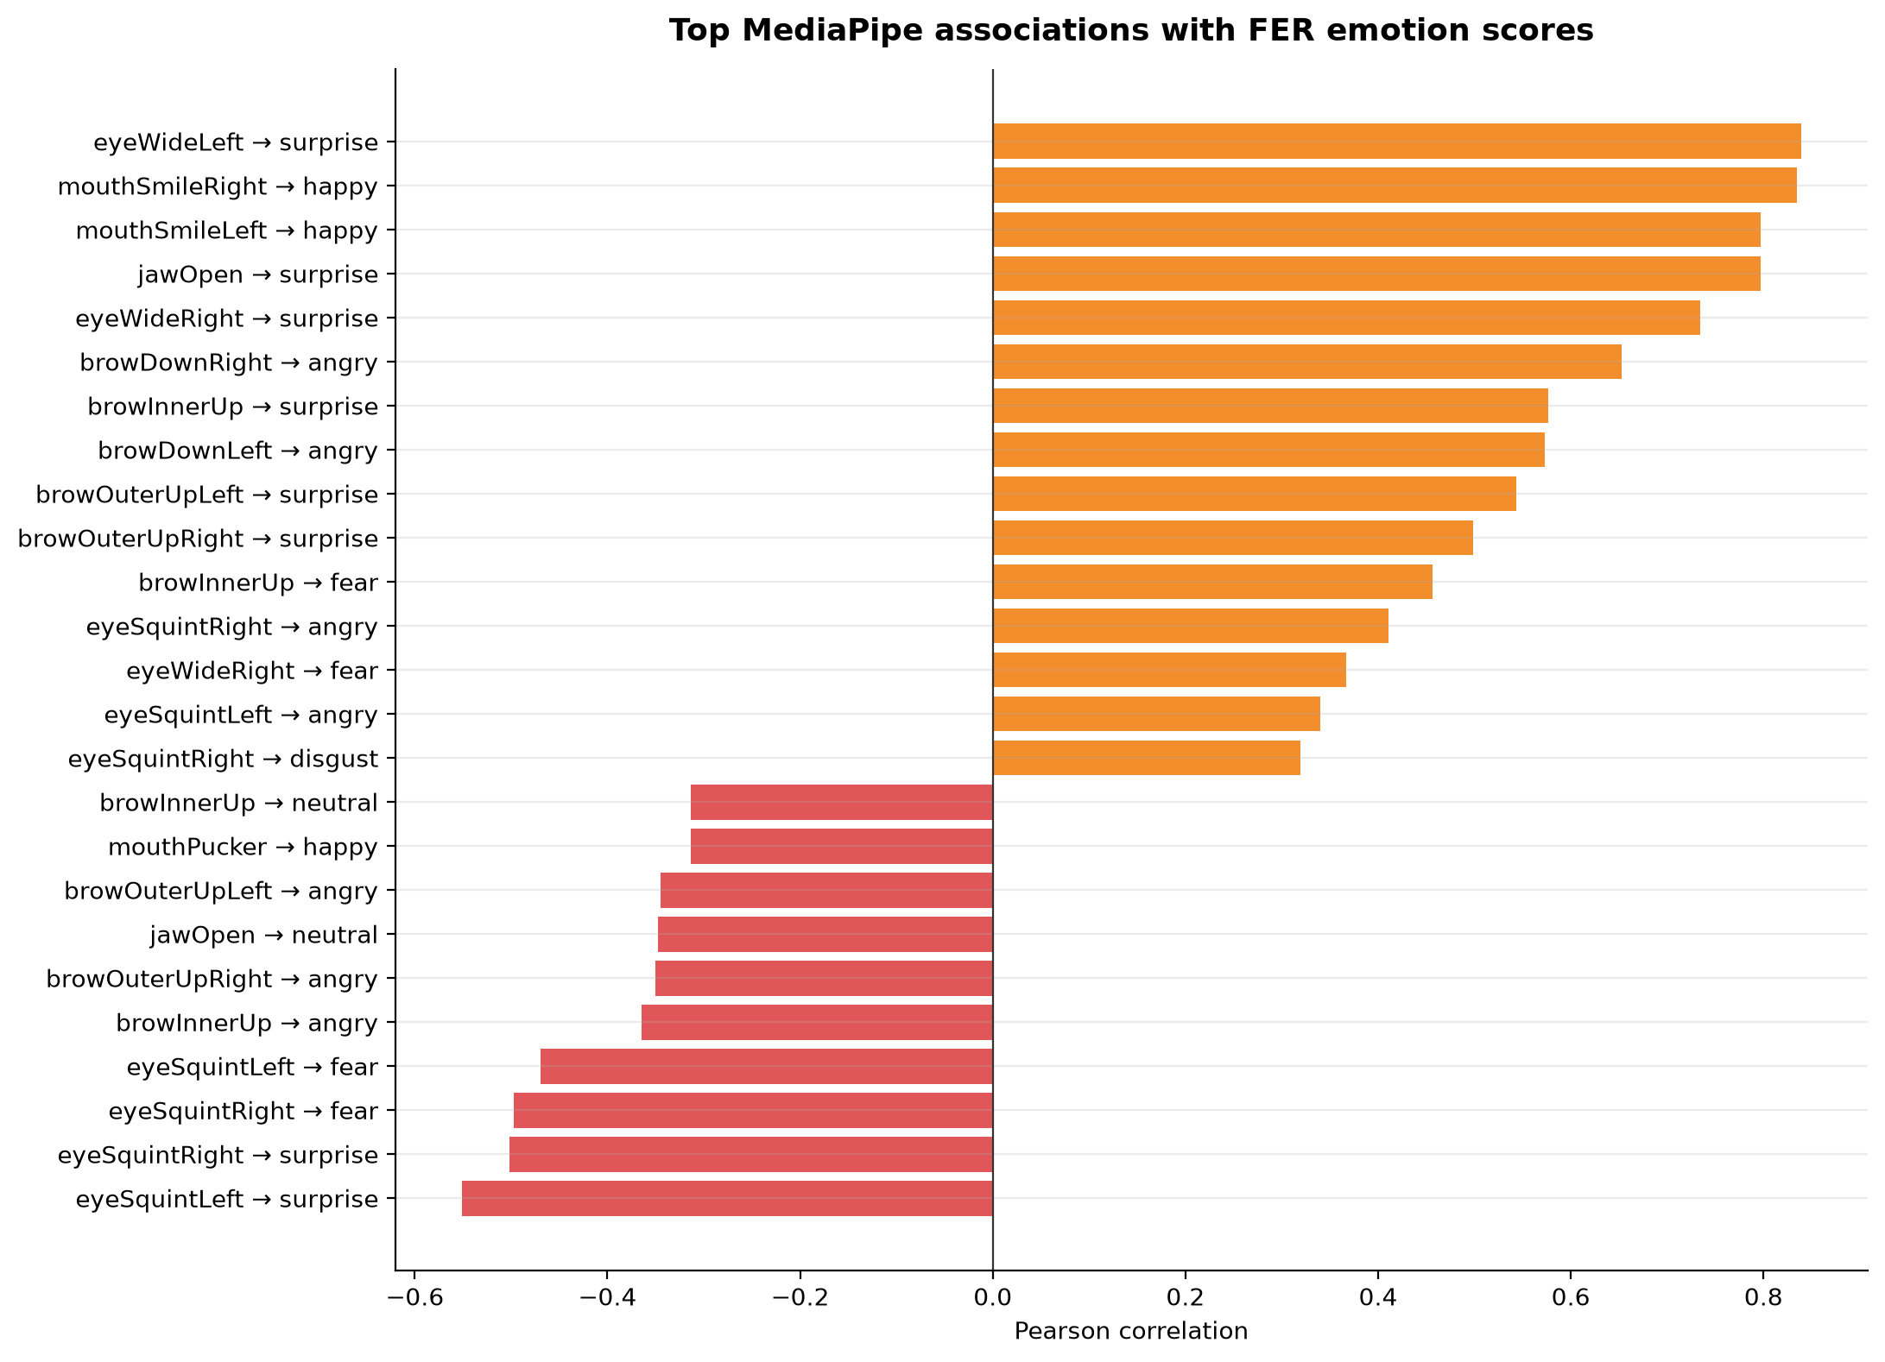
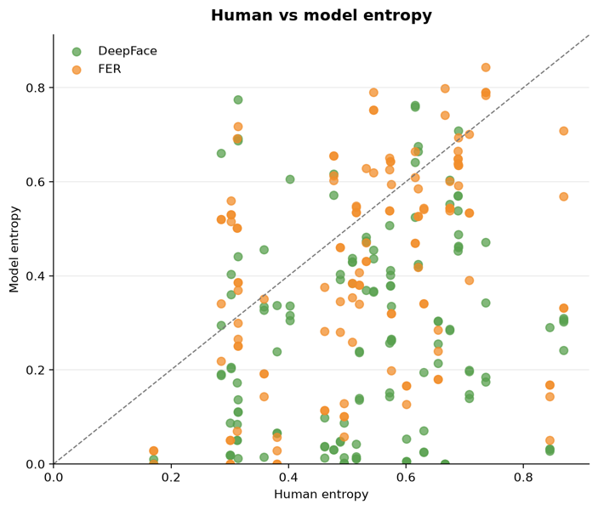
- Human and model uncertainty
Fig. 11
Human response entropy was positively associated with the entropy produced by both FER and DeepFace, indicating that images perceived as more ambiguous by participants also tended to produce greater uncertainty in the AI models.
However, considerable variation was observed around the diagonal reference line, particularly for DeepFace, suggesting that model uncertainty did not consistently match the level of uncertainty expressed by human participants.

E. Facial Landmark Associations

MediaPipe results showed that several emotion scores were connected to clear facial movement features. Eye widening was strongly related to surprise, mouth-smile features were related to happiness, and jaw opening was also associated with surprise.
These relationships suggest that MediaPipe is useful as an explanatory layer: it does not classify emotions on its own in this study, but it helps connect human and AI emotion scores to visible facial cues. (Figures 12 through 14)

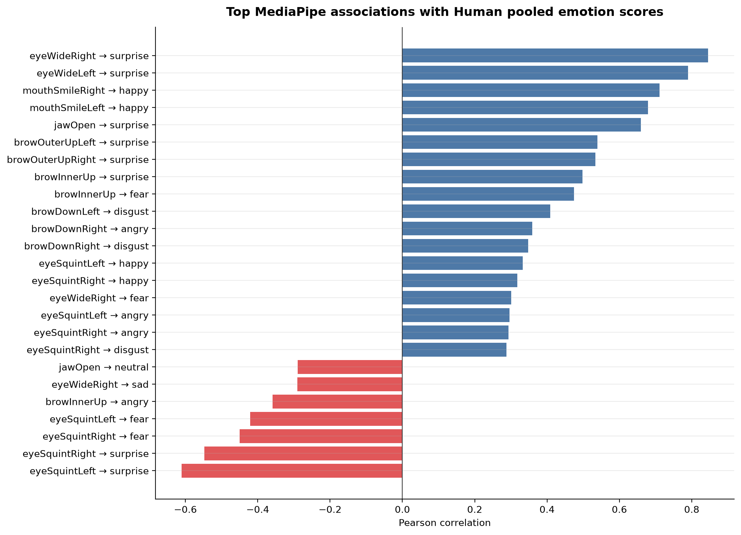
Fig. 12

Fig. 13
Fig. 11
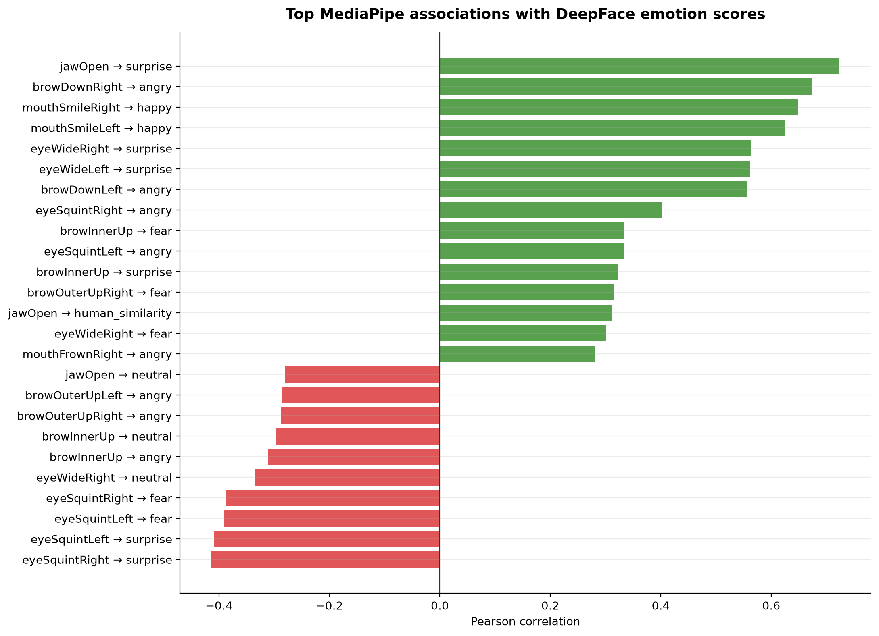
Fig. 14

Conclusion

This study shows that facial emotion recognition is better treated as a comparison of interpretation when ground-truth labels are uncertain. In this dataset, FER aligned more closely with pooled human ratings than DeepFace, while ambiguous and degraded images reduced the stability of emotion interpretation. MediaPipe blendshape features helped explain some of these patterns by linking emotion scores to visible facial movements.
Overall, the results highlight the importance of analyzing agreement, disagreement, and robustness rather than relying only on direct accuracy.

References
- [1] P. Ekman and W. V. Friesen, “Constants across cultures in the face and emotion,” Journal of Personality and Social Psychology, vol. 17, no. 2, pp. 124–129, 1971.
- [2] I. J. Goodfellow et al., “Challenges in representation learning: A report on three machine learning contests,” arXiv:1307.0414, 2013.
- [3] Y. Taigman, M. Yang, M. Ranzato, and L. Wolf, “DeepFace: Closing the gap to human-level performance in face verification,” in Proc. IEEE Conf. Computer Vision and Pattern Recognition, 2014, pp. 1701–1708.
- [4] C. Lugaresi et al., “MediaPipe: A framework for building perception pipelines,” arXiv:1906.08172, 2019.
- [5] S. Minaee and A. Abdolrashidi, “Deep-emotion: Facial expression recognition using attentional convolutional network,” arXiv:1902.01019, 2019.
- [6] Y. Khaireddin and Z. Chen, “Facial emotion recognition: State of the art performance on FER2013,” arXiv:2105.03588, 2021.

