**DEVELOPMENT OF TIME DASH MOBILE GAME (2D GAME) (GAMIFICATION TECHNIQUE IN WORKING PLACE)**

# Salahuddin Bin Azeesur Rahman1, Sity Nurul Asyadha Binti Taijuddin2 and Dr. Tan Siok Yee3

## 1 Bachelor of Software Engineering (Multimedia System Development) with Honours,

Faculty of Information Science & Technology,

Universiti Kebangsaan Malaysia, 43600 UKM, Bangi Selangor.

2 AGM Learning Consultants Level 14(South), Menara TM,

Jln Pantai Baharu, 50672, Kuala Lumpur,

3 Center of Artificial Intelligence Technology, Faculty of Information Science & Technology,

Universiti Kebangsaan Malaysia, 43600 UKM, Bangi Selangor,

1 [deanazees@gmail.com,](mailto:asrahlim2211@gmail.com) 2 [asyadha@tm.com.my,](mailto:gurpreet@biji-biji.com) 3 [esther@ukm.edu.my](mailto:khairul.azmi@ukm.edu.my)

**ABSTRACT:** This project is to develop a mobile game application from scratch which focus about gamification concept, which is to increase employee productivity and make them learn something by playing games. In other words, gamification is a method that meant to make the employees be more productive in doing their work. This project is to develop a fun and simple mobile game that tackles the management problem among the employees. To be more precise in this context, is time management problem among employees as there are some of the employees in the company using social media like Facebook, Twitter and Instagram during their working time in the office. They need to fully focused on their jobs and only use social media outside the working hours. The objectives for this project are, to provide gamification medium to staffs at the workplace to make them learn more about time management. Next, to provide a fun way (game) for staffs at the workplace to ensure they learn more effectively about time management. Method used for this project is Incremental Model whereby this model involves developing system process and tested by stages. This mobile game developed using Unity Game Engine. As a result a mobile game named as “Time Dash” had developed to tackle the problem. This game will be uploaded to TM learn portal (website) where the users can play it online. Besides that, ts have been exported to apk file(android application) to be play in any android device.

**KEYWORDS: G**amification, Unity, android application, time management.

1. **INTRODUCTION** This project is developed based on the requirement from the client which is from department of AGM Learning Consultants at Level 14 (South) Menara Telekom Malaysia (TM) which located at Jalan Pantai Baharu, Kuala Lumpur. This project is to develop a mobile game from scratch using Unity Game Engine tool. The name of mobile game is “Time Dash”. This mobile game is an example of application of the gamification concept in workplace environment. Whereby this mobile game is developed to teach the staff in a fun way by playing game to educate them that important of time in workplace and the uses of social media need to be decreased during working hours. The objectives of this project are, to provide gamification medium to staff TM to learn about time management. Next, to provide more fun way (games) for staff TM to learn about time management. The scope of this project involves TM staffs specifically TM staffs works in the department of AGM Learning Consultants. The developed mobile game will be uploaded in TM Learn Portal
2. **RELATED WORKS** Based on a research conducted in polytechnic Muadzam Shah Pahang to study on the effectiveness of gamification technique for higher education students engagement in polytechnic Muadzam Shah Pahang, Malaysia [1]. The research mentions that gamification technique really helps in the learning process of the students. “Not all educators are creative enough to include gamification in their lessons, thus online platforms such as Kahoot!, Quizizz, Socrative, and Quizalize provide excellent options for educators to choose from in diversifies lesson plans and activites that can captivate and inspire student’s motivation and increase students’ engagement during lessons in the classroom.”. Thus, this research concludes that there are many more advantages that weighs over disadvantages on this use of gamification technique. “Therefore, it can be concluded that Kahoot! and Quizziz as gamification platforms selected in this study are able to enhance student engagement in classroom.”. As a solution, this research states that “Therefore, gamification platforms such as Kahoot! and Quizizz as well as other similar platforms can be proposed as a learning tool in the classroom at Polytechnic Muadzam Shah Pahang, Malaysia.”

Based on a research article titled “Game development software engineering process life cycle: a systematic review” [2].It states that game has so many functions and it can be applied in many different kinds of things in our life such as for education. The research states that “Software game is a kind of application that is used not only for entertainment, but also for serious purposes that can be applicable to different domains such as education, business and health care”. The main objective of this research was to provide a detailed study insight into the Game Development Software Engineering (GDSE) process life cycle domain because, in the past, researchers have pointed out that it is different from the traditional software development process. As a solution, this research reinforces that GDSE process life cycle domain is a complex scientific domain comparable to the software engineering development process and presents a systematic literature review of the Game Development Life Cycle (GDLC) topics. The advantages of this research is it will helps researchers to identify research gaps in the GDLC and highlight areas for further research contributions.

Based on a research article titled “Applying user – centered techniques to analyze and design a mobile application” [3]. This research objective is to prove that techniques that help in understanding and designing user needs are increasingly being used in Software Engineering to improve the acceptance of application. The techniques are, personas, scenarios and interaction models. To be more detailed, personas are fictious representations of target users, scenarios to provide various types of information at different levels of abstraction and interaction models help in design of an adequate user interaction with the system. The solutions that’s have been suggested from this research are to employ personas and scenarios to understand the requirements, to employ interaction models to understand the behavior between user and system also using interaction models as basis to develop other artifacts. This supported by the research that states “Based on our research, we suggest this set of practical activities for the analysis and design of user – centered systems in Software Engineering. This set of practical activities can help the software engineers regarding the quality in use of applications and the development of other artifacts”. The advantage of this research is, to provide support for software engineers willing to adopt techniques that support the analysis and design of applications aiming at better quality of use for their users.

Based on a research article titled “Using a gamified mobile app to increase student engagement, retention and academic achievement”, this research objective was to investigate whether the use of a gamified mobile learning app influenced students’ academic performance and boosted their engagement in the subject [4]. The problem that have been studied in this research was students not engaged completely in the lecturer content. So, as a solution, an application was developed and used to deliver multiple-choice content-based quizzes directly to students’ personal mobile devices post-lecture and pre-tutorial. As stated in the research, ”Increase in students’ average academic performance may also suggest there is a potential to go beyond simply ‘engaging’ students in the learning activities with the app to actually boosting their academic knowledge acquisition and retention, converting it into higher final grades.” The advantage of this research was, after the application introduction, student retention rates and academic performance increased, and there was a positive correlation between students’ scoring highly in the app and achieving higher academic grades.

Based on a research article titled “Game-based learning and gamification in initial teacher training in the social sciences : an experiment with MinecraftEdu”, the research objective was to analyze the application of game-based learning and gamification using MinecraftEdu, which allows for an exploration of the possibilities regarding immersive learning enivronments [5]. The problem that have been determined in this research was the students consider video games as non-essential tools in an education context. The solution that was proposed, is unlike other typical video games this game is an unqiue in a way that this game-based learning through immersive environments allow for learning that involves a higher level of activity and engagement of the students. As mentioned in the research, “this study provides evidences of attitudes, values and perspectives on game-based learning and gamification in university settings, noting that applications with MinecraftEdu enable a number of benefits and advantages centred on pedagogies that allow for greater activity, motivation and involvement of students.” The advantage of this research was, students value the fact and understand that game-based learning through immersive environments allows for learning that involves a higher level of activity and engagement of the students. As, interest level, educational innovation and motivation are valued positively and show statistically significant improvements.

* Analysis of the existing applications

Fig. 1 and Fig. 2 shows the main page and gameplay respectively of the game Crossy Road. This game is developed by Hipster Whale company using Unity Game Engine also. This game is a huge hit in Ios and Android platform and become very popular during the time of its releasing. The objective of Crossy Road is to cross an endless series of roads and obstacles as far as possible without dying. The player plays as a chosen character and must tap to go forward or swipe the screen in the appropriate direction to move the character horizontally. The game consists of an endless series of obstacles in a set path, such as rivers, cars and trains. The player must time movements correctly in order to pass these obstacles without dying. For example, in the instance of a river, the player must cross the river using floating logs, without landing in the water. If the player takes too much time crossing an obstacle, or goes idle, a bald eagle will snatch the character, resulting in the game's end. Every forward movement will earn one point, with every fifty points sounded out by an effect. Furthermore, there are coins scattered across the environment that can be used to make new characters playable.

The player is also able to collect coins; an in-game currency, characterised by its squarish shape and red C in its middle. These are obtained in-game by collection during gameplay, watching advertisements, completing tasks, collecting a free gift given every few real-time hours, and using legal currency to buy them in various amounts. Coins are counted the top right corner of the screen. One hundred coins can be used for a chance at a new character from a lottery machine. If the player owns the Piggy Bank mascot, red coins worth five coins each are added to the game, and coins received from free gifts or watching ads are doubled.

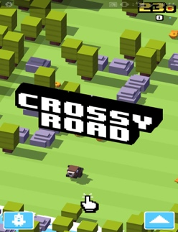

Fig. 1 Main interface of Crossy Road

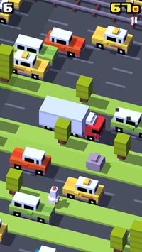

Fig. 2 Gameplay of Crossy Road

1. **METHODOLOGY :** In this section, the requirement analysis and in depth about detailed user needs and expectation are discuss. System design and system implementation also will be discuss in this section.
   1. **Requirement Analysis :** In process of collecting information, technique that used for survey is using Google Form as a medium to do the survey. This survey is given to AGM Learning Consultants department staffs.

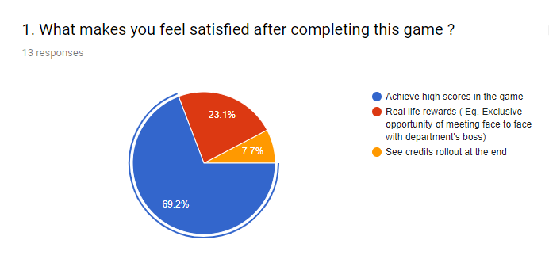

Fig. 3 Evaluating users game experience

Based on the above statistics (Fig. 3), this shows that majority of people choose achieve high scores in the game as the things that makes them feel satisfied after completing this game. This can be inferred that many people choose instant rewards system in the game after they finished playing the game.

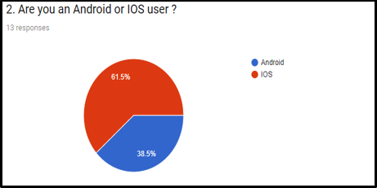

Fig. 4 Evaluating peoples preferences on smartphone

Based on the above statistics (Fig. 4), this shows that majority of people are using android smartphone.

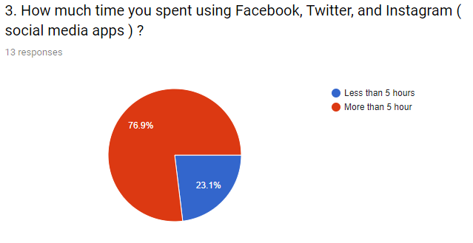

Fig. 5 Estimation users time spent on social media

Based on the above statistics (Fig. 5), this shows that more than half of the people spent more than 5 hour of their time using social media apps. It can be inferred that many people are addicted to social media.

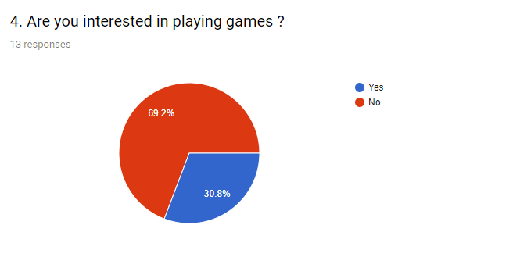

Fig. 6 Users preference in playing games

Based on the above statistics (Fig. 6), this shows that more than half of the people interested in playing games. This can inferred that, playing games is still relevant among working people.

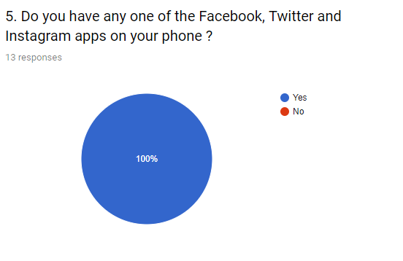

Fig. 7 Number of people using social media in their life

Based on the above statistics (Fig. 7), all of the people admit that they have one of the social media applications from Facebook, Twitter and Instagram application installed on their phone. This can be inferred as, nowadays everyone is into social media applications and spends many time using it.

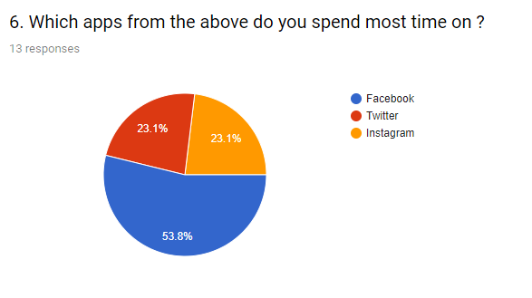

Fig. 8 Popularity of social media among users

Based on the above statistics (Fig. 8), more people prefer using Facebook as social media applications that they spend most of their time on compared relatively to twitter and Instagram. An interesting result is, respondents result for both of twitter and Instagram are sharing the same the same value which is 23.1%. From this results, it can be inferred that many people like Facebook more compared to other two which are Twitter and Instagram.

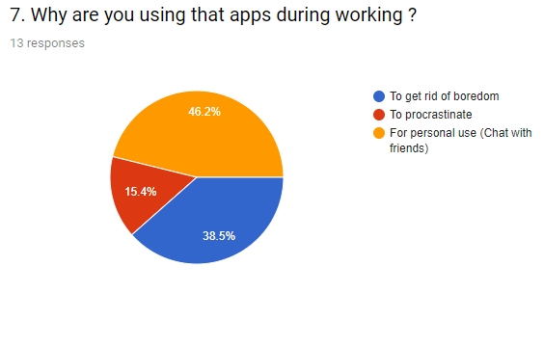

Fig. 9 Reasons for users using social media during working

Based on the above statistics (Fig. 9), majority of people using social media application during working for their personal use such as chat with friends. Followed closely by, to get rid of boredom and the least choosen answer is to procrastinate. It can be inferred that, many people still using social media application for their fully personal use only such as connecting with their friends and other personal things.

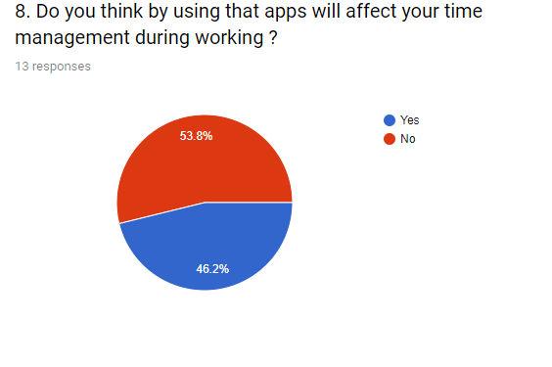

Fig. 10 Users opinion on social media affect their working productivity

Based on the above statistics (Fig. 10), majority of people choose no when asking about do they think by using that social media applications it will affect their time management during working. It can be inferred that, most of people still in denial and don’t want to accept the fact that social media application do indeed affect their time management during working.

* 1. **System Design :** This subsection will explains about the storyboard and interfaces for this game.

Storyboard 1

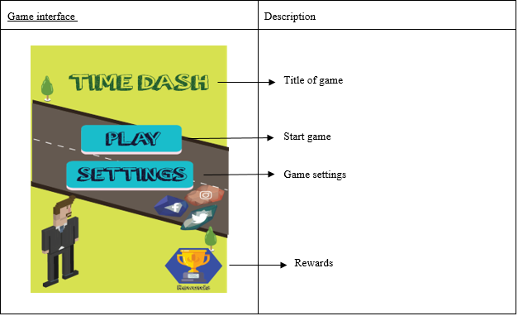

Storyboard 2

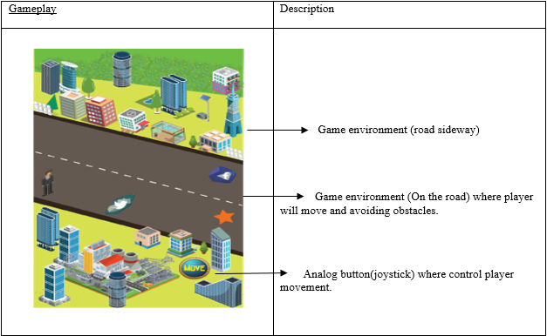

Storyboard 3

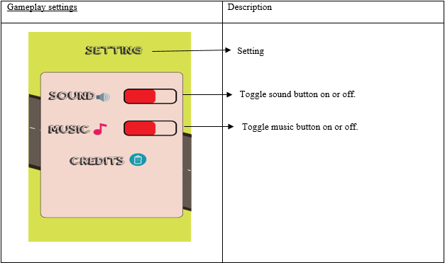

Storyboard 4

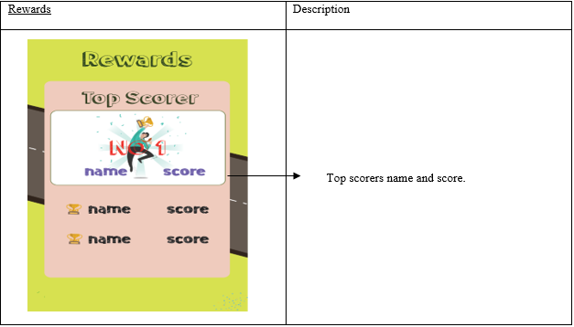

**3.2.1 System Design :** Interfaces for the game

|  |  |
| --- | --- |
| Picture/Icon | Description |
| C:\Users\user\Desktop\Time Dash Backup Completed 2\Time Dash resources\sprites\Player\heero2_big.png | * Player avatar |
| C:\Users\user\Desktop\Time Dash Backup Completed 2\Time Dash resources\sprites\UI\Button\button_home.png | * Home button |
| C:\Users\user\Desktop\Time Dash Backup Completed 2\Time Dash resources\sprites\UI\Button\button_play.png | * Play button |
| C:\Users\user\Desktop\Time Dash Backup Completed 2\Time Dash resources\sprites\UI\Button\button_restart_big.png | * Replay (to play game again) button |
| C:\Users\user\Desktop\Time Dash Backup Completed 2\Time Dash resources\sprites\Platform\Office building (3).png | * An example of the buildings in the game. |
| C:\Users\user\Desktop\Time Dash Backup Completed 2\Time Dash resources\sprites\Player\left.png | * Analog button to move the player to left |
| C:\Users\user\Desktop\Time Dash Backup Completed 2\Time Dash resources\sprites\Player\right.png | * Analog button to move the player to right |
| C:\Users\user\Desktop\Time Dash Backup Completed 2\Time Dash resources\sprites\Obstacles\item_star.png | * Collectible items(stars) to collect points in the game for scores. |

|  |  |
| --- | --- |
| C:\Users\user\Desktop\Time Dash Backup Completed 2\Time Dash resources\sprites\Obstacles\3drock_facebook.png | * Obstacles for the player that player need to be avoided. * Facebook logo on the rock metaphorically represents social media facebook. * In this game, its obstacles = enemy for the player so its symbolically represents in the real life social media Facebook is enemy for people because its wasting peoples time. |
| C:\Users\user\Desktop\Time Dash Backup Completed 2\Time Dash resources\sprites\Obstacles\3drock_twitter.png | * Obstacles for the player that player need to be avoided. * Twitter logo on the rock metaphorically represents social media twitter. * In this game, its obstacles = enemy for the player so its symbolically represents in the real life social media Twitter is enemy for people because its wasting peoples time. |
| C:\Users\user\Desktop\Time Dash Backup Completed 2\Time Dash resources\sprites\Obstacles\3drock_instagram.png | * Obstacles for the player that player need to be avoided. * Instagram logo on the rock metaphorically represents social media instagram. * In this game, its obstacles = enemy for the player so its symbolically represents in the real life social media Instagram is enemy for people because its wasting peoples time. |
| C:\Users\user\Desktop\Time Dash Backup Completed 2\Time Dash resources\sprites\Obstacles\item_spike4.png | * Spike obstacles that player need to be avoided. |

* 1. **System Implementation :** Evaluation of the systems and system installation.

The game has been developed and has been exported to apk file using Unity Game Engine. The end users mostly find it interesting to play this game and liked this game. The system installation and operational in the production environment will be shown below.

|  |  |
| --- | --- |
| Events | Description |
| C:\Users\user\Desktop\gambar survey\Screenshot_2019-01-09_160930.jpg | * Installation page. System prompting users whether to install the game and informing the users that the game don’t need any access to the users phone. |
| C:\Users\user\Desktop\gambar survey\Screenshot_2019-01-09_160935.jpg | * Loading the installation of the game in android smartphone. |
| C:\Users\user\Desktop\gambar survey\Screenshot_2019-01-09_160947.jpg | * System notifying the game has been installed in android smartphone. |
| C:\Users\user\Desktop\gambar survey\Screenshot_2019-01-09_161055.jpg | * Unity welcoming screen before launching the game. |
| C:\Users\user\Desktop\gambar survey\Screenshot_2019-01-09_161103.jpg | * Main screen of the game. |
| C:\Users\user\Desktop\gambar survey\Screenshot_2019-01-09_161207.jpg | * The gameplay |
| C:\Users\user\Desktop\gambar survey\Screenshot_2019-01-09_161219.jpg | * Game paused screen |
| C:\Users\user\Desktop\gambar survey\Screenshot_2019-01-09_161234.jpg | * Game over screen. |

1. **Results and Discussion :** During the 20 weeks of my internship, in the end I have finish developed my Time Dash mobile game ( 2d game ) from scratch using Unity Game Engine as my project for my internship. I am happy and proud of myself for managed to finish my project during that period and achieved my goal to finish my internship project with success. From the results of testing and evaluation, many end users liked to play this mobile game as it is very simple to play in their smartphone and quite fun. My industry supervisor comments that she’s liked my game and feel happy because I managed to finish my internship project on time. She also pleased with me for my hardwork and commitment that I have shown in completing this mobile game and finish up my internship project. She mentioned to me that I have achieved my internship project goal and I should be proud of myself for achieving my goal by finishing my internship project. Knowledge and skills that I have learnt from doing this internship project was, my programming skill especially in C# has improved and from completing this project, it has certainly contributed in improvement of my programming skills to become better. My finished developed mobile game project will be uploaded to portal(website) TM Learn and it will benefit the company as all the users who visited that portal can try have a fun and play this simple yet interesting game. The suggestion to enhance my mobile game project is to add more features., like adding more playable characters, adding more obstacles and make the challenges in games more hard so that it will be more exciting to play.
2. **Conclusion :** I have completed my 20 weeks of internship at AGM Learning Consultants at Menara Telekom Malaysia. In the end, I have got many experiences and lessons that I have learnt from my internship. In summary, my internship project was about developing a mobile game ( 2d game ) from scratch that touches about gamification concept in workplace environment among employees. Gamification is a method to use game in a way to make employees more productive in their working. To be more specific, there is a time management problem among employees such as they are using social media Facebook, Twitter and Instagram during their working time., so I need to come up with a solution to tackle this problem. Thus, I come up with a solution that using gamification concept and developing a game to solve this problem. By playing this game, they will learn more about time management and will manage their time more effectively. For instance, they will use less of social media during their working time and only use them outside their working time. The results are, some of the staffs that played this game were enjoying this game and at the same time unconsciously learnt that social media is wasting their working time in a way that social media are represented as enemies in the game and metaphorically giving a meaning that social media is “enemies” in real life that wasting their working time and make them less productive in their working time at office. In conclusion, by developing this mobile game as my internship project I have learnt many technical skills such as animating the characters, editing voice and sound in the game, editing interfaces in the game and many more. More importantly, I learnt more in programming and take my skills in programming higher to another level. I am very happy and proud of myself for achieving my goal. Overall, I have learnt many things during my internship and it really helps me to be more prepared mentally and physically to join workforce as soon as I have completed my studies.

**ACKNOWLEDGEMENT** First and foremost, I would like to thank Telekom Malaysia (TM) for giving me the opportunity to do my internship at AGM Learning Consultants on level 14 at Menara TM. I’m also thankful to the love of my mother, Ummul Rasheeda, for giving me guidance and support me in my efforts to pursue a higher level education in Software Engineering. I would also like to thank my university’s supervisor, Dr. Tan Siok Yee for helping me in my internship project. Lastly, I want to thank Sity Nurul Asyadha, my industry supervisor for helping me throughout my internship.

**REFERENCES**

Bibliography}

[1] R. Ab. Rahman, S. Ahmad, U.R. Hashim, The effectiveness of gamification technique for higher education students engagement in polytechnic Muadzam Shah Pahang, Malaysia, Int. J. Educ. Technol. High. Educ. (2018). doi:10.1186/s41239-018-0123-0.

[2] S. Aleem, L.F. Capretz, F. Ahmed, Game development software engineering process life cycle: a systematic review, J. Softw. Eng. Res. Dev. (2016). doi:10.1186/s40411-016-0032-7.

[3] A. Lopes, N. Valentim, B. Moraes, Re. Zilse, T. Conte, Applying user-centered techniques to analyze and design a mobile application, J. Softw. Eng. Res. Dev. 6 (2018).

[4] E. Pechenkina, D. Laurence, G. Oates, D. Eldridge, D. Hunter, Using a gamified mobile app to increase student engagement, retention and academic achievement, Int. J. Educ. Technol. High. Educ. (2017). doi:10.1186/s41239-017-0069-7.

[5] R. Cózar-Gutiérrez, J.M. Sáez-López, Game-based learning and gamification in initial teacher training in the social sciences: an experiment with MinecraftEdu, Int. J. Educ. Technol. High. Educ. (2016). doi:10.1186/s41239-016-0003-4.

**APPENDIX**

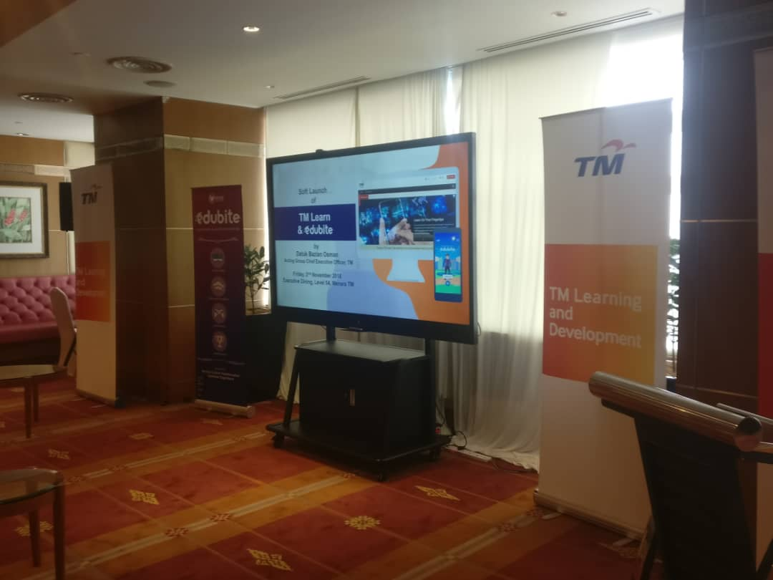

Figure 1 The launching of portal website TM Learn where my finished developed game will be uploaded

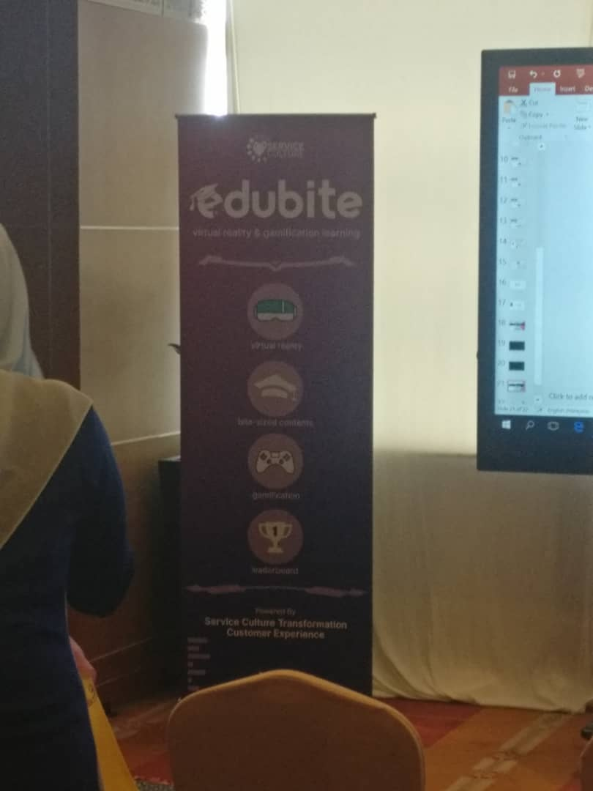

Figure 2 The contents of gamification technology that Telekom Malaysia want to apply in its company

