5_Hatzis_2011_models
- Patients prospectively consented to a research biopsy by fine needle aspiration (FNA) or core biopsy (CBX) prior to any systemic therapy, and to the future assessment of pathological response and/or survival endpoints.

- Form analysis :
- shape : 310 patients / 22303 features
- dtypes: 22285 floats / 17 object / 1 int64
- Target : RECIST (Response)

Progression free survival distribution RECIST Distribution
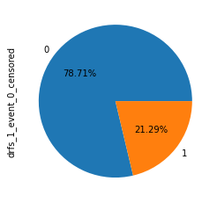
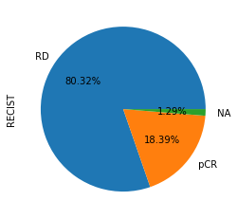

- Genes status : (0 : positif ; 1: negatif )

- er_ihc ==> 0.0 174 1.0 131

- pr_ihc ==> 1.0 162 0.0 142

- her2 ==> 1.0 291 0.0 4

- esr1_stat ==> 0.0 175 1.0 135

- erbb2_stat ==> 1.0 298 0.0 12

Percentage of missing data (nan) Age(year) and PFS(year) distribution

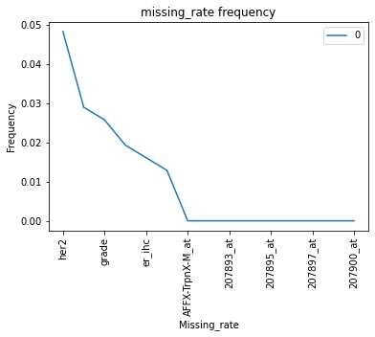
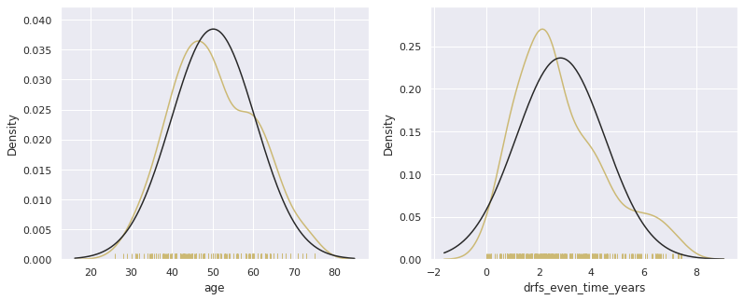

- New Table : 4 patient who donc have response data

Patient_ID | RECIST | Genes expression
306 patients | RD & pCR | 22284 Features

Genes expression distribution
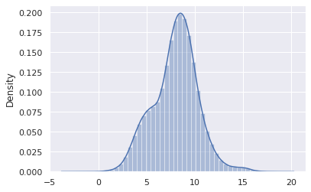

- Scores table

Models  Scores | KNN |  |  | LR |  | RF |  | SVM |  |  | STACK MODEL  (knn-svm-rf-lr) | DT
Splits | TTS | CV | CV: CVS | CV | CV:CVS | CV | CV:CVS | TSS | CV | CV:CVS | TSS | TSS  d = 3  CV | PCA  36f
ACC | 0.822 | 0.800 | 0.800 | 0.800 | 0.800 | 0.817 | 0.817 | 0.76 | 0.810 | 0.810 | 0.833 | 0.867 | 0.844
MCC | 0.325 | 0.190 | 0.242 | 0.191 | 0.185 | 0.068 | 0.136 | 0.111 | 0.216 | 0.225 | 0.371 | 0.539 | 0.478
AUC | 0.597 |  |  | 0.708 |  | 0.688 |  | - |  |  | 0.701 | 0.708

- Some Plotting :

Acc score according to n_neighbord (Knn model) Scores according to n_depth (dt model)
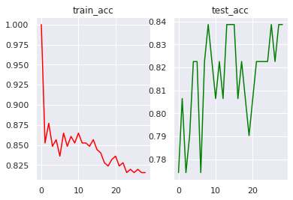
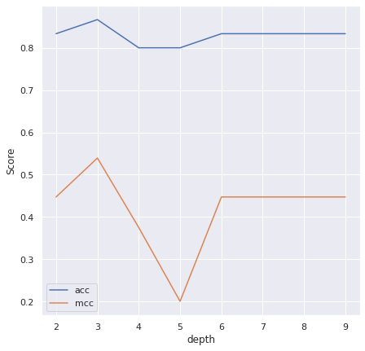

AUC curve (dt model) Mcc & Acc scores according to n_components(dt model)
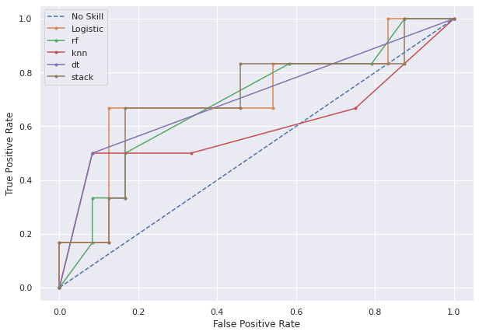
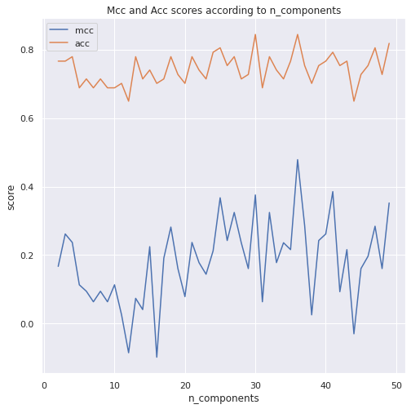

- Compare Mcc and Acc scores between models

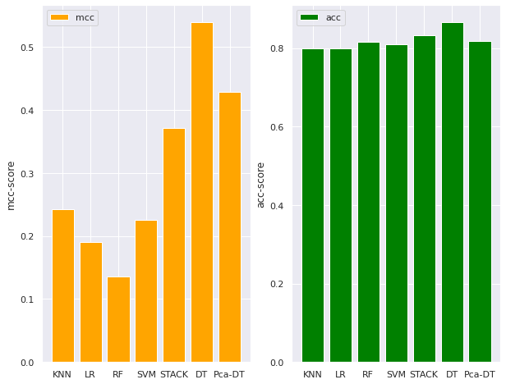

- Feature selection (chie2)

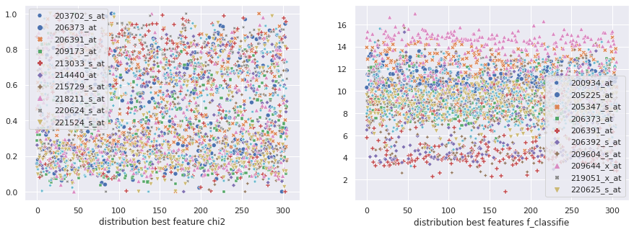

- Compare Mcc and Acc scores between models fitted with 10 best features

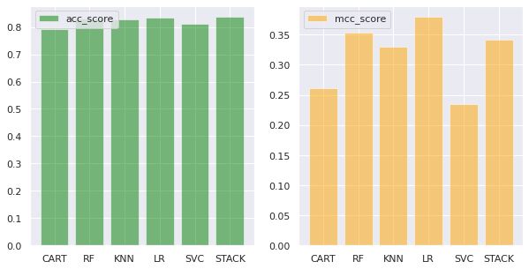

Models  scores | CART | RF | KNN | LR | SVC | STACK
mcc | 0.261 | 0.354 | 0.330 | 0.379 | 0.235 | 0.341
acc | 0.791 | 0.830 | 0.827 | 0.833 | 0.810 | 0.836

Scoring

==============> Knn
- tts :

ACC : 0.8225806451612904
mcc: 0.32500996627872475

- cv : each fold is splited in train and test

moyenne mcc =====> 0.19000156807101704
moyenne score-knn =====> 0.800537634408602
- cv : cvs

acc : 0.800537634408602
MCC ==> 0.2421359969137853

=============> LR
- cv : each fold is splited in train and test
mcc =====> 0.19177436784633778
acc =====> 0.8006451612903225
- cv : cvs
acc = 0.8006451612903225
mcc==> 0.18534381900987618
=============> RF
cv : each fold is splited in train and test
mcc =====> 0.06856592701857847
ACC =====> 0.8170967741935483

cv : cvs
ACC == > 0.8170967741935483
MCC==> 0.13696145424787262

=============> SVM
- tts :
ACC ==> 0.7666666666666667
mcc ==> 0.1111111111111111
- cv : cvs
acc ===> 0.8105376344086022
MCC ==> 0.22503123660337787
cv : each fold is splited in train and test
mcc =====> 0.2161477495676373
acc =====> 0.8105376344086022
============> stack model : knn / svc / rf / lr
- tts :
Acc ===> 0.8333333333333334
Mcc ===> 0.3713906763541038
=============> DT
- tts
depth 3 Acc CART ===> 0.8666666666666667
depth 3 Mcc CART ===> 0.5393193716300061
- pca / (39 is the best)
best mcc : 0.4287808161645165
best acc : 0.8181818181818182

