Model 3
EfficientNet
1280 variables

pca ALL VARIABLES

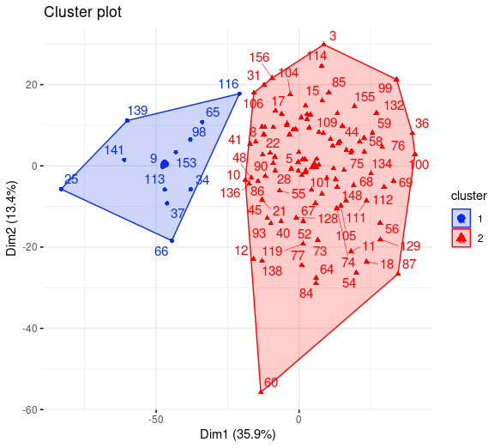
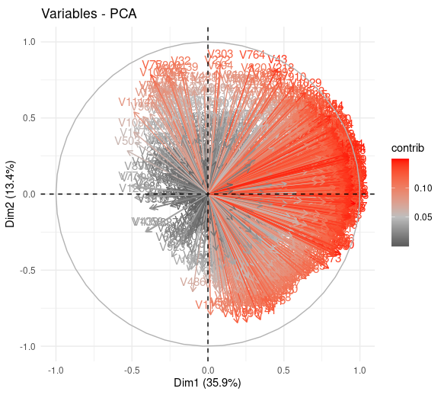
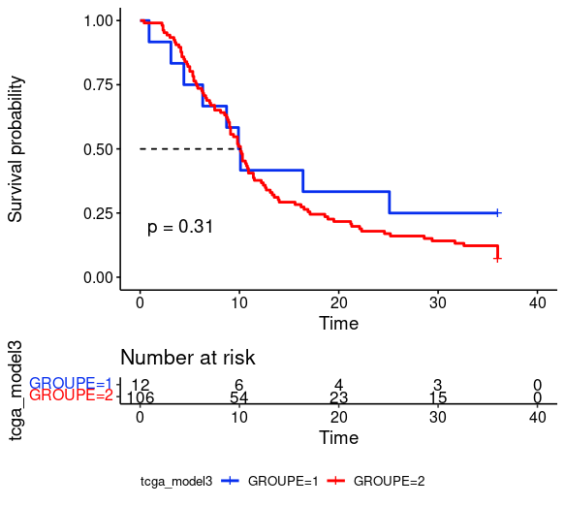

univariate 14 variables
"V7" "V22" "V91" "V322" "V382" "V544" "V587" "V812" "V907" "V947" "V1059" "V1175" "V1246" "V1248"
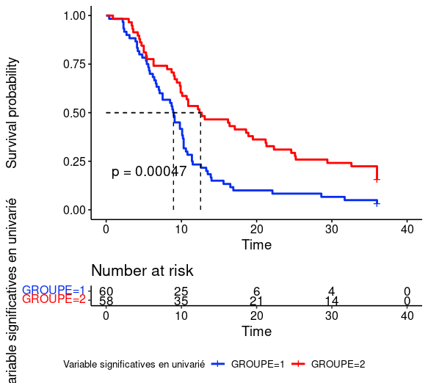
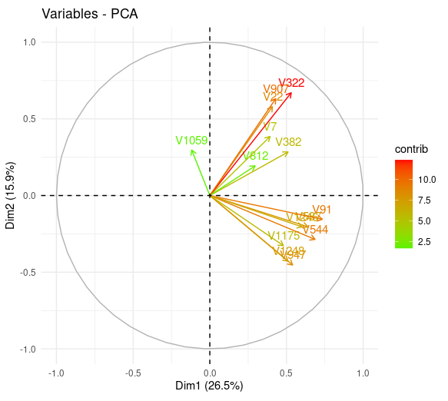
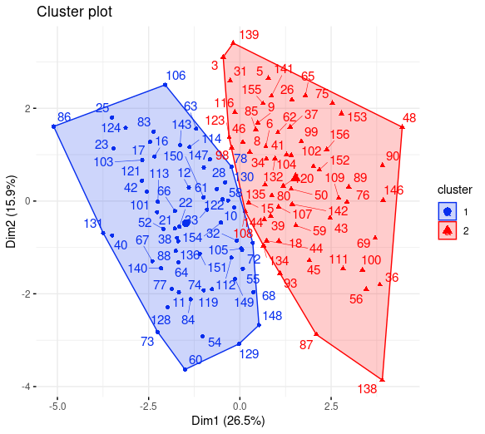

cox ph

maxstat -0,452

Train TEST Test (maxstat0.151)
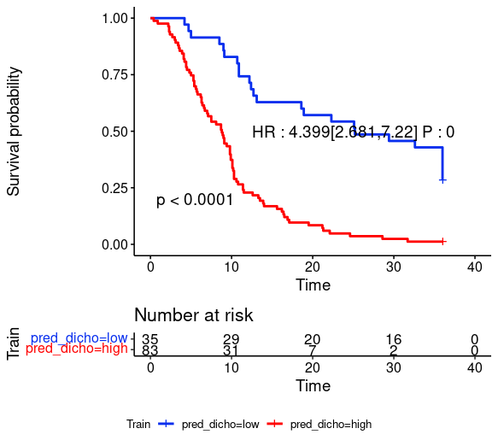
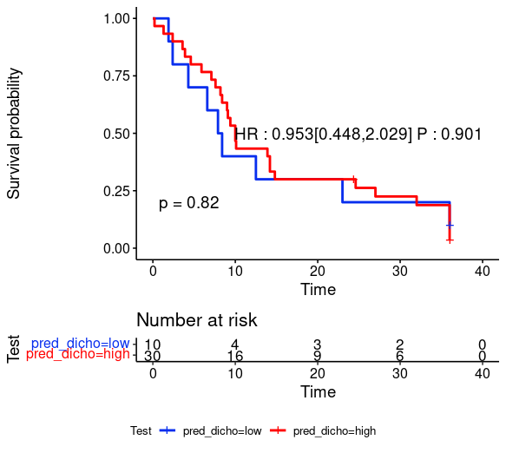
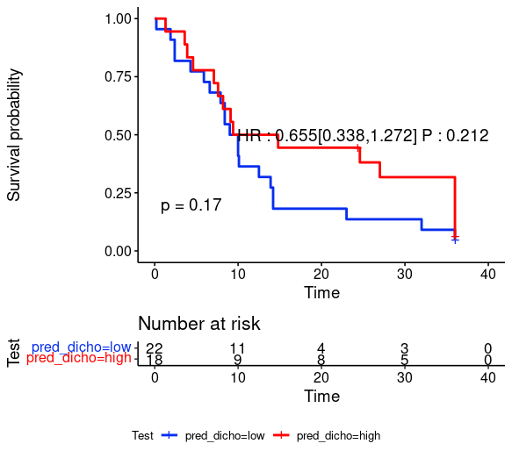

COX PH T80
adding lasso cox model
maxstat = -0.284
vars = "V101" "V181" "V312" "V478" "V574" "V599" "V609" "V625" "V781" "V823" "V873" "V931" "V1037"

TRAIN TEST TEST PROPRE
