PostgreSQL Data Collection Setup
Sequential Anomaly Detection on Database Event Logs
Dinan Sooriyaarachchi
April 9, 2026

Overview
This document records the steps taken to set up a PostgreSQL database environment for generating real audit logs. As described in the research proposal, the data collection methodology avoids synthetic CSV generation by executing real SQL queries against a live PostgreSQL instance with log_statement='all' enabled. The resulting log file (sample_pg2.log) contains 1,617 event lines across 62 sessions (50 normal, 12 anomaly), with session lengths ranging from 5 to 50 queries.
The setup was performed on a MacBook Pro (13-inch, M1, 2020) running macOS Ventura 13.4 with 8 GB RAM.

Environment
Machine: MacBook Pro 13-inch, M1 chip, 8 GB RAM, macOS Ventura 13.4
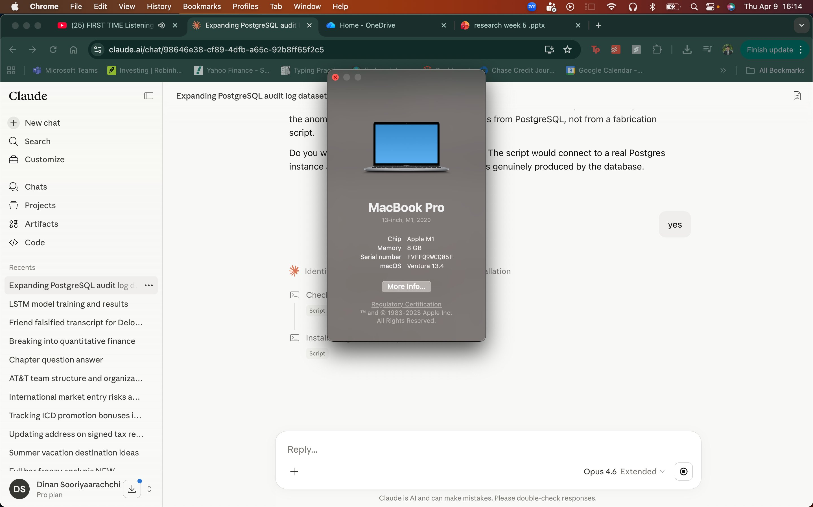
Figure 1. System information confirming hardware specifications.

Step 1: Install PostgreSQL via Homebrew
PostgreSQL 16 was installed using Homebrew, the standard macOS package manager. The following command was run in the terminal:
brew install postgresql@16
Homebrew downloaded and compiled all required dependencies including libunistring, gettext, icu4c, ca-certificates, openssl, xz, cmake, and zstd. The installation took approximately 20 minutes due to source compilation on the M1 architecture.
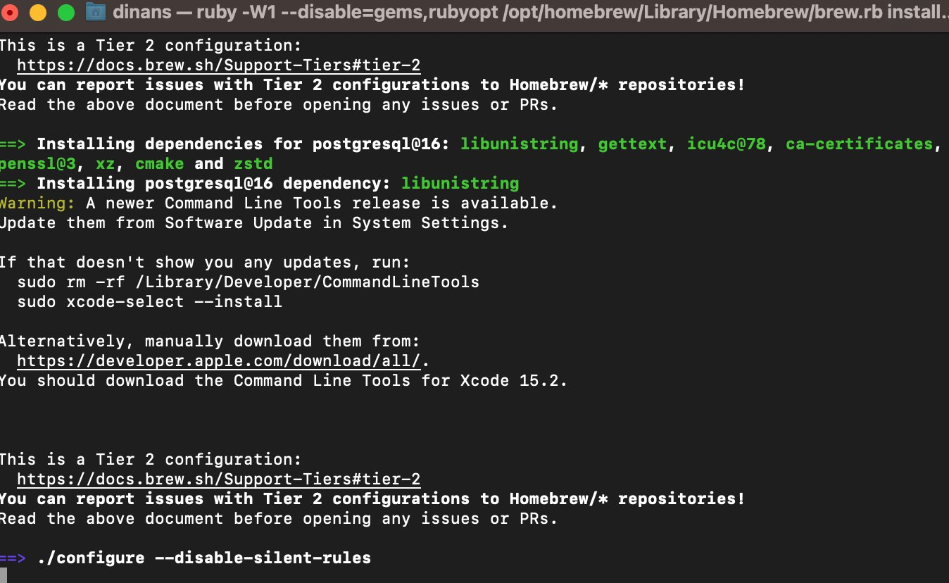
Figure 2. Homebrew beginning the PostgreSQL 16 installation and downloading dependencies.
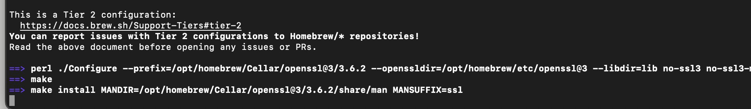
Figure 3. OpenSSL dependency compiling during the installation process.
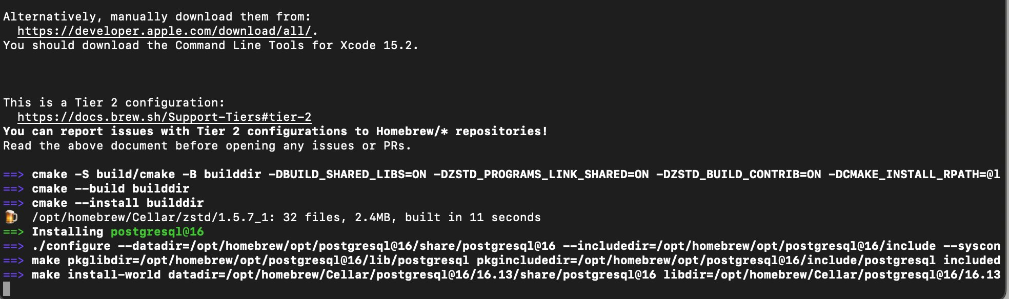
Figure 4. PostgreSQL 16 itself begins installing after all dependencies are built.
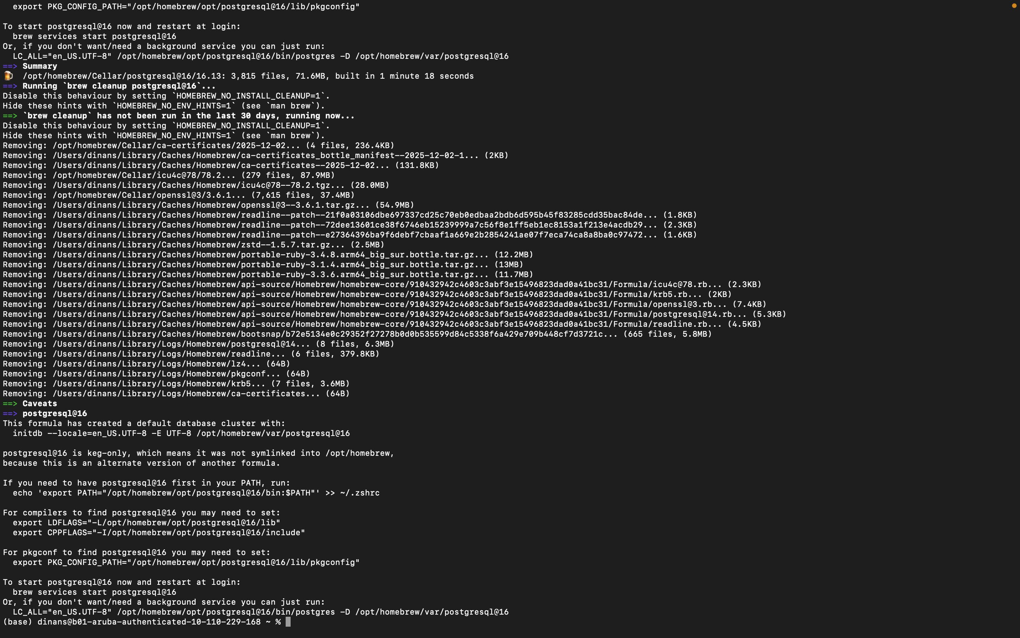
Figure 5. Installation complete. Summary shows postgresql@16/16.13: 3,815 files, 71.6MB, built in 1 minute 18 seconds.

Step 2: Start PostgreSQL and Add to PATH
PostgreSQL was added to the system PATH and started as a background service:
echo 'export PATH="/opt/homebrew/opt/postgresql@16/bin:$PATH"' >> ~/.zshrc
source ~/.zshrc
brew services start postgresql@16
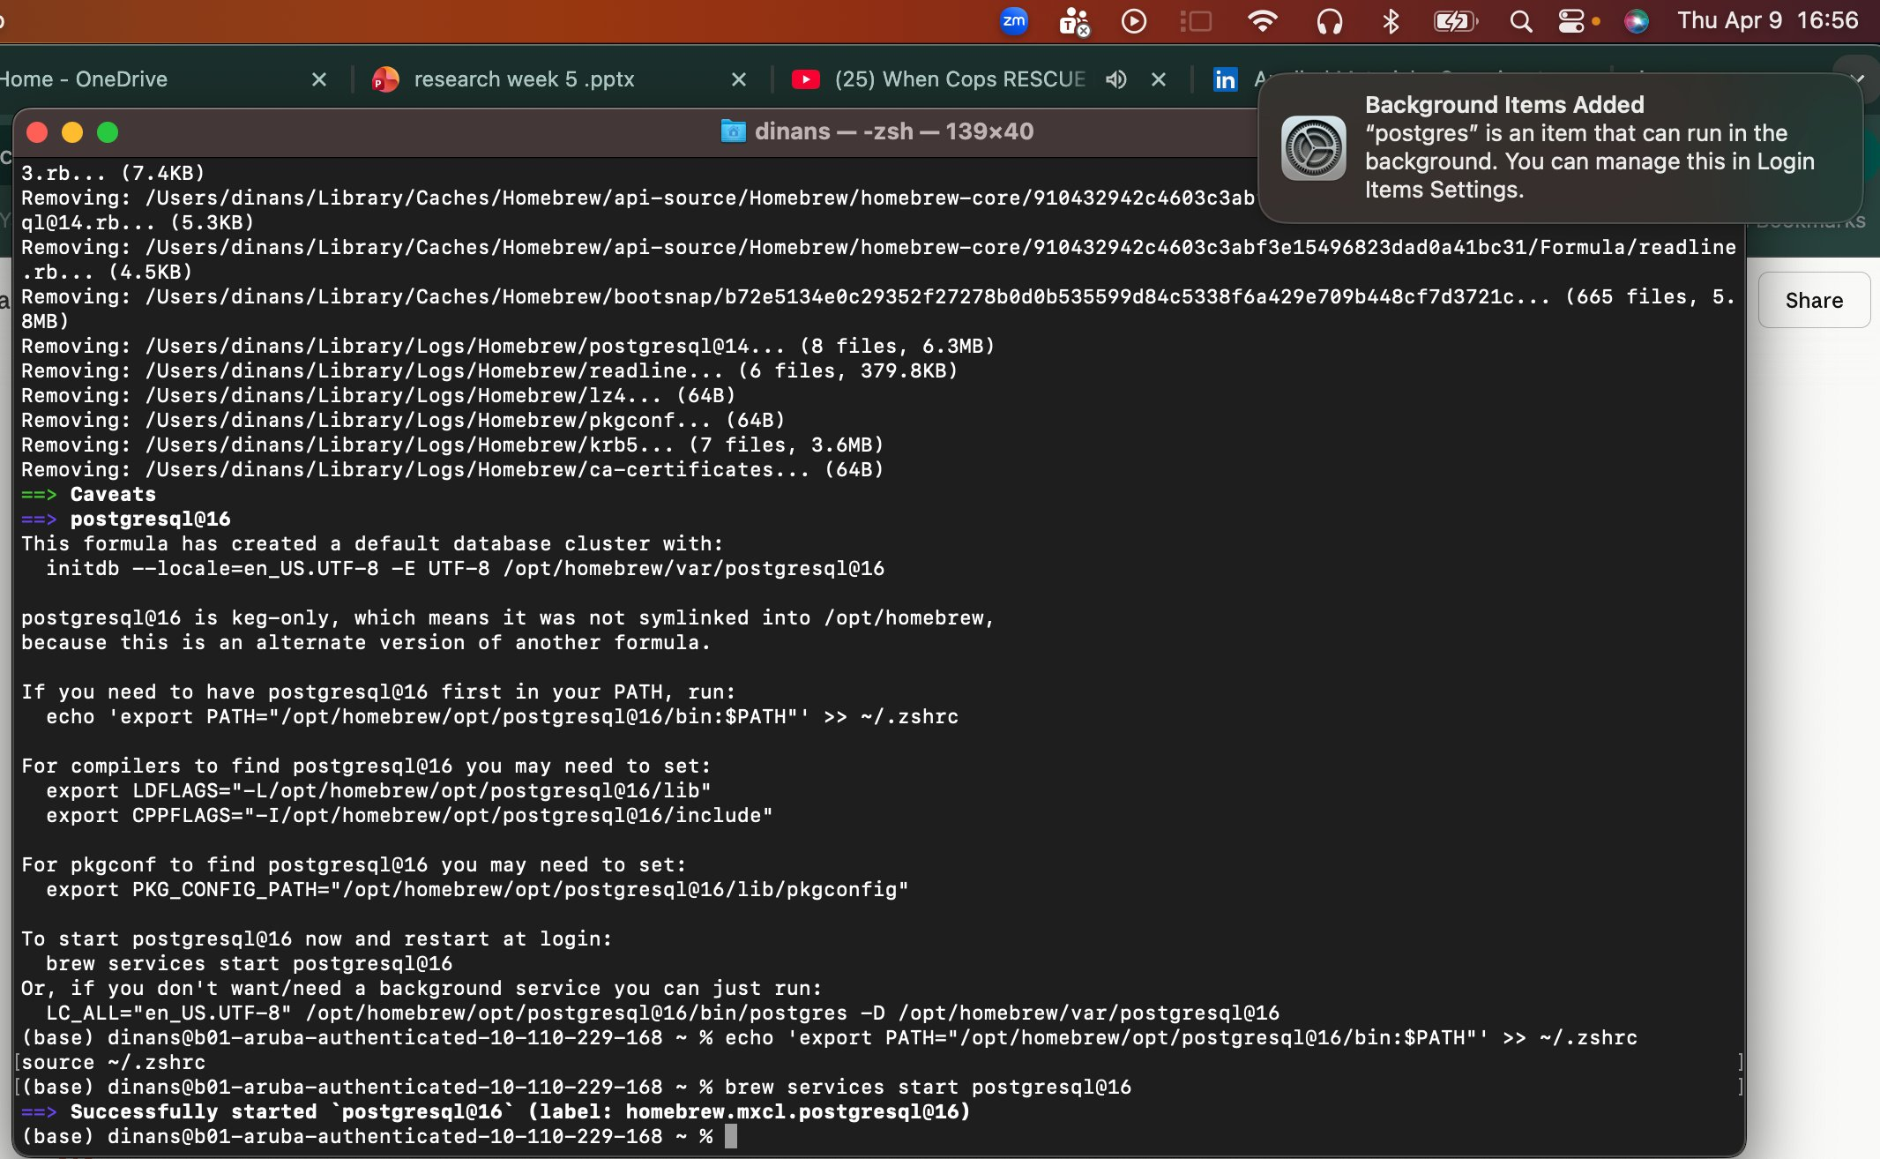
Figure 6. PostgreSQL service started successfully. macOS notification confirms background process is running.

Step 3: Initialize Database Cluster
The initial start produced an error because the data directory did not exist. An existing PostgreSQL 14 installation was also found to be conflicting. After stopping the old version and initializing the data directory, PostgreSQL 16 started successfully:
brew services stop postgresql@14
initdb /opt/homebrew/var/postgresql@16
brew services restart postgresql@16
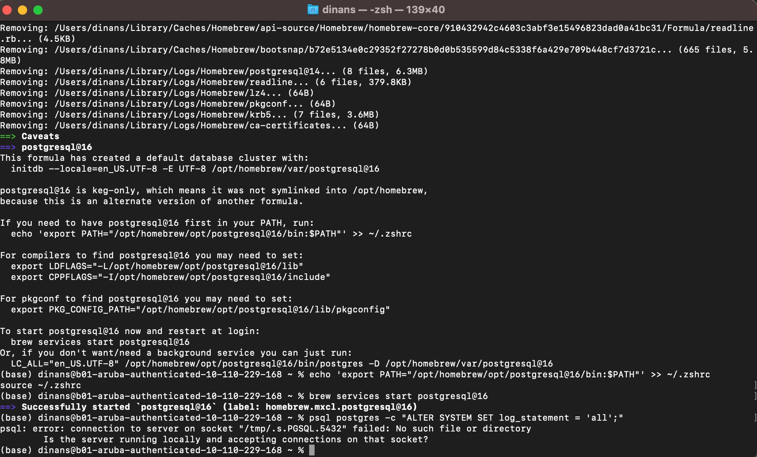
Figure 7. The initdb error was resolved, and audit logging was enabled.

Step 4: Enable Audit Logging
PostgreSQL was configured to log all SQL statements by setting log_statement to 'all'. This ensures every query executed against the database is recorded in the audit log, as specified in the research proposal:
psql postgres -c "ALTER SYSTEM SET log_statement = 'all';"
brew services restart postgresql@16

Step 5: Create Database and Seed Data
The setup_database.sql script was executed to create the prod database, schemas (public, payroll, admin), and four tables: customers (200 rows), products (100 rows), orders (500 rows), and payroll.sensitive_payroll (50 rows). This data gives the workload generator realistic rows to query against:
psql postgres -f ~/Downloads/setup_database.sql
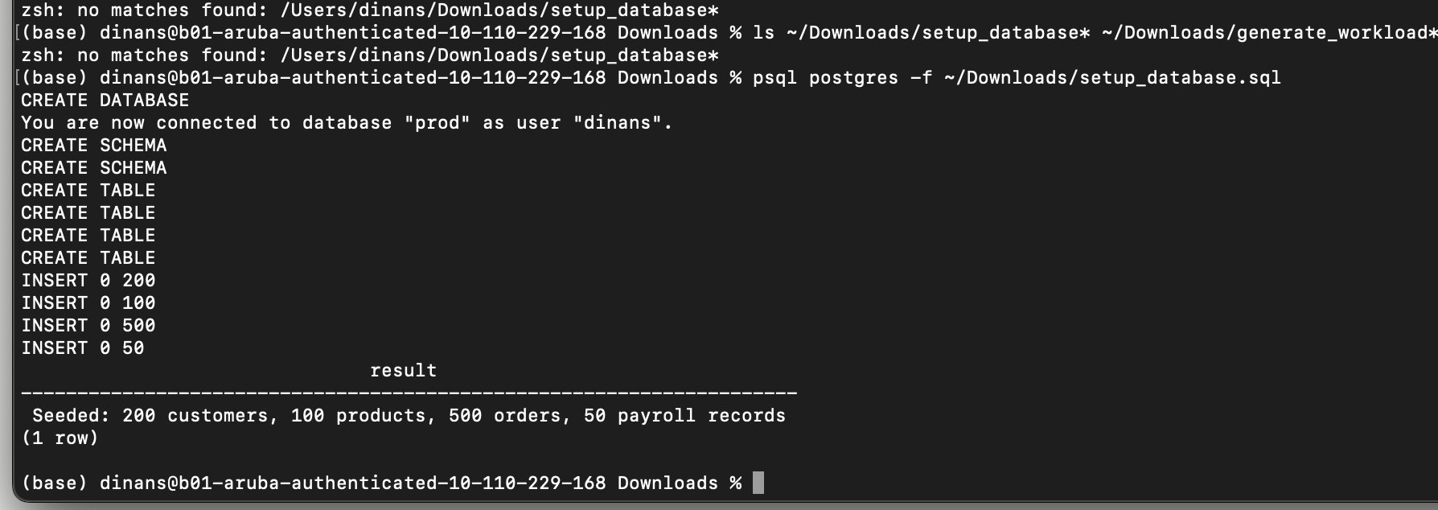
Figure 8. Database created and seeded successfully with 200 customers, 100 products, 500 orders, and 50 payroll records.

Step 6: Install Python Driver and Generate Log
The psycopg2-binary Python driver was installed to allow the workload script to connect to PostgreSQL:
pip install psycopg2-binary
The generate_workload.py script was then executed. This script connects to the live PostgreSQL instance and runs real SQL queries, capturing actual timestamps, row counts, durations, and success/failure statuses. The script generated 50 normal sessions (as app_user, analyst, dev_user, report_svc) and 12 anomaly sessions (privilege escalation, data exfiltration, schema tampering, brute-force access):
python ~/Downloads/generate_workload.py

Output
The script produced sample_pg2.log with the following characteristics:
Total sessions: 62 (50 normal, 12 anomaly)
Total event lines: 1,617
Session length range: 5 to 50 queries per session
Average session length: 26.1 events
All queries were executed against a live PostgreSQL instance with real row counts and durations captured from actual query execution. The log file follows the pipe-delimited format with 14 fields per line: timestamp, user, role, session_id, ip, device, database, schema, query_type, table_name, status, rows_returned, duration_ms, and sql.

Files Produced
setup_database.sql: Creates the prod database, schemas, tables, and seeds them with data.
generate_workload.py: Connects to PostgreSQL and executes real queries to produce the structured log file.
sample_pg2.log: The output log file used as input to the preprocessing notebook (preprocess_demo2.ipynb).

