1)

* 3 phases: initial, second and final phases
* An entity–relationship model (or ER model) describes interrelated things of interest in a specific domain of knowledge. A basic ER model is composed of entity types (which classify the things of interest) and specifies relationships that can exist between entities

2, 3)

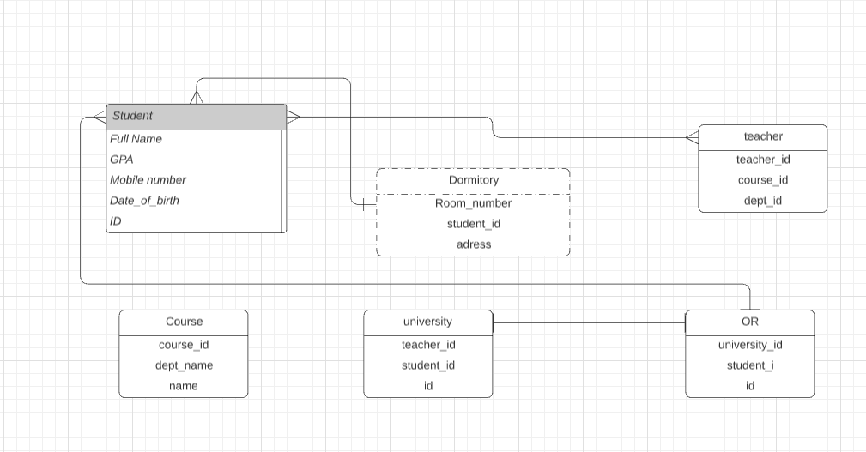

4)

