**Flowchart dan Usecase Program Compare Material Price (FA & IC)**

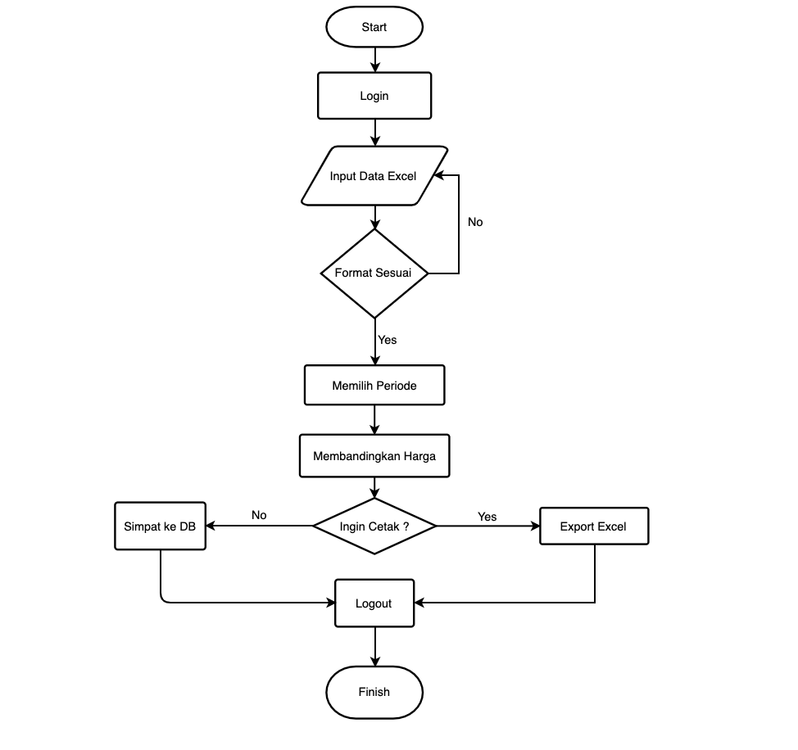

|  |  |  |
| --- | --- | --- |
| **Keterangan** | **Admin** | **User** |
| Login ke Aplikasi | √ | √ |
| Upload Data Invoice | √ | √ |
| Upload Data Penawaran | √ | √ |
| Melihat Data | √ | √ |
| Membandingkan Harga | √ | √ |
| Download Hasil Perbandingan Harga | √ | √ |
| Menambah user | √ | - |
| Logout dari Aplikasi | √ | √ |